Week: 18 Date of planning: 31/12/2023
Period: 69 Date of teaching: 02/01/2024
CORRECT THE FIRST TERM TEST- GRADE 3
Time: 40 minutes

I. Objectives:
By the end of the lesson, students will be able to:
1. Knowledge:
-Students know the answer of the test and why?.
- Teacher will have more suitable methods to teach Ss in the next units.
2. Skills:
- Listening, reading, writing, use of language
3. Attitudes/ Quality:
- Responsible
- Confident when using English
- Working hard
- Be honest
4. Forming competence:
- Self-study
- Ss can complete missions by themselves
II. Methods: Chatting, picture cues, elicit.
III. Preparation.
1. Teacher’s preparation: paper test, audio
2. Student’s preparation: pens
IV. Procedures.
1. Organization.
Class | Date of teaching | Absent Ss
3C

2. Answer key
ANSWER KEYS
PART 1: LISTENING
- Listen and draw lines. There is one example. (2 points)

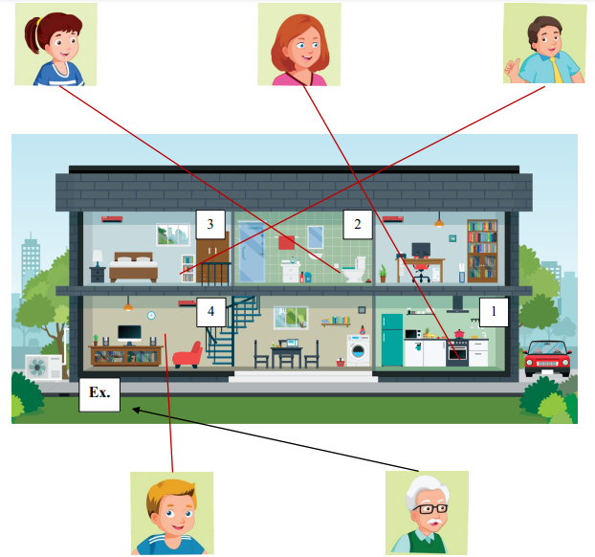

2. Listen and number. There is an example (2 points)
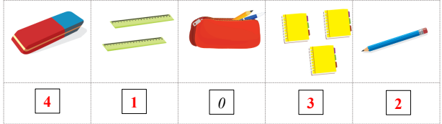

PART 2: READING AND WRITING
I. Look, read and draw lines. (1 point)
1.- a 2-d 3-e 4 – b
II. Look, read and circle the correct answer. (1 point)
5. Amy 6. two years old 7. White and black 8. Sleeping
III. Order the letters. There is one example. (1 point)
9. Cooking 10. English 11. Saturday 12. Dancing
IV. Reorder the words to make a correct sentence. (1point)
13. It’s nice to meet you.
14. This is my grandmother.
15. My favorite color is black.
16. The mirror is in the living room.
PART 3: SPEAKING
- Talk about familiar objects (1 point)
My name is…..
I’m ….years old.
I’m from Vietnam
- Look at the picture and answer the questions (1 point)
She / he is…….
Yes, it is/ No, it isn’t

Week: 18 Date of planning: 01/01/2024
Period: 70 Date of teaching: 03/01/2024
THE FIRST END- GRADE 3
Time: 40 minutes

I. Objectives:
By the end of the lesson, students will be able to:
1. Knowledge:
- Get the comments from teacher
- Teacher will have more suitable methods to teach Ss in the next units.
2. Skills:
- Listening, reading, writing, use of language
3. Attitudes/ Quality:
- Responsible
- Confident when using English
- Working hard
- Be honest
4. Forming competence:
- Self-study
- Ss can complete missions by themselves
II. Methods: Chatting, picture cues, elicit.
III. Preparation.
1. Teacher’s preparation: student’s name list
2. Student’s preparation: pens, notebook
IV. Procedures.
1. Organization.
Class | Date of teaching | Absent Ss
3C
2. Give comments for each students

Week: 18 Date of planning: 03/01/2024
Period: 71 Date of teaching: 05/01/2024
Extra exercises
- Look at the picture and put a tick or a cross
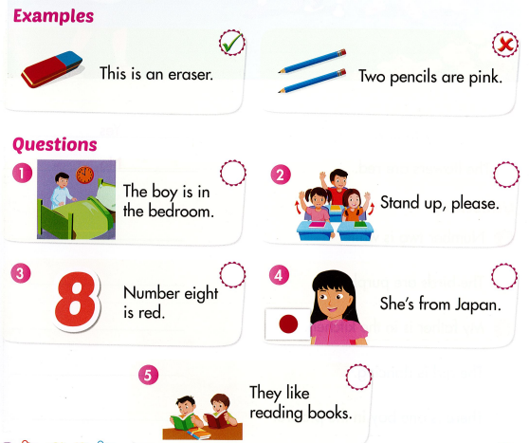

- Read and match
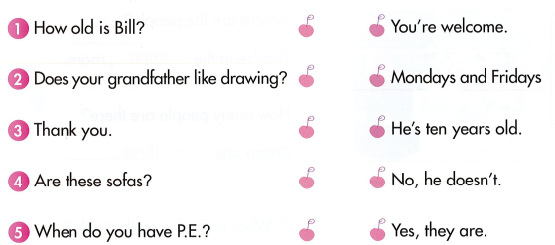
3. Look and write
