Week: 18 Date of planning: 31/12/2023
Period: 69 Date of teaching: 02/01/2024
REVIEW

- Objectives
By the end of this lesson, students will be able to review their English skills from Unit 1 to Unit 4
- Extra exercises
Exercise 1: Listen and tick the correct answer
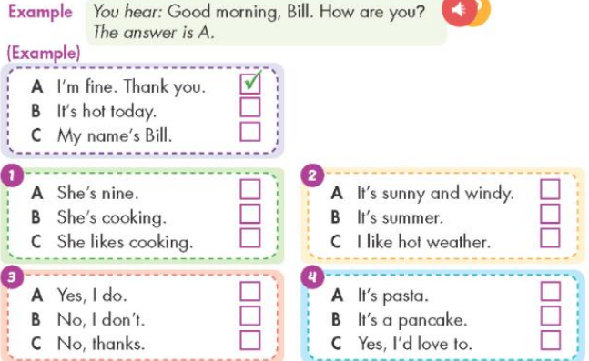

Exercise 2: Listen and tick right or wrong

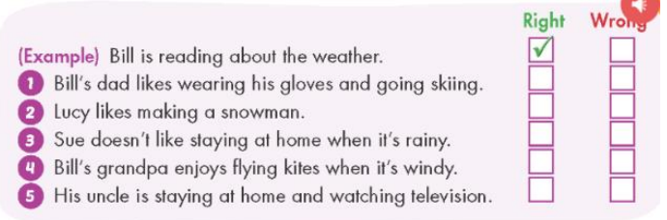

Exercise 3: Read and choose the correct word
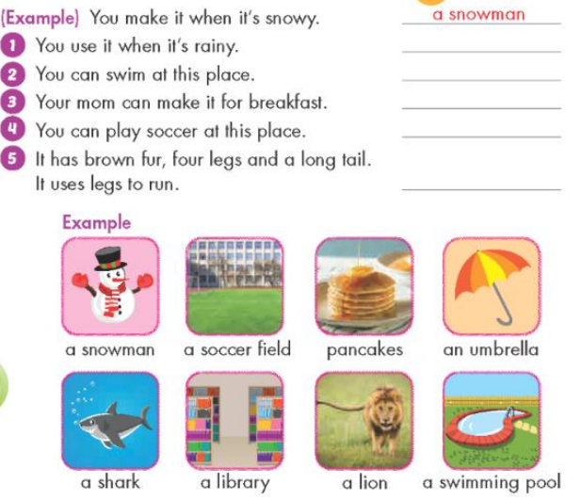

Week: 18 Date of planning: 02/01/2024
Period: 70 Date of teaching: 04/01/2024
REVIEW

- Objectives
By the end of this lesson, students will be able to review their English skills from Unit 1 to Unit 4
- Extra exercises
Exercise 1: read and number. There is an example.
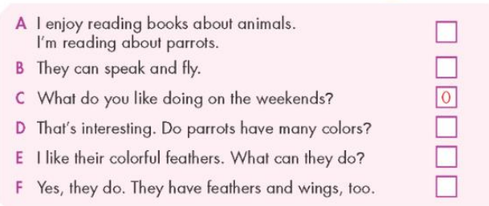

Exercise 2: Read and complete. There is an example.

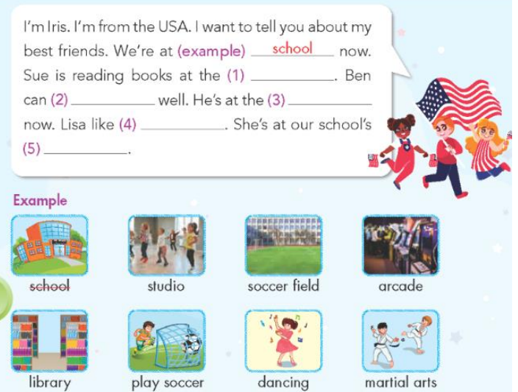

Week: 18 Date of planning: 04/01/2024
Period: 71 Date of teaching: 06/01/2024
REVIEW

- Objectives
By the end of this lesson, students will be able to review their English skills from Unit 1 to Unit 4
- Extra exercises
Exercise 1: read and write. There is an example.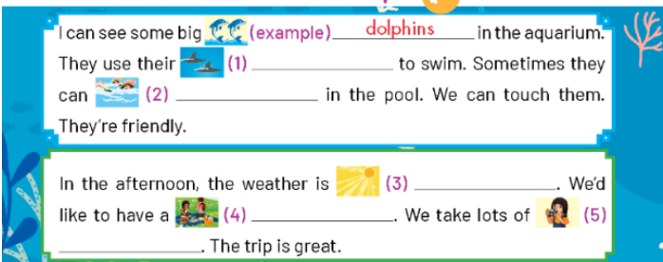

Exercise 2: Order the words to make a sentence. There is an example.

