School: Chu Minh Primary School THE FIRT TERM TEST
Full name: ___________________ ENGLIST – GRADE 4
Class: 4___ School year: 2022 – 2023
Time: 40’
Mark | Teacher’s remark

Part 1: Listening (3p)
Question 1: Listen and tick: (1p)
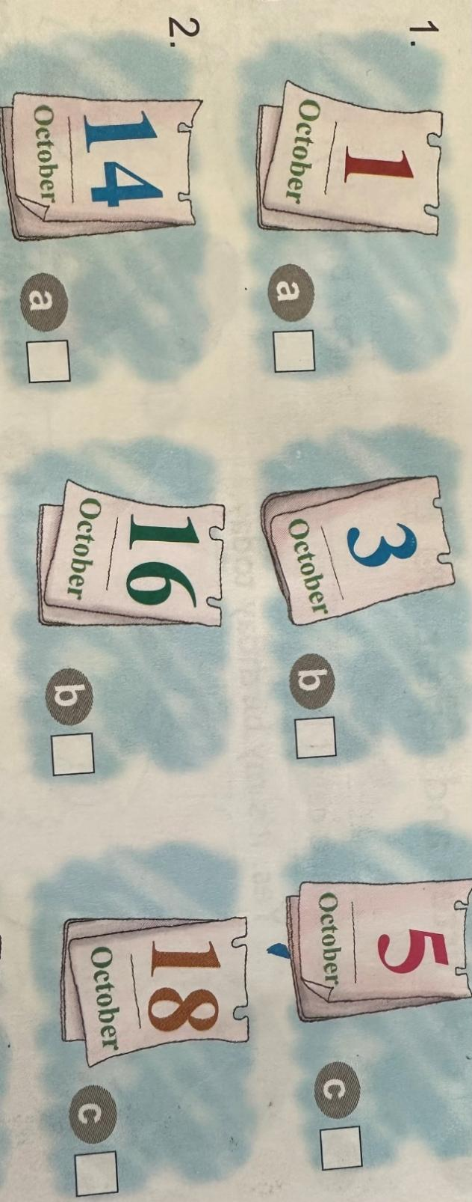
Question 2: Listen and number: (2p)
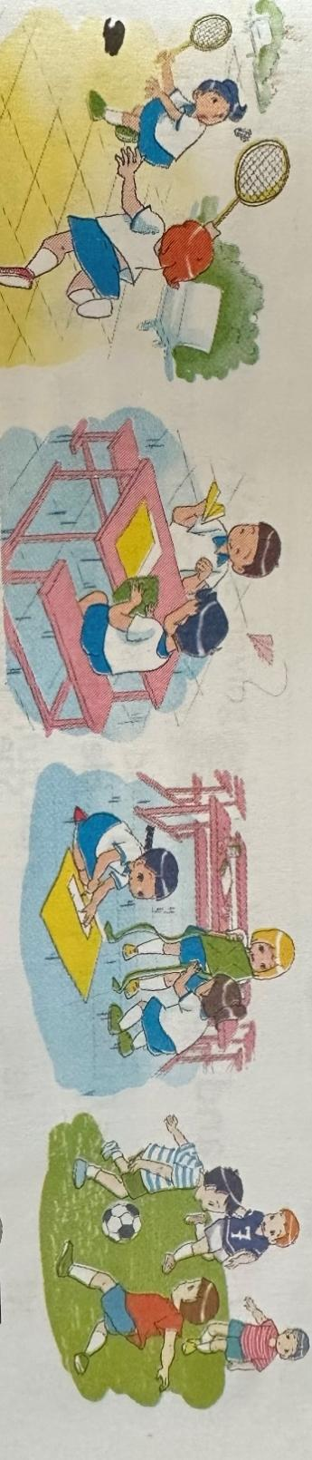
A. B. C. D.

Part 2: Reading and writing (4p)
Question 3: Read and match: (1p)
A | B | ANSWERS
1.Where are you from? | A.I was on the beach | 1 -
2.What do like you doing? | B. I am from Viet Nam | 2 -
3.What subjects do you have today? | C. I like playing badminton | 3 -
4. Where were you yesterday? | D. I have English and Math | 4 -

Question 4: Read and complete: (2p)
Hello danced birthday IT Monday
(0)Hello, I’m Mimi from Mayan Primary school. It’s (1)_______today. I’m in class now. We have Art and (2)______today. We are surfing the Internet for our IT project. Yesterday was Sunday. I was not at scholl. I had a (3)_______party with a lot of classmates. We had lots of fun. We had a big birthday cake. We watched videos, listened to music and (4)______
Question 5: Reoder the words to make sentences: (1p)
- you / like / do / What / doing / ?
______________________________________________________________
- subjects / have / What / you / do / ?
______________________________________________________________
Part 3: Speaking (3p)
- Can you Speack English ?
………………………………………………………………………………………….
- What subjects do you have today?
………………………………………………………………………………………….
- Where were you yesterday?
………………………………………………………………………………………….

