School: Chu Minh Primary School THE FIRT TERM TEST
Full name: ___________________ ENGLIST – GRADE 5
Class: 5___ School year: 2022 – 2023
Time: 40’
Mark | Teacher’s remark

Part 1: Listening (3p)
Question 1 : Listen and tick: (1p)
1. 2.
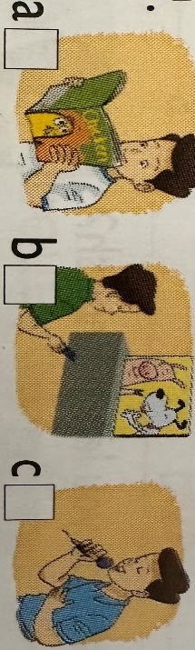

Question 2 : Listen and number: (2p)
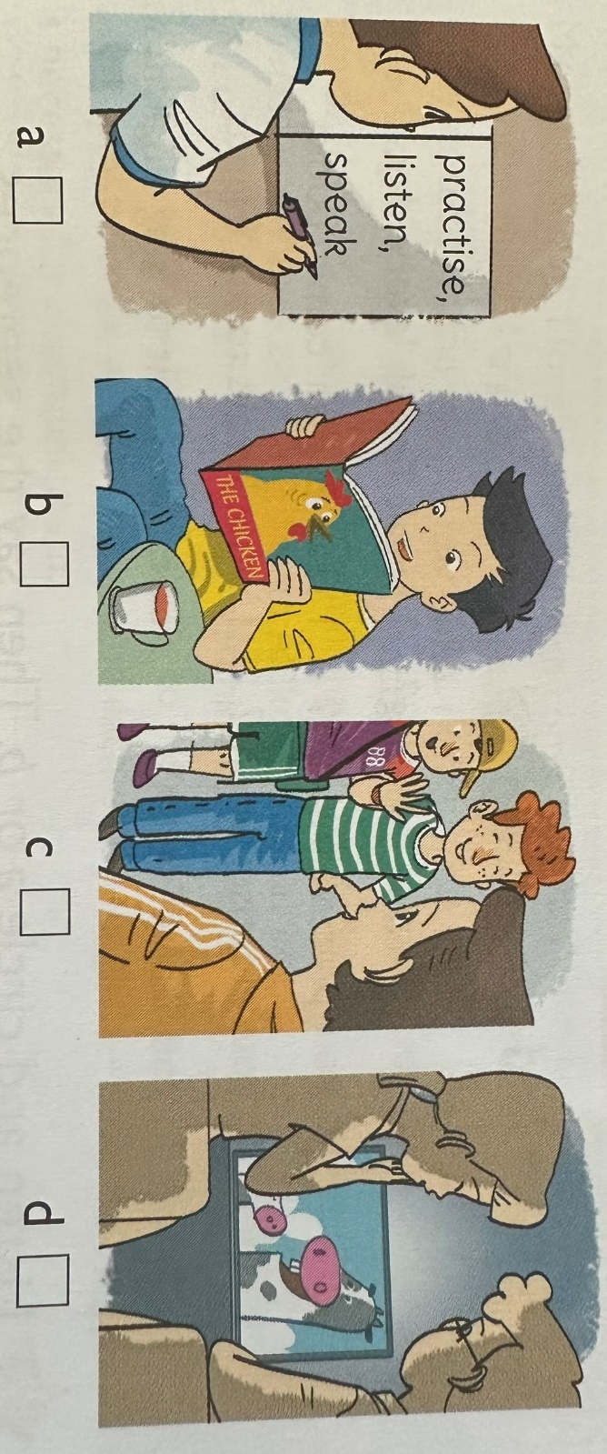

Part 2: Reading and writing: (4p)
Question 3: Circle the letter A, B, C, D to odd one out: (1p)
- A. learns B. plays C.travels D.speak
- A. always B. often C. thin D. usually
- A. character B. clever C. generous D. kind
- A. see B. ate C. speak D. read
Question 4: Fill in each gap with a suitable word from the box: (2p)
friendly English subject lessons
It is Friday today. Quan is at Son Da Primary School. He has four (1)__________:Vietnamese, Maths, English and IT. Quan has (2)____________four times a week. Miss Trang is his English teacher. She is a kind and (3)____________teacher.English is one of Quan’s favourite (4)_________ because he loves reading English short short stories and comic books. Quan also likes chatting online with his foreign like Akiko, Tony, Linda and Petter.
Question 5: Reoder the words to make sentences: (1p)
- pandas / saw / two / at / the / She / zoo /.
………………………………………………………………………………………….
- I / times / have / a / English / four / week / .
………………………………………………………………………………………….
- will / Teacher’s Day / be / When / ?
………………………………………………………………………………………….
- subjects / you / What / do / today / have / ?
………………………………………………………………………………………….
Part 3: Speaking: (3p)
- What’s your address?
………………………………………………………………………………………….
- How many lessons do you have today?
………………………………………………………………………………………….
- Why do you learn English?
………………………………………………………………………………………….

