MINH CHÂU PRIMARY SCHOOL THE MID-TERM 2
Mark

Full name :………………………………. Subject : English
Class : 4……………………….… Grade : 4
Time : 35 minit
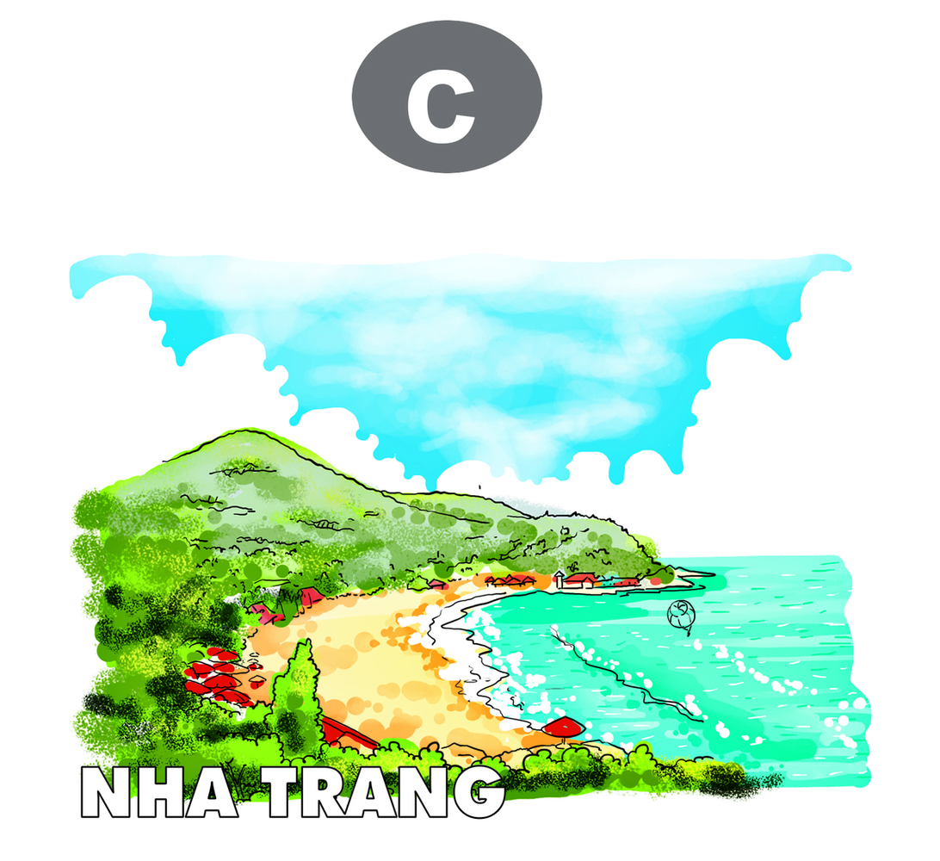
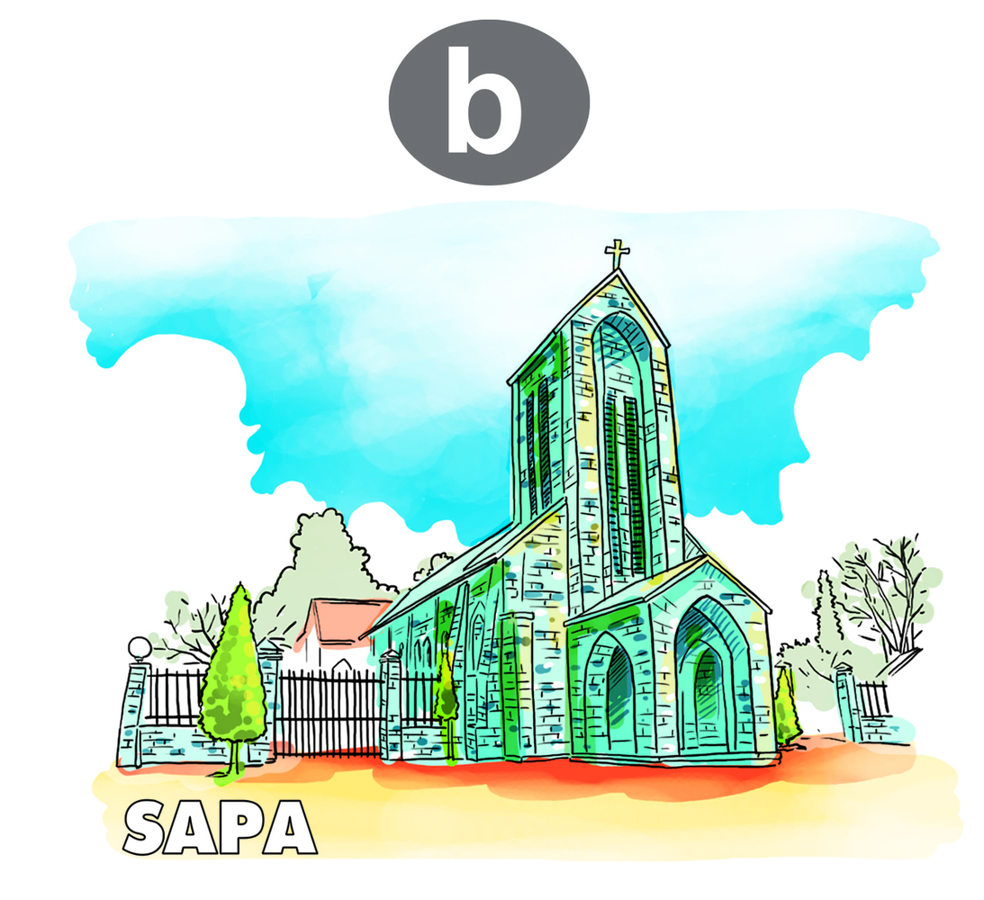
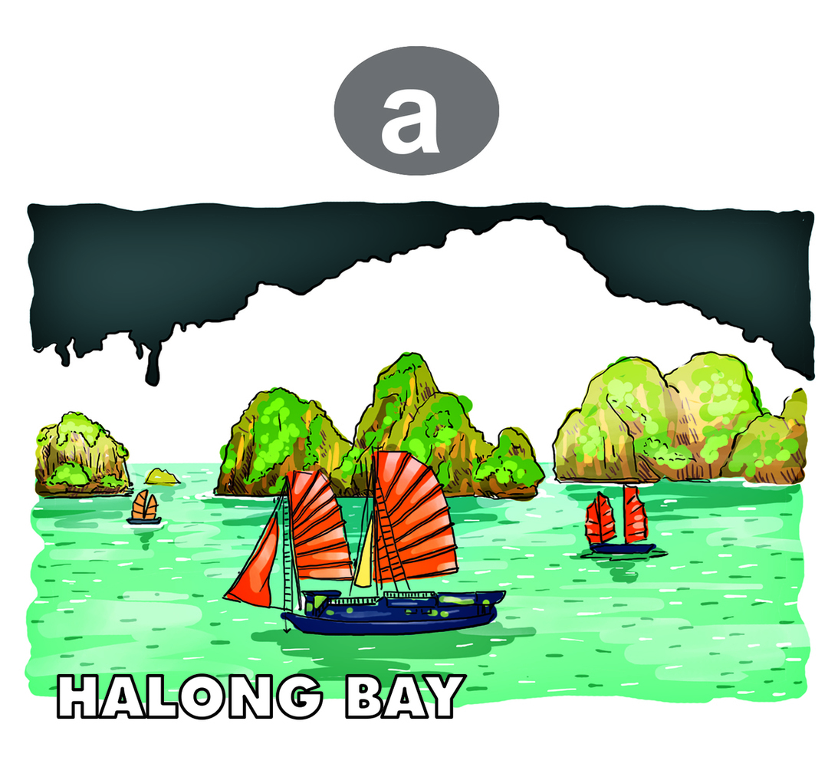
Question 1: Listen and tick (1,5p)
1
c
b
a
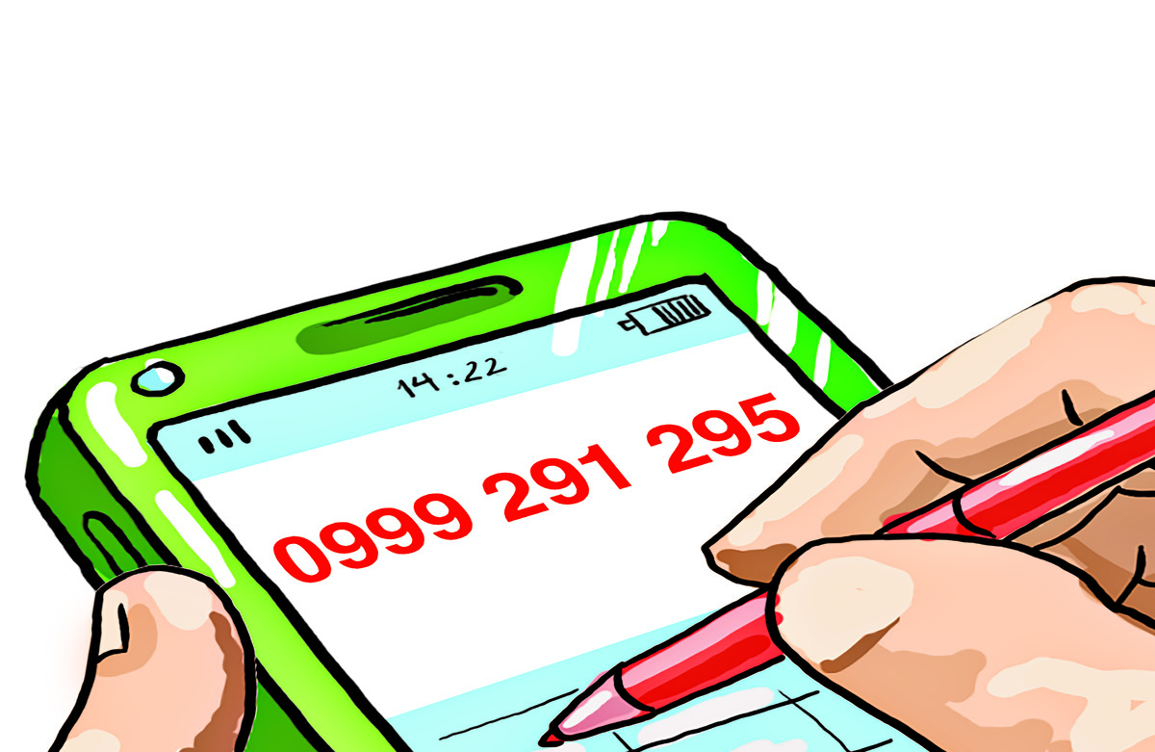


2
c
b
a
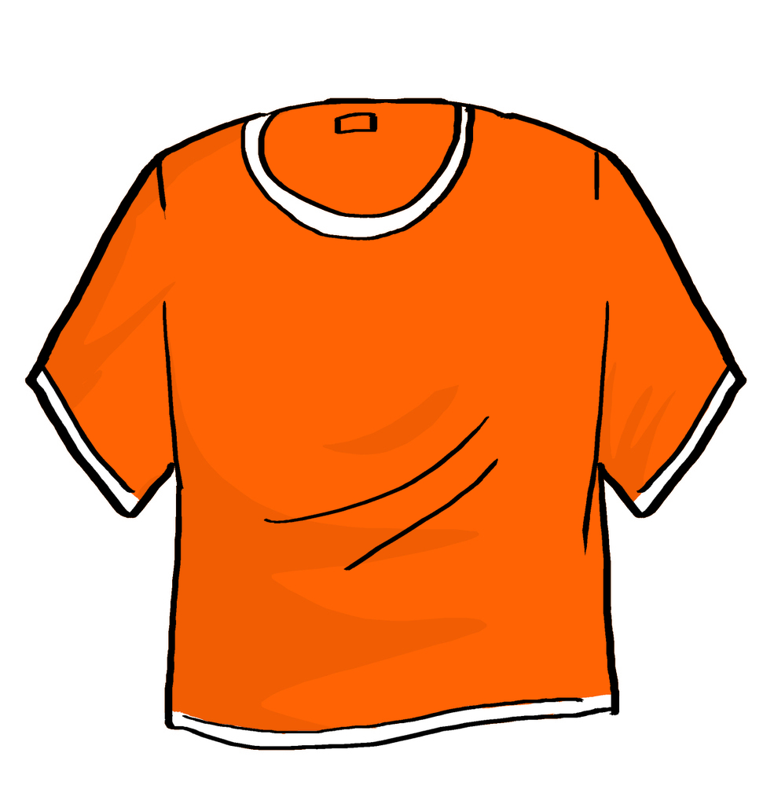
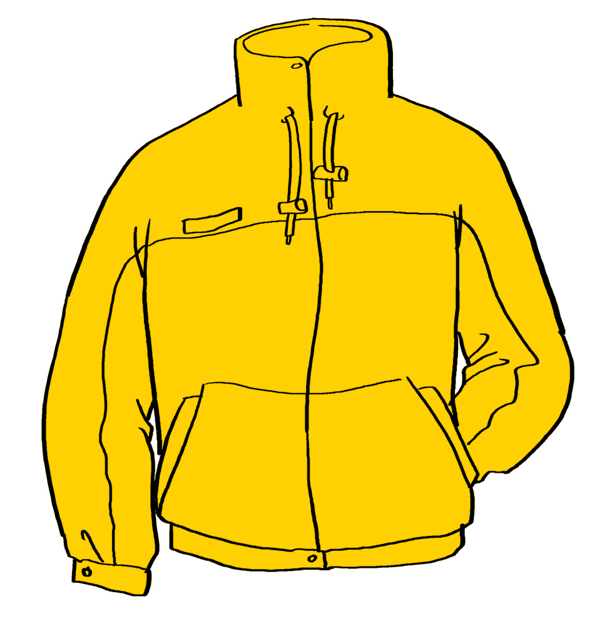
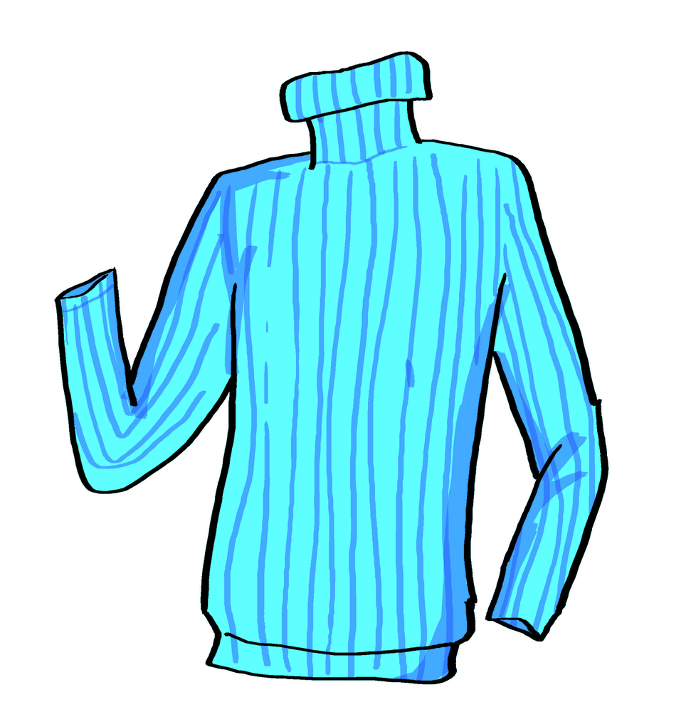
60.000 dong
50.000 dong
40.000 dong
3

c
b
a

Question 2: Listen and circle (2p)
1. Mai wants to go to the ………………………..
a. zoo b. sweetshop c. bookshop
2. Phong want to go ……………
a. skating b. fishing c. picnic
3. Phong wants to buy some ………
- Rulers b. pens c. books
4. Nam’s phone number is………………….
a. 0438 456 339 b. 0463 393 845 c. 0999 291 195
Question 3: circle the odd one out(1,25p)
- tiger kangaroo zoo crocodile
- fishing skating singing morning
- home eat build go
- jeans sandals trousers skirt
- scary big fun fast
Question 4: Choose the correct answer(2,5p)
      - What time is it? - …………………nine o’clock.
- Its B. It is C. It’s is
      - ………… does your father do? - He’s a teacher
- When B. what C. where
      - A farmer………… in a …………
- Work/ field B. works/ field C. field/ works
      - ………… your favourite food?
A. Would B. what C. what’s
5. ………… you like some lemonade?
- Would B. do C. what
- What does he ………… like? – He’s tall.
A. Do B. slim C. look
- . The mother is ………… than the sister.
A. Young B. new C. older
8. Teacher’s Day is on ………… .
A. The twentieth of November.
B. The first of January.
C. The twenty- fifth of December.
9. Nam and his family watch ………… at Tet.
A. Firework display B. display firework C. firework displays
10. What’s your favourite drink?
- It’s beef. B. It’s apple juice. C. It milk.
Question 5: Read the passage and complete the sentence (1,5).

My name is Joe. I’m 10 years old. I’m in class 4B. I get up at 6 o’clock., then I go to school. I have lunch at 11: 30, and I go home at 4 o’clock in the afternoon. I like beef and orange juice. My father is a worker. He works in a factory. My mother is a nurse. She works in a hospital. My brother is a student. He is in class 6A. my brother is tall and slim. I’m shorter than him. My parents are young. We love Tet very much. We make banh chung, decorate the house and wear new clothes at Tet.
- Write True (T) or False (F):
- Joe is in class 6A.
- He has a brother.
- His father is a farmer.
- His mother works in a school.
- His brother is a driver.
- Joe is shorter than his brother.
Question 6: Reorder the sentences(1,25p)

      - I/ like/ monkeys/ don't.
..........................................................................................................................
      - is/ Ho Chi Minh/ He/ to/ going/ city.
............................................................................................................................
      - go/ post office/ to/ you/ want/ to/ why/ the/ do?
.............................................................................................................................
      - like/ I’d/ to/ noodles/ ./ eat
............................................................................................................................
5. what animal/ want/ see/ you/ do/ to
............................................................................................................................

-The end-

