THE LAST TERM TEST 2
Subject : English – Grade 5
Full name:…………………………………..
Class :…………………………………..…
Minh Châu Primary School



Question 1 : Listen and tick ( 2p)
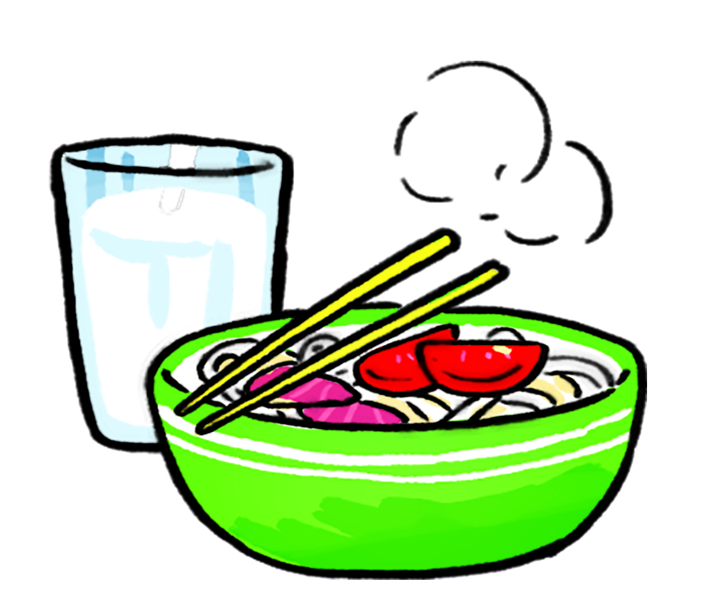
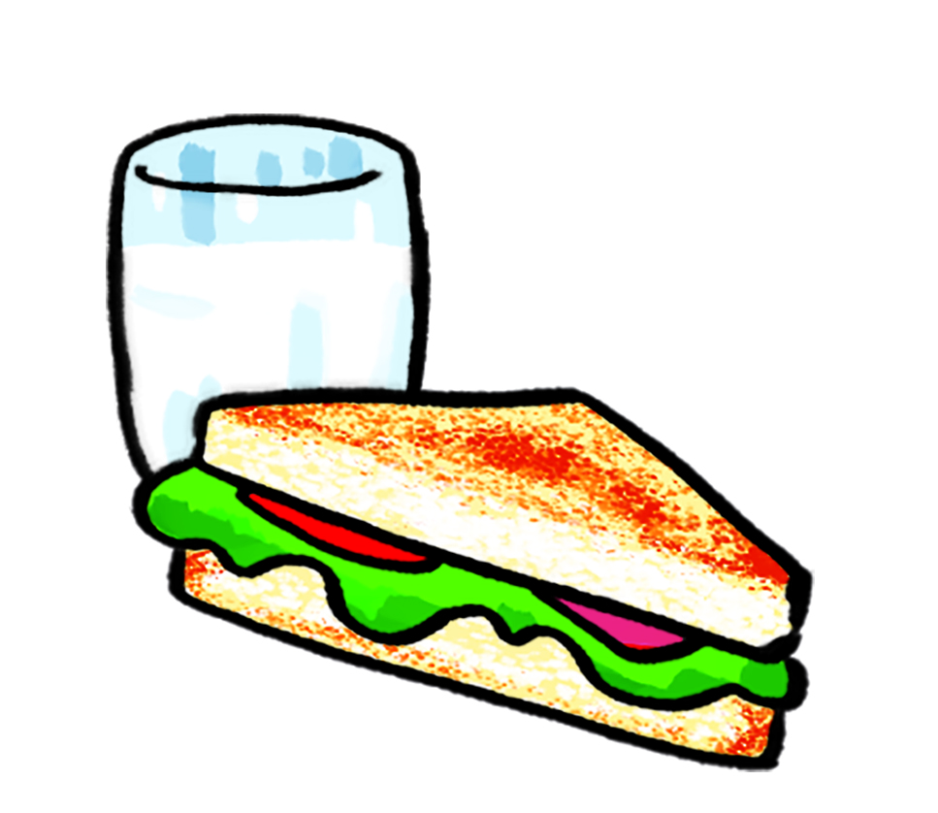

1
c
b
a
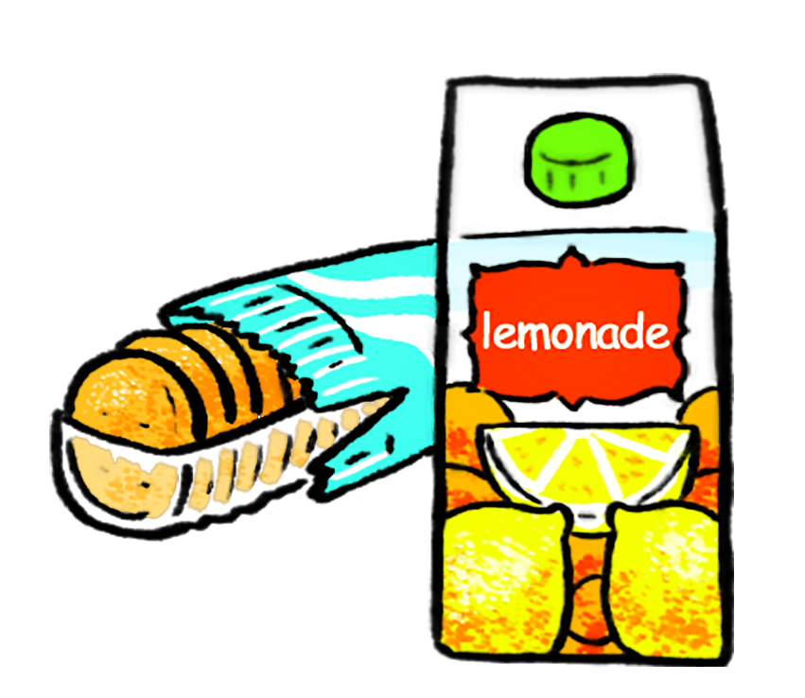
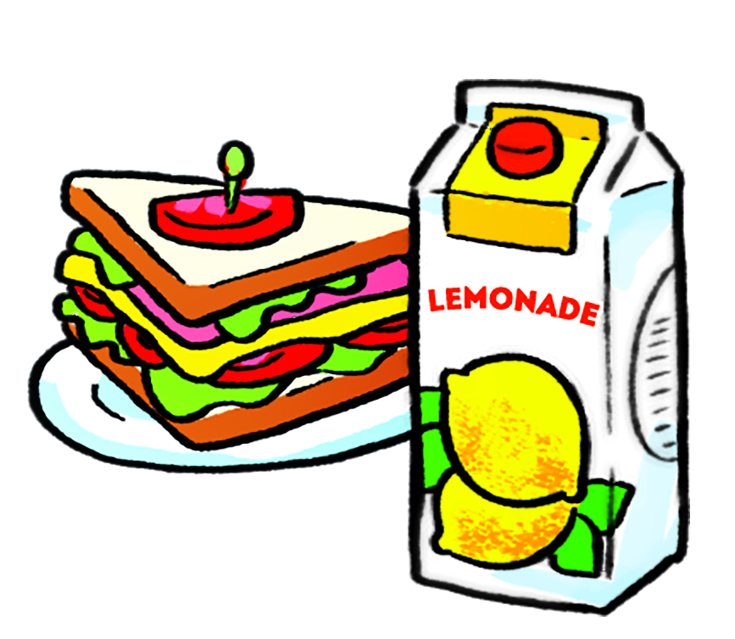
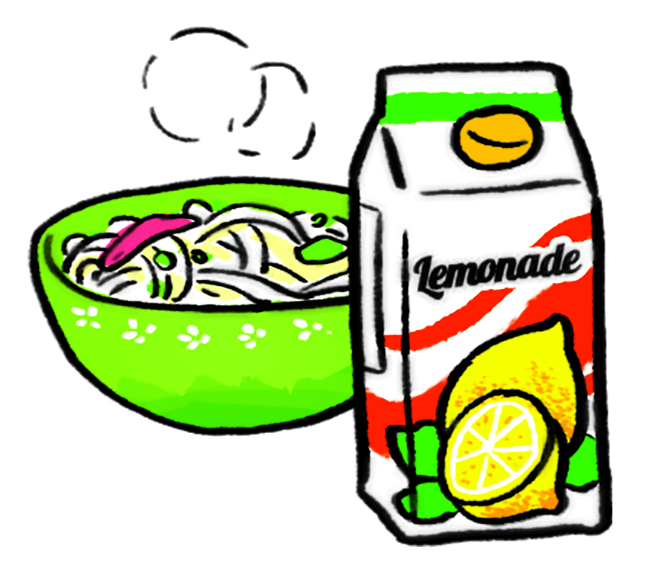
2
c
a
b

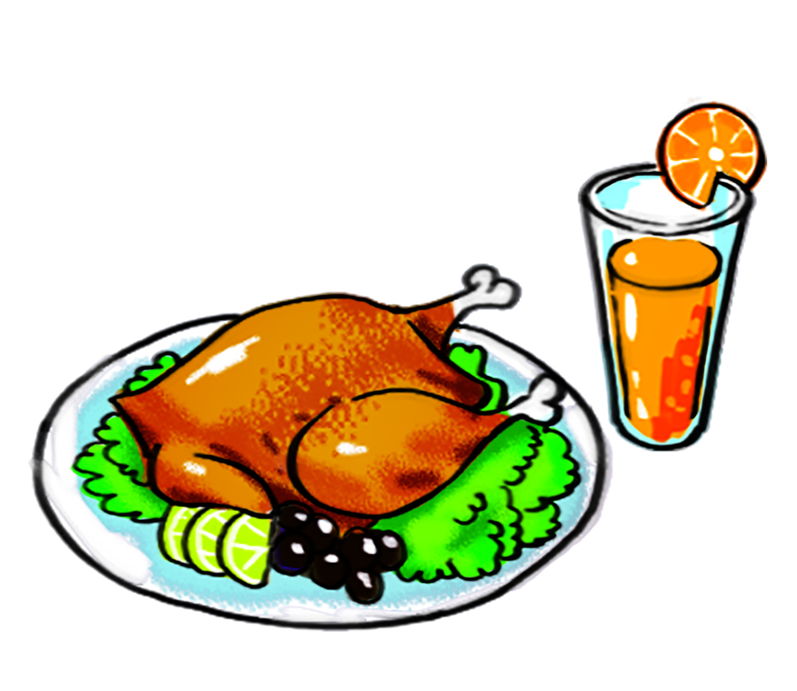
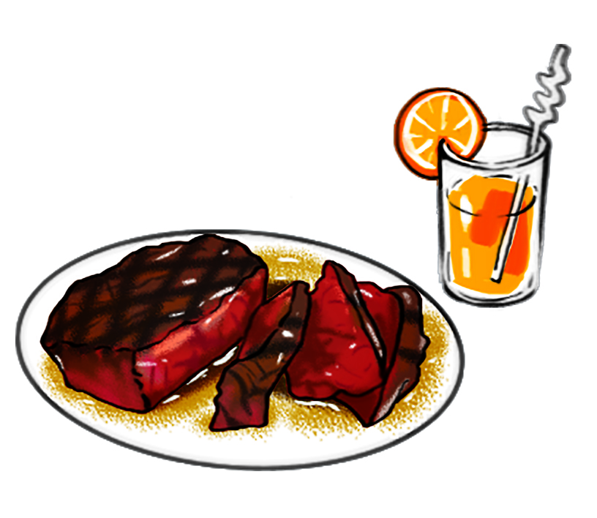
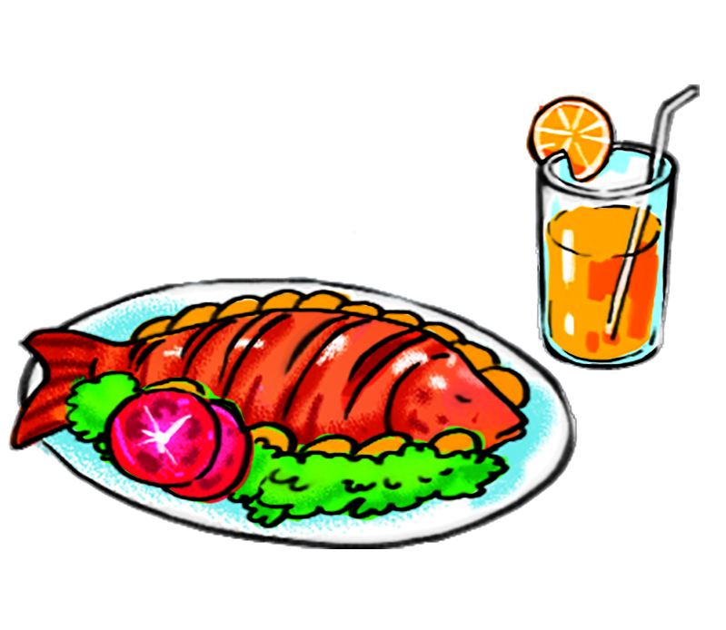
3
c
b
a
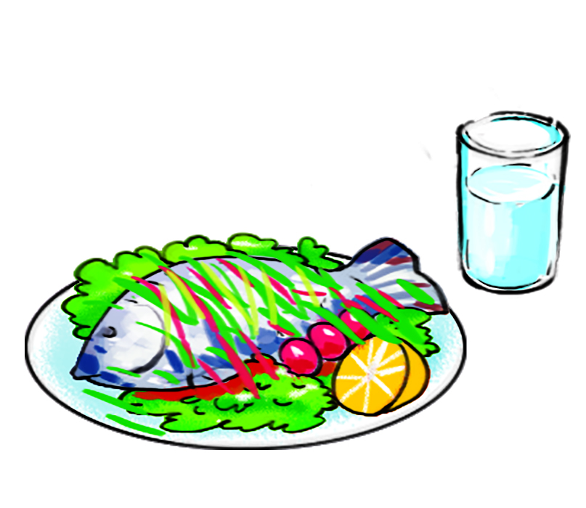
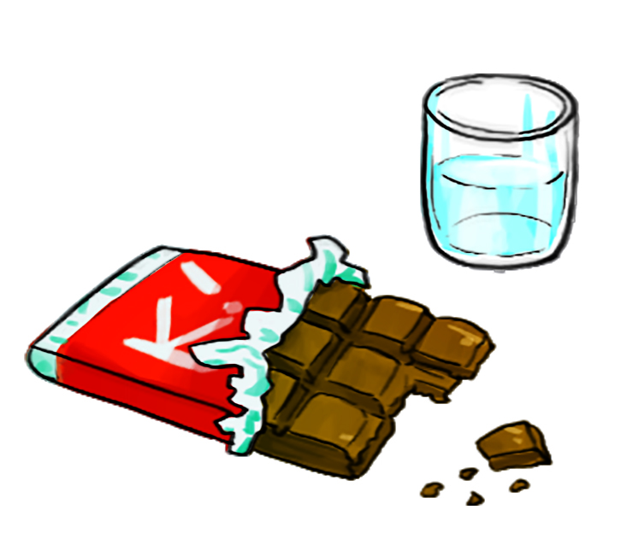
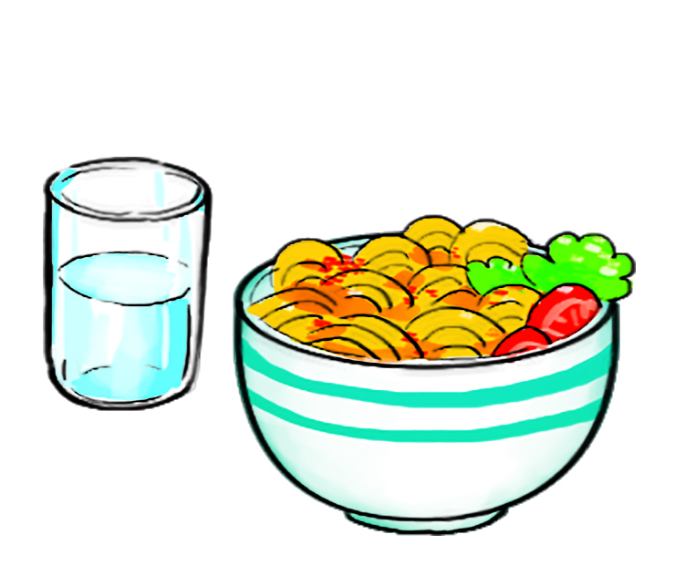
4

a
b
c

Question 2 : Listen and circle a, b or c (1p)
1. Which place would Mai like to visit?
a. the City Theatre b. Ben Thanh Market c. Thien Mu Pagoda
2. How much rice does Nam eat every day?
a. Two bowls. b. Three bowls. c. Four bowls.
3. Tony thinks Nha Trang is more ___________ than he expected.
a. attractive b. exciting c. beautiful
4. London is more ___________ than Da Lat.
a. peaceful b. beautiful c. exciting
Question 3 : Odd one out (1,25p)
1. A. autumn B. winter C. summer D. season
2. A. happy B. rainy C. foggy D. snowy
3. A. interesting B. beautiful C. pagoda D. exciting
4. A. smaller B. larger C. noisier D. sister
5. A. chocolate B. water C. biscuit D. bread
Question 4 : Choose the best answer a, b , c or d (2,5p)
- What do you usually do ______ spring?
a. on b. by c. at d. in
2. ____ can I get to the park?
a . What b . Where c . How d. When
3. Which place would you like to visit, _____?
a. a pagoda but a pagoda b . a museum or a pagoda
c . a museum and a pagoda d. a museum in a pagoda
4. What do you think _____ Dam Sen Park?
a. of b. out c . on d. at
5. What will the weather _____ tomorrow?
a . be b. like c . be like d. to like
6. What would you like to drink?
I’d like …………………….
a . A cup of coffee b. a bar of chocolate
c . a packet of biscuits d. a bowl of rice
7. The museum is ……………………….the theatre and the postoffice
a . opposite b. next to c . beside d. between
8. You can …………. a coach to Sapa.
a . go b. by c. take d. get
9. In summer, It is usually……………. There are a lot of………………….
a . hot - flower b. hot - rain c. rain - storm d. hot - sunny
10. Nha Trang is ……………………………………..than Ha Long City.
a . more bigger b. more beautiful
c. more excitinger d. more smaller

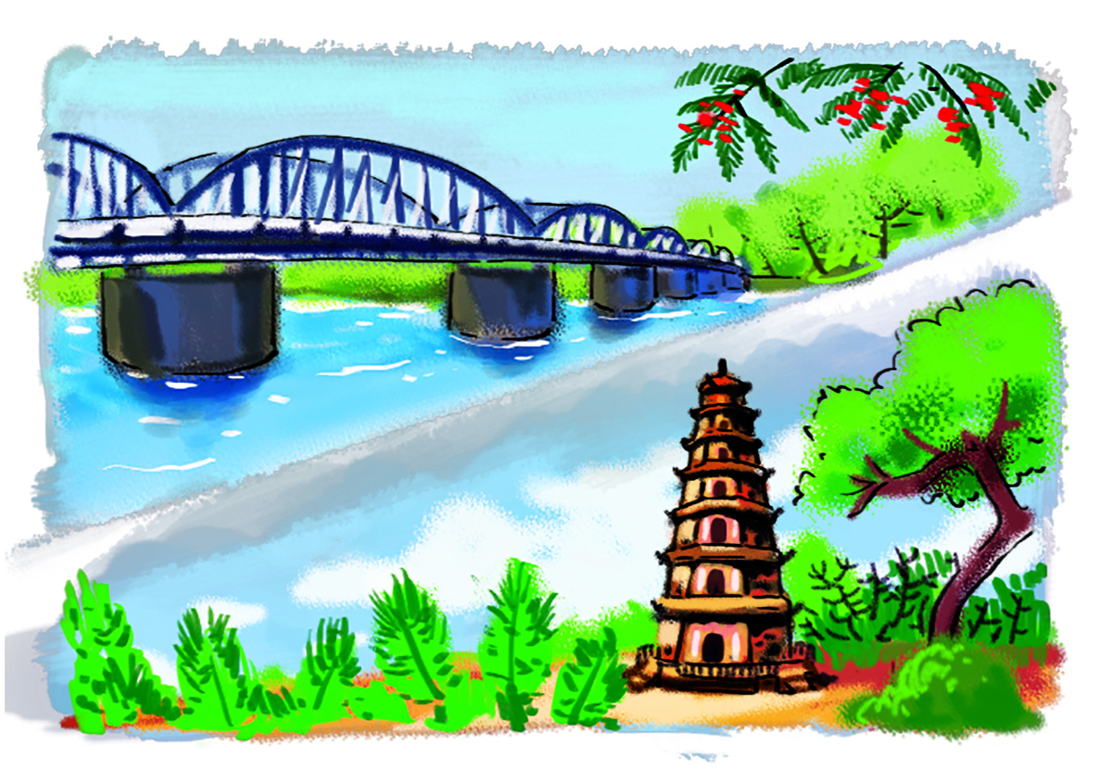
Question 5: Read and match (1,25p)
a
- What will the weather be like tomorrow ?
- It will be hot and sunny.


b
- What would you like to drrink?
- I’d like a glass of orange juice.

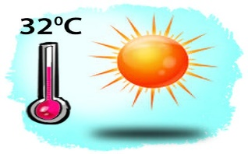
3. Which place would you like to visit, Trang Tien Bridge or Thien Mu Pagoda?
- I’d like to visit Thien Mu Pagoda
c
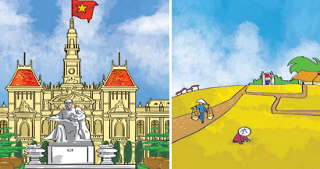
e
5. Which one is more exciting, life in the city or life in the countryside?
- I think life in the city is.
d
- Where is the market ?
- It is opposite the pharmacy.
Answer key : 1 - ……… ….… 2 - ……………… 3 - ……………………
4 - …………….. 5 - ………………

Question 6: Read and tick True (T) or False (F) (1,5p)
Peter wakes up at seven o’clock, but he doesn’t get up until 7.15. He has a shower and gets dressed. After breakfast, he brushes his teeth. He leaves the house at eight o’clock and catches the 8.15 train to work in Manchester. On the train, he reads the newspaper. He comes home at about half past six. After dinner, he washes up. Then he usually watches TV. He goes to bed about 11.30.
F
T

- He gets up at 7 o’clock
- He brushes his teeth after having dinner
- He goes to work by bus
- He works in Manchester
- He goes to bed about eleven thirty

Question 7: reorder the sentence (1,5p)

1. is / which / larger / Paris / London / one / or
……………………………………………………………………………………
2. in / spring / What / like / is / the / weather / ?
………………………………………………………………………………………
3. by/ go/ school/ doesn’t/ He/ to/ motorbike.
………………………………………………………………………………………
4. museum/ the/ next/ the/ to/ pharmacy/is
……………………………………………………………………………………….
5. like/ I’d/ visit/ Thong Nhat Park/ to
…………………………………………………………………………………….

