ĐIỂM
KIỂM TRA CUỐI HỌC KỲ I
Môn: Tiếng Anh lớp 5
Năm học: 2023-2024
Thời gian làm bài 35 phút (không kể thời gian giao bài)
Full name: ………..………………………….. Class: 5 ………
School: Minh Quang A Primary School

I. LISTENING (3 points)
Question 1: Listen and circle A, B, C or D (1 point)
Example: What’s the city like? - It’s ……………………………….
A. big and busy B. far and quiet C. large and crowded D. small and busy
1. What do you do in the afternoon Quan? - I ………………. do my homework.
A. always B. usually C. often D. sometimes
2. Linda went to her hometown by ……………………
A. bus B. coach C. plane D. train
3. What did you see at the zoo? - I saw …………………….
A. crocodiles B. gorillas C. tigers D. pythons
4. Mai bought some …………………………..
A. comic books B. story books C. fairy tale D. short stories
Question 2: Listen and tick (2 points)



Example:

A. B. C.



11

1
A. B. C.
11

1
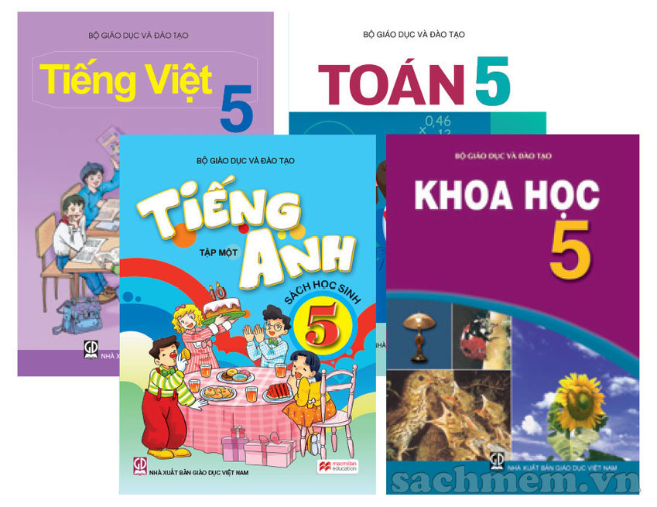
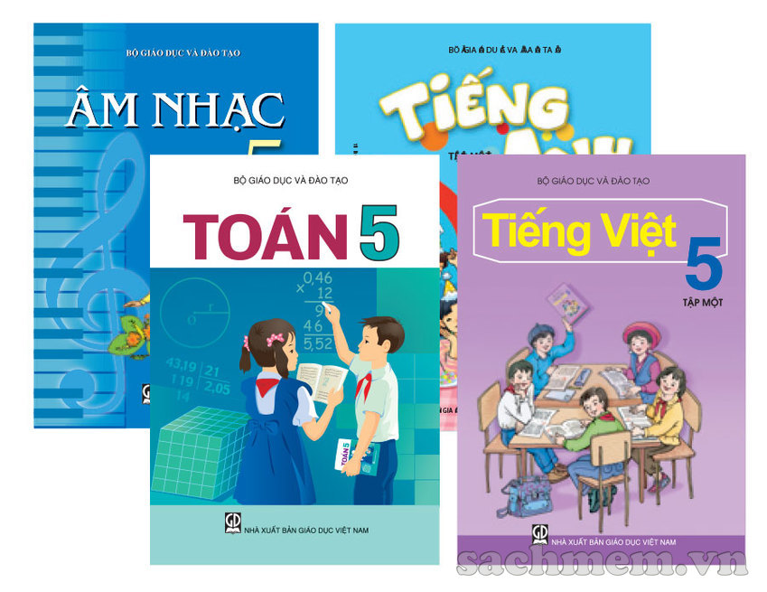
2.
A. B. C.
11

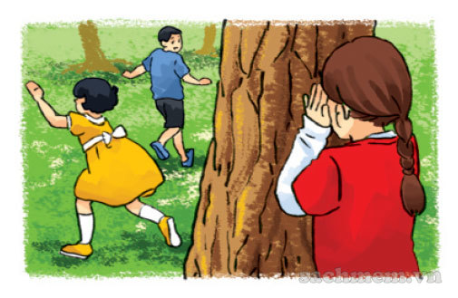


3.

A. B. C.
11
1


4
A. B. C.
11

II. READING AND WRITING (7 points)
Question 3: Circle the odd one out (1 point)
Example: A. nurse B. picture C. doctor D. dentist
1. A. banana B. watermelon C. starfruit D. fruit
2. A. Who B. What C. there D. When
3. A. spring B. doing C. watching D. reading
4. A. island B. forest C. beach D. tiger
Question 4: Match the sentence with an appropriate response (1 point)
A | B
1. Where is your hometown?  2. How many seasons are there in your country?  3. Do you like living in a big city?  4. What’s An Tiem like?  5. How do you practise reading? | a. There are four seasons.  b. I read English comic books.  c. It’s in Bac Giang Province.  d. He’s hard-working.  e. Yes, I do.
Your answer: 1 - c 2 - ………… 3 - ……… 4- ………. 5 - ……..
Question 5: Choose the correct option to complete the sentences (2 points)
Example: She teaches in a school, so she is a ………………………………
A. worker B. nurse C. teacher D. farmer
1. He ………………… at home last night.
A. stays B. staying C. to stay D. stayed
2. You should ………………. the doctor.
A. see B to see C. seeing D. saw
3. …………………. do you go to school? - By bike.
A. How far B. How C. How long D. How often
4. Did you do your homework last night?
A. Yes, I didn’t B. No, I did C. Yes, I did D. Yes, I do
5. How often do you have Science? - I have it ………………….
A. one a week B. two a week C. twice an week D. twice a week
6. …………….. you like English?
A. Do B. Does C. Are D. Is
7. Peter doesn’t want ………….. football.
A. play B. to play C. playing D. played
8. I live …………….. the second floor of Ha Noi Tower.
A. in B. on C. at D. of
Question 6: Read the passage and answer the question (2 points)
Linda is from England. There are four seasons in her country. In summer, it is hot. She often goes swimming. In autumn, it is cool and wet. Her father and she sometimes go fishing. It is very cold in winter. They usually go skiing in the mountains. In spring, it is warm and beautiful. They often go camping in the park.
Example: 0. Where is Linda from?
- She is from England.
1. What is the weather like in summer?
- ………………………………………………………………………………………..
2. What does she often do in summer?
- ………………………………………………………………………………………...
3. Does she go skiing in winter?
- ………………………………………………………………………………………...
4. What do they do in spring?
- ………………………………………………………………………………………...
Question 7. Put the words in the correct order (1 point)
Example: 0. she / Where / does / live? /
- Where does she live?
1. lives / My / in / brother / Da Nang. /
- ………………………………………………………………………………………...
2. do / every day. / Mai / morning exercise / doesn’t /
- ………………………………………………………………………………………...

HƯỚNG DẪN CHẤM ĐIỂM KIỂM TRA HỌC KỲ I
Năm học 2023-2024
Môn: Tiếng Anh lớp 5
I. LISTENING (3 points)
Question 1: Listen and circle A, B, C or D (1 point)
1-B 2-D 3-D 4-A
Question 2: Listen and tick (2 points)
1-B 2-C 3-B 4-A
II. READING AND WRITING (7 points)
Question 3: Circle the odd one out (1 point)
1-D. fruit 2-C. there 3-A. spring 4-D. tiger
Question 4: Match the sentence with an appropriate response (1 point)
1-a 2-e 3-d 5-b
Question 5: Choose the correct option to complete the sentences (2 points)
1-D. stayed 2-A. see 3-D. How often 4-C. Yes, I did
5-D. twice a week 6-A. Do 7-B. to play 8-B. on
Question 6: Read the passage and answer the question (2 points)
1. It is hot.
2. She often goes swimming.
3. Yes, they do.
4. They often go cmping in the park.
Question 7. Put the words in the correct order (1 point)
1. My brother lives in Da Nang.
2. Mai doesn’t do morning exercise in the morning.

MA TRẬN ĐỀ HỌC KÌ 1
Năm học: 2023 - 2024
Môn: Tiếng Anh lớp 5
Kỹ năng | Nhiệm vụ đánh giá/ kiến thức cần đánh giá | Mức/ Điểm |  |  |  | Tổng số câu, số điểm, tỷ lệ %
Listening | Nhiệm vụ đánh giá/ kiến thức cần đánh giá | M1 | M2 | M3 | M4
Listening | Question 1:  1. M2 2. M1  3. M1 4. M3 | 0,5đ | 0,25đ | 0,25đ |  | 8 câu, 3 điểm, tỷ lệ 26,7%
Listening | Question 2:  1. M1 2. M4  3. M3 4. M2 | 0,5đ | 0,5đ | 0,5đ | 0,5đ | 8 câu, 3 điểm, tỷ lệ 26,7%
Reading & Writing | Question 3:  1. M3 2. M1  3. M2 4. M3 | 0,25đ | 0,25đ | 0,5đ |  | 22 câu, 7 điểm, tỷ lệ 73,3%
Reading & Writing | Question 4:  1. M1 2. M1  3. M2 4. M1 | 0,75đ | 0,25đ |  |  | 22 câu, 7 điểm, tỷ lệ 73,3%
Reading & Writing | Question 5:  1. M4 2. M3  3. M1 4. M2  5. M4 6. M1  7. M3 8. M2 | 0,5đ | 0,5đ | 0,5đ | 0,5đ | 22 câu, 7 điểm, tỷ lệ 73,3%
Reading & Writing | Question 6:  1. M1 2. M1  3. M2 4. M1 | 1,5đ | 0,5đ |  |  | 22 câu, 7 điểm, tỷ lệ 73,3%
Reading & Writing | Question 7:  1. M2 2. M3 |  | 0,5đ | 0,5đ |  | 22 câu, 7 điểm, tỷ lệ 73,3%
Total |  | 12  40% | 9  30% | 6  20 % | 3  10% | 30

