Name: ………………………….  Grade 4 | UNIT 1: NICE TO SEE YOU AGAIN!
BÀI TẬP CƠ BẢN
Exercise 1: Write the missing letters.
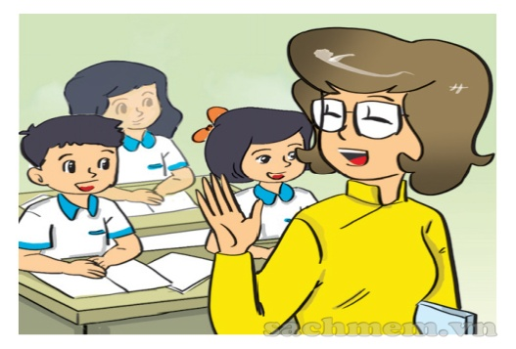 | 
1…………………………….. | 2……………………………..
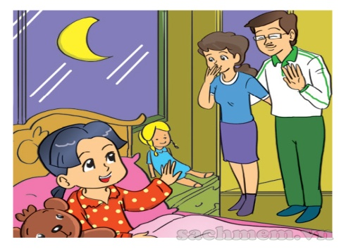 | 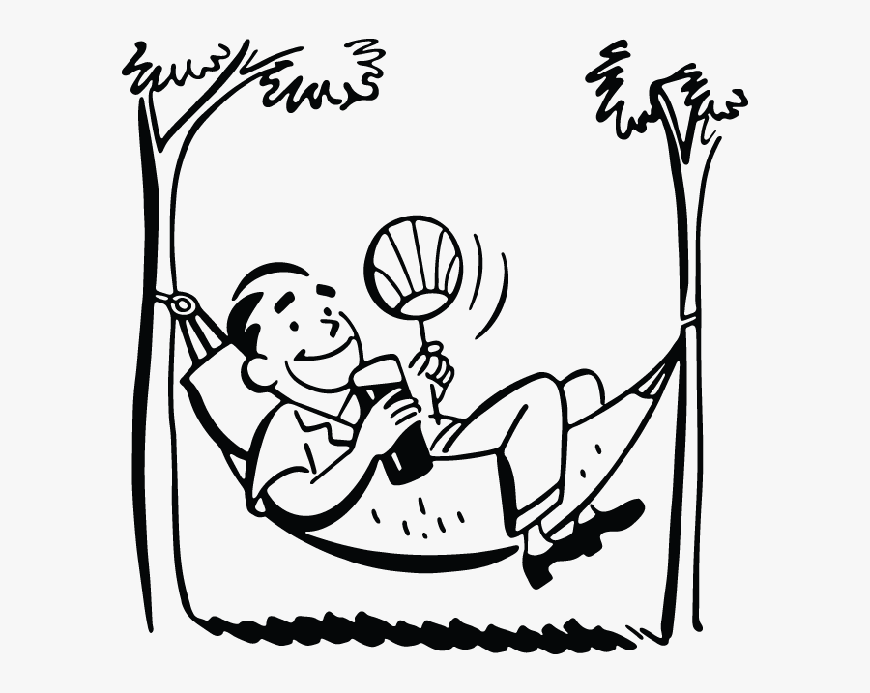
3………………………………. | 4…………………………………..
LJLJ
Exercise 2: Complete.
tomorroww
night
again
good

1. Nice to see you……………....................
2. ……….............morning, Miss Hien.
3. See you…………………………………
4. Good……………!
Exercise 3: Complete the dialogue.
Mai: Hello, my (1)……........is Mai.
Lan: (2)…………......, Mai. I (3) ……………..Lan. How (4)…………..you?
Mai: (5)………………….fine, thanks. And (6)………………….?
Exercise 4: Look and complete.
1. They are ……………………….  at Tran Hung Dao Primary School. | 2. This is an ……………………...
 | 
3. He has many…………………….. | 4. Clare is from …………………...
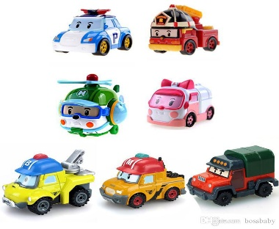 | 
5. This is his school ………………..
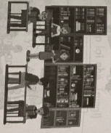

Exercise 5: Reorder.
1. to/ you/ see/ nice/ again/.
……………………………………………………………………..
2. morning/ children/ good/, /dear /.
……………………………………………………………………..
3. you/ tomorrow/ see.
……………………………………………………………………..
4. later/ see/ you/.
……………………………………………………………………..
5. am/ well/ I/ very/.
……………………………………………………………………..
6. to/ too/ nice/ you/ see/.
……………………………………………………………………..
7. Hoa/ are/ you/, / how/?
……………………………………………………………………..
8. ten/ robots/ I/ have/.
…………………………………………………………………….
Exercise 4: Read and match.
a. Nice to see you, too.
1. Good morning, class.
2. How are you, Mai?
3. Goodbye, Miss Hoa.
4. Nice to see you again.
b. Bye, Lan. See you tomorrow.

c. Good night.

d. Good morning, Miss Hoa.

e. I’m very well, thank you.
4. Good night, Mom.

BÀI TẬP NÂNG CAO
Exercise 7: Read and circle the correct answer.
Hello, my name is Nam Phong. I am from Hanoi. I study at Doan Thi Diem primary School. It is a big school in Hanoi. I have many friends. Tim, Phong Sarah and Mai are friends.
B. No, he isn’t
A. Yes, he is
1.Is Nam Phong a primary pupil?
B. No, it isn’t
A. Yes, it is
2.Is his school in Hanoi?

B. No, it isn’t
A. Yes, it is
3.Is his school small?

B. No, she isn’t
isn’t
A.Yes, she is
4.Is Sarah his friends?
Exercise 8: Write questions for the answers
Ví dụ: What’s your name? My name’s Nam.
1………………………………………….? He is from Australia.
2………………………………………….? She is ten years old.
3………………………………………….? She is reading a book.
4………………………………………….? There are 20 students in the class.
5………………………………………….? I’m a pupil.
Exercise 9: Fill in the blank with ONE word.
1. I am …………………...student.
2. Nice to ………………..…...again.
3. I’m …………………....England.
4. She is………………..…...Class 4A1.
5. Her……………..……...is Thuy Ngan.
6. ……………………....you later!
7. I study at Tran Hung Dao primary……………………....
8. It’s……………………...to see you again.
Exercise 10. Write complete sentences.
1.She/ in/ class 4A.
………………………………………………………………………………
2. How/ your parents? / / They/ very well/ thanks.
………………………………………………………………………………
3. They/ from/ Ho Chi Minh City.
………………………………………………………………………………
4. There/ ten/ student/ the classroom.
………………………………………………………………………………
5. Nam/ new pupil/ my class.
………………………………………………………………………………
6. They/ reading/ books/ library.
………………………………………………………………………………
7. Hoa/ like/ her school/ very much.
………………………………………………………………………………
8. Your school/ big/ small?
…………………………………………………………
Exercise 11: Read and answer the questions.
Her name is Thu Huong. She’s from Hanoi, Vietnam. She studies at Doan Thi Diem Primary School. She is in Class 4A3. She has some close friends.
They are Hung, Quang and Phong.
1.What is her name?
………………………………………………………………………………
2. Where is she from?
………………………………………………………………………………
3. Which class is she in?
………………………………………………………………………………
4. Where does she study?
………………………………………………………………………………
5. Who are her close friends?
………………………………………………………………………………
Exercise 12. Underline one mistake in each sentence and correct it.
1.Nam’s school are Le Loi Primary school.
………………………………………………………………………………
2. Peter and David is from England.
………………………………………………………………………………
3. My best friend, Hoa are in class 4C.
………………………………………………………………………………

4. They studies at Nguyen Binh Khiem Primary School.
………………………………………………………………………………
5. They likes footaball, badminton and tennis.
………………………………………………………………………………
6. My brother likes robots and my sister doesn’t like them.
………………………………………………………………………………
7. What toys do Hoa like?
………………………………………………………………………………
8. Hung have many good friends.
………………………………………………………………………………
9. There are a pen, a ruler and two pencils in my bag.
………………………………………………………………………………
10. Tuan, Manh, and Hoa are my friend.
………………………………………………………………………………

Name: ………………………  Grade 4 | UNỈT 2: I AM FROM JAPAN.
BÀI TẬP CƠ BẢN

Exercise 1: Write the name of the country.

 |  | 
1. ……………………… | 2. ………………………… | 3…………………………..
 |  | 
4. ……………………… | 5. ………………………… | 6. …………………………

Exercise 2: Read and complete.
Vietnammam
American
Japan

England
Sunday
Korea

Hello. I’m Linh. I’m from (1) ………………… I am Vietnamese. Today is (2) ………………….. I go swimming with my friends. Mary is from (3) ……………….. She is English. Tom is from New York. America. He is (4) ……………….. Akira is from Tokyo, ………………… And Min Hye comes from (6) …………………….

Exercise 3: Look and match:

1.  | A. I’m from Japan
2. 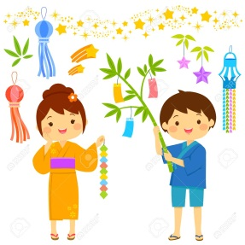 | B. I’m from China
3.  | C. I’m from France
4. 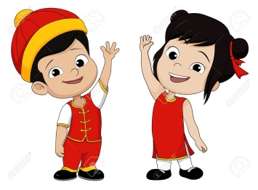 | D. I’m from Canada
5.  | E. I’m from Russia
6. 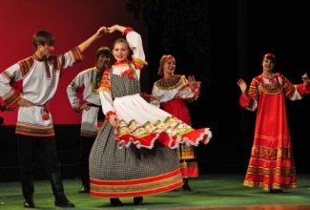 | F. I’m from Germany

1……….2……….3……….4……….5………..6…………

Exercise 4: Look and complete.
 | 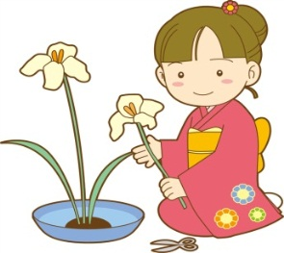
1. I’m from Australia.  kjjh  I’m ……………………..….. | 2. I’m from Japan.  kjjh  I’m ……………………..…..
 | 
3. I’m from America.  kjjh  I’m …………… | 4. I’m from ………………..…………  kjjh  I’m French
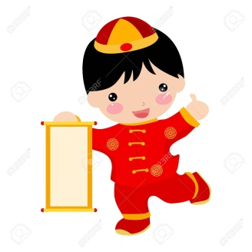 | 
5. I’m from……………..  kjjh  I’m Chinese | 6. I’m from Russia.  kjjh  I’m …………………………….

Exercise 5: Read and match.

1. Is your friend Japanese? | A. Hung H-U-N-G  kjjh | 1…..…
2. How do you spell your name? | B. I am from Korea.  kjjh | 2…..…
3. Where are you from? | C. Yes, she is.  kjjh | 3…..…
4. How old are you? | D. She is my friend.  kjjh | 4…..…
5. Who is the girl? | E. I am ten years old.  kjjh | 5…..…

6: Read and complete.
Hello
Japan
Vietnam

Vietnamese
Japanese

Hoa: (1) …………………………… I’m Hoa.
Chiko: Hi, Hoa. I’m Chiko.
Hoa: Nice to meet you, too. Where are you from?
Chiko: I’m from (2) …………………….. I’m (3) ………………….And you
Hoa: I’m from (4) ………………………… I’m (5)…………………

BÀI TẬP NÂNG CAO

Exercise 7: Reorder.
kjjh
1. are/ you/ nationality/ what/ ?
=> ………………………………………………………………………………
2. City/ Nam/ from/ is/ Ho Chi Minh/ , / Vietnam.
=> ………………………………………………………………………………
3. are / from / you / where/ ?
=> ………………………………………………………………………………
4. come / they/ Japan /.
=> ………………………………………………………………………………
5. am / I / Vietnamese/ .
=> ………………………………………………………………………………
6. you/ do / from/ Malaysia/ come/ ?
=> ………………………………………………………………………………
Exercise 8: Read and write True or False:

Hello. My name is Tuan. I am from Nghe An, Vietnam. I am Vietnamese. I am in Hanoi now. I have many friends. They are from different countries. Seong is from Seoul, Korea. She is Korean. Michio is from Tokyo, Japan. He is Japanese. Sarah is from Washington D.C, America. She is American.

- Tuan is Vietnamese
kjjh
- Tuan doesn’t have any friends.
kjjh
- Seong is from Japan.
kjjh
- Michico is from American.
kjjh
- Sarah is from America.
kjjh
- Sarah is English
kjjh
Exercise 9: Circle the correct answer.
1. There ………………………….three dogs under the table.
A. is | B. do | C. does | D. are
2. She …………………..from Malaysia
A. am | B. is | C. are | D. come
3. This is my friend. …………………….is Nam.
A. I | B. We | C. His | D. He
4. Hakim is from Malaysia. …………………….nationality is Malaysian.
A. Your | B. My | C. Their | D. His
5. We……………………. From France.
A. come | B. see | C. meet | D. am
6. Where’s …………………..mother from?
A. you | B. she | C. yours | D. your
7. How many books ……………Lan have?
A. do | B. is | C. does | D. are
8. Tom is ……………………..America.
A. x | B. a | C. from | D. an
9. They are ………………………..soccer in the playground.
A. playing | B. play | C. plays | D. to playing
10. Tony is from Australia. He is ………………………………
A. Australia | B. Australias | C. Autralia | D. Australian

Exercise 10: Underline one mistake in each sentence and correct it.
kjjh
1. My brother’s name is Hung. She is 16 years old.
=> ………………………………………………………………………………
2. My mother is cooking and my father is watch TV.
=> ………………………………………………………………………………
3. There is ten goldfish in the fish tank.
=> ………………………………………………………………………………
4. I am Hoa. I come from Vietnam and I am Korean.
=> ………………………………………………………………………………
5. Hoa, Lan and Giang is my friends.
=> ………………………………………………………………………………
6. There are a lot of flower in front of my house.
=> ………………………………………………………………………………
7. She has five robots but five goldfish.
=> ………………………………………………………………………………
8. Where do Akiko come from?
=> ………………………………………………………………………………
9. She come from Hanoi, Vietnam.
=> ………………………………………………………………………………
10. They are Canada.
=> ………………………………………………………………………………
kjjh
Exercise 10: Fill in the blank.
kjjh
1. Michio and I ……………….from Japan.
2. He is Nam. …………nationality is Vietnamese.
3. She is from Korea. She is ………………
4. - What is ………………nationality? – They are Cambodian.
5. - ……………..is Hari from? – She is from Seoul, Korea.
6. - What ………………is that bag? – It’s red.
7. - What ………………does she like? – She likes dolls and robots.
8. How ……….people are there in the room?
9. There ……..four big trees behind my house.
10. - Does she come from Australia? – Yes, she ……….
kjjh
Exercise 11: Read the passage and answer the questions:
kjjh
My name is Tuan Anh. Now, I live in Hanoi, Vietnam. I am Vietnamese.
I am nine years old. I am in class 4A1. My school is Cau Giay Primary school.
I like playing football. My favourite footballer is Quang Hai. He is twenty. He is a skillfull player. He plays football very well. I want to be a football player, too.

1. Where does Tuan Anh live?
=> ………………………………………………………………………………
2. What nationality is he?
=> ………………………………………………………………………………
3. Which class is he in?
=> ………………………………………………………………………………
4. Where does he study?
=> ………………………………………………………………………………
5. Does he like playing footaball?
=> ………………………………………………………………………………
6. Who is his favourite footballer?
=> ………………………………………………………………………………
7. How old is his favourite footballer?
=> ………………………………………………………………………………
8. Does Quang Hai play football well?
=> ………………………………………………………………………………

Name: ………………  Grade 4 | Unit 3: WHAT DAY IS IT TO DAY?

BÀI TẬP VẬN DỤNG CƠ BẢN
Exercise 1: Find the words.
Sunday | Saturday | Monday | Wednesday | Tuesday | Friday | Thursday

L | D | I | T | I | T | U | E | S | D | A | Y | S | S | Y
U | J | M | O | G | E | R | R | O | O | P | V | N | A | F
N | T | H | U | R | S | D | A | Y | M | P | Y | V | T | R
C | O | O | C | H | I | C | K | E | N | L | V | E | U | I
H | R | T | W | E | D | N | E | S | D | A | Y | G | R | D
N | A | V | U | O | J | T | E | M | T | S | I | D | D | A
M | O | N | D | A | Y | S | U | N | D | A | Y | D | A | Y
O | J | T | E | M | N | E | E | I | K | F | A | D | Y | K

Exercise 2: Look and answer.
 | 1. What does he do on Mondays?  ………………………………………………
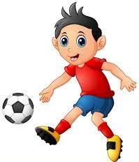 | 2. What does he do on Tuesdays?  ………………………………………………
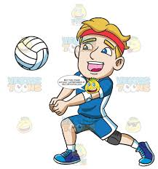 | 3. What does he do on Wednesdays?  ………………………………………………
 | 4. What does he do on Thursdays?  ………………………………………………
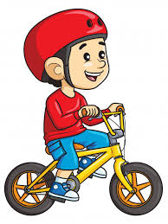 | 5. What does Nam do on Fridays?  ………………………………………………

Exercise 3: Look and write.
surf
dance
play tennis
skate
swim
watch TV
relax
play football
draw
study

  1………………………………. |   2……………………………….
3………………………………. |   4……………………………….
5………………………………. |   6……………………………….
  7………………………………. |   8……………………………….
  9………………………………. |   10……………………………….

Exercise 4: Look and answer.
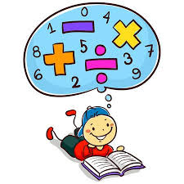 | 1. What do we have on Monday?  ……………………………………………………..
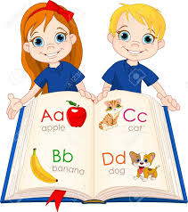 | 2. What do we have on Tuesday?  ……………………………………………………..
 | 3. What do we have on Wednesday?  ……………………………………………………..
 | 4. What do we have on Thursday?  ……………………………………………………..
 | 5. What do we have on Friday?  ……………………………………………………..

Exercise 5: Circle the correct answer.
- ………… do you have English? – I have English on Monday.
- What B. When C. How many D. How
- Hi, I’m Michio. Nice to ………… you.
- Like B. look C. meet D. miss
- Where do you come …………? – I come from Japan.
- On B. in C. about D. from
- What ………… is it today? –It’s Tuesday.
- Date B. day C. week D. month
- I ………… comics on Sundays.
- Read B. play C. ride D. visit
Exercise 5: Reorder.
- class / in / are / What / you /?
=> ……………
2. am / class / 4A3 / in / I ./
=> ……………
3. do / you / What / do / the / weekend / at /?
=> …………….

4. my / help / grandparents / I /.
=> ……………..
5. school / goes / from / Monday / Friday / She / to /.
=> ………………
6. in / afternoon / the / about / How /?
=> ………………
7. go / I / zoo / afternoon / the / to / in / the /.
=> ……………….
8. you / have / when / English / do /?
=> ………………..
9. Lan / go / school / Does / to / every / day / ? - does / she / Yes /, /.
=> …………………
10. name / her / What / is / ? - Trang / is / She /.
=> ………………..
11. morning / school / go / to / I / every /.
=> ……………….
12. next / class / When / is / English / the / ?
=> ………………
13. Mondays / have / on / Maths / and / Fridays / I /.
=> ………..……..
14. He / not / Vietnamese / on / Tuesday / have / does /.
=> …..………….
15. from / Japan / Min Hye / is / ? - not / is / she / No /.
=> …………..……

Name:……………………..  Grade 4 | UNIT 4: WHEN’S YOUR BIRTHDAY?
BÀI TẬP CƠ BẢN
Exercise 1: Complete the table.
Months of a year
1……………………… | 5………………………. | 9……………………….
2………………………. | 6………………………. | 10…………………….
3………………………. | 7………………………. | 11……………………..
4………………………. | 8………………………. | 12……………………..
Ordinal numbers
1st ………………… | 11th ……………………… | 20th ………………….……..  jjk
3rd ………………… | 13th ……………………… | 22nd ………………………...  jjk
5th ………………… | 14th ……………………… | 25th …………………………  jjk
7th ………………… | 17th ……………………… | 30th …………………………  jjk
9th ………………… | 19th ……………………. | 31st …………………………..  jjk

Exercise 2: Write the missing words.
1, J _ N _ A _ _ 7. J _ L _
2. FE _ RU _ _ Y 8. AU _ US _
3. M _ RC _ 9. SE _ _ EM _ _ R
4. A _ P _ L 10. OC _ O _ E _
5. _ A _ 11. N _ V _ MB _
6. J_N_ 12. DE _ _ M _ E

Exercise 3: Look and write.
1 | A: When’s the Women’s Day?  B: It’s …………………………………….…. | 
2 | A: What’s the date today?  B: It’s……………………………………..…….. | 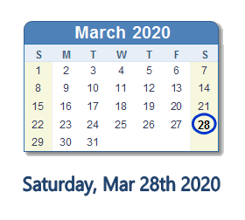
3 | A: When is your birthday?  B: It’s ………………………………..………….. | 
4 | A: When’s Children’s Day?  B: It’s ………………………………..…………. | 
5 | A: When’s Independence Day?  B: It’s …………………………………………….. | 
6 | A: When’s Teacher’s Day?  B: It’s …………………………..……………….. | 

Exercise 4: Match.

- The seventh of June | - 2/7  ddd | 1………..
- The third of December | - 1/1 | 2……….  ddd
- The fifteenth of March | - 7/6 | 3………..  ddd
- The second of July | - 3/12 | 4………..  ddd
- The first of January | - 15/3 | 5………..

Exercise 5: Circle the correct answer.
1. When’s ……………………..birthday?
A. you | B. her | C. I | D. She
2. It’s the twenty-first………………….. October.
A. in | B. to | C. of | D. on
3. Her………………..is on the tenth of November.
A. day | B. birthday | C. date | D. birh
4. ………………………is the date today?
A. What | B. When | C. Where | D. How
5. My birthday is on the …………………………of July.
A. four | B. fourteen | C. fourteenth | D. twenty-four
6. His birthday is………………………. The thirty- first of March.
A. on | B. in | C. of | D. to
7. It’s on the ……………………………..of December.
A. date | B. day | C. week | D. month
8. When’s your birthday? ………………………….
A. It’s Wednesday.  - It’s my birthday . |  | C. It’s on the twentieth of March.  D. Happy birthday!

BÀI TẬP NÂNG CAO
Exercise 6: Match.
- When’s your birthday? | - He’s American  fgfg
- What is the date today? | - They’re from Vietnam.  fgfg
- When do you have Vietnamese? | - Oh, happy birthday to you.  fgfg
- What nationality is Tom? | - I have it on Wednesdays and Fridays
- It’s my birthday today? | - It’s on the seventh of December.  fgfg
- Where’re Tam and Hoa from? | - It’s the sixth of September.
- What do you have on Thursday? | - It’s on Wednesday.
- When is the next English class? | - We have English.

1……….2………3………..4……….5………..6……….7………..8…………
Exercise 7: Look and answer.
Ví dụ: When’s your birthday? (5/6)
- It is on the fifth of June.

- When’s your birthday, Mai ? (20/3)
=>…………………………………………………………………………….
2. When’s your birthday, Lan? (30/1)
=>…………………………………………………………………………….
3. When’s your birthday, Nam? (22/12)
=>………………………………………………………………….………….
4. When’s your birthday, Huy? ( 11/2)
=>…………………………………………………………………….……….
5. When’s your birthday, Linda? (15/11)
=>…………………………………………………………………..………….
6. When’s your birthday, Hari? (8/10)
=>…………………………………………………………..………………….
Exercise 8: Reorder to make a dialogue.
- It’s on the seventh of April 1…………..
- Happy birthday, Sarah. 2………….
- Oh, What a nice cake! 3………….
- Thank you ! 4…………
- When’s your birthday, Hoa? 5………...
- Yes, it’s my birthday, today! 6…………
Exercise 9: Write the questions for the underlined part.
1, Her birthday is on the tenth of Octorber.
=>………………………………………………………………….

2. It’s the sixth of April today.
=>………………………………………………………………….
3. My father’s birthday is on the eight of September
=>………………………………………………………………….
4. No, today isn’t my birthday.
=>………………………………………………………………….
5. My place of birth is in Nghe An
=>………………………………………………………………….
6. It is Monday, today.
=>………………………………………………………………….
7. Yes, she has English on Thurday.
=>………………………………………………………………….
8. They visit their friends at the weekend
=>………………………………………………………………….
9. She watches TV in the evening.
=>………………………………………………………………….
10. Yes, my brother’s birthday is on the third of June.
=>………………………………………………………………….

Name: ……………………  Grade 4 | UNIT 5: CAN YOU SWIM?
BÀI TẬP CƠ BẢN
Exercise 1: Look and write
1. | I can……………………………………. | 
2. | I can’t…………………………………… | 
3. | I can’t…………………………………… | 
4. | I can……………………………………. | 
5. | I can……………………………………. | 
6. | I can’t…………………………………… | 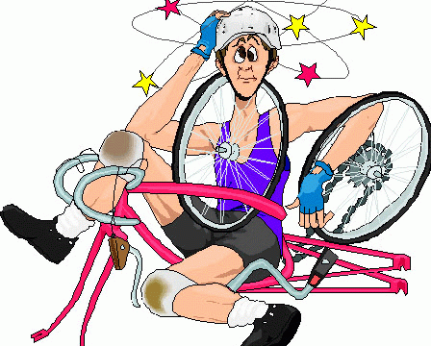

Exercise 2: Answer about yourself
1. Can you sing?
=>
2. Can you dance?
=>
3. Can you swim?
=>
4. Can you play football?
=>
5. Can you play chess?
=>
6. Can you skate?
=>

7. Can your mother sing?
=>
8. Can your father draw?
=>

Exercise 3: Look and match
21
11
 | a. He can play the guitar.  b. He can ride a bike. | 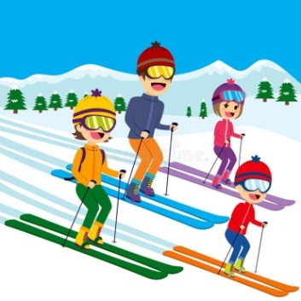
31   | c. They can ski.  d. She can sing. | 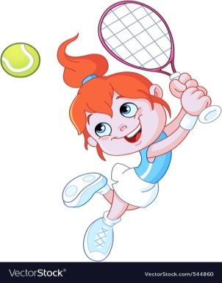  41
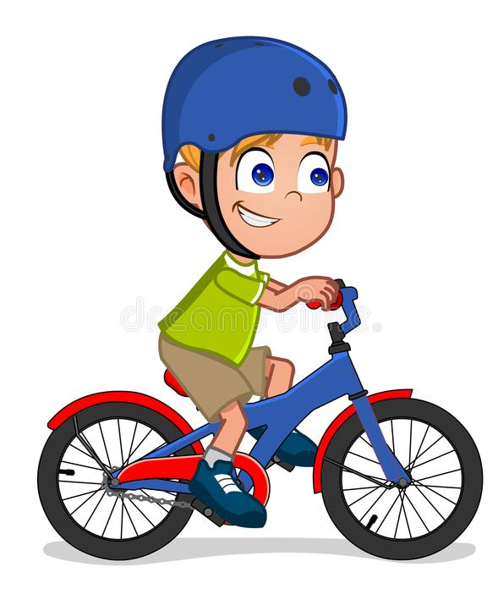  51 | e. They can swim.  f. He can play golf. |   61
71  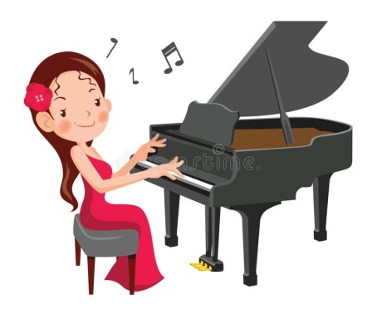 | g. He can run.  h. They can dance. |   81
  11  91 | i. She can play tennis.  j. He can play football. | 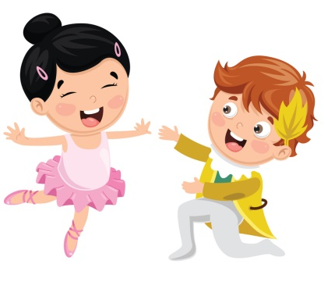  12  10
 | k. He can drive a car.  l. She can play the piano | 

1………… | 2………… | 3………… | 4………… | 5………… | 6…………
7………… | 8………… | 9………… | 10………… | 11………… | 12…………

Exercise 4 : Look and answer
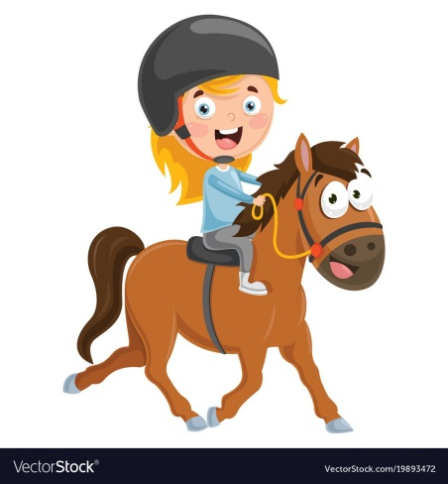 | 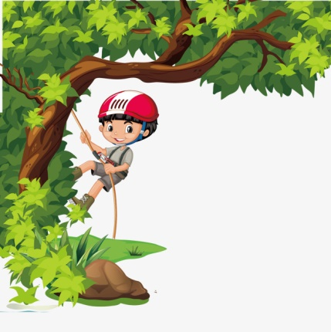
1. What can she do?  =>…………………………………….. | 2. What can he do?  =>……………………………………..
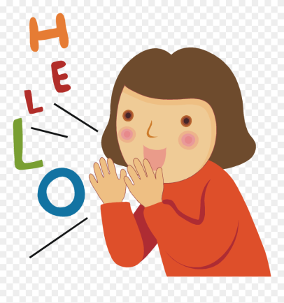 | 
3. What can she do?  =>…………………………………….. | 4. What can he do?  =>……………………………………..
 | 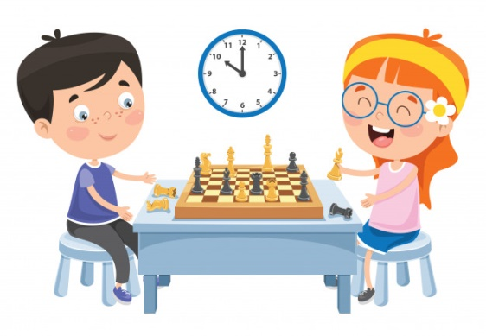
5. What can she do?  =>…………………………………….. | 6. What can they do?  =>……………………………………..

Exercise 5: Write
1. My mother can
2. She can’t
3. My father can
4. He can’t
5. I can
6. I can’t
Exercise 6: Read and complete
can
pet
it
sing
yes

Hoang: Do you have a (1)………………., Nam?
Nam: (2)…………., I do. I have a parrot.
Hoang: What (3)…………….it do?
Nam: It can fly, (4)………………and climb a tree.
Hoang: Can it speak?
Nam: Yes, (5)……………count from one to ten in English.
Hoang: Oh, it’s wonderful.

Exercise 7: Match

a. She can skip rope.

1. I can draw my house.

b. No, she can’t.

2. What can Cuc do?

c. I can play the piano.

3. Can you play volleyball?

d. I can, too.

4. Can Thuong dance?

5. What can you do?

e. Yes, I can.

BÀI TẬP NÂNG CAO
Exercise 8: Reorder
1. do/ grandfather/ what/ your/ can/?
=>
2. play/ can/ Dung/ football/.
=>
3. you/ volleyball/ can/ play/?
=>
4. ride/ horse/ can’t/ Hung/ a/.
=>
5. cook/ I / well/ can/ Yes./ very/.
=>
6. mother/ speak/ well/ can/ my/ very/ English/.
=>
7. friend/ my/ but/ bike/ cannot/ a/ he/ badminton/ can play/ ride/.
=>
8. can play/ sing/ the/ English/ guitar/ and/ many/ she/ songs/.
=>
9. play/ in/ let’s/ park/ soccer/ together/ the/.
=>
10. birthday/ the/ of/ on/ January/ tenth/ his/ is/.
=>
11. has/ friends/ her/ she/ many/ from/ presents/ birthday/.
=>
12. friend/ Club/ Wednesday/ to/ the/ Music/ goes/ on/ my/ afternoons/.
=>
Exercise 9: Circle the correct answer

1. I can……………..a cat.
A. swim | B. skate | C. draw | D. dance
2. What……………you do?
A. are | B. can | C. about | D. is
3. I can’t dance, ……………I can sing.
A. but | B. and | C. or | D. Ø
4. When’s ……………..birthday?
A. your | B. he | C. I | D. she
5. Can you play……………….?
A. table | B. the guitar | C. a cat | D. a bike
6. Phong can…………….a bike.
A. skate | B. play | C. cook | D. ride
7. Can you swim? -……………………
A. Yes, I can’t. | B. No, I can’t. | C. Yes, you can. | D. No, I can.
8. What can you do?-……………………….
A. I can’t skip. | B. She can cook. | C. I can play chess. | D. Yes, I can.
9. What ……………….your mother often do in her free time?
A. is | B. can | C. do | D. does
10. He…………….TV with his family every evening.
A. watch | B. watches | C. watching | D. is watch
Exercise 10. Fill in the blank with ONE word
1. I go to school…………………….Mondays to Fridays.
2. We don’t go to school………………………Saturdays and Sundays.
3. My family often watches TV…………………the evening.
4. Tuan and Huy go swimming…………….the weekend.
5. The books are………………the table.
6. There are many pictures………………..the wall.
7. My cousin is………………Japan. She is Japanese.
8. My birthday is…………………the senventh of October.
9. The children play football…………………..the afternoon.
10. My wife is………………..the kitchen. She is cooking dinner.
11. Where is your brother? – He is reading……………..his room.
12. She doesn’t go out…………….the evening.
Exercise 11: Underline the mistake and correct it
1. She from American.
=>
2. Today is Sunday. We not go to school.
=>
3. He name is Tuan.
=>
4. Dogs can walking.
=>
5. Can he plays the piano?
=>
6. My mother can play the guitar and my father cannot.
=>
7. What are you from?
=>
8. What is your birthday?
=>
9. Who is it? – It’s an English book.
=>
10. Today is on the fifteenth of December.
=>
11. My birthday is in the ninth of November.
=>
12. Nga, Tuan and Huong is playing chess.
=>
13. I likes playing chess, table tennis and football.
=>
14. She does cannot play volleyball.
=>
15. Can Mr. Tuan sing songs Vietnamese?
=>

Exercise 12. Read and answer
Hello. My name is Tuan. I like sports very much. I can play football and volleyball, but I can’t play badminton and table tennis. I have some close friends. They are Hoa, Huy and Hung. Hoa can sing and dance, but she can’t play the guitar. Huy can skate, but he can’t ride a bike. Hung likes playing chess but he can’t skate.

1. Does Tuan like sports?
=>
2. What can he do?
=>
3. Can he play table tennis?
=>
4. Who are his close friends?
=>
5. Can Hoa dance?
=>
6. Can Hoa play the guitar?
=>
7. What can Huy do?
=>
8. Can Hung skate?
=>

Name:………………….  Grade 4 | UNIT 6: WHERE IS YOUR SCHOOL?

BÀI TẬP CƠ BẢN
Exercise 1: Look and match.
1
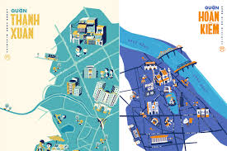  2 | A. class  B. School |   6  5
  3 | C. village  D. study |   7
 | E. address  F. city | 
  4 | G. district  H. road | 8

Exercise 2: Complete the table about yourself.
Name | ………………..……………………..
Age | ………………..……………………..
School | ………………………………………..
Class | ………………………………………..
School address | ………………………..……………………..
Exercise 3: Read and match.
1. Where do you live? |  | a. It's on the second of August.
2. Is your school big? |  | b. Yes, I like it very much.
3. What class are you in? |  | c. Yes, I can.
4. What day is it today? |  | d. They're Vietnamese.
5. What nationality are Chinese and Russian? |  | e. Yes, it is.
6. Can you swim? |  | f. It's Monday.
7. Do you like English? |  | g. I'm in class
8. When's your mother's birthday? |  | h. I live at 60 Hung Vuong Street

1………2…..….3………4………5……….6………7……….8………..
Exercise 4: Read and complete.
class
what | meet | going |  | where

Hoa: Hi, Nam.
Nam: Hello, Hoa.
Hoa: Where are you (1) …………………?
Nam: I'm going to school.
Hoa: (2) ………………… is your school?
Nam: It is in Nguyen Hue Street.
Hoa: (3) ………………… class are you in?
Nam: I'm in (4) ………………… 4D.
Hoa: OK. See you soon.
Nam: Nice to (5) ………………… you again.

Exercise 5: Underline one mistake in each sentence and correct it.
1. Her school are in Cau Giay District.
=>
2. The rivers is long.
=>
3. She can sings very well.
=>
4. My daughter doesn't goes to school at the weekends.
=>
5. I live in a village small in south, Vietnam.
=>
6. My uncle and aunt lives in Da Nang City.
=>
7. I go to school on the morning.
=>
8. What can she does?
=>
9. My school is Nguyen Hue School Primary.
=>
10. Where his school is?
=>

BÀI TẬP NÂNG CAO

Exercise 6: Reorder.
1. on / is / my / Street / school / Nguyen Du /.
=>
2. way / this / l / to / park / is / the / go / the /.
=>
3. class / you / in / are / what /?
=>
4. 4A2 / in / she / Class / is /.
=>
5. at / Cau Dien / study / we / School / Primary /.
=>
6. her / Minh Khai / school / is / Street / on /?
=>
7. color / her / schoolbag / is / what /?
=>
8. Hoa / Hanoi, / from / Vietnam / is /.
=>
9. the / December / her / is / on / birthday / fifth / of /.
=>
10. America / and / come / brother / her / Kelly / from /.
=>

Exercise 7: Write questions for the answers.
1. My school is in Tran Hung Dao Street.
=>
2. Hoa is in class 4A.
=>
3. My School is To Huu Primary School.
=>
4. I can cycle and skip.
=>
5. It's the second of March.
=>
6. My mother's birthday is on the third of February.
=>
7. Yes. She can sing.
=>
8. My mother can cook.
=>

Exercise 8: Fill in the blank.
1. I go to school …………………….…….. Monday to Friday.
2. They like …………………………….. rope.
3. My ………………………….. is Hoa Hong Primary School.
4. I am in …………………..…….. 4A5.
5. My friend's school is ………………………….. Cau Giay Street.
6. My uncle lives in Ho Chi Minh ………………..…………... .
7. His school is in Bat Trang ………………………..……... .
8. Where does your sister ……………………..…..? - She lives in Hanoi.
9. What class …………………………... Lisa in?
10. The rivers …………………………….. long and beautiful.

Exercise 9: Circle the correct answer.
1. My brother can …………….. very well.
A. swims B. swim C. swimming D. go swim
2. …………….. birthday is on the tenth of February.
A. He B. I C. Hers D. His

3. Her school is …………….. Kim Lien Village
A. on B. at C. in D. of
4. My cousin is …………….. .
A. Vietnam B. Cambodian C. Malaysia D. America
5. I was born …………….. June.
A. at B. on C. in D. of
6. My mother often …………….. TV every evening.
A. watches B. watching C. watch D. is watching
7.- What is he doing now? - He …………….. books in his room.
A. reads B. is reads C. reads D. is reading
8. What toys …………….. they like?
A. is B. are C. do D. does
9. - ……………..? - It's Ngo Si Lien Primary School.
A. Where is her school? B. What is the name of her school?
C. Is it her school? D. Is Ngo Si Lien Primary School big?
10. Peter: ……………..? - Mary: It's Monday.
A. Is it Monday B. What is the date today?
C. What day is it today? D. Is Monday your favorite day?

Exercise 10: Read and answers.

My name is Truc. I'm nine years old. I'm from Hanoi, Vietnam. I'm Vietnamese. My school is on Nguyen Trai Street, Thanh Xuan District, Hanoi. Its name is Nguyen Trai Primary School. It's a big school. I'm in Class 4A. There are forty students in my class. I love my class very much.
1. What's her name?
=>
2. How old is she?
=>
3. What nationality is she?
=>
4. Where is her school?
=>
5. What is the name of her school?
=>
6. Is it a small school?
=>
7. What class is she in?
=>
8. How many students are there in her class?
=>
Name: …………………….  Grade 4 | UNIT 7: WHAT DO YOU LIKE DOING?

BÀI TẬP VẬN DỤNG CƠ BẢN
Exercise 1: Look and match.
1. 2.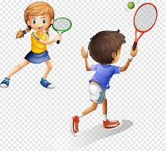 3.  4. 
5.  6. 7.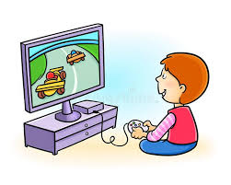 8.
a. They like playing computer games.

b. She likes riding a bike.

c. He likes singing.

d. My brother likes playing tennis.

e. He likes listening to music.

f. My parents like dancing.

g. He likes swimming.

h. She likes riding a horse.

Exercise 2: Look and complete.
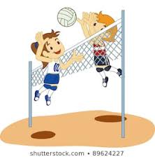
1. They like……………………………. 2. My friends like……………………..

3. She likes……………………………4. They like………………………………...

5. They like…………………………… 6. My father likes…………………………
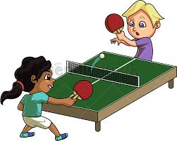
7. They like…………………………. 8. Tom likes…………………………………
Exercise 3: Look and answer.
 | 1. What do they like doing?  …………………………………………………………….
 | 2. What do you like doing?  …………………………………………………………….
3. What do you like doing?

……………………………………………………………..
 | 4. What does he like doing?  ……………………………………………………………..
 | 5. What do you like doing?  …………………………………………………………….
 | 6. What does your brother like doing?  …………………………………………………………….
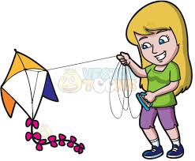 | 7. What do you like doing?  …………………………………………………………….
 | 8. What does your sister like doing?  …………………………………………………………….
9. What do they like doing?

…………………………………………………………….
10. What do you like doing?

…………………………………………………………….

Exercise 4: Look and write full sentences.
No. | Person | like | dislike
1 | Hoa | cook | sing
2 | Nam | play soccer | collect stamps
3 | Hung | Watch TV | swim and dance
4 | Huy | listen to music and go shopping | fly a kite
5 | Lisa | take photographs | play computer games
6 | Mai | sing and dance | collect coins

1. Hoa likes cooking. She doesn’t like singing.
2…………………………………………………………………………………..
…………………………………………………………………………………..
3………………………………………………………………………………….
……………………………………………………………………………………
4………………………………………………………………………………….
………………………………………………………………………………….
5…………………………………………………………………………………
………………………………………………………………………………….
6…………………………………………………………………………………..
…………………………………………………………………………………..
Exercise 5: Match.
1. Does your father like reading book? | a. I visit my relatives.
2. What can your father do? | b. Yes, he can.
3. What’s your hobby? | c. It’s on the third of March.
4. What do you do on Saturday morning? | d. It’s in Long Bien District.
5. What nationality is David? | e. Yes, he does.
6. Can your grandfather ride a bike? | f. I like swimming and skipping.
7. Where’s your school? | g. He can play the piano and sing.
8. When’s your birthday? | h. He’s American.

1. | 2. | 3. | 4. | 5. | 6. | 7. | 8.

Exercise 6: Read and complete.
many | collect | like | presents | Have  ggg

Tom: Do you (1)…………………… anything?
Mary: Yes, I do. I collect dolls.
Tom: Dolls?
Mary: Yes, I (2)…………….. them very much.
Tom: How (3) ……………… do you have?
Mary: I (4)………………….. 20.
Tom: Did you get all of them as birthday (5)…………………….
Mary: No, I only get some of them on my birthday. When I get good marks, my mother buys me a doll.
BÀI TẬP NÂNG CAO
Exercise 7: Reorder.
1. school/ this/ go/ I/ the/ to/ way/ is/.
……………………………………………………………………………….
2. in/ is/ my/ Thanh Xuan/ District/ school/.
………………………………………………………………………………
3. you/ like/ songs/ to/ listening/ do/ English/?
………………………………………………………………………………..
4. class/ she/ what/ in/ is/?
………………………………………………………………………………….
5. my/ football/ brother/ playing/ likes/ much/ very/.
……………………………………………………………………………………..
6. she/ reading/ does/ like/ books/?
…………………………………………………………………………………..
7. I/ school/ Tom/ some/ in/ and/ the/ study/.
………………………………………………………………………………………
8. taking/ we/ not/ photos/ like/ do/.
……………………………………………………………………………………….
9. Hoa/ piano/ does/ like/ the/ not/ playing/.
………………………………………………………………………………………
10. badminton/ her/ hobby/ is/ brother’s/ playing/.
…………………………………………………………………………………….
Exercise 8: Underline the mistake in each sentence and correct it.
1. What are your brother’s hobby?
……………………………………………………………………………….
2. My grandparent don’t like flying kites.
…………………………………………………………………………………
3. Does Hoa and her sister like collecting stamps?
………………………………………………………………………………….
4. My friend likes playing to a yo-yo.
………………………………………………………………………………..
5. My sister enjoys making cakes and watches TV.
……………………………………………………………………………………
6. They can swim very good.
…………………………………………………………………………………
7. My birthday is at Monday, the tenth of March.
………………………………………………………………………………
8. My school name is Nguyen Hue Primary School.
…………………………………………………………………………………..
9. What does your sisters like doing?
…………………………………………………………………………………..
10. They like chatting with their friends in the Internet.
…………………………………………………………………………………….
Exercise 9: Fill in the blank with ONE word.
1. He’s……………………… Can Tho city.
2. Lisa likes………………. coins.
3. My grandparents like………………..TV in the evening.
4. Hung and Nam go to English Club…………..Monday and Thursday afternoon.
5. Today is the tenth………………...November.
6. I go to work………………..…. morning.
7. I study at Nguyen Du Primary………….………….
8………………….. are you from?
9. What’s his………………………..?-He likes cooking very much.
10. My sister likes listening to………….. in her free time.
11. The boy doesn’t like…………….. kites.
12. We like…………………… photos.
13………………. a horse is really interesting.
14. Min Hye is from Korea. She is………………..
15. What………………. is it today?
16. I like……………….. books.
Exercise 10: Read and answer.
My name is Hung. Playing sports is my hobby. I like playing soccer and badminton. I don’t like singing and dancing. At the weekends, I like going to the gym to do exercise or going to the zoo with my parents. In the afternoon, I like reading books in the school library. In the evening, I like staying at home and watching TV. I don’t like going out. My friend, Nam loves listening to music and singing. He doesn’t like reading books because he thinks reading is boring.
1. What is his name?
…………………………………………………………………………..
2. Does Hung like playing sports?
……………………………………………………………………………
3. Which sports does he like playing?
………………………………………………………………………………
4. What does he like doing at the weekend?
………………………………………………………………………………..
5. What does he like in the afternoon?
………………………………………………………………………………….
6. Does he like going out in the evenings?
……………………………………………………………………………......
7. What is Nam’s hobby?
………………………………………………………………………………..
8. Why doesn’t Nam like reading books?
…………………………………………………………………………………..

Name: ……………  Grade 4 | Unit 8: WHAT SUBJECTS DO YOU HAVE TODAY?
BÀI TẬP CƠ BẢN

Exercise 1. Look and complete.

1……………………… |   2…………………………. | 3…………………..
  4……………………. | 5……………………….. | 6………………………
7………………………. |   8……………………………

Exercise 2: Odd one out.

1.A. Art B. Monday C. Science D. English
2. A. like B. play C. run D. late
3. A. chess B. badminton C. table D. tennis
4. A. boring B. swimming C. listening D. reading
5. A. cooking B. interesting C. boring D. exciting

Exercise 3: Fill in the blank with ONE word.
Hoa: What (1)…………………is it today?
James: It is Monday.
Mary: What (2)…………………do you have today?
James: I have Maths and English. English is my (3)……………….subject
Mary: I like (4)…………………,too. So, what subject don’t you like?
James: I don’t like (5)………….………It’s so boring.
Mary: Really? I don’t think so. I think History is interesting. You can know about the history of our country.
Exercise 4: Find the subjects.
Art Physical Education Maths English
Vietnamese History Science Music

P | O | W | M | F | A | X | C | H | J | C | S | P | U | E | S | U
E | H | R | A | A | Y | T | O | A | A | U | S | E | C | S | P | N
K | T | Y | T | K | T | L | N | R | R | F | N | N | L | T | P | H
C | C | L | S | A | L | H | O | T | I | D | T | G | F | O | V | W
A | L | E | S | I | M | L | E | Y | S | U | N | L | L | C | I | U
R | E | I | N | S | C | I | E | N | C | E | I | I | H | K | E | S
Y | W | Y | J | R | K | A | N | E | A | P | S | S | H | I | T | T
R | S | H | S | G | Y | M | L | T | Q | R | A | H | R | N | N | U
O | L | E | G | Y | S | A | T | E | M | E | S | E | W | G | A | E
T | I | F | T | Z | C | V | Y | P | D | P | U | D | Q | N | M | U
S | B | C | I | S | U | M | P | W | T | U | H | U | R | S | E | G
I | C | T | S | X | F | A | W | Z | S | P | C | K | D | T | S | O
H | H | Y | O | U | Z | T | E | O | Q | U | S | A | N | A | E | U
C | T | N | D | L | E | H | B | T | N | V | W | T | T | R | R | S
W | K | N | W | G | T | S | F | A | J | S | Y | J | X | I | P | A
P | K | S | E | I | D | U | T | S | R | E | U | U | P | M | O | C
V | C | T | S | X | F | N | W | Z | S | P | C | K | D | T | P | N

Exercise 4. Look and answer

 | - - What subject do you have today?  => ………………………………………
 | - - What subject do you have today?  => ………………………………………
 | - - What subject do you have today?  => ………………………………………
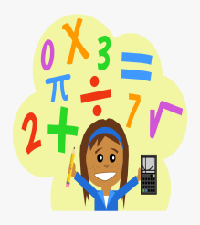 | - - What subject do you have today?  => ………………………………………
 | - - What subject do you have today?  => ………………………………………
 | - - What subject do you have today?  => ………………………………………
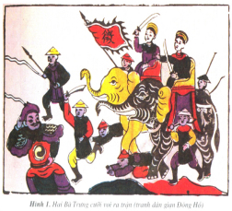 | - - What subject do you have today?  => ………………………………………
 | - - What subject do you have today?  => ………………………………………
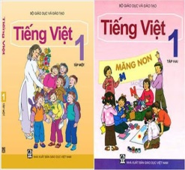 | - - What subject do you have today?  => ………………………………………
 | - - What subject do you have today?  => ………………………………………

BÀI TẬP NÂNG CAO

Exercise 6. Look at the timetable and answer.

Monday | Tuesday | Wednesday | Thursday | Friday
Maths | PE | Art | English | IT
Science | History | Geography | Music | Maths
English | Vietnamese | Maths | PE | Vietnamese

1. Do you have English on Wednesdays?
=> ………………………………………………………………………………
2. What subjects do you have on Mondays?
=> ………………………………………………………………………………
3. When do you have Music?
=> ………………………………………………………………………………
4. When do you have Vietnamese?
=> ………………………………………………………………………………
5. When do you have PE?
=> ………………………………………………………………………………
6. When do you have IT?
=> ………………………………………………………………………………
7. What subjects do you have on Tuesdays?
=> ………………………………………………………………………………
8. Do you have Maths on Fridays?
=> ………………………………………………………………………………
Exercise 7. Reorder

1. does/ she/ when/ Vietnamese?/ and/ English/ have/
=> ………………………………………………………………………………
2. History/ have/ do/ they/ today?/ and IT/
=> ………………………………………………………………………………
3. have/ do/ what/ on/ ?/ subjects/ you/ Thursdays/
=> ………………………………………………………………………………
4. subjects/ have/ Hoa/ does/ today?/ what/
=> ………………………………………………………………………………
5. I/ English/ Tuesday./ have/ Science/ on/ and/
=> ………………………………………………………………………………
6. you/ English/ have/ Monday/ do/ on/?
=> ………………………………………………………………………………
7. subjects/ like/ she/ what/ does/ ?
=> ………………………………………………………………………………
8. it/ doesn’t/ boring/ because/ is/ History/ Hoa/ like/.
=> ………………………………………………………………………………
9. favourite/ Nam/ what/ your/ subject/ ,/ is/ ?
=> ………………………………………………………………………………
10. often/ have/ how/ she/ Maths/ does/?
=> ………………………………………………………………………………

Exercise 8. Fill in the blank with ONE word.

1. My………………..subjects are Vietnamese and English.
2. We have Science………………..Tuesdays.
3. They are………………..soccer now.
4. What do you like……………………?-I like………………..coins.
5. What is his………………….?-He likes playing the piano.
6. ……………………to music is my brother’s hobby.
7. What subjects do you have on Mondays?
-I……………………….Maths, Vietnamese and History.
8. My sister likes……………………..models.
9. He goes to the zoo…………………….his parents at the weekend.
10. What…………………do you have on Tuesdays?
- I have Maths, Science, and Music.
11. We study in the same…………………..It’s Tran Hung Dao Primary School.
12. It’s in Hoan Kiem……………………, Ha Noi.
13. I like……………………with a yo-yo.
14. ……………………is your English teacher?
15. We’re…………………..for school. Let’s run.

Exercise 9. Underline the mistake in each sentence and correct it.

1. He have Maths, Art and English every Thursday.
=> ………………………………………………………………………………
2. I like play chess and table tennis.
=> ………………………………………………………………………………
3. My mother can cook very good.
=> ………………………………………………………………………………
4. My friends like take photos very much.
=> ………………………………………………………………………………
5. My sister doesn’t has Science on Tuesdays.
=> ………………………………………………………………………………
6. We’re late to school. Let’s run.
=> ………………………………………………………………………………
7. English, Music and Art is my favourite subjects.
=> ………………………………………………………………………………
8. Does she likes IT?
=> ………………………………………………………………………………
9. When does Peter and Hoa have Science? They have it on Monday and Wednesday.
=> ………………………………………………………………………………
10. I am a pupil on Quang Trung Primary School.
=> ………………………………………………………………………………
Exercise 10. Read and answer.

Hi, my name is Hoa. I go to school from Monday to Friday. I have Maths and Vietnamese every day. I have English on Mondays, Wednesdays and Fridays. I have Science on Tuesdays and Thursdays. On Wednesdays and Fridays, I have PE. I have Music on Mondays and Art on Thursdays. On Tuesdays, I have IT.
1. What’s her name?
=> ………………………………………………………………………………
2. When does she have English?
=> ………………………………………………………………………………
3. How often does she have Maths?
=> ………………………………………………………………………………
4. What subjects does she have on Wednesdays?
=> ………………………………………………………………………………
5. When does she have PE?
=> ………………………………………………………………………………
6. When does she have Music?
=> ………………………………………………………………………………
7. Does she have English on Tuesdays?
=> ………………………………………………………………………………
8. When does she have IT?
=> ………………………………………………………………………………

Name:……………………..  Grade 4 | UNIT 9: WHAT ARE THEY DOING?
BÀI TẬP VẬN DỤNG CƠ BẢN
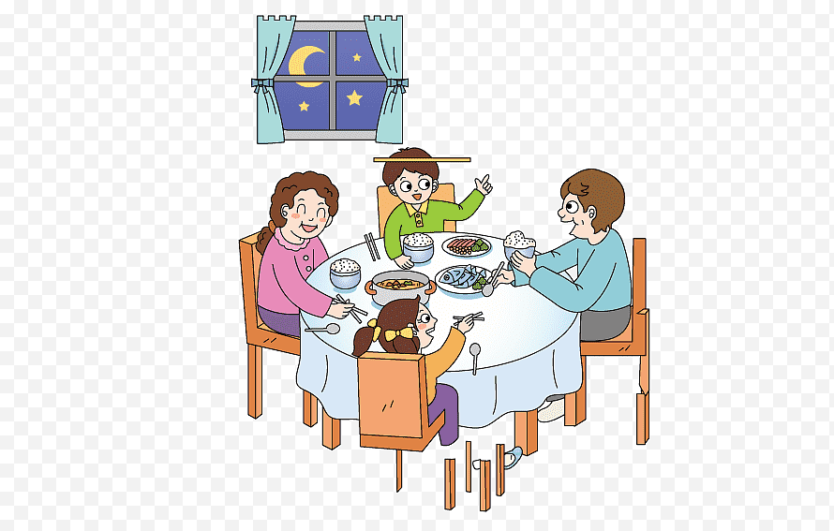Exercise 1: Match.
a.They are swimming.

4
b.They are eating dinner.
1
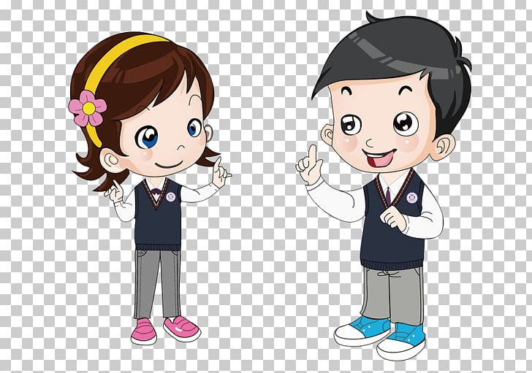
c.They are fishing.

d.They are walking.
5
2

e.They are dancing.

f.They are talking.
6
3

Exercise 2: Look and answer.
 | 1.What are you doing?  ………………………………………………………..
2.What is she doing?
………………………………………………………….
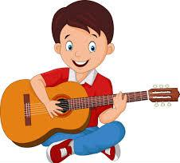 | 3. What is he doing?  ………………………………………………………….
 | 4.What are they doing?  …………………………………………………………..
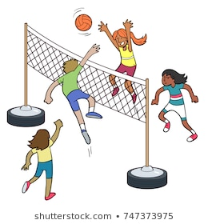 | 5.What are they doing?  …………………………………………………………..
 | 6.What are they doing?  …………………………………………………………..
 | 7. What are they doing?  …………………………………………………………..
 | 8. What are they doing?  …………………………………………………………..
 | 9. What is she doing?  …………………………………………………………..
 | 10. What is he doing?  …………………………………………………………..

Exercise 3: Match.
a.She is making a paper boat.
1.What subjects do you have today?

b. I’m reading a text.
2. When do you have English?

c. I have it on Monday and Thursday.
3.What are you doing?
d. I have English and Math.
4. What is Hoa doing?

e. Yes, they are.
5. Are Nam and Hung drawing pictures?

1………...2……….3…………4…………5…………..
Exercise 4: Complete.
Nam: Hello, Mai. Where (1)………………… Tom?
Mai: He’s (2)………………… the classroom.
Nam: What is he doing?
Mai: He (3)………………… a book.
Nam: What (4)………………… you doing?
Mai: I (5)………………… to music.
Nam: Let’s (6)………………… volleyball together.
Mai: Great idea!

Exercise 5: Reorder.
1. Are/ a / having / they / lesson / Geography ?
=>………………………………………………………………………………………
2. is / He / in / painting / his / picture / a / room/.
=>………………………………………………………………………………………
3. the / are / The / puppet / a / boys / making / classroom / in /.
=>………………………………………………………………………………………
4. He / in / exercise / the / is / playground / doing / school/.
=>………………………………………………………………………………………
5. are / friend / his / making / and / paper / Nam / planes/.
=>………………………………………………………………………………………
6. My / reading / is / brother / text / a /.
=>………………………………………………………………………………………
7. a / are / break / We / having/.
=>………………………………………………………………………………………
8. play / Let’s / piano / together / the /.
=>………………………………………………………………………………………
9. here / We / having / of / a / are / fun / lot /.
=>………………………………………………………………………………………
10. doing / What / they / are /?
=>………………………………………………………………………………………
BÀI TẬP NÂNG CAO
Exercise 6: Circle the correct answer.
1. We are …………………... exercise in the school playground. (doing/ playing/ skipping/ making)
2. Nam and Hoa …………………... rope in the schoolyard. (is playing/ is skipping/ are skipping/ are playing)
3. He is looking …………………... the mask. (on/ at/ up/ in)
4. What can she …………………...?(do/ doing/ does/ like doing)
5. Where’s the boy? - …………………... in the library. (They are/ She is/ He is/ I am)
6. Lan …………………... paper planes in her room. (are doing/ is doing/ are making/ is making)
7. They like …………………... TV. (listening/ are listening/ are watching/ watching)
8. What are your brothers doing? - …………………... in the room. (He is sleeping/ He sleeps/ They sleep/ They are sleeping)
9. …………………... the pupils reading books in the library? (Are/ Is/ Am)
10. Let’s …………………... lunch together. (eating/ eat/ eats/ to eat)
Exercise 7: Fill in the blank with ONE word.
1. He’s reading a book ………………….................the classroom.
2. Let’s …………………................. swimming, Minh.
3. She’s …………………................. a dictation.
4. He is in the computer ………………….................
5. …………………................. are the students doing in the classroom?
6. …………………................. the white table, they are drawing pictures.
7. They’re making a …………………................. plane.
8. He’s making …………………................. kite.
9. Are they having …………………................. English lesson?
10. The girls are playing badminton …………………...............the playground.
11. She’s looking at the picture …………………................. the wall.
12. We are having …………………................. break.
13. He’s …………………................. exercise in the classroom.
14. Linda and Sarah …………………................. playing volleyball.
15. …………………................. do you have Maths?
Exercise 8: Write questions for the underlined part.
1. I’m reading a text.
=>…………………………………………………………………………………………
2. My brother is making a puppet.
=>…………………………………………………………………………………………
3. Tim is drawing pictures.
=>…………………………………………………………………………………………
4. The boys are playing football.
=>…………………………………………………………………………………………
5. Yes. Lan is listening to music.
=>…………………………………………………………………………………………
6. No. My mother isn’t cooking.
=>…………………………………………………………………………………………
7. She often does her homework in the evening.
=>…………………………………………………………………………………………
8. They have English on Mondays and Fridays.
=>…………………………………………………………………………………………
9. His favourite subjects are Maths and English.
=>…………………………………………………………………………………………
10. They likes Science because it is interesting.
=>…………………………………………………………………………………………

Exercise 9: Underline the mistake and correct it.
1.Is Mary and her friend making a puppet?
=>…………………………………………………………………………………………
2. David aren’t writing a dictation.
=>…………………………………………………………………………………………
3. What are you and your sister doing?
=>…………………………………………………………………………………………

Name: …………………….  Grade 4 | UNIT 10: WHERE WERE YOU YESTERDAY?
BÀI TẬP VẬN DỤNG CƠ BẢN
Exercise 1: Look and answer.
 | 1. Where were you last weekend, Nam?  =>………………………………………………….
 | 2. Where were you yesterday morning, Hoa and Mai?  =>…………………………………………………………
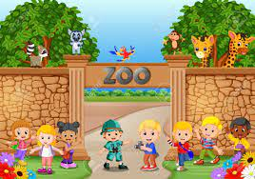 | 3. Where were you yesterday, Hoa?  =>…………………………………………………………
 | 4. Where were she last night?  => ………………………………………………………...
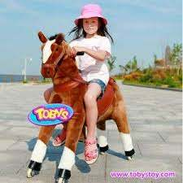 | 5. Where were they yesterday?  =>………………………………………………………...
Exercise 2: Match.
- Where were you yesterday morning? |  | a.She was at home.
2. Did you go out last night? |  | b. I’m from Seoul, Korea.
3.What’s he doing? |  | c. She is cooking in the kitchen.
4. Does she have any toys? |  | d. Yes, I did.
5. Where was she last weekend? |  | e. It was the first of April.
6. What were the date yesterday? |  | f. He’s drawing a dog.
7. What is your mother doing? |  | g. Yes, she does.
8. Where are you from? |  | h. I was in the school library.

1………2………3……….4……….5……….6………..7………..8…………

Exercise 3: Complete.
home
played
weekend
watched
watered
did

Nam: Where were you last (1)…………………..?
Hung: I was at (2)…………………………………
Nam: What (3)……………………………you do?
Hung: I (4)……………………….. the trees in the morning. In the afternoon,
I(5) ……………….… soccer with my friend. In the evening,
I(6)………………….TV.

Exercise 4: Write the past form of the verbs.
Động từ nguyên thể | Động từ ở quá khứ | Động từ nguyên thể | Động từ ở quá khứ
go | -> | run | ->
sleep | -> | wash | ->
buy | -> | talk | ->
teach | -> | sing | ->
play | -> | speak | ->

Exercise 5: Circle the correct answer.
- The teacher …………………………………..friendly.( is/ am/ are)
- The students …………………………….very intelligent. (am/ is/ are)
- One boy …………………………………….in the class. (is/ am/ are)
- We……………………………sorry for being late. ( is/ am/ are)
- He………………….handsome. (is/ am/ are)
- I……………… happy yesterday.( was/ were)
- Hoa and her friend …………………..at the zoo this morning. (was/ were)
- My sister………………………in Hanoi last week. (was/ were)
- The man………………………..on the beach last weekend. (was/ were)
- It………………………..cold yesterday. (was/ were)

BÀI TẬP NÂNG CAO
Exercise 6: Look and answer.
 | 1) What did they do yesterday?  ………………………………………………….
2) What did he do yesterday?
………………………………………………….
 | 3) What did he do last week?  ………………………………………………….
1) What did they do yesterday?
………………………………………………….
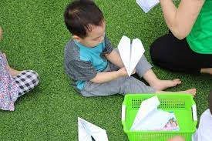 | 1) What did they do yesterday afternoon?  ………………………………………………….
Exercise 7: Reorder.
1. nice/ she/ a/ picture/ painted/ yesterday/.
=>…………………………………………………………………………………
2. morning/ he/ piano/ yesterday/ the/ played/.
=>………………………………………………………………………………….
3. this/ TV/ watched/ and/ brother/ Lisa/ her/ morning/.
=>…………………………………………………………………………………..
4. video/ evening/ a/ watched/ yesterday/ Tom/.
=>………………………………………………………………………………..
5. afternoon/ she/ do/ did/ this/ what/?
=>…………………………………………………………………………………
6. chess/ did/ they/ the/ room/ play/ in/?
=>………………………………………………………………………………….
7. were/ morning/ where/ you/ yesterday/?
=>…………………………………………………………………………………..
8. I/ morning/ the/ this/ flowers/ and/ father/ my/ watered/.
=>……………………………………………………………………………………..
9. yesterday/ Tom/ David/ played/ and/ afternoon/ volleyball/.
=>…………………………………………………………………………………..
10. park/ she/ went/ the/ ago/ two/ to/ days/.
=>……………………………………………………………………………………..
Exercise 8: Circle the correct answer.
1. We are ………………………………………a picture in the classroom.
A. paint B. painting C. paints D.painted
2. What did your father ……………………..yesterday morning?
A. do B. doing C. did D. does
3. Was she at the zoo? – Yes, she……………………..
A. isn’t B. is C. was D. wasn’t
4. My father can……………….. the guitar very well.
A. plays B. play C. playing D. played
5. The teacher ……………….reading a dictation for the students now.
A. is B. was C. are D. am
6. Nam and Hung……………………………a video last night.
A. watch B. are wactching C. watched D. watches
7. Mai………………………late this morning.
A. gets up B. got up C. getting up D. get up
8. ……………………nationallity is Min Hye?
A. What B. Who C. Where D. How
9. My sisters ……………………..at home yesterday.
A. wasn’t B. isn’t C. aren’t D. weren’t
10. I ……………………… a paper puppet with my friends last week.
A. am making B. makes C. made D. maked
Exercise 9: Underline the mistake and correct it.
1.Is Mary and her friend making a puppet?
=>…………………………………………………………………………………
2. David aren’t writing a dictation.
=>…………………………………………………………………………………
3. What are you and your sister doing?
=>…………………………………………………………………………………
4. At the yellow table, the boys are paint paper planes.
=>…………………………………………………………………………………..
5. Today is Saturday, the eight of November.
=>…………………………………………………………………………………..
6. I like listen to music in the evening.
=>…………………………………………………………………………………..
7. Where are you last weekend?
=>…………………………………………………………………..........................

8. What are your brother doing now?
=>…………………………………………………………………………………..
9. Hoa is read a text and Mai is writing a dictation.
=>……………………………………………………………………………….....
10. Look! Linh and Lan are stand near the table.
=>…………………………………………………………………………………..
11. My favourite subjects in English and Maths.
=>…………………………………………………………………………………..
12. She plays table tennis with her friend last Monday.
=>…………………………………………………………………………………..
13. Hoa studies at Cau Dien Primary School.
=>………………………………………………………………………………….
14. Two days ago, we are on the beach.
=>…………………………………………………………………………………..
15. My parents enjoy watch TV programs.
=>…………………………………………………………………………………..
16. Her hobby are collecting stamps.
=>…………………………………………………………………………………..
17. My mother is born in 1985.
=>…………………………………………………………………………………..

18. It is hot and sunny yesterday.
=>…………………………………………………………………………………..
19. Her birthday is in the May.
=>………………………………………………………………………………….
20. Are they at home yesterday?
=>………………………………………………………………………………….
Exercise 10: Read and answer.
My name is Huy. It was Sunday yesterday. I was at home. I got up late. In the morning, I went to the zoo with my parents. In the afternoon, I watered the flowers and trees, in the garden. Then I played football with my friends. In the evening, I watched TV and had dinner with my family. After dinner, I went to the cinema with my friends, Linh and Mai. We watched an interesting movie. At 10 o’clock I went to bed.
- What day was it yesterday?
=>…………………………………………………………………………………
2. Where was Huy?
=>………………………………………………………………………………….
3. Did he get up early yesterday?
=>………………………………………………………………………………….
4. What did he do in the morning?
=>……………………………………………………………………………….
5. Was he at the zoo yesterday afternoon?
=>…………………………………………………………………………………
6. Did he play soccer with his friends yesterday?
=>………………………………………………………………………………….
7. What did he do in the evening?
=>……………………………………………………………………………….
8. Where did Huy, Linh and Mai go after dinner?
=>……………………………………………………………………………….
9. What time did he go to bed?
=>……………………………………………………………………………….

