Name:………………………….  Grade 4 | UNIT 11: WHAT TIME IS IT?
BÀI TẬP CƠ BẢN
Exercise 1: Look and complete.
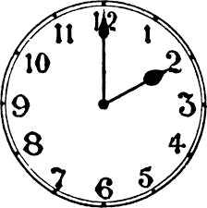 | 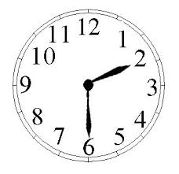
1. It’s…………………………………… | 2. It’s……………………………..………
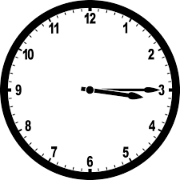 | 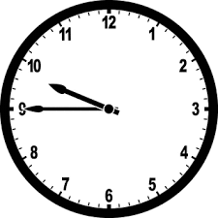
3. It’s……………………………..…… | 4. It’s………………………………..……
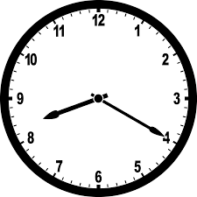 | 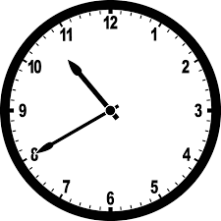
5. It’s…………………………………… | 6. It’s………………………………..……

Exercise 2: Match.
1. Does he go to bed at 10 o’clock? | A. Yes, I do.
2.What are you doing? | B. She goes to school at seven o’clock.
3.Do you like Math? | C. Yes, he does.
4.Do you like Math? | D. I have lunch at 12 o’clock
5.What time do you have lunch? | E. I’m learning English.

1……….2…………3………..4…………5……………

Exercise 3: Look and answer.
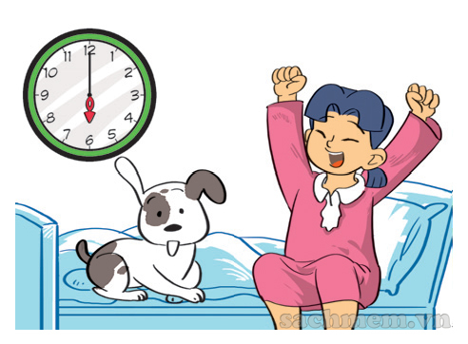 | 1. What time does she get up?  ………………….………………………………..
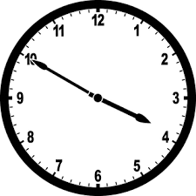 | 2.What time does he go home?  ………………….………………………………..
 | 3.What time does she have lunch?  ………………….………………………………..
 | 4. What time does he go to bed?  ………………….………………………………..
 | 5.Do they go to the zoo at 3 o’clock?  ………………….………………………………..
 | 6.What do they do in the afternoon?  ………………….………………………………..
 | 7.What does he do at 6 o’clock ?.  ………………….………………………………..
 | 8. Does Nam do his homework in the evening?  ………………….………………………………..
 | 8.What time do they play football ?.  ………………….………………………………..
 | 9.What time do you do at 6 o’clock?.  ………………….………………………………..

Exercise 4: Reorder.
1.husband/ up/ does/ your/ time/ get/ what/?.
………………………………………………………………………………………
2.in/ morning/do/ the/ what/ you/ do/?.
……………………………………………………………………………………
3.this/ zoo/ went/ and/ brother/ the/ to/ Hung/ his/ morning.
………………………………………………………………………………………..
4. I/ afternoon/ the/ play/ guitar/ the/ in/.
……………………………………………………………………………………
5. gets/ my/ early/ up/ mother/.
……………………………………………………………………………………
6.boys/ football/ moon/ the/ play/ at?/.
……………………………………………………………………………………..
7. lunch/ we/ chool/ had/ yesterday/at.
……………………………………………………………………………………..
8. mother/ dinner/ often/ my/ at/ o’clock/ cooks/ five/.
………………………………………………………………………………………
9. she/ Sunday/ and/ doesn’t/ to/ is/ go /today/ to/ have/ school/.
………………………………………………………………………………………
10. yesterday/ sister/ to/ my/ music/ listened/ morning.
………………………………………………………………………………………
Exercise 5. Make complete sentences using the words given.
Ví dụ: He/ get/ up/ 6.30
What time does he get up?
He gets up at half past six/ six thirty.
1.He/ go/ to/ school/ 6.4
………………………………………………………………………………………..
………………………………………………………………………………………..
2. Mai/ have bbreakfast/ 7.10
………………………………………………………………………………………..
………………………………………………………………………………………..
3. You/ take a shower/ 6.00
………………………………………………………………………………………..
………………………………………………………………………………………..
4.They/ have lunch/ 11.30
………………………………………………………………………………………..
………………………………………………………………………………………..

5. Your/ mother/ go to work/ 8.20
………………………………………………………………………………………..
………………………………………………………………………………………..
BÀI TẬP NÂNG CAO
Exercise 6. Circle the correct answer.
1.What………………… is it? –It’s 11.15
A. color B. time C. natonality D.name
2. It’s time to go…………………………………a walk.
A.to B. at C. for D. thONey
3. My mother gets up …………………………….6 o’clock every morning.
A.at B.on C. from D.to
4. What time do………………………. go ton work everyday? I go to work at 7.30
A. he B.she D. you D.they
5. I……………………….. breakfast at 6.45 every morning.
A. do B. learn C. go D.have
6.My sister……………………. TV in the morning.
A. watches B. reads C. opens D. goes
7. She……………………………. Football in the afternoon.
A. don’t play B. don’t plays C. doesn’t play D. doesn’t plays
8.My son usually ………………………………. to the park at the weekend.
A. go B. is going C. goes D. going
9. What time does your father……………………………..?.
A. go to home B. goes to home C. go home D. goes home
10. ……………………………. in his room now?
A. is Tom reading B. Does Tom read C. Tom is reading D. is Tom reads.
Exercise 7. Put the verbs in the correct form.
Her name is Huong. Every day, she (1. get)……………………. up at six o’clock. Then she ( 2. brush)…………………….. her teeth and ( 3.wash) ……………………. her face. She ( 4. eat) ………………………. break fash at haft past six. After breakfast, she ( 5. go) …………………………. To school at seven o’clock. She ( 6. have)…………………….. lunch school at twelve o’clock. In the afternoon, she has three classes. School ( 7. finish)…………………………… at five o’clock. Then she (8. play)……………………….. badminton with her friends.
Exercise 8. Fill in the blank with one word.
1.What time……………………………………………….. it?.
- It……………………………….. 10. 30.
2. What………………………….. do you get up?.
3. I…………………………. dressed at six o’clock.
4. I go to school ……………………………….. 8.m. to 5 p.m.
5.She……………………………… lunch at 11.30
6.What time ………………………………. Your mother go to work?
7. She plays football ………………………………….. noon.
8. ………………………………………… your father watching TV?
9. When…………………………………….. Nam have English?.
10. Her birthday is ………………………………… the nine of October.
Exercise 9. Read and answer.
Tuan studies at Nguyen Hue primary school. Every day he gets up at 6 o’clock. Then he has breakfast with his family at 6. 30. He goes to school at 7.15 a.m. School starts at 7.30 a.m. and finishes at 4.30 p.m. After school he plays soccer with his friends. He goes home at 5.30. He has dinner at 7.o’clock. Then he does his homework or watches TV with his parents. He goes to bed at 9.30.
1.What time does Tuan get up?.
…………………………………………………………………………………….
2. Does he have breakfast at 6.30 ?
…………………………………………………………………………………….
3. What does he do at 7.15 a.m. ?
…………………………………………………………………………………….
4. What time does school finish?
…………………………………………………………………………………….
5. What does he do after school?
…………………………………………………………………………………….
6. What time does he have dinner?
…………………………………………………………………………………….
7. Does he go out in the evening?
…………………………………………………………………………………….
8. What does he do at 9.30?
…………………………………………………………………………………….
Exercise 10:. Write a paragraph (about 10 sentences) to tell about your daily routines.
…………………………………………………………………………………..
…………………………………………………………………………………..
…………………………………………………………………………………..
…………………………………………………………………………………..
…………………………………………………………………………………..
…………………………………………………………………………………..
…………………………………………………………………………………..
…………………………………………………………………………………..
…………………………………………………………………………………..
…………………………………………………………………………………..
…………………………………………………………………………………..
…………………………………………………………………………………..
…………………………………………………………………………………..
…………………………………………………………………………………..
Name: ………………  Grade 5 | Unit 12: WHAT DOES YOUR FATHER DO?
BÀI TẬP CƠ BẢN
Exercise 1: Look and complete
 |  | 
1. He is .......................... | 2. He is .......................... | 3. She is ..........................
 | 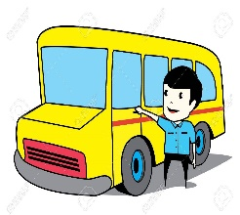 | 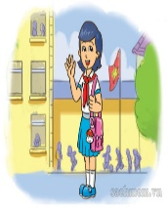
4. He is .......................... | 5. He is .......................... | 6. I am ..........................
 |  | 
7. She is .......................... | 8. He is .......................... | 9. She is ..........................

Exercise 2: Look and match

1. |  | - My father is a doctor.
2. |  | - My brother is a student.
3. |  | - He is a factory worker.
4. |  | - She is a nurse.
5. |  | - My friend is a football player.
6. |  | - My sister is a teacher.
1 .......... 2.......... 3. .......... 4.......... 5.......... 6..........

Exercise 3: Match
1.What time did you go to school yesterday? | a. It’s on the eighth of November.
2. What time does your sister have breakfast? | b. I work in a factory.
3. Were you at school this morning? | c. At 10 P.m
4. Where does your mother work? | d. No, he is a teacher.
5. Where do you work? | e. She is a clerk.
6. What time is it now? | f. She has breakfast at 7 a.m
7. What does your mother do? | g. I went to school at 7.00.
8. What time do you go to bed? | h. It’s half past twelve.
9. Is your father a worker? | i. No, I wasn’t. I was at the zoo.
10. When’s her mother’s birthday? | j. She works in a hospital.

1…… 2…… 3…… 4…… 5…… 6…… 7…… 8……9……10……

Exercise 4: Complete the dialogue

brother worker taller factory students

Hi, My name is Hoa. There are four people in my family: my parents, my brother and me. My father is s (1) ………………. He works in a (2) ………………. My mother is a teacher. She teaches in a secondary school. She is shorter than my father. Hung is my (3) ……………… He is fifteen years old. He is (4) ………………than me. He and I are (5) ……………… I am nine years old. I am a primary pupil. We are a happy family.

Exercise 5: Circle the correct answer

1. | What is his job? - He is ................... architect.
a. | his | b. | a | c. | an | d. | the
2. | This is a photo ...................her family.
a. | from | b. | at | c. | in | d. | of
3. | ...................does your father do? – He is a doctor.
a. | What time | b. | What | c. | How | d. | Where
4. | My father drives a bus. He is a bus ...................
a. | teacher | b. | farmer | c. | engineer | d. | driver
5. | ...................does your mother work? – She works in an office.
a. | Where | b. | What | c. | How | d. | Why

BÀI TẬP NÂNG CAO
Exercise 6: Look and answer

1. |  | - What does she do?  - ......................................................................
2. | 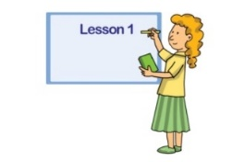 | - What does she do?  .......................................................................
3. | 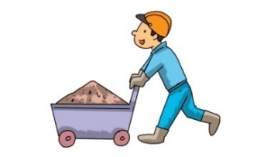 | - What does he do?  .....................................................................
4. | 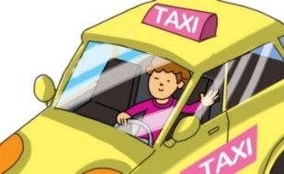 | - What does he do?  .....................................................................
5. |  | - What does she do?  ......................................................................
6. |  | - What does she do?  ........................................................................
7. | 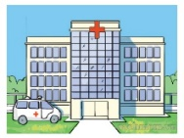 | - Where does your father work?  ........................................................................
 | 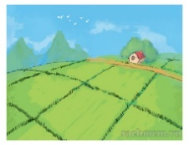 | - Where does your grandfather work?  .........................................................................
9. | 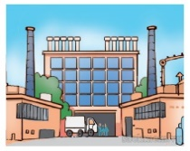 | - Where does your brother work?  .........................................................................
10. |  | - Where does your mother work?  .........................................................................

Exercise 7. Make complete sentences using the given words.
1. Nam and Hung/ student
=> ………………………………………………………………………………
2. His uncle/ driver
cccbb
=> ………………………………………………………………………………
3. My father and brother/ factory workers

=> ………………………………………………………………………………
4. My sister/ nurse
cccbb
=> ………………………………………………………………………………
5. Miss Hoa/ doctor
cccbb
=> ………………………………………………………………………………
6. I/ engineer
cccbb
=> ………………………………………………………………………………
7. Mr David / go to work/ 6.45
cccbb
=> ………………………………………………………………………………
8. He / do/ homework/ the evening
cccbb
=> ………………………………………………………………………………
9. What/ her sister/do/? – She/ student
cccbb
=> ………………………………………………………………………………
10. What time/ Mike/ cook dinner? - /7 o’clock /evening.
cccbb
=> ………………………………………………………………………………
11. She / work/ hospital/
cccbb
=> ………………………………………………………………………………
12. A clerk/ work/ office
cccbb
=> ………………………………………………………………………………
13. A worker/ work/ factory
cccbb
=> ………………………………………………………………………………
14. A teacher/ teach/ school
cccbb
=> ………………………………………………………………………………
15. What/ your father/ job? - He/ English teacher
cccbb
=> ………………………………………………………………………………
Exercise 8: Underline the mistake and correct it
1. I go to school yesterday.
=> ………………………………………………………………………………
2. My school finish at 11.30.
=> ………………………………………………………………………………
3. What do your sister do? - She is a nurse
=> ………………………………………………………………………………
4. My father water the flowers yesterday.
=> ………………………………………………………………………………
5. He goes on bed at 9.45’.
=> ………………………………………………………………………………
6. My mother gets up early on the morning.
=> ………………………………………………………………………………
7.Mr Huy is a doctor. He works in a field.
=> ………………………………………………………………………………
8. My grandfather work in a car factory.
=> ………………………………………………………………………………
9. Miss Hien teach English at my school. She is a teacher.
=> ………………………………………………………………………………
10. There is fifty people in the room.
=> ………………………………………………………………………………
Exercise 9: Write questions fpr the underlined part.
- She goes to work at 8 o’clock.
cccbb
=> ………………………………………………………………………………
2. Yes. My father works in a factory.
cccbb
=> ………………………………………………………………………………
3. It is the tenth of February today.
cccbb
=> ………………………………………………………………………………
4. They work in an office.
cccbb
=> ………………………………………………………………………………
5. Her sister is a nurse.
cccbb
=> ………………………………………………………………………………
6. I go home at 7 o’clock.
cccbb
=> ………………………………………………………………………………
7. It is ten past seven.
cccbb
=> ………………………………………………………………………………
8. My parents are teachers.
cccbb
=> ………………………………………………………………………………
9. My children go to school at 7 o’clock.
cccbb
=> ………………………………………………………………………………
10. We were in th e school library.
cccbb
=> ………………………………………………………………………………
Exercise 10. Answer the questions about you
cccbb
- What is your job?
- cccbb
=> …………………………………………………………………………
2. What time do you get up?
cccbb
=> …………………………………………………………………………
3. What time do you go to bed?
cccbb
=> …………………………………………………………………………
4. What time do you have lunch?
cccbb
=> …………………………………………………………………………
5. What does your father do?
cccbb
=> …………………………………………………………………………
6. Where does your father work?
cccbb
=> …………………………………………………………………………
7. What does your mother do?
cccbb
=> …………………………………………………………………………
8. Where does she work?
cccbb
=> …………………………………………………………………………
9. When’s your birthday?
cccbb
=> …………………………………………………………………………
10. What can you do?
cccbb
=> …………………………………………………………………………
Name: ………………  Grade 4 | UNIT 13: WOULD YOU LIKE SOME MILK?  (BẠN CÓ MUỐN UỐNG MỘT ÍT SỮA KHÔNG)
BÀI TẬP VẬN DỤNG CƠ BẢN
APPLES  BANANAS  BROCCOLI  BURGERS  BUTTER | CHEESE  CUCUMBERS  EGGS  JUICE  MILK | ORANGES  CAKES  POTATOES  RICE  WATER
Exercise1: Find the words.

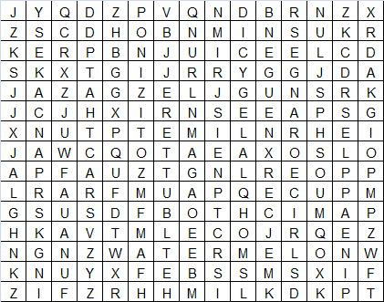

Exercise2: Look and answer.
 | 1.What is your favorite food?  =>…………………………………….
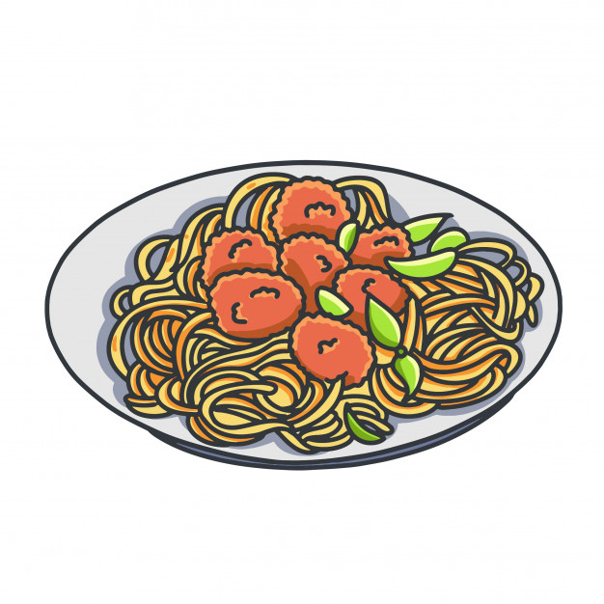 | - What is his favorite food?  =>…………………………………..……….
 | 3. What is her favorite drink?  =>…………………………………….
 | 4. What is his favorite food and drink?  =>…………………………………….
5.What is her favorite drink?
=>……………………………….
 | 6. What is your favorite food?  =>…………………………………….
 | 7. What is his favorite drink?  =>…………………………………….
 | - What is your favorite food?  =>…………………………………….
 | 9. What is his favorite food?  =>………………………………….

Exercise 3: Match
- Yes, please.
- What’s your favorite drink?
- Yes, you can.
- Does she like chicken?
- In a factory.
- Would you like some orange juice?

- Yes, please. I love noodles.
- What does she do?
- It’s orange juice.
- May I come in, sir?

- No, she doesn’t.
- Do you like your job?
- She’s a teacher.
- Would you like some noodles?
- Yes, I do.
- Where does your brother work?

- On Tuesdays and Thursdays.
- What time do you go to work?
- No, she’s American.
- Where are you from?

- It’s four fifty.
- What did you do last night?
l. I did my homework and watched TV.
- Did you go to school yesterday?
- At a quarter past seven.
- Is she English?

- Yes, I did.
- What time is it now?
- Ha Noi, Viet Nam..
- When do you have English?

1……..2…….3……..4……..5……..6……..7…….8…….9……..10…….
11…….12…….13…….14……..15………
Exercise 4: Circle the correct answer.
- Would you like……….pork?
- An B. a C. some D. the
- My husband………………..his job.
A: like B. loves C. do D. have
- What…………..your uncle do?
A: is B. am C. do D. does
- My parents………………..to work in the morning.
A: goes B. do C. go D. did
- What………..she do yesterday?
A: do B. does C. did D. was
- Lan……………..on the beach last weekend.
A: is B. was C. been D. am
- My………………drink is milk.
A: like B. favorite C. love D. drink
- School starts at 8 a.m and………………………..at 4.30 p.m
A: works B. teaches C. finishes D watches
- My father is a farmer. He works in a………………………
- Factory B. school C. office D field
10. Every day I get…………………at 6 o’clock.
A: up B. in C. to D down
- My father’s favourite drink is………………………
A: bread B. beef C. fruit juice D chicken
- ……………………does she work? – In an office.
A: What B. Who C. When D. Where
- I am thirsty. I would like some……………..
A: water B. bread C. rice D. noodles
- Mr Hung is a doctor. He works in a……………………….
A: field B. factory C. hospital D. police station
- My parents are working on the………………….now.
A: farm B. office C. hospital D. school
ffaaf
Exercise 5: Reorder.
- Like/ I/ orange juice/ would/ some/.
=>…………………………………………………………………………………
- What/ his/ drink/ favorite/ is/?
=>…………………………………………………………………………………
- Lan’s/ food/ is/ what/ favorite/?
=>…………………………………………………………………………………
- drink/ is/ juice/ favourite/ my/ apple/.
=>…………………………………………………………………………………
- child/ chicken/ noodle/ likes/ my/ and/.
=>…………………………………………………………………………………
- have/ you/ breakfast/ do/ what/ for/?
=>…………………………………………………………………………………

- is/ drink/ your/ favourite/ lemonade/?
=>…………………………………………………………………………………
- mother/ home/ late/ goes/ evening/ the/ in/ my/.
=>…………………………………………………………………………………
- his/ factory/ worker/ works/ in/ and/ he/ is/ father/ a/ a/.
=>…………………………………………………………………………………
- Mike/ some/ like/ would/ and/ bread/ water.
=>…………………………………………………………………………………
BÀI TẬP NÂNG CAO
Exercise 6: Circle the correct answer.
- I……...................(go/ goes/ went) to the park last week.
- My mother…………..………….(is/ are/ was) an actress.
- I would like………………….…….(a/ an/ some/ any) milk.
- She enjoys…………………….…(listen/ listens/ listening) to music.
- Would you like…………………….(eat/ to eat/ eating) some cakes?
- …………………….(Is/ Are/ Do/ Does) your parents worker?
- …………………(What time/ How many/ How/ How often) does she go to the zoo? – Once a week.
- My sister…………… ….(wash/ washing/ washed) the dishes every day.
- What……………………..(do/ were/ did) you do yesterday?
- I ………………….……(meet/ am meeting/ met) him two days ago.

Exercise 7: Fill in the blank with ONE word.
- He …………………………to school from Monday to Friday.
- Mai was………………….…school this morning.
- She goes to bed…………….……….10 p.m.
- What time do you…………….………..breakfast?
- We don’t go to school………………………….Saturdays and Sundays.
- She goes to English club………….………..the afternoon.
- The cat is…………………..…the bed and the table.
- She has breakfast……………..…………her family at 7.30.
- The boys usually …………….…………..football every afternoon.
- ……………………..…….the red table, the girls are painting some masks.
- There are two pictures………..……………………..the wall.
- There is a well in………………..………of her house.
- My brother’s birthday is……………….………….Monday.
- The man is standing next……………………….the desk.
- He……………………….English and Maths on Tuesday.

Exercise 8: Underline the mistake in each sentence and correct it.

- I like mushrooms and potatos.
=>…………………………………………………………………………………
- Her favourite food are butter.
=>…………………………………………………………………………………
- My brother favourite drink is milk.
=>…………………………………………………………………………………
- My father don’t like fish.
=>…………………………………………………………………………………
- My mother and father likes watermelon.
=>…………………………………………………………………………………
- Is she favorite drink is coffee?
=>…………………………………………………………………………………
- I would like a apple.
=>…………………………………………………………………………………
- This is my brother. He teach English in a school.
=>…………………………………………………………………………………
- What does your father do last week?
=>…………………………………………………………………………………
- My father likes eggs and he doesn’t like chicken.
=>……………………………………………………………………………….

Exercise 9: Make complete sentences using the words given.

- I/ go/ cinema/ yesterday evening.
=>…………………………………………………………………………………
- Your father/ like/ potatoes?
=>…………………………………………………………………………………
- What time/ your uncle/ go/ work/ every day?
=>…………………………………………………………………………………
- They/ playing/ soccer/ school playground?
=>…………………………………………………………………………………
- We/ on/ beach/ last weekend.
=>…………………………………………………………………………………
- She/ do/ homework/ the evening?
=>…………………………………………………………………………………
- My parents/ work/ a factory.
=>…………………………………………………………………………………
- Her father/ often/ listen/ music/ every evening.
=>…………………………………………………………………………………

- She/ visit/ her grandparents/ last weekend?
=>…………………………………………………………………………………
- Hoa/ study/ Nguyen Du Primary School.
=>…………………………………………………………………………………

Exercise 10: Read and answer.
Hello. My name is David. I come from America and I am American. I’m a student at an International School. I don’t like meat. I love fish. It’s my favorite food. My mother likes beef. She doesn’t like pork. Chicken is my father’s favorite food. He doesn’t like cheese and butter. Tom is my brother. He is a primary student. He likes student. He likes pizza. It’s his favourite food.
- Does David like meat?
=>……………………………………………………………………………
- What is David’s favourite food?
=>……………………………………………………………………………
- What is his mother’s favorite food?
=>……………………………………………………………………………
- Does his father like chicken?
=>……………………………………………………………………………
- What does Tom do?
=>……………………………………………………………………………
- What is his brother’s favourite food?
=>……………………………………………………………………………

Name: …………………  Grade 4 | Unit 14: WHAT DOES HE LOOK LIKE?

BÀI TẬP CƠ BẢN

Exercise 1: Odd one out.

1) | A. tall | B. short | C. fat | D. like
2) | A. handsome | B. taller | C. bigger | D. happier
3) | A. thin | B. think | C. thick | D. slim
4) | A. me | B. him | C. she | D. us
5) | A. lemonade | B. fish | C. chicken | D. rice

Exercise 2. Look, Write the words and answer.
adds
1. What does he look like?  ……………………………………………. |  f……….
2. What does she look like?  ……………………………………………. | o………
3. What does she look like?  ……………………………………………. | 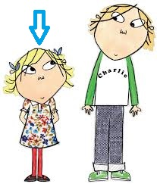 s……………
4. What does he look like?  ……………………………………………. | h………….....
5. What does he look like?  ……………………………………………. |  w………..
6. What does he look like?  ……………………………………………. | s…………..
7. What does she look like?  ……………………………………………. |  s…………
8. What does he look like?  ……………………………………………. |  t...........
9. What does she look like?  ……………………………………………. |  b…………..
10. What does he look like?  ……………………………………………. | 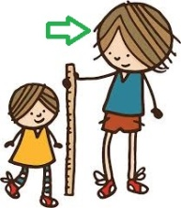 t…………….

Exercise 3: Match.
1. What’s your favourite drink? | a. She works in an office.
2. When is your birthday ? | b. I was at school.
3. What subjects does your brother like? | c.She’s a doctor.
4.Would you like some milk? | d. I like chicken and fish.
5.What did your sister do last night? | e. She watched TV.
6. Where does Huong work? | f. Yes, please. I love orange juice.
7. What’s your favourite food? | g. Maths, Vietnamese and PE.
8. What time does your family have lunch? | h. It’s on the third of November.
9. Where were you yesterday? | i. No, thanks.
10. Is she a doctor? | j. It’s Tuesday, the tenth of March.
11. Who is shorter, Hoa or Lien? | k. They are tall.
12. What does your parents look like? | L. No,she is a teacher.
13. Would you like some orange juice? | m. Lien is.
14. What is the date today? | n. It’s fruit juice.
15. What does your mother do? | o. We heve lunch at 11.30.

1……..2……3……4…….5……6……7……8……9……10……11……..
12…….13……….14…….15………
Exercise 4: Reorder.
1. like / mother / What / your / does / look / ?
=> …………………………………………………………………………
2. me / sister / is / older / my / than / .
=> …………………………………………………………………………
3. What / grandparents / do / like / his / look / ?
=> …………………………………………………………………………
4.is / father / srong / my / and / big / .
=> …………………………………………………………………………
5. slim / mother / my / is / tall / and / .
=> …………………………………………………………………………
6. grandparens / old / but / my / strong / are /.
=> …………………………………………………………………………
7. father / him / is / than / taller / Nam’s / .
=> …………………………………………………………………………
8. Hoa’s / does / What / do / husband / ?
=> …………………………………………………………………………
fgfggf
Exercise 5: Fill the blank with ONE word.

Mary: | This is a photo (1)………………my family.  fgfggf
Daisy: | Is this your mother?  fgfggf
Mary: | Yes, she is.  fgfggf
Daisy: | Oh,she is young and thin. What does she do?  fgfggf
Mary:  fgfggf | She is a (2)…………………… She teaches English.  fgfggf
Daisy: | What (3)……………..your father?  fgfggf
Mary: | He is (4)…………engineer for a foreign company.  fgfggf
Daisy: | He looks tall and handsome. Is your father taller (5)………….. your mother?  fgfggf
Mary: | Yes, he is.

BÀI TẬP NÂNG CAO

Exercise 6: Complete.

Tính từ | Nghĩa | Hình thức so sánh hơn
good
ddsds
Bad
ddsds
Noisy
ddsds
Expensive
ddsds
Nice
ddsds
Short
ddsds
Long
ddsds
Small
ddsds
Young
ddsds
Hard-working
ddsds

Exercise 7: Undeline the mistake in each sentence and correct it.

1. Mary is more nice than Lisa.
=> …………………………………………………………………………
2. His house is moderner than my house.
=> …………………………………………………………………………
3. She is old than her friend.
=> …………………………………………………………………………
4. Who is fater, Hung or Nam?
=> …………………………………………………………………………
5. What do your aunt look like?
=> …………………………………………………………………………
6. Lan is gooder student than Nam.
=> …………………………………………………………………………
7. Is your parents tall? - No, they are short.
=> …………………………………………………………………………
8. He can lift the heavy box. He is very stronger.
=> …………………………………………………………………………
9. Lisa is a girl beautiful.
=> …………………………………………………………………………
10. What does your father work? - In a factory.
=> …………………………………………………………………………

Exercise 8: Write questions for the underlined part.

1. Nam is taller than Lan.
=> …………………………………………………………………………
2. My mother is slim.
=> …………………………………………………………………………
3. Yes, She is short and fat.
=> …………………………………………………………………………
4. I would like some milk.
=> …………………………………………………………………………
5. No, thanks. I don’t like coffee.
=> …………………………………………………………………………
6. He works in an office.
=> …………………………………………………………………………
7. They went to bed at 9 P.M yesterday.
=> …………………………………………………………………………
8. My sister went to the zoo last weekend.
=> …………………………………………………………………………
9.Yes, she was on the beach.
=> …………………………………………………………………………
10. They were at school yesterday.
=> …………………………………………………………………………

Exercise 9: Put the adjectives into the correct form.

1. Mary is 12 years old. Lisa is 8 years old.
Mary is (old)………………..than Lisa.
2. This house is (high) ……………………than that one.
3. My room is (large) ……………………..than his room.
4. My results were (bad)…………………..than I thought.
5. This exercise is (difficult) …………………………..than that one.
6. He is (fat)……………….than his brother.
7. Is your brother (thin)…………………than your father?

Exercise 10: Read and answer.

Dear Tim,
My name’s Hoa. I’m nine years old and I live in Hanoi, Vietnam. There are four people in my family: my father, my mother, my broher and me. My faher is 35 years old. He’s an English teacher in a Secondary School. He is tall and slim. My mother is 34 years old.She is a doctor in a hospital. She is tall and beautiful. My brother and I are pupils at an International Primary School. I’m younger than my brother but he’s taller than me.
Best wishes,
Hoa

1. How many people are there in Hoa’s family?
=> …………………………………………………………………………
2. What does her father do?
=> …………………………………………………………………………
3. What does her father look like?
=> …………………………………………………………………………
4. What does her mother do?
=> …………………………………………………………………………
5. What does her mother look like?
=> …………………………………………………………………………
6. What do Hoa and her brother do?
=> …………………………………………………………………………
7. Who is older, Hoa or her broher?
=> …………………………………………………………………………
8. Who is shorter, Hoa or her brother?
=> …………………………………………………………………………

Name: ………………  Grade 4 | Unit 15: WHEN’S CHILDREN’S DAY?
BÀI TẬP CƠ BẢN
Exercise 1: Look and write the name of the festival.
  1. ………………………………….. |   2. …………………………………..
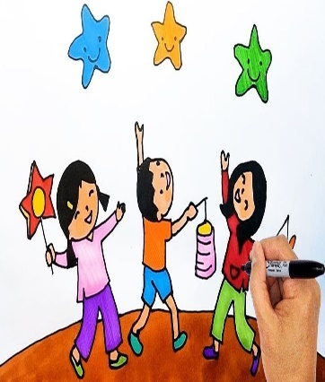  3. ………………………………….. |   4. …………………………………..
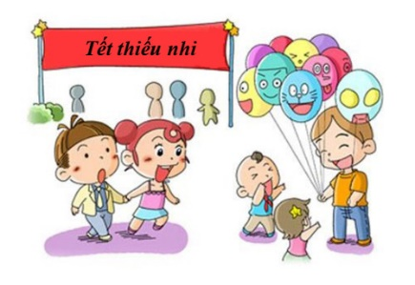  5. ………………………………….. |   6. …………………………………..

Exercise 2: Look and answer.
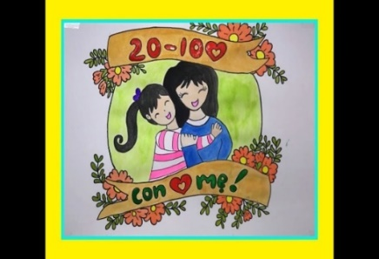 | 1.When is Vietnamese women’s day ?  ……………………………………………………….
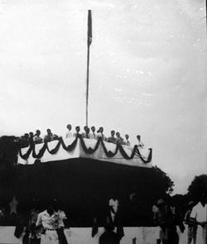 | 2.When is Vietnamese National day?  ……………………………………………………….
3.When is Children’s Day?

……………………………………………………….
 | 4.When is Reunification Day?  ……………………………………………………….
 | 5.When is Teachers’Day?  ……………………………………………………….
 | 6.When is New Year?  ……………………………………………………….
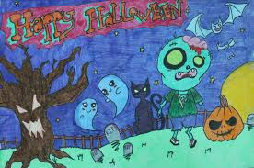 | 7. When is Halloween?  ……………………………………………………….
8. When is Christmas?

……………………………………………………….

Exercise 3: Match.
1.When is Christmas? | A. Yes, she does.
2.What’s a mooncake? | B. I visit my grandparents?
3.Does she decorate the house at Tet? | C. They watch firework displays.
4.What do they do at Tet? | D. It is a cake for Mid-Autumn festival.
5.What do you do at Tet? | E. It’s on the twenty-fifth of December.

1……….2……….3………..4………..5………….
Exercise 4: Circle the correct answer.
1.What does your brother look like? _ He is ……………………..
a. handsome b.friend c.student d.twenty
2. …………….is New Year? _On the first of January.
a.What b. Where c.How d.When
3.There…………….a lot of fun on Christmas Day.
a.is b.are c.am d.have
4.We …………………our teachers and friends on Tet holidays?
a.go b.visit c.get d.eat
5. What are you going to do at Mid- Autumn? – I ……the School Lantern Parade.
a.join b.am going to join c.go to join d.go and join
6.Mai is very happy………………the New Year is coming.
a.and b.or c.because d. but

7…………dis you go to watch the firework displays? –I went to Hoan Kiem Lake.
a.How b.What c.Where d.Why
8.What does he do? – He is a…………………….
a.football b.football match c.football play d.footballer
Exercise 5: Reorder.
1.like/ my/ moon cakes/ daughter/.
…………………………. ……………………………………….……………..
2.Mid-Autumn/ we/ festival/ like/.
…………………………..………………………………………..……………..
3.got/ I/ a/ shoes/ new/ of/ have/ pair/.
………………………………………..………………………………………….
4.children/ wear/ lucky/ new/ money/ clothes/ on/ holiday/ and get/ Tet/.
……………………………………………………………………………………
5.can/ Santa Claus/ you/ see/ at Christmas/.
……………………………………………………………………………………
6.to/ I/ writing/ brother/ letter/ a/ my/ am/ elder/. …………………………………….……………………………………………..
7.grandmother/ old/ short/ is/ my/ and/.
…………………………………………………………………………………..
8.beautiful/ Hoa/ mother/ is/ than/ more/ her/.
…………………………………………… …………………………………….

BÀI TẬP NÂNG CAO
Exercise 6: Circle the word that has a different soud in the underline part.
- A.small B.tall C.bad D.ball
- A.visited B.watched C.cooked D.washed
- A.dislike B.kite C.ice- cream D.listen
- A.when B.why C.who D.where
- A.large B.bad C.fat D.handsome
Exercise 7: Fill in the blank with One word.
- Would you like a cup ………………...tea?
- I’d like some coffee. What ……………..you?
- His favourite drink is apple ………………
- What does your English teacher …………. .like? –She is tall and slim.
- It’s ………………….for breakfast.
- On Christmas Day, children can …………………..sweets from Santa Claus.
- …………………. Mother’s Day, I often give my mother a bunch of flowers.
- We often sing Christmas ………………..on Christmas Day.
- Would you like some milk? – No, …………………
- Students often ……………..lunch in the school canteen.
Exercise 8: Complete the conversation.
Tim: | When’s your birthday?
Nam: | It’s on (1)………………tenth of February.
Tim: | What do you do (2)……………..your birthday?
Nam: | I invite my friends (3) ………………..my house to eat birthday cakes.
Tim: | Do you like Tet?
Nam: | Yes, I like it very much. At Tet, I get lucky money (4) ……………..my parents ans relatives. I am happy.
Tim: | What do you do at Tet?
Nam: | I (5)………………….banh chung with my father and cook it.
Tim: | It sounds interesting.
hhh
Exercise 9: Make complete sentences using the words given.
1.She/ buy/ a lot/ flowers/ and/ decorate/ house/ Tet/.
……………………..………………………………………………………………..
2.What/ your sister/ do/ Tet/?
……………………………………….…………………………………………….
3.When/ New Year/ your country/?
…………………………………….………………………………………………

4.He/ want/eat/ cakes/ sweets/ for/ Children’s Day/.
……………………….…………………………………………………………..
5.My mother/ decorating/ house/ because/ it/ Tet/ soon/.
………………….……………………………………………………………….
6.We/ like/ wear/ new/ clothes/ Tet/.
………………………………………………………………………………….
7.He/ often/ clean/ house/ Christmas/.
………………………………………………………………………………….
8.They/ watch/ firework displays/ Tet holiday/?
……………………………….…………………………………………………
9.My sister/ like/ firework displays/ much/ because/ they/ colourful/.
…………..………………………………………………………………………
10.They/ give/ teachers/ lots/ flowers/ Teachers’Day/.
…………………………………………………………………………………
11.My mother/ clean/ floor/ now/.
…………………….……………..……………………………………………
12.We/ go/ market/ and/ buy/ many/ flowers/ yesterday/.
…………….…………..………………………………………………………
13.His mother/ like/ eat/ banh chung/ and/ chicken/ and/ drink/ orange juice/ during Tet/.
…………………………………………………………………………………….
14.What/ your father/ like/ do/ Christmas holiday/?
………………………….…………………………………………………………..
15.What time/ your grandparents/usually/ get up/ the morning/ ?
…………….……………………………………………………………………….

Exercise 10: Read and answer.
Hi! My name is Hoa. It’s Tet soon. My mother and I are going to the market to buy some food and flowers for Tet holiday. I like eating banh chung bacause it is a special dish at Tet. Before Tet, I clean the floor and decorate the house. I also help my parents make banh chung and cook it. During Tet, I visit my grandparents and relative with my parents. I love Tet very much because I can get lucky money from many people.

- Where are Hoa and her mother going?
………………………………………………………………………..
2.Why does she like banh chung at Tet?
…………….………………………………………………………….
3.What does she do before Tet?
……………….………………………………………………………
4.What does she do during Tet?
………………………………………………………………………
5.Why does she love Tet?
……………../.……………………………………………………….

Name: ………………  Grade 4 | Unit 16: LET’S GO TO THE BOOKSHOP!
BÀI TẬP CƠ BẢN
Exercise 1: Look and complete

 | 1. Let’s go to the ………………..…………………  I want to buy some ……….……………………………
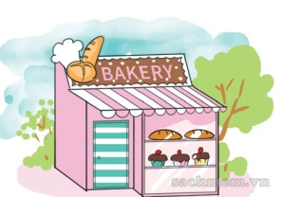 | 2. Why don’t we go to the …………..…………………  I want some ...….………………..…………………….
 | 3. I want to buy some ……………..…………………..  So I go to the …….……………………………………
 | 4. Why does he go to the ………..……………………  Because he wants to borrow some .…………………
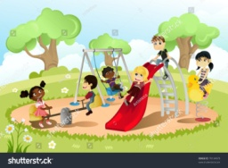 | 5. Why don’t we go to the……………………………...  I want to relax.
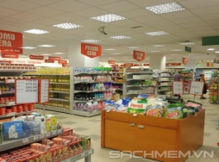 | 6. I want to buy some ………………………………….  So I go to the ………………………………………..
 | 7. Let’s go to the ……………………………………….  I want to buy some books.
 | 8. There is a movie on ……………………………….  Let’s go to the ……………………………..tonight.
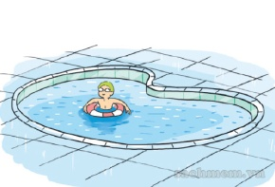 | 9. I want to …..…………………………………….  So I go to the …………………………………….
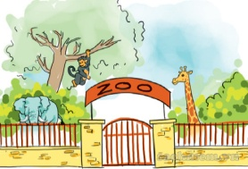 | 10. Why do you go to the ……………………………..  Because I want to see the ………………………….

Exercise 2: Match
ggbdgdf
1. Why do you go to the | a. have dinner.
2. Because I want to buy | b. to the zoo?
3. I go to the school playground to | c. play football.
4. Why don’t we go | d. some books.
5. they go to that restaurant to | e. library?

1…… 2…… 3…… 4…… 5……
ggbdgdf
Exercise 3: Complete the dialogue
ggbdgdf
buy bakery together there hungry where
ggbdgdf

Lan: | Hi, Phong. How are you?
Phuong: | Fine, thanks. And you?
Lan: | I’m well, thank you (1)…………………are you going?
Phuong: | I’m going to the (2)………………I want to (3)…………… some bread to eat.
Lan: | Oh! I am (4) ……………… now. I want to eat some bread, too.
Phuong: | Ok; let’s go there (5) ………………….
Lan: | Good idea! Where’s it?
Phuong: | Over, (6) …………...

Exercise 4: Circle and correct answer
ggbdgdf
1. What are they …………….? – They are reading.
A. reading B. writing C. doing D. dancing
2. Let’s go to the……………. I want some stamps.
A. bookshop B. post office C. cinema D. supermarket
3. They are going to …………….some sports together.
A. read B. dance C. walk D. play
4. …………do you want to go to the bank? – Because I want some money.
A. When B. What time C. Why D. Who
5. Children’s Day is on …………….
A. December 25th B. November 20th C. June 1st D. April 30th

6. Hoa is cleaning the ………………now.
A. food B. tree C. floor D. firework displays
7. I want to buy some vegetables, so I’d like to go to the …………….
A. are going B. go C. goes D. market
8. We ………………home at 5 p.m every day.
A. are going B. go C. goes D. to go
9. My sister is thirsty. She wants something to ……………….
A. eat B. drink C. cook D. draw
10. They watch firework displays at ………………….
A. Christmas B. Tet holiday C. Sunday D. Teachers’ Day
ggbdgdf
Exercise 5: Fill in the blank wit ONE word.
ggbdgdf
1. Huy wants to see animals, so he wants to go to the …………………………..
2. Tuan wants to see a film, so he wants to go to the ……………………………
3. I want to buy some sweets. Let’s go to the……………………………..…….
4. My sister wants to buy some medicine. She should go to the ………….……..…
5. Our parents want to buy some medicine. She should go to the ……………....….
6. Her friend wants to buy some books. She wants to go to the ……………..…
7. My uncle wants to …………………………dinner. He goes to the restaurant.
8. The children want to ………………..………. They go to the swimming pool.

BÀI TẬP NÂNG CAO

Exercise 6: Reorder
ggbdgdf
1.bed/ to/ at/ o’clock/ last/ Nam/ 10/ went/ night/.
=> .………………………………………………………………………
2. let’s/ swimming/ go/ to/ pool/ the/.
=> .………………………………………………………………………
3. firework/ like/ to/ my/ would/ son/ watch/ displays/.
=> .………………………………………………………………………
4. am/ I/ ,/ so/ hungry/ I / like/ some/ would/ noodles/.
=> .………………………………………………………………………
5. father/ work/ at/ 8 a.m/ to/ my/ goes/.
=> .………………………………………………………………………
6. some/ to/ books/ bookshop/ to/ the/ want/ I / to/ buy/ go/.
=> .………………………………………………………………………

7. animals/ see/ she/ wants/ the/ to/.
=> .………………………………………………………………………
8. are/ Peter/ going/ and/ Tom/ where/ now/?
=> .………………………………………………………………………
9. like/ they/ would/ to/ to/ the/ go/ sweet shop/.
=> .………………………………………………………………………
10. the/ want/ pharmacy/ go/ to/ I / because/ I / to/ medicine/ buy/ some/.
=> .………………………………………………………………………
ggbdgdf
Exercise 7. Circle the best answer.
ggbdgdf
- I …………………….(can/ am/ look/ would) like some coffee.
- How about………….. (go/ goes/ to go/ going) to the park?
- …………….(What/When/Where/Why) don’t we go swimming?
- She wants to see animals, ………...(go/ goes/ to go/ going) to the park.
- …………. (Do/Are/Would/Did) you like to drink some coffee?
- They ………(go/ goes/ are going/ went) to the library yesterday.
- Where ………..(are/ do/ were/ did) they yesterday morning?
- ……………... (Is/ Does/ Was/ Did) your brother go camping last weekend?
- ggbdgdf
Exercise 8: Write question for the underlined part.
ggbdgdf
1. They go to the library because they want to read books.
=> ………………………………………………………………………………
2. Nam is going to the zoo.
=> ………………………………………………………………………………
3. My father went to the cinema last night.
=> ………………………………………………………………………………
4. Yes. She wants to go to the bookshop.
=> ………………………………………………………………………………
5. My mother is going to the supermarket.
=> ………………………………………………………………………………
6. I often watch Tv in my free time.
=> ………………………………………………………………………………
7. He is tall and handsome.
=> ………………………………………………………………………………
8. Children’s Day is on the first of June.
=> ………………………………………………………………………………
9. He would like some books.
=> ………………………………………………………………………………
10. Tim visited his grandparents last weekend.
=> ………………………………………………………………………………

Exercise 9: Make complete sentences using the words given.
ggbdgdf
1. He/ want/ go/ park/ to/ fly/ kite.
=> ………………………………………………………………………………
2. They/ want/ buy/ some/ medicine/ so/ they go/ pharmacy.
=> ………………………………………………………………………………
3. Let’s/ not/ go/ swim/ there/.
=> ………………………………………………………………………………
4. What/ about/ go/ beach/ together/?
=> ………………………………………………………………………………
5. We/ not/ want/ him/ go/ home/ alone/.
=> ………………………………………………………………………………
6. Mai/ want/ buy/ any/ pens/ the bookshop?
=> ………………………………………………………………………………

Exercise 10. Read and answer.

It’s Saturday today. It’s a nice day, so Nam and Lan want to go to many places together. First, they go to the supermarket because Nam wants to buy some food. Then they go to the bookstore because Lan wants to buy some school things such as pencils, rulers and crayons. After that, they go to the cinema because they want to see a movie. Finally, they want to go to the bakery to buy something to eat because they are hungry.
1. Is it Sunday today?
=> ………………………………………………….…………………………
2. Do Nam and Lan want to go to many places?
=> ………………………………………………………………………………
3. Why do they go to the supermarket?
=> ………………………………………………………..……………………
4. What does Lan want to buy at the bookstore?
=> ...……………………………………………………………………………
5. Where do they go to see a movie?
=> ………………….…………………………………………..………………
6. What do they want to do finally?
=> ………………….………………………………………….………………
Name: …………………  Grade 4 | Unit 12: HOW MUCH IS THE T-SHIRT?

BÀI TẬP CƠ BẢN

Exercise 1: Match.

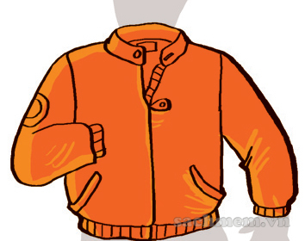  1 | A. dress  B. T-shirt |   2
  3 | D. jacket  C. scarf | 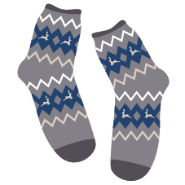  4
  5 | F. socks  G. boots  E. hat |   6
  7 | H. shoes |   8

Exercise 2: Fill in the blank with the word given.
T-shirt
skirt
jumper
shirt
shoes
trousers

T | R | O | U | S | E | R | S
S | O | C | X | K | S | I | H
H | Y | H | A | I | H | J | I
I | U | A | F | R | B | U | R
R | L | T | D | T | P | M | T
T | S | O | C | K | S | P | Y
J | U | M | T | S | N | E | H
J | S | H | O | E | S | R | G

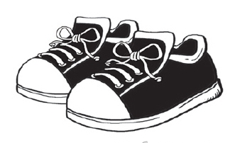 | 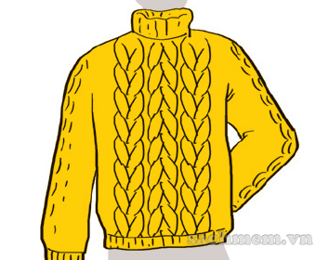 | 
1………………………. | 2………………………. | 3. ……………………….
 | 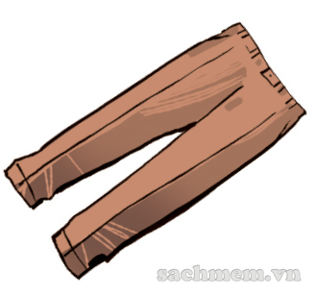 | 
4. ……………………. | 5. ………………………. | 6. ……………………….

Exercise 3: Look and anwer
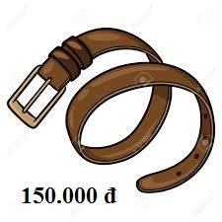 | - How much is the belt?  …………………………………………………………
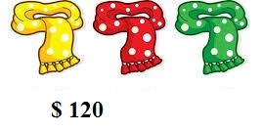 | - How much are those scrafs ?  …………………………………………………………
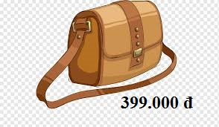 | - How much is that handbag?  ……………………………………………………………
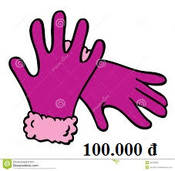 | - How much are those gloves?  ……………………………………………………………
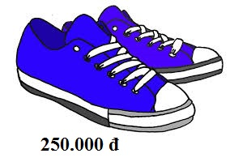 | - How much are those shoes?  ……………………………………………………………
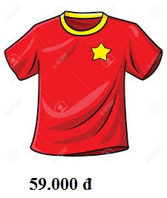 | - How much is that T-shirt?  …………………………………………………………
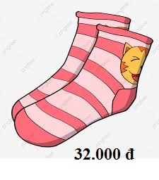 | - How much are those socks?  …………………………………………………………
 | - How much is that suit?  ……………………………………………………………
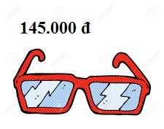 | - How much are those glasses?  ……………………………………………………………
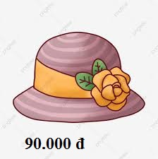 | - How much is that hat?  ……………………………………………………………

Exercise 4: Circle the correct answer.

1. The white shoes ……………………..very nice.
A. is | B. are | C. do | D. does
2. In summer, I often wear ……………………..
A. T-shirt | B. jacket | C. coats | D. scarfs
3. Can I see that blue skirt, please? - ……………………..
A. No, you can. | B. Here you are. | C. Yes, I can. | D. Thank you.
4. My father is short and ………………….
A. fat | B. tall | C. long | D. high
5. My favourite food is …………………..
A. milk | B. water | C. chicken | D. tea
6. My mother often ……………….up early to cook breakfast.
A. get | B. gets | C. got | D. is getting
7. Hoa wears new ………………..at Tet.
A. books | B. pens | C. flowers | D. clothes
8. How much ……………………..your trousers?
A. is | B. are | C. am | D. was
9. How much ……………….that yellow dress?
A. is | B. are | C. am | D. were
10. My mother likes ……………………bread and drinking milk for breakfast.
A. wearing | B. eats | C. eating | D. wears

Exercise 5: Match.
s
1. What colour is the T-shirt? |  | A. It’s twenty thousand dong.
2. Where does your husband work? |  | B. Great idea!
3. How much are these socks? |  | C. Yes, Ido.
4. Why do you want to go to the bakery? |  | D. I’m going to the supermarket.
5. What colour are the shoes? |  | E. Thank you.
6. What do you do, Nam? |  | F. She’s a teacher.
7. What would they like to drink? |  | G.It’s blue.
8. How much is your scarf? |  | H. They’re black.
9. Why do you want to go to the library? |  | I. Because I want to buy something to eat.
10. Excuse me. Can I have a look at that jumper? |  | J. Some apple juice.
11. Do you like this hat? |  | K. Because I want to borrow some books.
12. Oh, your skirt is very nice! |  | L. Sure. Here you are.
13. What does your mother do? |  | M. He works in an office.
14. Where are you going, Truc? |  | N. They’re fifty thousand dong.
15. Let’s o to the cinema, Sarah. |  | O. I’m a pupil.

1…… 2…… 3…… 4…… 5…… 6…… 7…… 8…… 9…… 10…… 11…… 12…… 13…… 14…… 15……

BÀI TẬP NÂNG CAO

Exercise 6: Fill in the blank with ONE word

Mai: | Excuse me. Can I have a look (1)……………………those black trousers?
Sale assistant: | Sure. Here (2)………………are.
Mai: | Thank you.How much are (3)…………………?
Sale assistant: | They’re 100,000 dong
Mai: | What (4)…………………..those white trousers over there? How much are they?
Sale assistant: | They are more (5)…………………..than those black trousers. They are 120,000 dong.

Exercise 7: Find and correct the mistakes.

1. She want a new shirt. Let’s go to the clothes shop!
=> ………………………………………………………………………………
2. How much are the pair of blue trousers?
=> ………………………………………………………………………………
3. Wha colour are the scarf? - they are red.
=> ………………………………………………………………………………
4. Do you want go to the clothes shop?
=> ………………………………………………………………………………
5. Nam want to see an film. Why don’t we go to the cinema?
=> ………………………………………………………………………………
6. How much are black those shoes?
=> ………………………………………………………………………………
7. Let’s ask to these sandals’ prices.
=> ………………………………………………………………………………
8. Those blue lovely jeans are 200,000 dong.
=> ………………………………………………………………………………

Exercise 8: Write questions for the answers.

1. The pair of black sandals is eighty-five thousand dong.
=> ………………………………………………………………………………
2. These white shoes are ninety thousand dong.
=> ………………………………………………………………………………
3. That jumper is orange and black.
=> ………………………………………………………………………………
4. The jackets are black.
=> ………………………………………………………………………………
5. He wears white shirts and trousers when he goes to school.
=> ………………………………………………………………………………
6. My brother went to the clothes shop yesterday because he wanted to buy coat.
=> ………………………………………………………………………………
7. Tim bought a new hat.
=> ………………………………………………………………………………
8. She likes going shopping in her free time.
=> ………………………………………………………………………………

Exercise 9: Put the verb into the correct form.

1. She enjoys ……………………….(wear) skirts in summer.
2. This pair of shoes……………….(be) black.
3. These jeans…………………..(be) nice.
4. Would you like ………………..(go) to the clothes shop?
5. She can ………………(sing) English songs well.
6. Nam ………………..(have) Maths on Sunday.
7. Huy doesn’t ……………………..(watch) TV in the evening.
8. What did your father …………………..(do) last night?

Exercise 10: Read and answer .

My name is Nam. I am a primary pupil. On hot days at school, I wear a shirt, a pair of trousers, a red scarf and a pair of sandals. On cold days, I wear a coat over a jumper, a pair of jeans, a red scarf and a pair of socks and shoes. At home, I wear different clothes. On hot days, I wear a T-shirt, a pair of shorts and a pair of slippers. On cold days, I wear a jacket, a pair of trousers and a pair of socks and slippers.
1. What does Nam do?
=> ………………………………………………………………………………
2. What does he wear on hot days at school?
=> ………………………………………………………………………………
3. Does he wear a pair of sandals on cold days a school?
=> ………………………………………………………………………………
4. What does he wear on hot days at home?
=> ………………………………………………………………………………
5. Does he wear a pair of socks on cold days at home?
=> ………………………………………………………………………………
6. What colour is his scarf?
=> ………………………………………………………………………………

Name: ………………  Grade 4 | Unit 18: WHAT YOUR’S PHONE NUMBER?
BÀI TẬP CƠ BẢN

Exercise 1: Look and complete.
 | 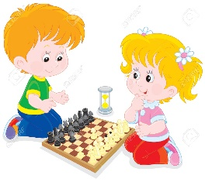 |  | 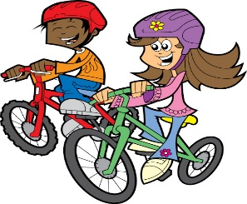 | 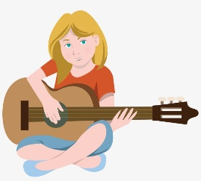
1.go …………….. | 2. play…………... |  | 3. go…………….. | 4. play the…………
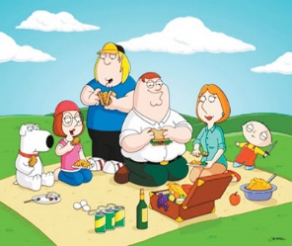 |  |  |  | 
5.go for a……..…. | 6. go………….. |  | 7. go……………… | 8. go………..……..
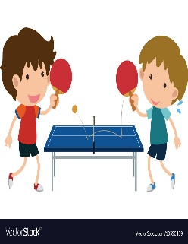 |  | 
9. play ……………………..…… |  | 10. play the …………………………

Exercise 2: Look and write.

0912353584 | 1. What’s Tuan’s phone number?  …………..…………………………………………………
0977885335 | 2. What’s Mai’s phone number?  …………..…………………………………………………
0904543221 | 3. What’s Mai’s phone number?  …………..…………………………………………………
0987887668 | 4. What’s Lan’s phone number?  …………..…………………………………………………
0904662209 | 5. What’s Phong’s phone number?  …………..…………………………………………………

Exercise 3: Match.
a. $ 100.
1. Why don’t we go skating?

b. It’s the jumper?
2. How much is the shirt?

c. Yes, it is.
3. What is that?

4. What is your mother’s phone number?
d. Great idea!

e. It is 0973 324 335.
5. Is this Phong’s phone number?

1………..2…………3…………4………….5…………

Exercise 4: Complete.
great
who
your
speak
call
climbing

A: Hello, May I (1) ……………….…….. to Lisa, please?
B: Speaking. (2) …………………….. is this?
A: It’s Tom. Would you like to go (3) …………..……….. tomorrow?
B: That sounds (4) ………………..……, but I have to ask my parents.
A: Ok. Then can you (5) …………..……… me back?
B: Of course, What’s (6) …………….……. Phone number?
A: It’s 0386 134 478.
B: Ok. Thank you so much.

Exercise 5: Circle the correct answer.
- …………….. hats are there on table? – There are two.
- How old B. How C. How much D. How many
- I’d like orange, please.
- a B. some C. an D. any
- ………….. are they? – They are one hundred thousand dong.
A. How many B. Where C. What D. How much
- The flowers are …………… you. Ms. Hoa.
A. on B. for C. in D. under
- He can …………….. the guitar very well.
A. ride B. play C. stay D. drink
- Are these your socks? No, …………
A. this isn’t B. they aren’t C. there aren’t D. they are
- Would you like to go to the park with me? - …………………..
- No, I would B. Yes, I will C. Sorry, I can’t D. No, please.
- What’s …………….. phone number?
- his B. she C. he D. they
- …………….. you like some coffee? – No, thanks.
- Are B. Did C. Would D. Were
- I learn …………….. read and write during English lessons.
- to B. about C. on D. at

BÀI TẬP NÂNG CAO

Exercise 6: Odd one out.
- A. like | - enjoy | - hobby | - love
- A. skating | - fishing | - shopping | - boring
- A. party | - invite | - complete | - repeat
- A. speak | - say | - back | - talk
- A. their | - me | - his | - our

Exercise 7: Fill in the blank with ONE word
1. She has ……………………… ask her parents.
2. ………………... you call me back? – Sure.
3. The pink skirts ……………..………. 150,000 dong.
4. They are ………………….. tomorrow, so they would like to go camping.
5. Let’s ask ……………….….. its price.
6. How much ……………….…. these jeans.
7. The pair ……………………. Black trousers is fifty nine thousand dong.
8. The pair of yellow ………..……. White shoes is one hundred thousand dong.
9. It’s a birthday present that I get ………………… my grandmother.
10. What’s your phone number? - ……….………. is 0987 487 823.
11. May I speak ……………..…… John, please?
12. Would you like to go ………………… a picnic?

Exercise 8. Underline the mistake in each sentence and correct it.

1. What color are the earing? – They’re yellow.
=> ………………………………………………………………………………
2. Would you like to go fish with me?
=> ………………………………………………………………………………
3. Is this your mother’s phone number? – No, it’s my father’s.
=> ………………………………………………………………………………
4. I’d like to go to a walk tonight.
=> ………………………………………………………………………………
5. Would you like drink some coffee? – No, thanks.
=> ………………………………………………………………………………
6. Yesterday I buy a new mobile phone.
=> ………………………………………………………………………………
7. Your shirt looks very beautifully .
=> ………………………………………………………………………………
8. She have to do these exercises.
=> ………………………………………………………………………………
9. Lisa invites me go for a picnic with her family.
=> ………………………………………………………………………………
10. I enjoy sit in the sun.
=> ………………………………………………………………………………

Exercise 9: Make complete sentences using the words given.

1. What / his mother / phone number?
=> ………………………………………………………………………………
2. Nam / want / invite / some friends / his / birthday party.
=> ………………………………………………………………………………
3. Nga / have to / complete / these exercises / carefully.
=> ………………………………………………………………………………
4. Your mother / enjoy / go / ski/ ?
=> ………………………………………………………………………………
5. Tim / like / go / picnic / his family / countryside/.
=> ………………………………………………………………………………
6. My father / enjoy / use / mobile phone / to / take / photos /.
=> ………………………………………………………………………………
7. She / often / cook / meals / her family / the weekends /.
=> ………………………………………………………………………………
8. What / about / go / skate / Saturday morning / ?
=> ………………………………………………………………………………

Exercise 10: Read and answer.

At weekends, Hoa often goes camping with some of her friends. She wants to relax and go sightseeing. She like taking photos with her moblie phone. She also likes singing but dislikes dancing. Her best friend, Nga enjoy listening to music and reading books. She also likes cooking very much, so she often cooks luch gor her friends. They have a lot of fun when they go camping together.

- What does Hoa often do at weekends?
=> …………………………………………………………………………
- Whuy does Hoa go camping?
=> …………………………………………………………………………
- Does Hoa like dancing?
=> …………………………………………………………………………
- What does Nga enjoy?
=> …………………………………………………………………………
- Does Nga like cooking?
=> …………………………………………………………………………
- Do they have fun?
=> …………………………………………………………………………
Name:……………………  Grade 4 | UNIT 19: WHAT ANIMAL DO YOU WANT TO SEE?
BÀI TẬP CƠ BẢN
Exercise 1. Look and complete.
 | 1. I like……………………….. because they are so cute.
 | 2. I don’t like………………………….because they are scary.
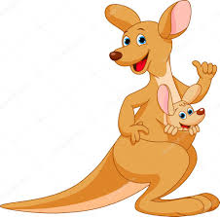 | 3. I like……………………….. because they are very fast.
 | 4. I like……………………….. because they are big.
 | 5. I like…………………….. because they are so beautiful.

Exercise 2. Look and write.
1. What animal do you like?  ………………………………………………………….. | 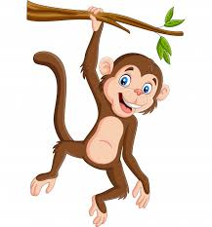
2. What animal do you want to see?

…………………………………………………………..

3. What animal does she want to see?  ………………………………………………………….. | 
4. What animal do they want to see?  ………………………………………………………….. | 
5. What animal does he want to see?  ………………………………………………………….. | 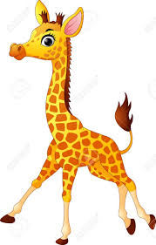
6. What animal does your sister want to see?  ………………………………………………………….. | 
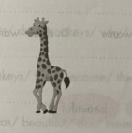
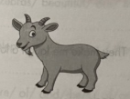
6. What animal does your sister want to see?
…………………………………………………………………………………
5. What animal does he want to see?
…………………………………………………………………………………
Exercise 3. Match.
1. I like monkeys. | A. because they are scary.
2. He doesn’t like crocodiles. | B. eating fish and honey.
3. The monkeys | C. because they are funny
4. Bears like | D. are big and strong.
5. The tigers | E. can swing very well.

1……….2………..3………..4………..5…………
Exercise 4. Circle the correct answer.
1. ………………………… does she want to see?.
A. What an animal B. What’s animal C. What animal D. What this animal
2. Why don’t we go to the zoo?.
A. going B. goes C.went D. go
3. I……………………. to see monkeys every day?.
A. wanting B. want C. wants D. wanted
4. Why do you want to go to the zoo?. - ………………………….. I want to see tigers.
A. so B. Because C. And D. After that
5. It’s…………………… now. Let’s go there later.
A. raining B. rains C. rained D. rain
6. What animal…………………………. they ……………….. to see?.
A. do- want B. did- wanted C. does-wants D. does- want.
Exercise 5. Complete with the words in the box.
beautiful
long
scary
funny
bad

1. I don’t like lion because they are……………………………….
2. She likes monkeys because they are……………………. . They make me laugh a lot.
3. The weather is……………………….. . We should stay at home.
4. My brother likes giraffes because they have ................................... neck.
5. Some zoo animals are very…………………………… . I like seeing them so much.
Exercise 6. Fill in the blank with one word.
Hung: I like going (1)…………………………………… the zoo at the weekend.
Mai: What (2)……………………………………. do you want to see.
Hung: I want to see monkeys.
Mai: What animal do you (3) ……………………………………………….?.
Hung: I like elephants.
Mai: (4)………………………………………….. do you like them?.
Hung: Because they are enomous. What is your (5)………………………… Animal, Mai?.
Mai: I like Kangaroos because (6) ……………………………….. are fast.
BÀI TẬP NÂNG CAO
Exercise 7. Reorder.
1. animal/ does/ want/ your/ see/ brother/ what/ to/?
……………………………………………………………………………………..
2. do/ can/ funny/ things/ monkeys/.
…………………………………………………………………………………….
3. wants/ Tuan/ bears/ see/ and/ to/ elephants/.
…………………………………………………………………………………….
4. mother/ very/ kangaroos/ my/ much/ likes/.
…………………………………………………………………………………….
5. does/ she/ monkeys/ why/ likes/.
…………………………………………………………………………………….
6. monkeys/ fast/ because/ they/ are/ intelligent/ and/.
…………………………………………………………………………………….
7. zebras/ beautiful/ are/ those/ I/ they/ like/ because/.
…………………………………………………………………………………….
8. elephants/ because/ they/ they/ scary/ like/ are/ don’t.
…………………………………………………………………………………….
9. are/ of/ and/ them/ of/ animals/ a lot/ very/ some/ are/ beautiful/there/.
…………………………………………………………………………………….
10. Thu Le/ visiting/ Cau Giay/ He/ Zoo/ is/ in/ District/.
…………………………………………………………………………………….

Exercise 8. Write questions for underlined part.
1. Nam wants to see tigers.
…………………………………………………………………………………….
2. His mother phone number is 0973 145 668.
…………………………………………………………………………………….
3. These shirts are 100.000 dong.
…………………………………………………………………………………….
4. She likes zebra because they are beautiful.
…………………………………………………………………………………….
5. My son wants to go to the zoo every weekend.
…………………………………………………………………………………….
6. They went to the zoo with their friends last week.
…………………………………………………………………………………….
7. My mother often takes me to the zoo at weekends.
…………………………………………………………………………………….
8. Lan likes tigers.
…………………………………………………………………………………….
9. There are 100 animals.
…………………………………………………………………………………….
10. It is hot and sunny in Ha Noi Today.
…………………………………………………………………………………….
Exercise 9. Rewrite the sentences.
1. Let’s go to the zoo.
What about……………………………………………………………?
2. I want to see tigers and bears.
I’d ……………………………………………………………………..?
3. How much does the pair of jeans cost?.
How ……………………………………………………………………..?
4. What does your mother do?.
What is …………………………………………………………………..?
5. She likes going to the zoo on the weekends.
She enjoys ………………………………………………………………?
6. Hung comes to the zoo because he want to see crocodiles.
Hung wants to see ……………………………………………………….?
7. What animal do you like?
………………………………………………………………………………
8. She like playing the guitar.
Playing …………………………………………………………………..?
Exercise 10. Read and answer.
My name is Huong. It is Sunday and the weather is nice today, so I go to Thu Le zoo with my friends. There are lots of animals at this zoo. Some of them are beautiful and friendly but some look scary. I like bears because they are big. I don’t like crocodiles because they look scary. Mai likes zebras and kangaroos because they are beautiful. Nam likes monkeys but he doesn’t like tigers.
- Is the weather bad today?.
……………………………………………………………………………….
- Where does Huong go?
……………………………………………………………………………….
- Are all animals friendly?
……………………………………………………………………………….
- What animal does Huong like? And why?.
……………………………………………………………………………….
- What animal doesn’t Huong like? And why not?.
……………………………………………………………………………….
- What animal does Mai like?
……………………………………………………………………………….
- Does Nam like monkey?
……………………………………………………………………………….
- Does he like tigers?
……………………………………………………………………………….

Name:…………………..  Grade 4 | UNIT 20: WHAT ARE YOU GOING TO DO THIS SUMMER?

BÀI TẬP CƠ BẢN

Exercise 1. Look and complete.
  1. I'm going to Phu Quoc  …....................................... |   2. She is going to Ba Na  …...........................................
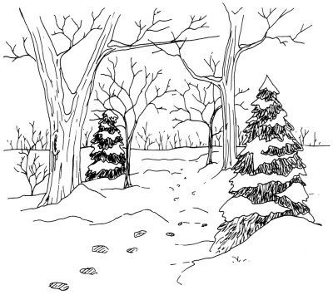  3. In ….................................., it is cold. |   4. In …................................, it is hot.
5. Do you like …..................? Yes, I do. It is delicious | 6. In …................................., it is cool.
  7. We are going to the  …............................................ | 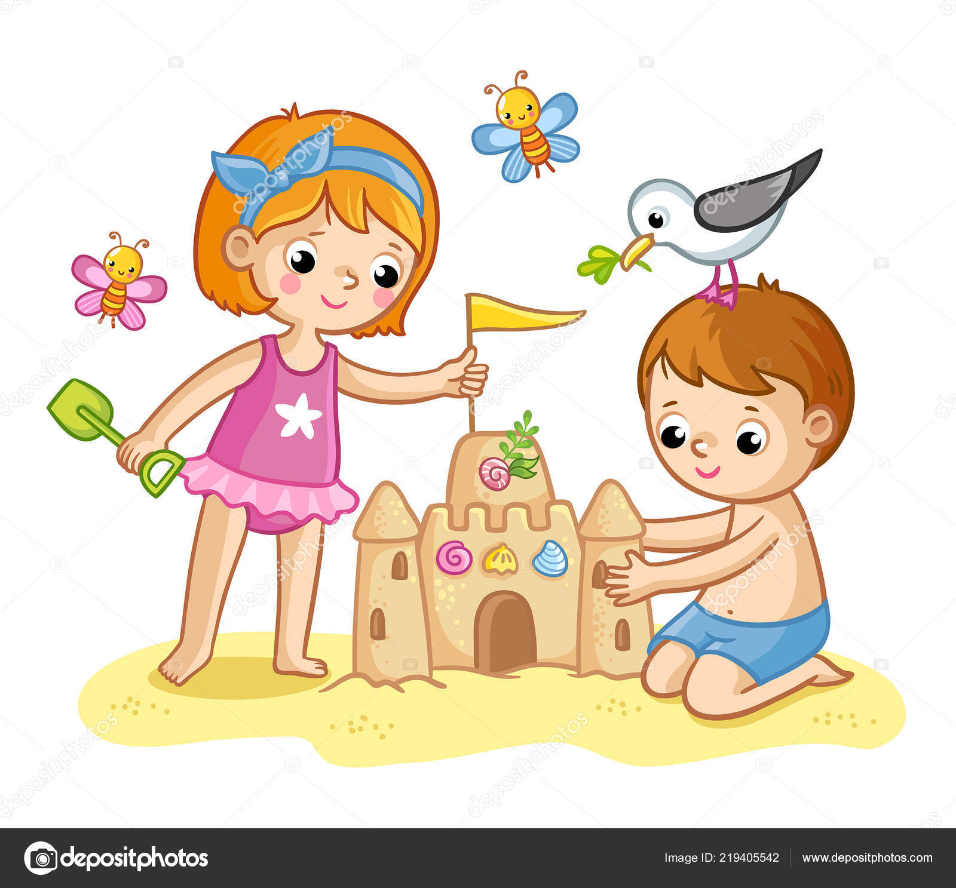  8. They are going to build  …............................................
 | 9. In ….................................., it is warm.

Exercise 2. Look and answer.
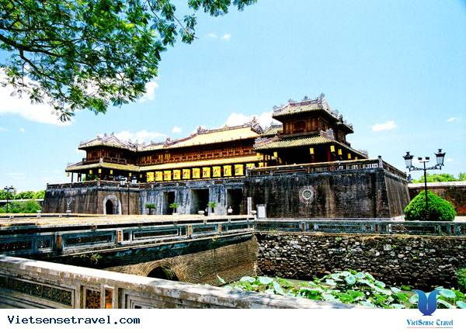 | 1. Where are you going this summer?  =>…......................................................................
 | 2. Where is she going in November?  =>…........................................................................
 | 3. Where is your father going next week?  =>….......................................................................
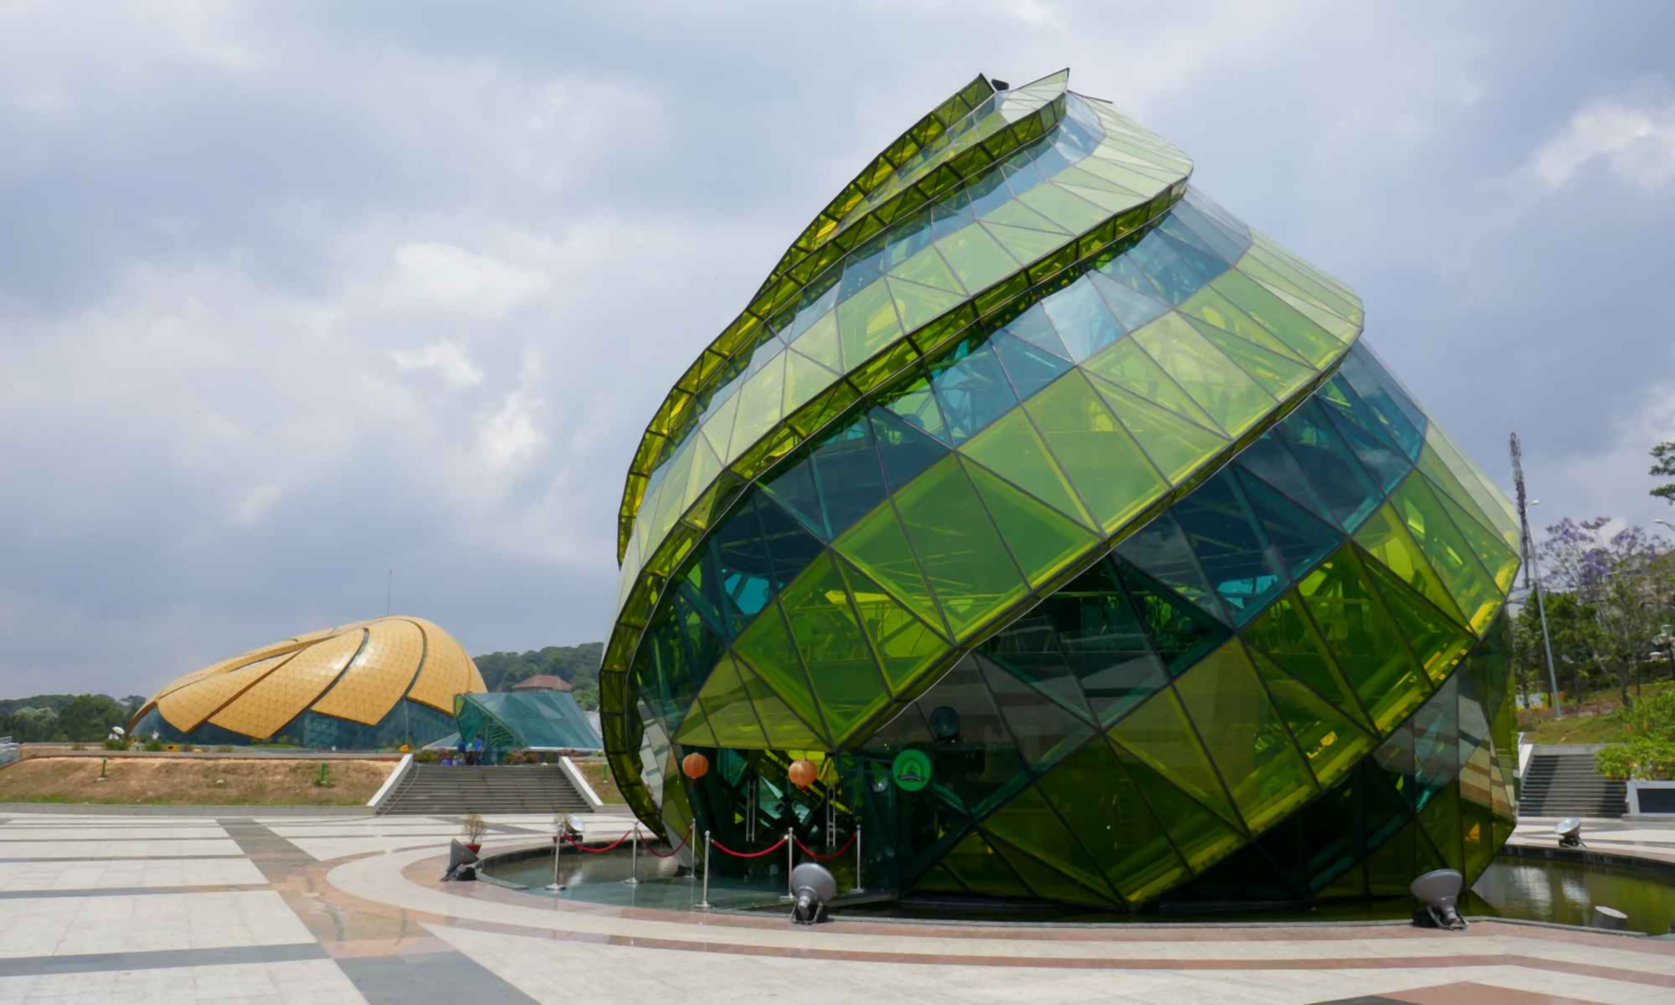 | 4. Where are they going next June?  =>…........................................................................
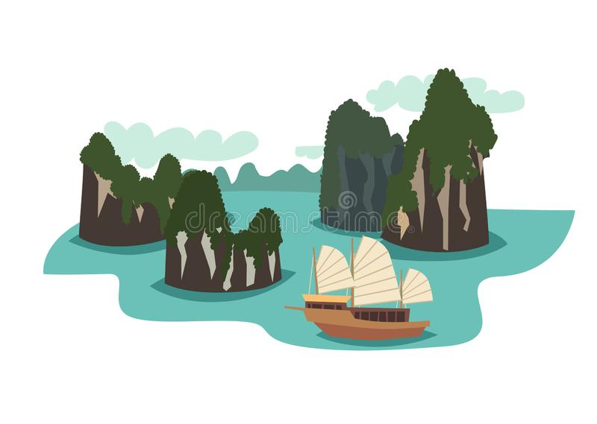 | 5. Where is your sister going this winter?  =>…..........................................................................

Exercise 3. Match.

1. Where are you going this summer? | A. She's going to visit her friend.
2. What are you going to do tomorrow evening? | B. I'm going to Sa Pa.
3. What is your mother going to do? | C. In a hotel.
4. Are you going there with your friend? | D. No. I'm going there with my father.
5. Where are they going to stay? | E. I'm going to do my homework.

1………..2………..3…………4………..5…………..

Exercise 4. Circle the correct answer.

- …........... they going to stay in a hotel in Hue?
A. Are B. Is C. Am D. Be
- We are going …........ a new house.
A. buy B. Bought C. To buy D. Buying
- What are you doing? - I …....... books.
A. read. B. Am reading C. Reads D. Am going to read
- …......... does your mother do in her free time?
A. how B. Which C. When D. What
- My brother goes …............ in his free time.
A. fishing B. The zoo C. Gym D. The movies
- She plays ….............. at weekends.
A. guitar B. Swimming C. Rope D. Badminton
- …............ are you going next month? - I'm going to Ha Noi.
A. When B. What C. Where D. How
- …............. does she go fishing? - Once a week.
A. When B. Which C. How often D. What
- …............ is she going to buy a house? - Next June.
A. What B. Why C. Where D. When
- She …......... to English every day.
A. listens B. Is listening C. Listened D. Is going to listen

Exercise 5. Answer about yourself.

- What animal(s) do you like? Why?
gjkk
=>…............................................................................................................................

- What are you going to do tonight?
- gjkk
=> …............................................................................................................................
- Where are you going this summer?
- gjkk
=> …............................................................................................................................
- What is your mother going to do this summer?
- gjkk
=> …............................................................................................................................
- What is your father going to do this summer?
- gjkk
=> …............................................................................................................................

BÀI TẬP NÂNG CAO

Exercise 6. Fill in the blanks with ONE word.
gjkk
- Only one week …......................... our summer holidays!
- Where …........................... you going this summer, Nam?
- I'm going …........................... play soccer this afternoon.
- They have ….............................. learn Vietnamese.
- Where are they going …........................... June?
- I'm going to France …................................. my summer holiday.
- I'm going to swim …............................. the sea.
- My sister and I …..................... going to have a holiday next week.
- We are going to stay …....................... a big hotel in Ha Noi.
- My friends …........................ going to eat delicious seafood.
- They are going to ….................... sandcastle.
- In the afternoon, we are going to play football …..................... our classmates.
- She often goes ….................. a walk with her friends.
- They enjoy …............................. fishing in summer.
- The children are going to have a holiday in Vung Tau …...................... two months.

Exercise 7. Reorder.
gjkk
- zoo/ you/ at/ going/ home/ the/ or/ to/ stay/ to / are / go/ ?
- gjkk
=> …............................................................................................................................
- going/ City/ a/ is/ to /she/ in/ nice/ in / stay/ hotel/ Ho Chi Minh/ .
- gjkk
=> …............................................................................................................................
gjkk
…………………………………………………………………………………..
- going/ buy/ to/ laptop/ I/ new/ buy/ am / a/ .
- gjkk
=> …............................................................................................................................
- she/ to/ who/ with/ is/ going/ stay?
- gjkk
=> …............................................................................................................................
- am/ family/ TV/ with/ watching/ my/ I/ now/ .
- gjkk
=> …............................................................................................................................
- stay/ is / to / going/ your/ friends/ with/ sister/ her/ tonight/ ?
- gjkk
=> …............................................................................................................................
- summer/ my/ this/ and/ are / to /a /in/ friends/ I/ going / have/ holiday/ Da Lat/ .
- gjkk
=> …............................................................................................................................
- week/ to/ parents/ are/ where/ your/ going/ stay/ next/ ?
- gjkk
=> …............................................................................................................................
- family/ with/ he/ play/ going/ beach/ at/ to/ is/ his/ swim/ the/ and/ volleyball/ .
- gjkk
=> …............................................................................................................................
gjkk
………………………………………………………………………………….
- plan/ would / the/ to/ about/ holidays/ you/ my/ like/ tell/ for/ I/ summer /.
- gjkk
=> …............................................................................................................................

Exercise 8. Underline one mistake in each sentence and correct it.

- My uncle and I am going to Hue next year.
=> …............................................................................................................................
- He is going to stay on a big hotel by the sea.
=> …............................................................................................................................
- They are going to play volleyball in the beach.
=> …............................................................................................................................
- How much is the tickets?
=> …............................................................................................................................
- We are going to enjoy seafood delicious.
=> …............................................................................................................................
- She likes swim in the sea all day.
=> …............................................................................................................................
- He is going to Ha Long Bay yesterday.
=> …............................................................................................................................
- Is your sister going to Ho Chi Minh City this summer?
=> …............................................................................................................................
- They have to staying at home to do their homework.
=> …............................................................................................................................
- Miss Hoa and her husband is going to build a house by the sea.
=> …............................................................................................................................
Exercise 9. Make complete sentences using the words given.
gjkk
- My father/ going/ visit/ Sa Pa / September/ .
=> …............................................................................................................................
- You/ go/ boat cruise/ next summer/ ?
=> …............................................................................................................................
- She / preparing/ her/ summer/ vacation/ ?
=> …............................................................................................................................
- My mother/ like/ swim/ the sea/ in / morning/ .
=> …............................................................................................................................
- My sister / going / stay/ home/ because/ she/ have/ to / learn/ English / .
=> …............................................................................................................................
- Where / Nam/ go / this summer/ ?
=> …............................................................................................................................
- We/ like /stay/ a hotel/ by/ sea/ .
=> …............................................................................................................................
- I/ want/ eat/ delicious/ seafood/ Nha Trang/ so / I / going / there/ my/ husband/ next week/ .
=> …............................................................................................................................
- You/ have/ holiday/ Phu Quoc/ next weekend/ ?
=> …............................................................................................................................
- We/ not/ going/ eat/ seafood/ because / it / expensive/ .
=> …............................................................................................................................
gjkk
Exercise 10. Read and answer.
gjkk
My name is Hung. My parents and I are going to the beach in Nha Trang this summer. We are going to stay in a big hotel by the sea for two weeks. I am going to buid sandcastles, go sailing, and go fishing. My mother is going to relax by lying on the sand and sunbathing. My father is going to swim in the sea and go on a boat cruise. We are going to eat seafood in the evening. We are going to have a lot of fun there!

- Where are Hung and his parents going this summer?
=> …............................................................................................................................
- How long are they going to stay there?
=> …............................................................................................................................
- What is Hung going to do there?
=> …............................................................................................................................
- What is his mother going to do there?
=> …............................................................................................................................
- Is his father going to play volleyball?
=> …............................................................................................................................
- What are they going to eat?
=> …............................................................................................................................

