Name:…………………………..  Grade 3 | UNIT 1: HELLO!

BÀI TẬP CƠ BẢN
Exercise 1. Write the missing letters.
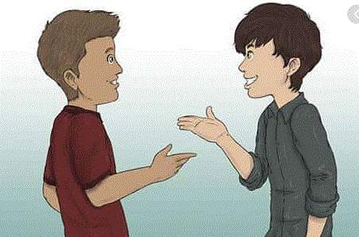  1.  __ello! |  | 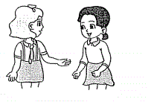  2.  H__! | T_ank you!
  3. | By__! |   4.  Good af__ernoon! | T__ank you!
5. 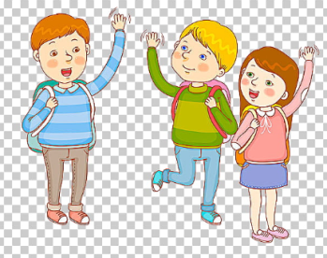  Goo__bye! |  | 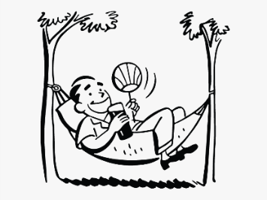  6.
7. 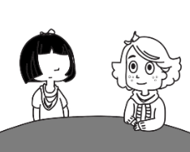  __!I’m Mai! |  | 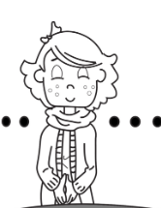  8.  HI. I__Hoa.
Exercise 2: Read and complete
thanks
Hello
How
fine

Tuan: (1)………………., Miss Hoa. (2) ……………….are you?
Miss Hoa: Hello, Tuan. I’m OK, (3) ……………….And you?
Tuan: I’m (4) ……………….,thank you. Goodbye, Miss Hoa.
Miss Hoa: Goodbye, Tuan
Exercise 3: Find the words
hello
q | h | g | w | r | a | e | o | d | i
y | i | o | p | f | s | w | p | f | i
p | w | o | h | e | l | l | o | i | i
f | f | d | i | g | d | q | p | y | h
d | d | b | y | e | f | w | t | b | a
v | v | y | i | i | g | r | h | d | n
i | p | e | i | h | h | t | k | s | k
k | e | e | a | a | k | y | l | n | S
….bye
bye
bye
bye
hi
thanks

goodbye
Exercise 4: Read and match
- are you?
1.Hello

b. thanks.
2.Hi,

3.How
c. I’m Nam.

4.I’m fine
d. to meet you.

5.Nice
e. Mai, I’m Quan.

Exercise 5: Write the missing letters

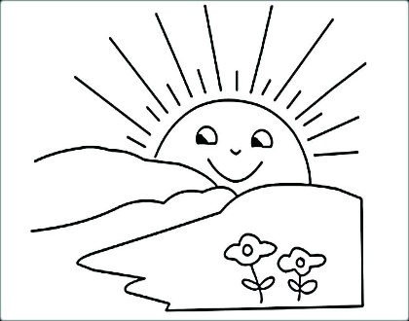
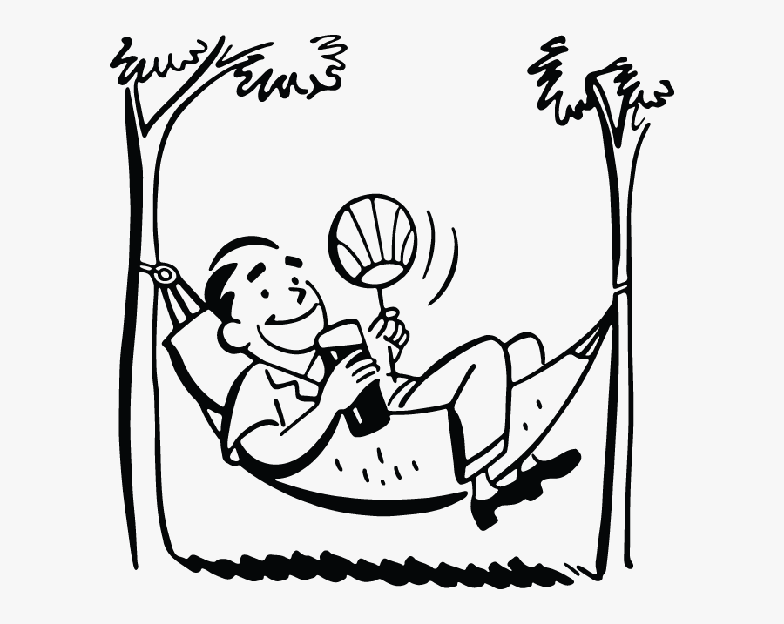
1. GOOD M_ _ _ _ _ G 2. GOOD A_T_ _ _ _ _ N
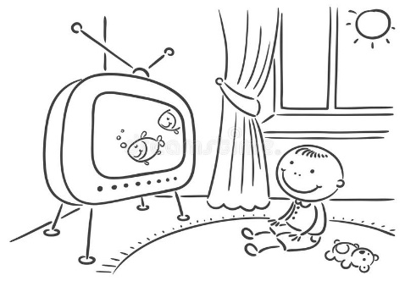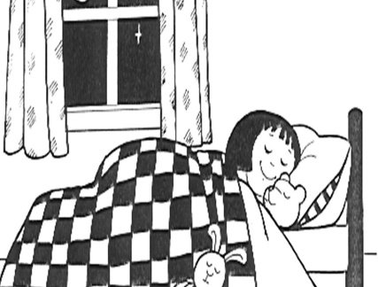
3. GOOD E_ _ N_ _ G 4. GOOD N_G_ _
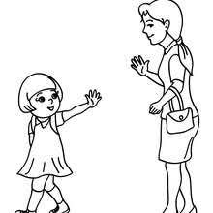
5._ E _ _ O 6. GOOD _ _ _

Exercise 6. Finds the words

p | b | h | a | p | y | g | a | z | n | j | s  good morning  good evening  good night  hi  hello  goodbye  bye
u | m | e | i | t | a | a | e | y | k | g | g
s | y | l | e | w | b | o | i | c | c | o | e
h | g | l | u | w | r | d | c | k | c | a | l
x | o | o | x | r | d | e | g | h | y | d | i
b | o | q | s | y | e | v | v | g | y | m | t
p | d | x | x | c | p | e | c | o | u | o | f
r | n | g | f | t | q | n | u | o | i | r | p
e | i | j | k | v | p | i | y | d | z | n | y
l | g | e | p | v | b | n | z | b | y | i | y
w | h | h | y | q | y | g | t | y | b | n | s
q | t | z | y | d | e | j | i | e | p | g | u

Exercise 7: Reorder
1.you/ meet/ Nice/ to/.
……………………………………………………………………..
2.you/ are/ How/?
……………………………………………………………………..
3.thanks/ fine, / I’m/.
……………………………………………………………………..
4.you/ See/ again/.
……………………………………………………………………..
5.Mary./ Hello, /am / Tom/ I/.
……………………………………………………………………..

BÀI TẬP NÂNG CAO
Exercise 9. Fill in the blank.
SEE YOU AGAIN GOOD AFTERNOON GOOD MORNING
GOOD EVENING GOODNIGHT

1…..………………… | 2…………………….. | 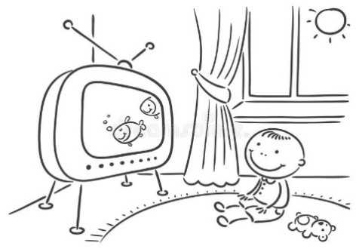  3. ……………………..
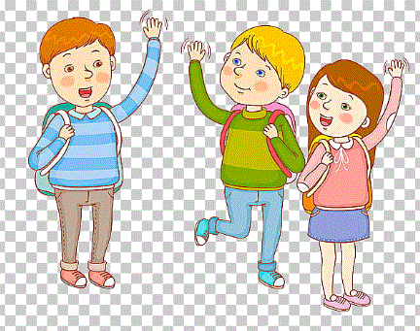  6……………………. |  | 5……………………….

Exercise 10. Odd one out.
A. he | B. hello | C. hi | D. bye
A. night | B. morning | C. evening | D. hello
A. fine | B. good | C. name | D. OK
A. Good morning | B. Good afternoon | C. Goodbye | D. Good evening
A. meet | B. fine | C. see | D. Greet

Exercise 11. Circle the correct answer.
1. That_____Nga.
A. are | B. is | C. am | D. it
2. I am Hung. I am _________Vietnam.
A. from | B. to | C. at | D. of
3. Peter: Hello. I am Peter.
John:__________. I am John.
A. Hello | B. Bye | C. Good night | D. Goodbye
4. Hello. My name is Tom.
Lisa:__________, Tom.
A. See you later | B. Nice to meet you | C. Goodbye | D. Good night
5. Mickey: Hi. I’m Mickey.
Donald:_____________.
A. Bye, Mickey. I am Donal. | B. Goodbey. I am Donald.
C. Hi. I am Donald. | D. Byebye. I’m Donald.

Exercise 12. Find the words.
bye, bye, bye, good afternoon, goodbye, good evening, good morning,
good night, hello, see you later, see you tomorrow

e | m | g | q | u | o | z | e | x | a | e | s | a | w | g
p | y | t | o | c | k | i | f | w | n | e | v | o | h | o
y | r | b | o | o | v | n | s | e | e | u | r | k | o | o
w | o | r | d | a | d | k | w | y | a | r | q | l | g | d
z | e | u | z | o | d | m | o | n | o | h | l | z | w | e
r | c | z | z | e | o | u | o | m | m | e | p | c | e | v
d | s | o | h | o | l | g | o | r | h | v | o | w | y | e
g | o | o | d | a | f | t | e | r | n | o | o | n | b | n
m | k | b | t | q | u | o | f | r | e | i | c | i | e | i
k | q | e | v | o | g | q | k | m | q | t | n | m | y | n
f | r | t | y | t | h | g | i | n | d | o | o | g | b | g
p | s | e | o | w | u | l | l | e | o | o | k | q | l | k
k | e | h | w | i | l | w | f | h | u | l | b | y | e | u
s | s | f | n | t | p | p | g | c | c | t | a | i | y | n
b | g | k | d | s | m | m | p | i | f | f | w | i | g | l

Name: …………  Grade 3 | UNIT 02: WHAT’S YOUR NAME?
BÀI TẬP CƠ BẢN
Exercise 1: Write the missing letters.
 | 
1. W_A_ | 2. _OW
 | 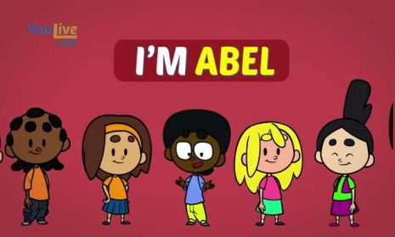
3. S_E_L | 4. NA_E
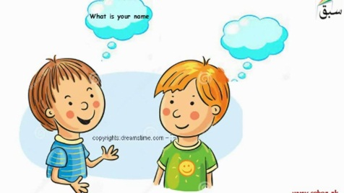 | 
5. Y_U | 6. _OU_

Exercise 2: Read and complete.
name
are
to
How
my
What’s

1. ………………your name?
2. ………………name’s Tim
3. ……………….do you spell your name?
4. My …………………..is Mary.
5. How …………………you?
6. Nice …………………meet you.
Exercise 3: Write the missing words.
1. A: How do you ……….your name?
B: M-I-M-I
2. Nice to meet …………
3. A: How …………..you spell your name?
B: N-A-M
4. Her …….. is Hoa.
5. He ……….Mr David.
6. A:……………do you spell your name?
B: L-A-N
Exercise 4: Read and match
a. My name’s Linda.
1. Hello. My name’s Peter.

b. L-I-N-D-A.
2. How are you today?

c. Hi, Peter. I’m Nam.
3. What’s your name?

d. I’m fine. Thank you.
4. How do you spell Linda?

Exercise 5: Reorder.

1. name / My / Giang / is / .
=> ………………………………………………………………………………
2. your/ What/ is / name / ?
=> ………………………………………………………………………………
3. do/ spell / name / you / How / your / ?
=> ………………………………………………………………………………
4. S -/ -A / S- / -N/ U-/
=> ………………………………………………………………………………

Exercise 6: Read and complete.
How
name’s
T-R-U-N-G
my
spell

Trung: Hi, (1) …………......name is Trung.
Linda: Hello, Trung. My (2) ………………… Linda. (3) …………….do you spell your name?
Trung: (4) ……………….How do you (5) …………….your name?
Linda: L-I-N-D-A

Exercise 7: Answer the questions.
1. What’s your name?
=> ………………………………………………………………………………
2. How do you spell your name?
=> ………………………………………………………………………………
Exercise 8: Circle the correct answer.
1. How…………….you?
A. am | B. is | C. are | D. it
2. Goodbye. …………………you later.
A. What | B. See | C. How | D. Are
3. ……………………I am Sarah.
A. Hello | B. Good-bye | C. It | D. You
4. Goodbye. See you …………………..
A. soon | B. late | C. how | D. are
5. ………………her name?
A. Hello | B. Goodbye | C. What | D. What’s

Exercise 9: Find the words.
proper
name
what
you
your
my
how
spell
do
is

c | f | s | p | e | l | l | d | x | s
s | a | d | y | n | z | s | h | a | e
h | e | p | q | a | b | d | o | c | q
z | m | y | f | m | v | t | w | h | c
p | r | o | p | e | r | h | b | s | y
y | o | u | r | x | k | p | i | k | x
p | p | w | h | a | t | v | s | o | t
v | s | f | t | d | y | a | s | e | z

BÀI TẬP NÂNG CAO

Exercise 10: Reorder.
1. LHOLE  2. BOGOEDY  3. OUYR  4. LSEPL  5. MAEN  6. EEMT  7. HWAT  8. NEGEVNI  9. ANONFTEOR  10. ORNMGIN | - …………………………………………..  - …………………………………………..  - …………………………………………..  - …………………………………………..  - …………………………………………..  - …………………………………………..  - …………………………………………..  - …………………………………………..  - …………………………………………..  - …………………………………………..
Exercise 11: Write the next two letters.
1. A B C … …  3. D E F … …  5. H I J … …  7. M N O … …  9. Q R S … …  11. G H I … … | 2. K L M … …  4. T U V … …  6. E F G … …  8. V W X … …  10. J K L … …  12. N O P … …

Exercise 12: Which letter is in the wrong place? Circle and copy correctly.

1. B C A E F G H
…………………………………………….
2. J K L I N O P
…………………………………………….
3. G R S T U V W
…………………………………………….
4. H I G K L M N
…………………………………………….

Exercise 13: Circle the correct answer.
1. My name …………Tom.
A. is | B. are | C. am | D. ‘m
2. How do …………… spell his name?
A. you | B. your | C. my | D. yours
3. Hoa: What ……..your name? Tony: My name …….Tony.
A. is - am | B. am - am | C. is - is | D. am - is
4. The boys …………..Hung and Nam.
A. is | B. am | C. do | D. are
5. My sister’s name ………….Mai
A. am | B. is | C. are | D. ‘re
6. Hi, …………name is Daisy and this is my friend, Tom.
A. my | B. your | C. his | D. her
7. A: …………………? B: J-E-R-R-Y
A. How are you |  | B. How do you spell your name?
C. What’s your name? |  | D. Are you Rerry?
8. Jerry: Hi, Kitty. ………………….? Kitty: Hi, Jerry. I’m fine, thanks. What about you?
A. What’s your name? |  | B. And you
C. What about you |  | D. How are you

Name: ………………  Grade 3 | Unit 3: THIS IS TONY.  BÀI TẬP CƠ BẢN
Exercise 1: Write the missing letter
  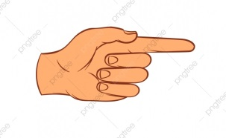  1. T _ I _ |   2. T _ A _
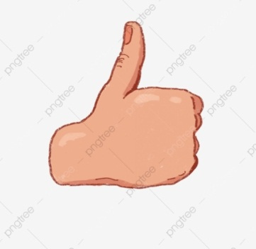  3. Y _ S | 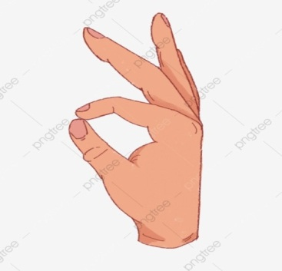  4. O _

Exercise 2: Read and complete.
his
and
is
name’s
That
meet

- Hi. My ………………… Truc.
- ………………… is Nam.
- I’m Huong ………………… this is Hung.
- Look at that boy. ………………… name is Bill.
- That girl ………………… Lisa.
- Nice to ………………… you, Peter and Linda.
Exercise 3: Reorder
- are / you / Hello / Nam ,/ How /?

- fine / thanks /, / I / am /.

- See / later / Goodbye, / you /.

- Manh / is / This /.

- Hanh / She / is /.

- name / your / What’s / ?

- My / This / sister / is /.

- brother / This / my / is /.

- / meet / Nice / , / too / you / to / .

- am / very / I / well /.

Exercise 4: Match
hgf
a. H-U-N-G.?

1. Who is this ?

e. My name is Tom.

d. I’m fine, too.

c. Yes, It is.

b. It is Nam.

2. Is that Lan ?

3. What is your name ?

4. How do you spell Hung?

5. I’m fine. How about you?

Exercise 5: Leave ONE unnecessary letter and then rewrite.
- THOIS =>
- YOUN =>
- THATY =>
- THASNKS =>
- NOI =>
- ISK =>
- SPENLL =>
- WKHAT =>
- MEETA =>
- FINOE =>
Exercise 6: Write questions for the underline part.
- H-O-A-N-G
- How ?
- Yes, it is Nam.
- Is ?
- My name is Lan.
- What ?
- I’m OK, thanks.
- How ?
Exercise 7: Complete the sentences with THIS or THAT
1. …………………..is a key.  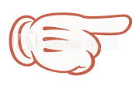 | 2. ……………………a ball.  
3. …………. is a table.  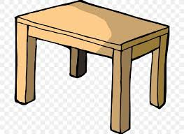 | 4. …………. is a doll.  
5. …………. is a boat.   | 6. …………. is a house.  
7. …………. is a pen.   | 8. …………. is a toy box.  
9. …………. is an umbrella   | 10. …………. is a toy car.  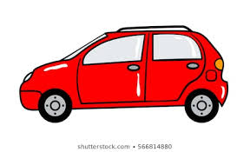

BÀI TẬP NÂNG CAO
Exercise 8: WRITE A OR AN.
1. ………… horse | 6. ……… lion
2. ………… tiger | 7. ……… airplane
3. ………… eye | 8. ………. pen
4. ………… pig | 9. ………..orange
5. ………… umbrella | 10. ………. doll

Exercise 9: Match.
 |  | This is a flower.
 |  | This is a car.
 |  | This is a puppy.
 |  | This is an orange.
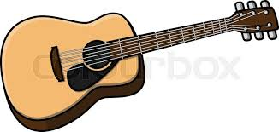 |  | This is a ball.
 |  | This is a guitar.

Exercise 10: Look and answer
 |  | 
2. What is this?  - It’s a …………………. | 2. What is this?  - It’s a …………………. | 3. What is this?  - It’s a ………………….
 |  | 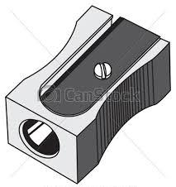
4. Is this a ruler?  ……………………….. | 5. Is this a schoolbag?  ………………………… | 6. Is this a pencil sharpener?  ……………………………..
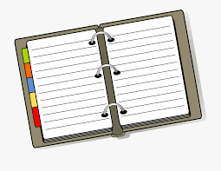 | 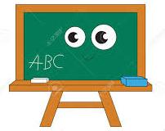 | 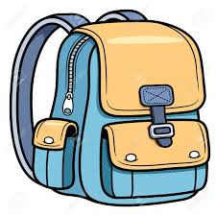
Is this a notebook?  …………………… | 8. Is this a desk?  …………………….. | 9. What is this?  ………………………….…
Exercise 11: Reorder the sentences to make a dialogue.
1. a. Pretty well, thanks. And you?  b. Hi, Sally.  c. Hello, Linda. How are you?  d. I’m fine. Thank you. | …………………………………….  ……………………………………  ……………………………………  ……………………………………
2. a. Hi, guys! How are you?  b. I’m fine, too. Thanks.  c. We’re fine, thank you. And you? | ……………………………………  ……………………………………  ……………………………………

Name: ………………………..  Grade 3 | Unit 4: HOW OLD ARE YOU?
gdsss
BÀI TẬP CƠ BẢN
Exercise 1: Write the missing letters.
A. | B.  | C. 
N _ NE | _ I _ E | FO _ R
D.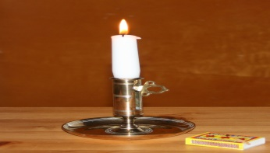 | E.  | F. 
O _ E | S _ V _ N | _ I _ HT
gdsss
Exercise 2: Match.
three | seven | nine | five | four | six | ten | two | one | eight

1 | 2 | 3 | 4 | 5 | 6 | 7 | 8 | 9 | 10
gdsss
Exercise 3: Complete.
1, _.ell._, Alice.
2. What’s h _ s name?
3 H _ w old are th _ y?
4. I am e _ l _ ven years old.
5. S_ _ you l _ t _ r.

Exercise 4: Read and Match.
1, Who ‘s that? | 1…….. | a. No, It isn’t. It is a pen
2. How old are you? | 2……. | b. It’s Mr Hoang
3. Is that Mai? | 3…….. | c. she is ten year old
4. How old is Mai? | 4…….. | d. I’m eight years old
5. Is this a pencil | 5……… | e. Yes, it is
gdsss
Exercise 5: Read and Complete.
is
name’s
She
years
Seven

gdsss
Hi, my………………Tuan. I’m eight …………………old. I’m in class 3A. This……………..Mai………………is eight , too. Here are Peter and Linda. Peter is …………and Linda is nine.
BÀI TẬP NÂNG CAO
Exercise 6: Reorder.
1, That / Trang / Miss / is /.

g ………………………………………………………………………………
dfgfd
g2. How / you / old / are / ?
dfgfd
g ………………………………………………………………………………
dfgfd
g3. Tom / is / this /.
dfgfd
g ………………………………………………………………………………
dfgfd
g4. eight / She / years / old / is / .
dfgfd
………………………………………………………………………………

g5. Nice / meet / too / you /.
dfgfd
g ………………………………………………………………………………
dfgfd
g6. spell / do / How / name / ? / you / your /.
dfgfd
g ………………………………………………………………………………
dfgfd
g7. old / How / Tom / and / Peter / are / ?
dfgfd
g ………………………………………………………………………………
dfgfd
dfgfd
Exercise 7: Fill the blank with ONE word.
1, How old…………they?

2. …………….is this?. It is Tim.
g
3. This is Linda…………..that is Mary.
g
4. I am twelve…………….old.
g
5. ……………..is she? She is fine, thanks!
g
xbxb
Exercise 8: Circle the correct answer.
1. This …………….Hoa and that ………………..Mai
A. Is _ are | B. is _is |  | C. is _am | D. am –is
2. These boys……………..ten years old.
A. is | B. am |  | C. are | D. do
3. ……………………are you? _ Very well, thanks.
A. How | B. What |  | C. Where | D. How old
4. Hello, Peter. This is Hoa…………………..is my friend
A. I | B. She |  | C. her | D. my
5. ……………………………………..? B: T-H-A-N-H
- What is your mother’s name? |  | - How are you?
- How do you spell your name? |  | - Are you Thanh?
dfgfd
Exercise 9: Reorder the sentences to make a dialogue.
1, I’m fine, thank you! And you?  gfd  2. Hi, Hoa. How are you?  gfd  3. I ‘m fine, thanks! This is Thuy. She is my friend.  gfd  4. Hello, Nam.  gfd  5. Good morning, Hoa. Nice to meet you!  gfd  6. Good moring, Thuy. Nice to meet you! | ……………………  gfd  …………………..  gfd  …………………  gfd  …………………  gfd  ………………….  ………………….

Name: …………..……  Grade 3 | UNIT 5: ARE THEY YOUR FRIENDS?
BÀI TẬP CƠ BẢN

Exercise 1: Write the missing letters

  IS HE N_W?  I DON’T KNOW.  IT IS _ BOOK. |   S _ _ IS VAN.
  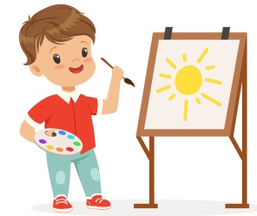  _ _ IS HAI.  IT’S MY BROTHER JOHN.  THIS _ _ DAISY | 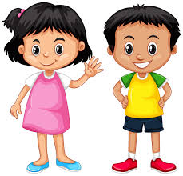  _ _ _’S THIS?
   | 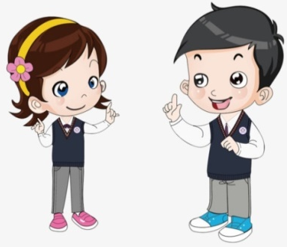  
THIS IS A _ _ _ _.  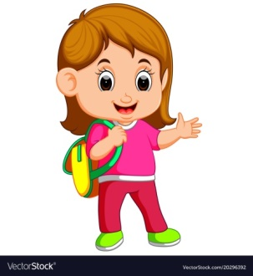 |   THIS IS A _ _ _ .

Exercise 2: Circle the correct answer
1. He is my (friend/ friends).
2. She is my (friend/ friends).
3. They’re my (friend/ friends).
4. Peter and Linda are my good (friend/ friends).
Exercise 3: Fill in the blank with I, WE, YOU, THEY, SHE, HE or IT

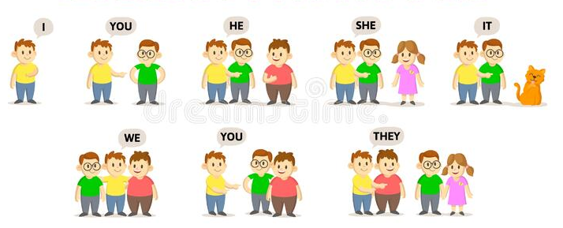

Exercise 4: Write THIS or THAT
1. ……………is a boy.     | 2. …………..is a ball.    
3. ……………is a blackboard.   | 4. …………..is a cat.  
5. ……………is a ruler.  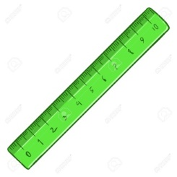 | 6. …………..is a pencil.  
Exercise 5: Read and match

a. Yes, they are.

1. Is this Linda?

b. They’re Peter and Mary.

2. Is that Tom?

c. Yes, it is Linda.

3. Who are they?

d. No, it isn’t. It is Tim.

4. Are they your friends?

Exercise 6: Reorder
1. is/ This/ friend/ my/.
=>
2. they/ Are/ friends/ your/?
=>
3. not/ they/ No,/ are/.
=>
4. that/ your/ friend/ Is/?
=>
Exercise 7: Fill in the blank with AM, IS, or ARE
1. Hello, I………………Hoa.
2. Hello Hoa, I…………Nga, and this………….Tuan.
3. Who…………that?
4. That……………..Dung.
5. ……………they your friends?
6. Yes, they……………
7. No, they……………not.
8. How old…………..she?
9. He…………..eight years old.
10. ……………..this Quang? – No, it………….not.
11. I…………..fine, thanks.
12. Mai and Lan……………..my friends.
13. That…………..my friend, Linda.
14. …………….they Hung and Trung?
15. No, they……………not.
16. My name …………….Huong.
17. His name ……………….Tim.
18. Her name…………………Susan.
19. How…………….you?
20. What…………..your name?

BÀI TẬP NÂNG CAO
Exercise 8: Circle the correct answer
1. Are you Hoa?
A. Yes, I do.  C. Yes, I am. | B. Yes, I am not.  D. Yes, she is.
2. Who’s that?
A. I’m Tim.  C. You are Tim. | B. It’s Tim.  D. Yes, it’s Tim.
3. What’s her name?
A. My name is Lan.  C. She is Lan. | B. His name is Hung.  D. She is my friend.
4. Are you a new student?
A. No, she’s not.  C. No, I’m not. | B. No, I am a new student.  D. Yes, I am a teacher.
5. Is this your friend?
A. Yes, it is.  C. She is fine, thanks. | B. It is Kelly.  D. This is my friend, Kelly.

Exercise 9: Fill in the blank with I, WE, YOU, THEY, SHE, HE or IT

1. Tom, Peter and I are reading books.  ……………are reading books.  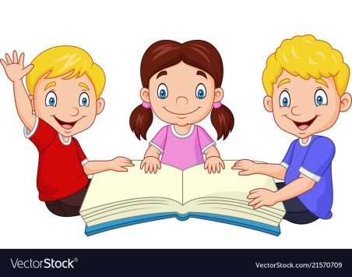 | 2. Hoa, Nga and you are jumping rope. …………….are jumping rope.  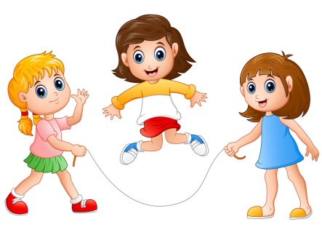
3. This bike is new. …………is new.  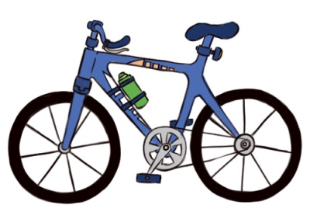 | 4. These pencils are beautiful. ………….are beautiful.  
5. Sally and David are dancing. ……………are dancing.  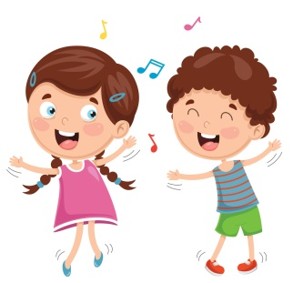 | 6. Tom is riding his bike. ……………..is riding his bike.  
7. Linda is going to read a book. ……………is going to read a book.   | 8. The bee is yellow and black. ……………is yellow and black.  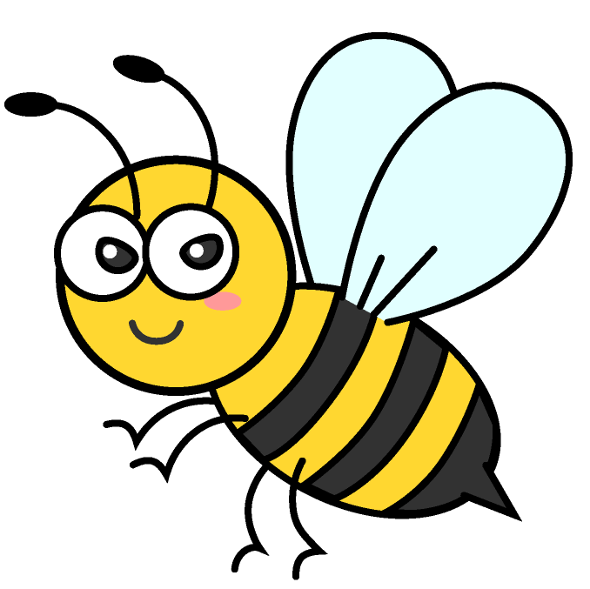

Exercise 10: Circle the odd one out
1. THEY:
A. Mike and Tim  C. Tim | B. The teachers  D. Mum and Dad
2. HE:
A. A Tim  B. Dad | C. Mum  D. Tom
3. SHE:
A. my sister  B. my brother | C. Mum  D. Hoa
4. IT:  A. My dog  B. A tiger | C. A banana  D. My friend
5. WE:
A. My mum and I  B. My friends and I | C. A friend and I  D. My friends

Exercise 11: Fill in the blank with AM, IS or ARE
1. The boys ………….playing football.
2. The apple………….red.
3. Hoa and I…………..friend.
4. My friends………….eight years old.
5. I……….Huy.
6. These dogs…………..cute.
7. Linh……………my good friend.
8. My friends…………….at home.
9. Peter, Tom and you……………..my friends.
10. David…………..at school.

Exercise 12: Write I, WE, YOU, THEY, HE, SHE or IT
1. the cat ……….. | 6. the banana …………..
2. David and Mary ………….. | 7. the boy …………..
3. Hoa and you …………… | 8. the girls ………….
4. my friend and I …………. | 9. my mother………….
5. Susan ……………… | 10. the children ………….

Name: …………………  Grade 3 | Unit 6: STAND UP!

BÀI TẬP CƠ BẢN

Exercise 1: Write he missing letter.
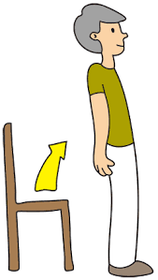 | 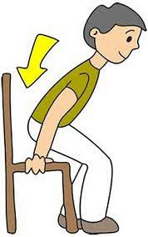 | 
1. S_A_D UP | 2. S_T DO_N | 3. _R_TE
 | 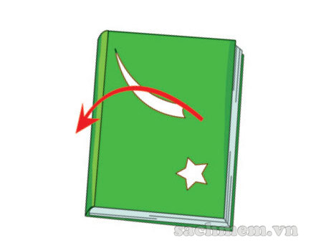 | 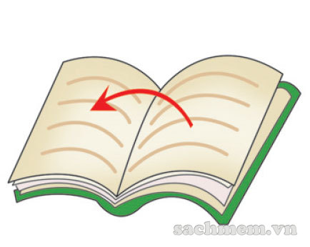
4. S_EA_ | 5. _ _ _ _ YOUR BOOK | 6. _ _ _ _ _ YOUR BOOK

Exercise 2: Fill the words.

STAND UP | COME IN | SIT DOWN | READ | WRITE
QUIET | SILENT | NOTEBOOK | OPEN | CLOSE

E | M | G | Q | U | S | Z | E | R | A | E | S | A | W | G
P | Y | T | O | C | T | I | F | E | N | E | V | O | N | O
Y | R | B | O | O | A | N | S | A | E | U | Q | K | O | O
W | O | R | P | A | N | K | W | D | A | R | U | L | T | D
C | O | M | E | I | D | M | O | N | O | H | I | Z | E | E
R | C | Z | N | E | U | U | W | R | I | T | E | C | B | C
D | S | O | H | O | P | G | O | R | H | V | T | W | O | L
G | O | S | I | T | D | O | W | N | N | O | O | N | O | O
M | K | B | T | Q | U | O | F | R | E | I | C | I | K | S
K | Q | E | V | O | G | S | I | L | E | N | T | M | Y | E

Exercise 3: Reorder.

1. may / , / sir / come / in / I /?
f
=>…………………………………………………………………………
2. book / Open / please. / your /,
gf fgf
=>…………………………………………………………………………
3. May / I / a / question / ask / you /?
gfgf f
=>…………………………………………………………………………
4. quiet / Be / , / please.
gfgf f
=>…………………………………………………………………………
5. out / May / I / go /?
gfgf f
=>…………………………………………………………………………
6. here / I / May / my / write / name /?
gfgf f
=>…………………………………………………………………………
7. not / No, / can / you /.
gfgf f
=>…………………………………………………………………………
8. Nam /, / here / Come /.
gfg ff
=>…………………………………………………………………………
9. is / that / Who /?
gfgf f
=>…………………………………………………………………………
10. is / name /her / What /?
gfg ff
=>…………………………………………………………………………

Exercise 4: Fill the blank.

1. May I ……………….. in, Miss Huong?
2. Close ……………….. book, please!
3. May I go ……………….., Mr Tuan?
4. Sit ……………….., please!
5. ……………….. up, please!
6. Yes, you ………………..
7. ………………. quiet, please!
8. ………………. I come in, Miss Lan?
9. No, you ……………….
10. Come here, ……………….!

Exercise 5: Circle the correct answer.

1. May I come in?
a. Yes, you can.
b. I can come in.
2. What's this?
a. Yes, it is.
b. It's a pen.
3. What color is this?
a. It's black.
b. It's a bag
4. Is this a book?
a. It's a pen.
b. No, it is not

Exercise 6. Read and match.

1. Sit |  | a. up, please.
2. Stand |  | b. your book, please.
3. Come |  | c. down, please.
4. Open |  | d. here, please.
5. Write |  | e. the board.
6. Clean |  | d. be late.
7. Do |  | e. on the board.
8. Don't |  | e. your homework.

BÀI TẬP NÂNG CAO

Exercise 7: Write.
sit down  clean the board  stand up | open your book  raise your hand  close your book | listen  close the door  take out your book

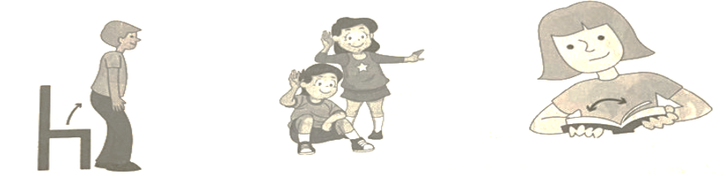
1. ………………….. | 2. ………………….. | 3. …………………..
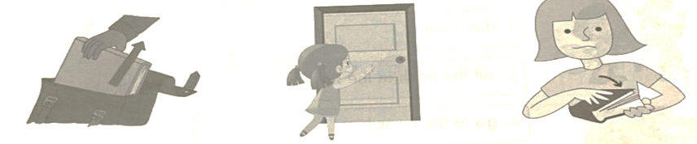
4. ………………….. | 5. ………………….. | 6. …………………..
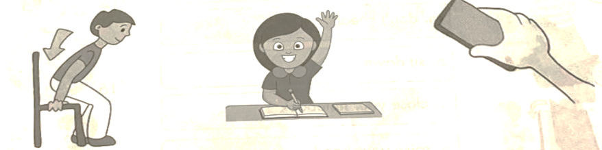
7. ………………….. | 8. ………………….. | 9. …………………..

Exercise 8: Reorder.
hh
1. noise / don't / make /.
dsdf
=>……………………………………………………………………
2. hands / clap / your /.
dsdf
=>……………………………………………………………………
3. the police / call / don't /.
dsdf
=>……………………………………………………………………
4. other / each / help /.
dsdf
=>……………………………………………………………………
5. to / the teacher / listen /.
dsdf
=>……………………………………………………………………
6. the classroom / keep / clean /.
dsdf
=>……………………………………………………………………
7. play / games / don't /.
dsdf
=>……………………………………………………………………
8. your / do / homework /.
dsdf
=>……………………………………………………………………
9. a / circle / draw /.
dsdf
=>……………………………………………………………………
10. talk / class / in / don't / the /.
dsdf
=>……………………………………………………………………

Exercise 8: Reorder.

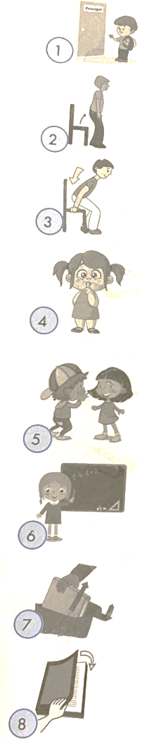 |  | 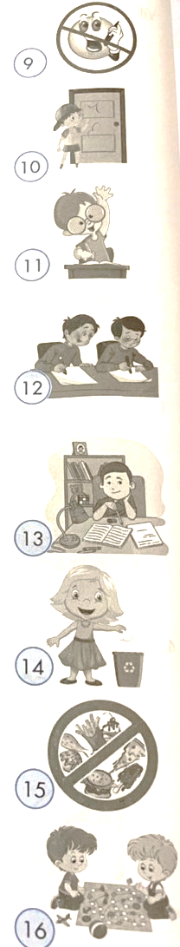
  a. do your homework
  b. be quiet!
  c. knock on the door
  d. stop chatting!
  e. take out your notebook
  f. let's play a game
  g. stand up
  h. go to the principal's office
  i. don't eat!
  j. put the trash in the bin
  k. go to the board
  l. put your mobile in your schoolbag
  m. don't cheat!
  n. sit down
  o. close your notebook
  p. raise your hand

Exercise 9: Look and complete the crossword.
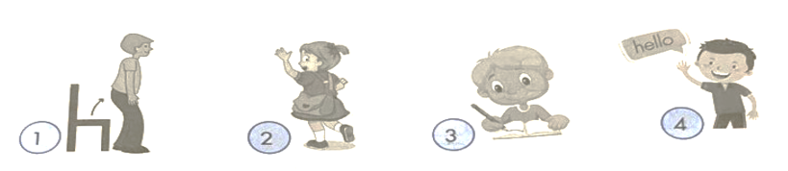
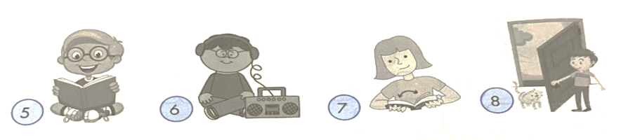
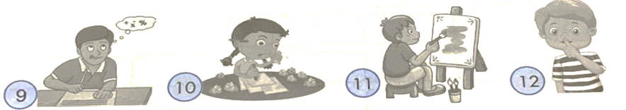
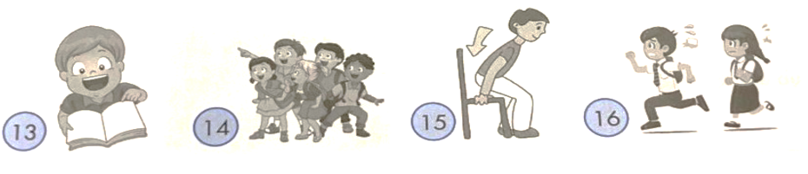

Name: …………………….  Grade 3 | UNIT 7: THAT’S MY SCHOOL

BÀI TẬP CƠ BẢN
Exercise 1: Write the missing letters.
 | 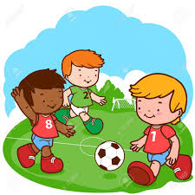 | 
dfhhd  1. L_ _ R R _  dfhhd | dfhhd  2. F_ _ T _ _ L L | dfhhd  3. _ _ MP _ T _ R _ _ M
 |  | 
dfhhd  4.C _ _ T _ _ N  dfhhd | dfhhd  5. M _ S_ _ R_ _ M | dfhhd  6. C _ A _ S _ _ OM

Exercise 2: Odd one out.
1. A. new B. big C.old D. school
2. A. classroom B. library C.schoolyard D. friend
3. A. small B. pencil C. ruler D. schoolbag
4. A. short B. pen C. new D. long
Exercise 3: Reorder the sentences to make a dialogue.
- It’s Le Loi school.
- Fine, thanks. And you?
- Oh, it’s big and nice. What’s its name?
- Good morning, Nam.
- That is my school.
- Good morning, Hoa. How are you?
- I’m OK. Thank you.
1………. 2……….. 3………. 4……… 5………… 6…………. 7…………..

Exercise 4: Read and match.
1. Good morning, class. |  |  |  | a. No, it isn’t. It’s Nam.
2. May I come in, sir? |  |  |  | b. Nice to meet you, too.
3. Is your school big? |  |  |  | c. Her name’s Bich.
4. Be quiet! |  |  |  | d. I’m eight years old.
5. What’s her name? |  |  |  | e. I’m sorry.
6. Nice to meet you, Hung. |  |  |  | f. Good morning, Miss Hoa.
7. How old are you, Lan? |  |  |  | g. Yes, you can.
8. Is that Tuan? |  |  |  | h. Yes, it’s big and nice.
1. | 2. | 3. | 4. | 5. | 6. | 7. | 8.
Wgw
Exercise 5: Fill the blank with IS, AM, ARE.
1. This………………… my new friend, Hoa.
2……………………….the gym big or small?
3. What…………………….his name?
4. How………………. you? - I…………….. fine, thank you.
5. I……………………… nine.
6. This…………….. my friend.
7. That………………. my school.
8. The classroom…………….. small but nice.
9………………… they your friends? - Yes, they………………
Exercise 6: Reorder the words.
1. is/ That/ classroom/ my/.
fjjd
……………………………………………………………………….
fjjd
2. It’s/ school/ Hung Vuong/ Primary/.
fjjd
……………………………………………………………………….
fjjd
3. school/ is/ and nice/ My/ big/.
fjjd
……………………………………………………………………….
fjjd
4. the/ playground/ Is/ large/? –is/ not/ it/ No/.
fjjd
……………………………………………………………………….
fjjd
5. go/ I/ every/ to/ school/ day/ .
fjjd
……………………………………………………………………….

Exercise 7: Reorder.
1. SCALSC …………....... |  | 2. SALML …….……………  hddfh
3. GBI …………….. |  | 4. AGLER …………….……  hddfh
5. EWN …………….. |  | 6. LOD …………………  hddfh
7. LBRIAYR ……………..  hddfh |  | 8. EUBTALIUF ……….…………  hddfh
9. CISUM ……………… |  | 10.TRA ………………….  hddfh

BÀI TẬP NÂNG CAO
Exercise : Write the numbers.
1. classroom | 2. Hallway | 3. Library | 4. Computeroom
5. Music room | 6. Art room | 7. Nurse’s office | 8.Science room
9. Canteen | 9. Canteen | 10. Toilet

A.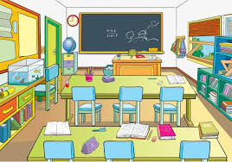 | B. | C.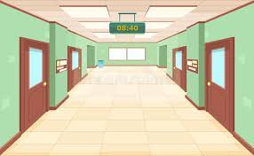
D. | E. | F.
G.  | H. 

Exercise 9: Circle the correct answer.
1. Tim: Is that the classroom? Hoa:……………………….
sgssg
A. Yes, it is.  C. Yes, it is the schoolyard. | B. No, it isn’t.  D. The classroom is big.  sgssg
2. Peter: Who is this? Mary:……………………………..
sgssg
A. It is a pencil.  C. It is my brother, Tim  sgssg | B. Yes it is my brother.  D. My brother, Tim, is tall.  sgssg
3. Tim: is the library new? Mary:………………………..
sgssg
A. No, it is new.  C. Yes, it is old.  sgssg | B. No, it isn’t. It is old.  D. The library is new.  sgssg
4. Tom: What is this? Bill:……………………………..
sgssg
A. It is a pencil.  C. It is my brother.  sgssg | B. This is my friend.  D. Yes, it is my school.  sgssg
5. Lisa: Is that your classroom? Jack:…………………………..
sgssg
A. That’s the classroom.  C. No it isn’t. It’s Tom’s classroom.  sgssg | B. Yes, it is your classroom.  D. Your classroom is large.  sgssg

Exercise 10: Choose the correct answers.
1. toilet | 2. canteen | 3. computer room | 4. Classroom
5. science room | 6. playground | 7. Library

a. I read book. At the……………………………….
b. I learn to type. At the…………………………….
c. I learn science. At the…………………………….
d. I play game. At the……………………………….
e. I eat lunch. At the…………………………………
f. I practise English. At the………………………….
g. I go to the bathroom. At the………………………

Name: ………………  Grade 3 | Unit 8: THIS IS MY PEN
BÀI TẬP CƠ BẢN
Exercise 1: Write the missing letters.
 |  |  |  |  |  | 
1.B _ A _ D |  | 2.P_ _ |  | 3.B _ _ K |  | 4. _ CH _ _ L
 |  |  |  | 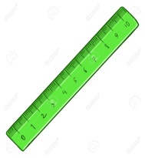 |  | 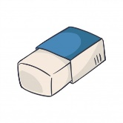
5.SC _ O _ LB _ G |  | 6. _ EN _ I _ |  | 7.R _ _ E _ |  | 8. R _ B _ _ R
Exercise 2: Look and write

 | - This is my…………………………
 | - That is my………………………
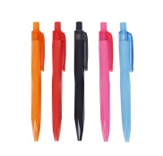 | - These are my…………………………
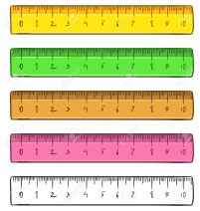 | - Those are my………………………

Exercise 3: Find 9 school things.

S | H | A | R | P | E | N | E | R | A  b |  | …………………………  …………………………  …………………………  …………………………  …………………………  ………………………….
C | E | G | A | D | E | S | K | R | D  b
I | D | L | O | K | S | Y | P | U  b | E
S | S | U | P | R | I | P | S | L | R  b
S | O | E | R | A | S | E | R | E  b | A
O | D | N | V | S | O | N | A | R | S  b
R | E | A | B | E | B | O | O | K  b | L
S | C | R | A | Y | O | N | K | E | R  b

Exercise 4: Reorder.
  1. epciln => p…………………… | 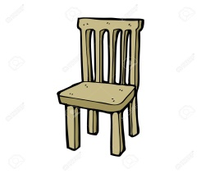  2. rahci => c……………………….
  3. burbre => r……………………. |   4. lurre => r………………………
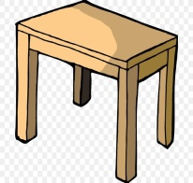  5. atleb => t…………………… |   6. okob => b…………………...
  7. siscsros => s………………….. |   8. mpocture =>…………………..

Exercise 5: Match.
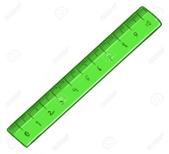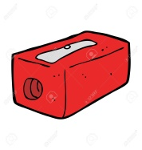
1 2 3 4 5
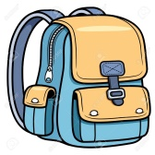
6 7 8 9 10
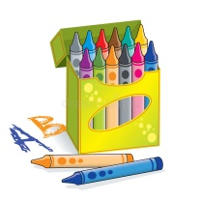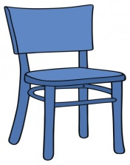
11 12 13 14

CHAIR | PEN | PENCIL CASE  ffh  b
RUBBER | SCISSORS | CRAYONS  ffh
NOTEBOOK | SCHOOLBAG | PENCIL  ffh
GLUE | PENCIL SHARPENER | BOOK  ffh
BOARD | RULER | ffh

Exercise 6: Read and fill in the blank.
ffh
They books That schoolbag new

ffh
This is my (1)………………….It is new. (2)………………..is my pencil sharpener. These are my pencils. (3)……………….are short. Those are my (4)……………..They are (5)…………………
fgdgg
BÀI TẬP NÂNG CAO
Exercise 7. Underline the mistake and correct.
1. These are my pens. It are very new.
=> ………………………………………………………………………………
2. She ruler is very long.
=> ………………………………………………………………………………
3. Are those your pencil?
=> ………………………………………………………………………………
4. That is he book.
=> ………………………………………………………………………………
5. Is this your erasers?
=> ………………………………………………………………………………
fgdgg
Exercise 8. Reorder.
1. is/ ruler/ my/ This/.
=> ………………………………………………………………………………
2. That/ your/ pencil case/ is/.
=> ………………………………………………………………………………
3. are/ These/ notebooks/ my/.
=> ………………………………………………………………………………
4. his/ are/ Those/ pens/.
=> ………………………………………………………………………………
5. those/ Hoa’s/ books/ Are/ ?
=> ………………………………………………………………………………
fgdgg
Exercise 9: Complete the dialogue with the given cues.
A.Is it new | B. here are my school things | C. It’s long
D. I also like it | E. Are those rubbers small?
Lan: Trung, (1)………………………………….
Trung: You have so many school things. Look! Is this your ruler?
Lan: Yes, it is. See! (2)…………………………..
Trung: And it’s very nice. What’s this?
Lan: It’s my notebook.
Trung: (3)…………………………..?
Lan: No, it’s old. And these are my rubbers.
Trung: (4)……………………………
Lan: Yes, they are. And here is my schoolbag.
Trung: Your schoolbag is very large. I like it.
Lan: (5)………………………………
hfh
Exercise 10: Fill in the blanks with the words below.
my your his her its our their
1.The girl likes…………….…school.
2. Tim meets…………….……friends.
3. I forget…………………..books.
4. We bring………………..crayons to class.
5. The man sees………………………friends every week.
6. You should talk to………………….mother.
7. They love……………………..school.
8. The bird sleeps in……………………….nest.
fgdgg
Exercise 11: Circle the correct answer.
1. (This/ These) are pretty dolls. | 5. (Those/ That) red car is my father’s.
2. (That/ Those) is my sister. | 6. (These/ This) pencils are new.
3. (This/ These) is a beautiful school. | 7. (That/ Those) house is new.
4. (These/ This) are my books. | 8. (That/ Those) flowers are for you.
fgdg
Exercise 12. Make these nouns plural.
ccdzz
1.cat => | 6. glass =>
2. book => | 7. boy =>
3. potato => | 8. shoe =>
4. ice cream => | 9. witch =>
5. dish => | 10. chair =>
gdgg
Exercise 13. Make these sentences plural.
ccdzz
1. This mouse is grey. | => ……………………………………………  hfh
2. That child is very lovely. | => ……………………………………………  hfh hf
3. This is my apple. | => ……………………………………………  hfh
4. That is her pencil | => ……………………………………………  hfh
5. That banana is sweet and yellow. | => ……………………………………………  hfh
6. That baby is crying. | => ……………………………………………  hfh
7. This brush is pink. | => ……………………………………………  ccdzz

Name: ……………………….  Grade 3 | UNIT 9: WHAT COLOR IS IT?
BÀI TẬP VẬN DỤNG CƠ BẢN
Exercise 1: Look and answer.
 | 1.What color is it?  ………………………………………………………………..
 | 1.What color is it?  ………………………………………………………………..
 | 1.What color is it?  ………………………………………………………………..
 | 1.What color is it?  ………………………………………………………………..
 | 1.What color is it?  ………………………………………………………………..
 | 1.What color is it?  ………………………………………………………………..
 | 1.What color is it?  ………………………………………………………………..
 | 1.What color is it?  ………………………………………………………………..
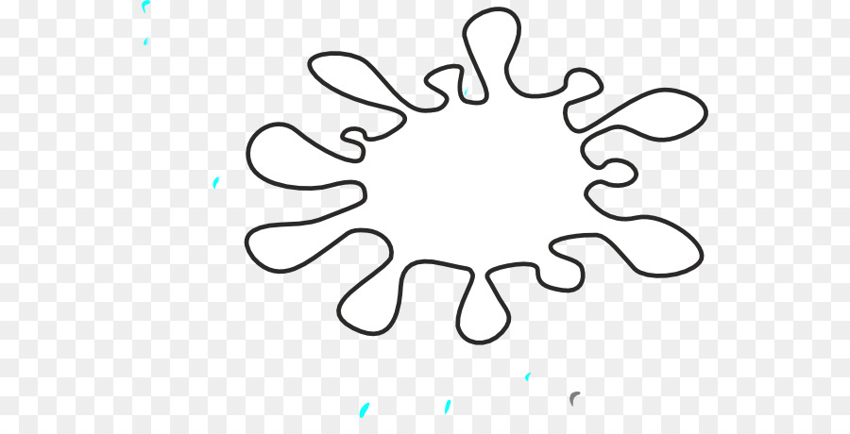 | 1.What color is it?  ………………………………………………………………..

Exercise 2: Look and write.
1.What are they?  =>……………………………………………  What color are they?  =>…………………………………………… | 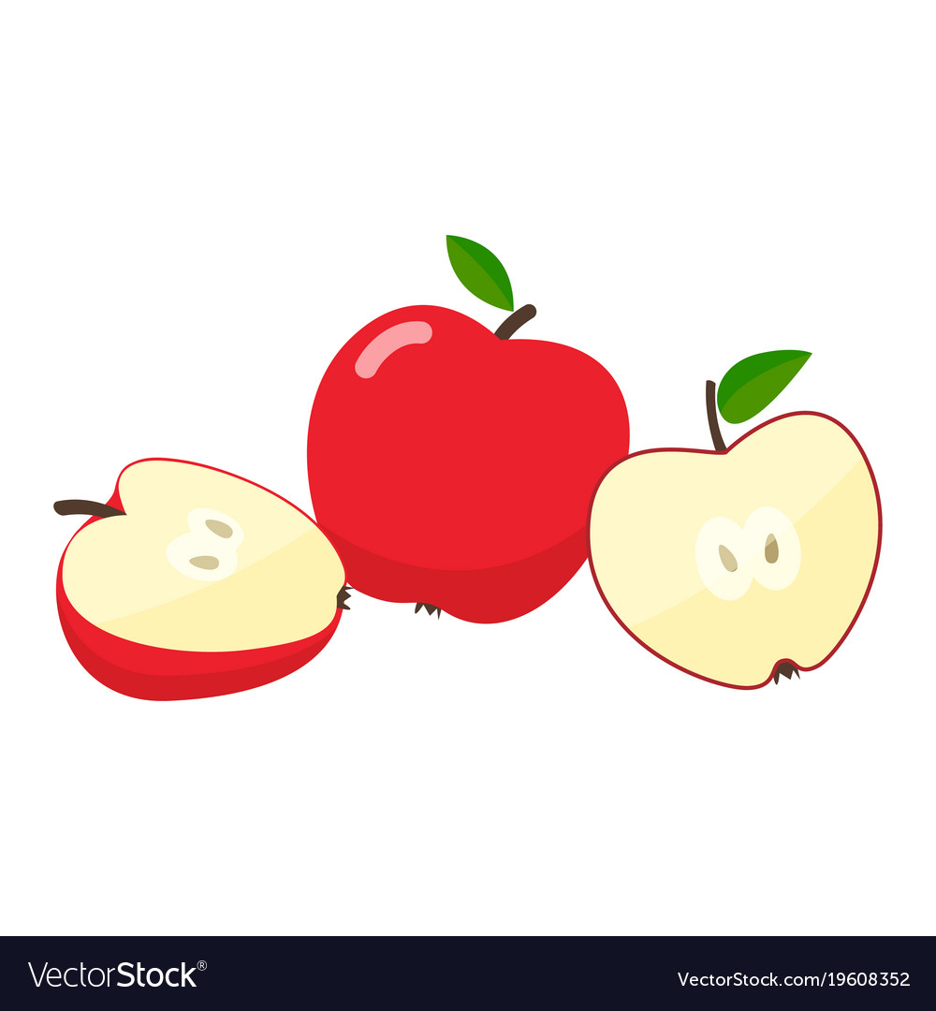
2.What are they?  =>……………………………………………  What color are they?  =>…………………………………………… | 
3.What are they?  =>……………………………………………  What color are they?  =>…………………………………………… | 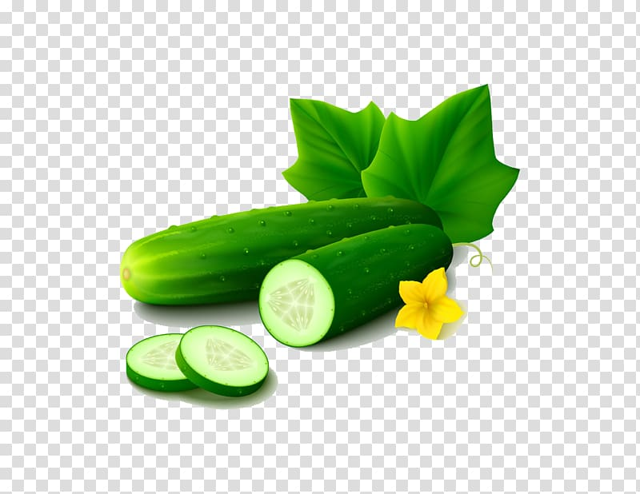
4.What are they?  =>……………………………………………  What color are they?  =>…………………………………………… | 
5.What are they?  =>……………………………………………  What color are they?  =>…………………………………………… | 

Exercise 3: Look and complete.
- 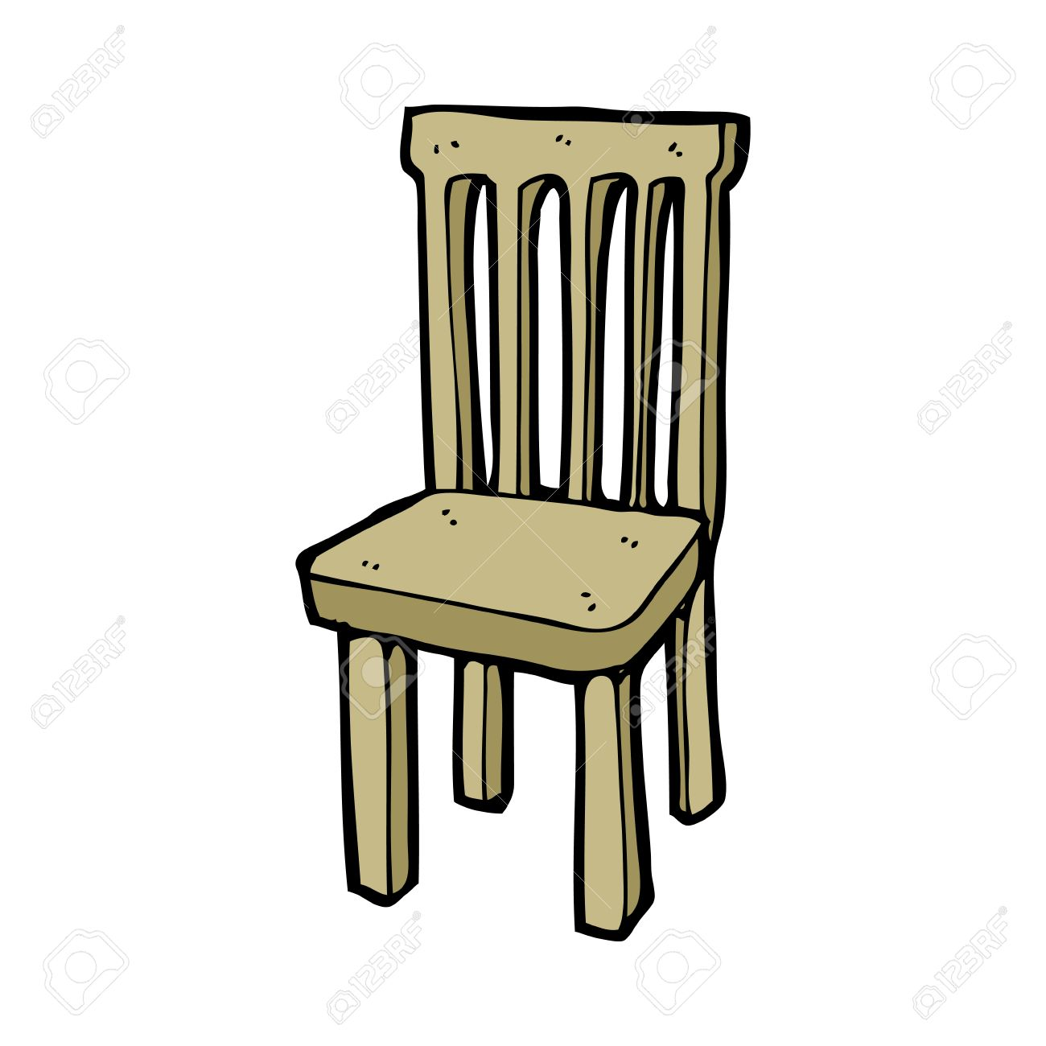 | - C………………………...…..
2. 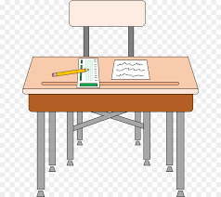 | - D…………………………...
3.  | - B………………….
4. 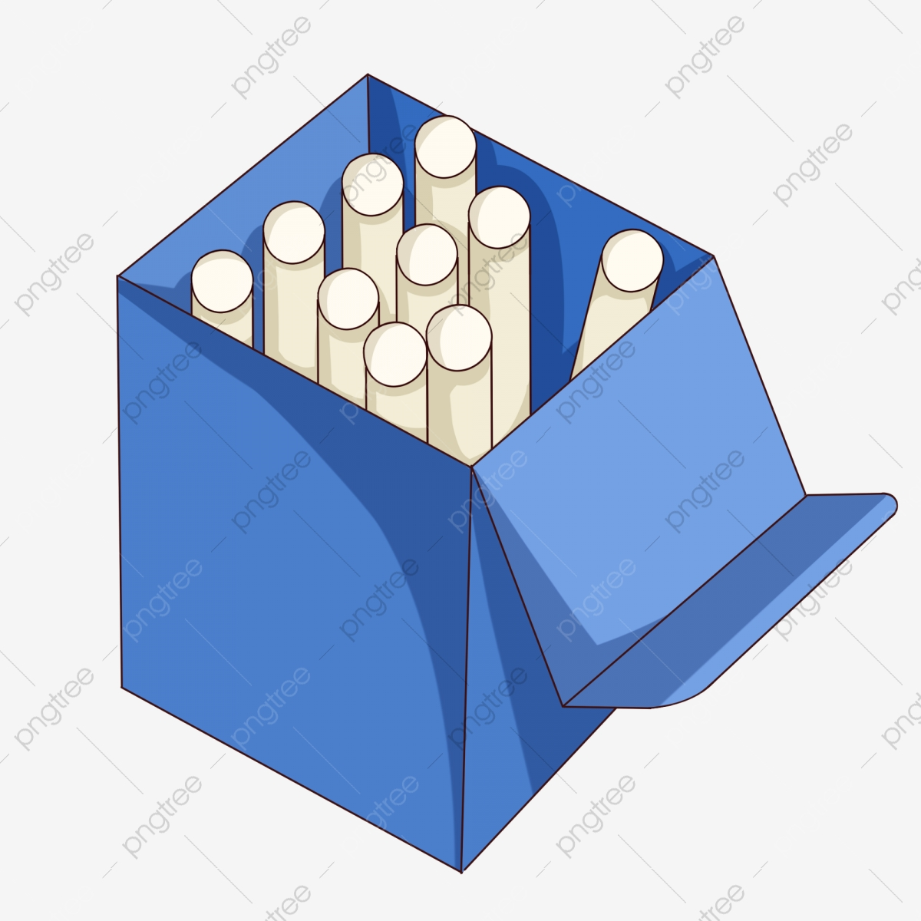 | - C………………….
5.  | - B…………………

Exercise 4: Match, color and write sentences.
1
a brown book

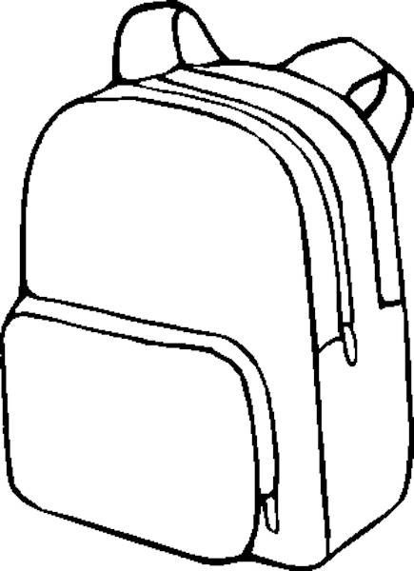 | an orange pencil case | 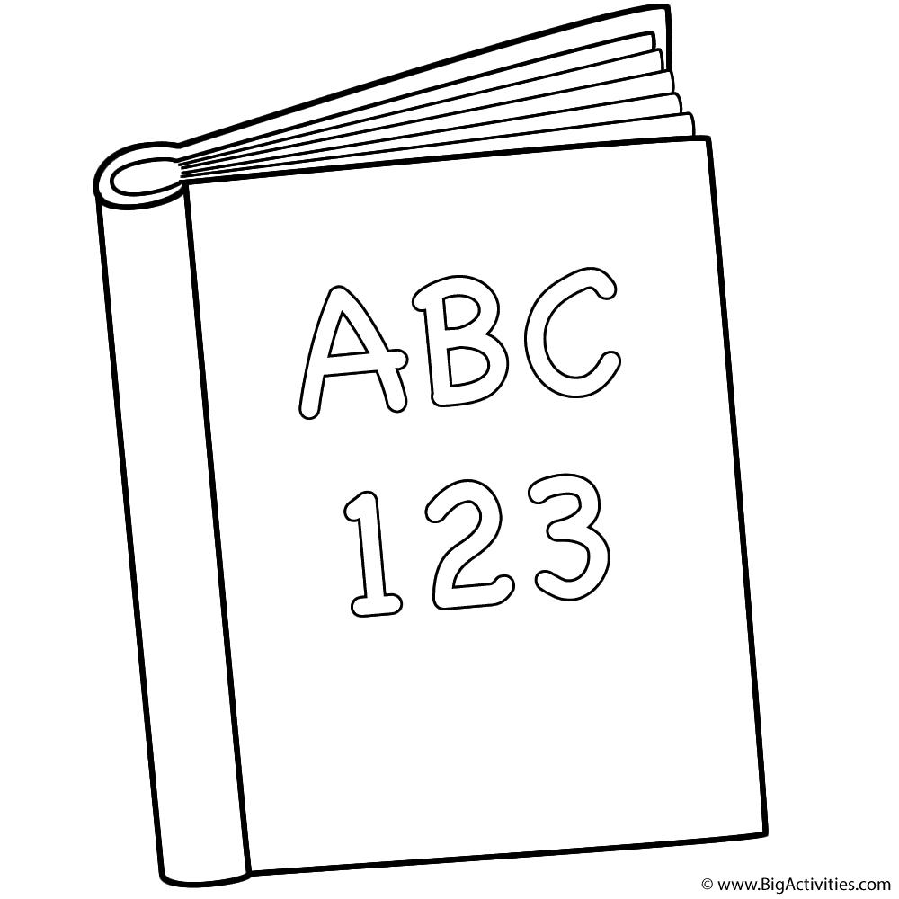  2
3  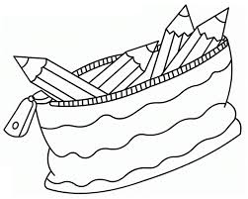 | a purple school bag  a pink notebook | 4  

1.It is a…………………………………………………………………………………….
2…………………………………………………………………………………………..
3…………………………………………………………………………………………..
4…………………………………………………………………………………………..
Exercise 5: Color.
THE LION IS BROWN THE SNAKE IS GREEN
THE TIGER IS YELLOW AND BLACK THE DOG IS BROWN
THE HIPPO IS GREY THE ELEPHANT IS GREY
THE TURTLE IS GREEN AND BROWN THE CAT IS ORANGE
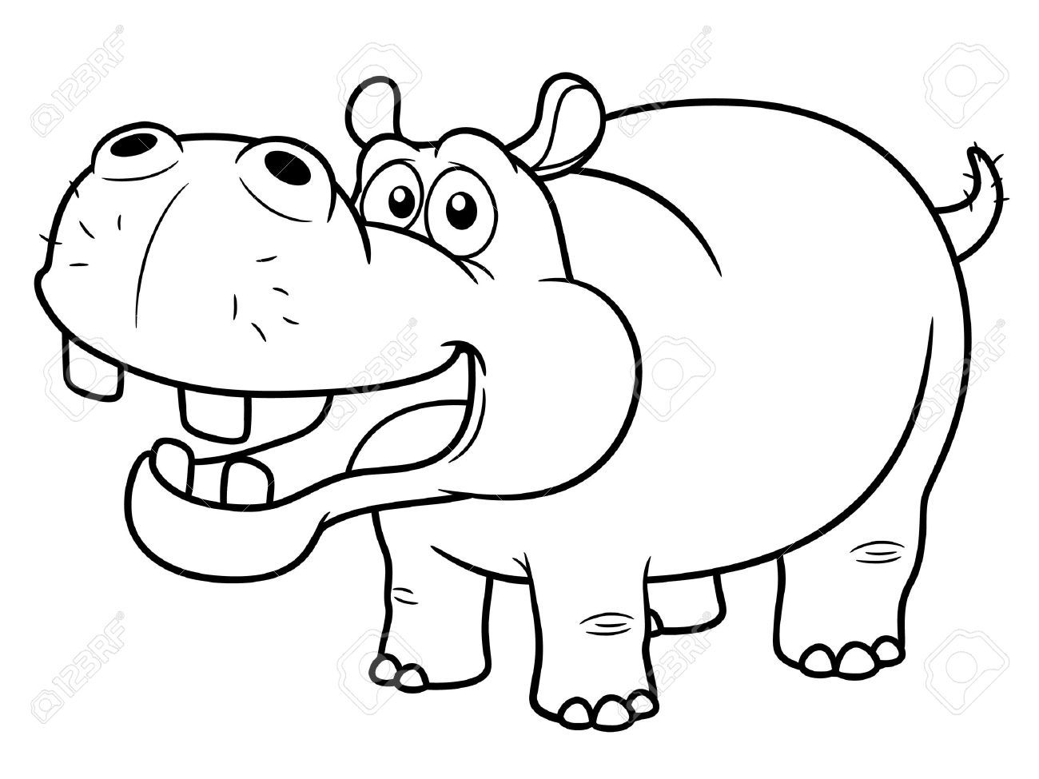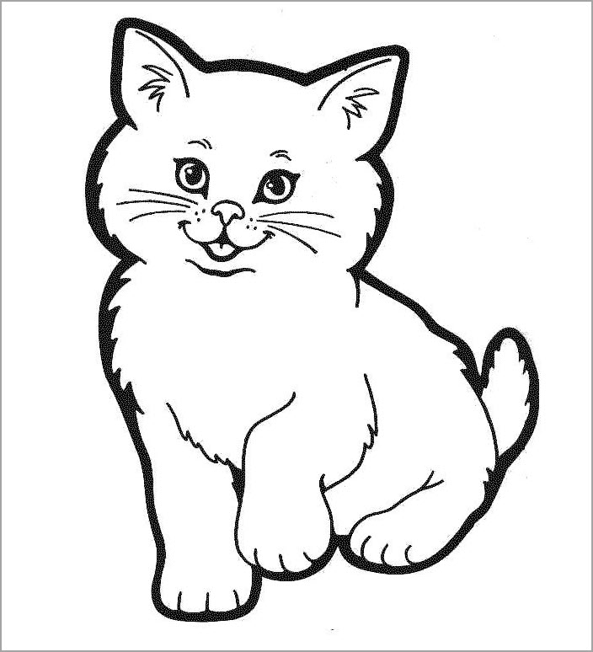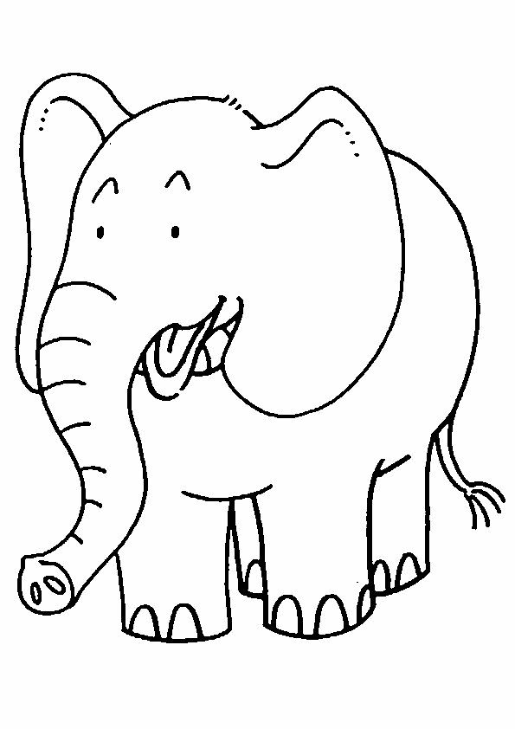
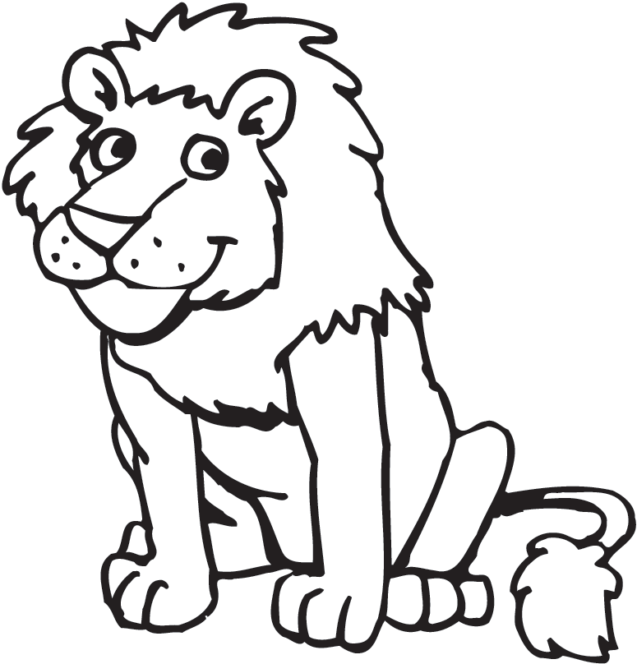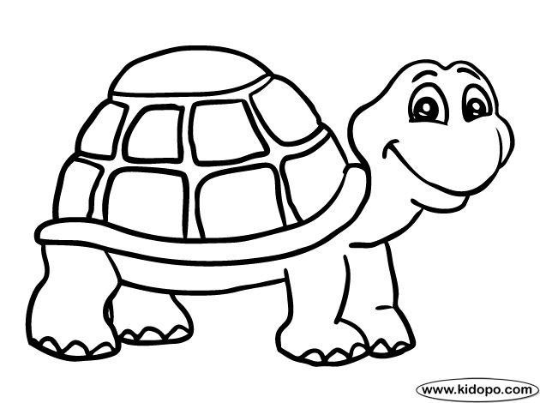
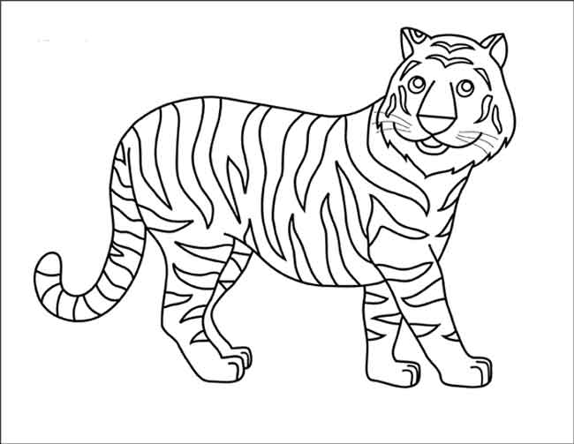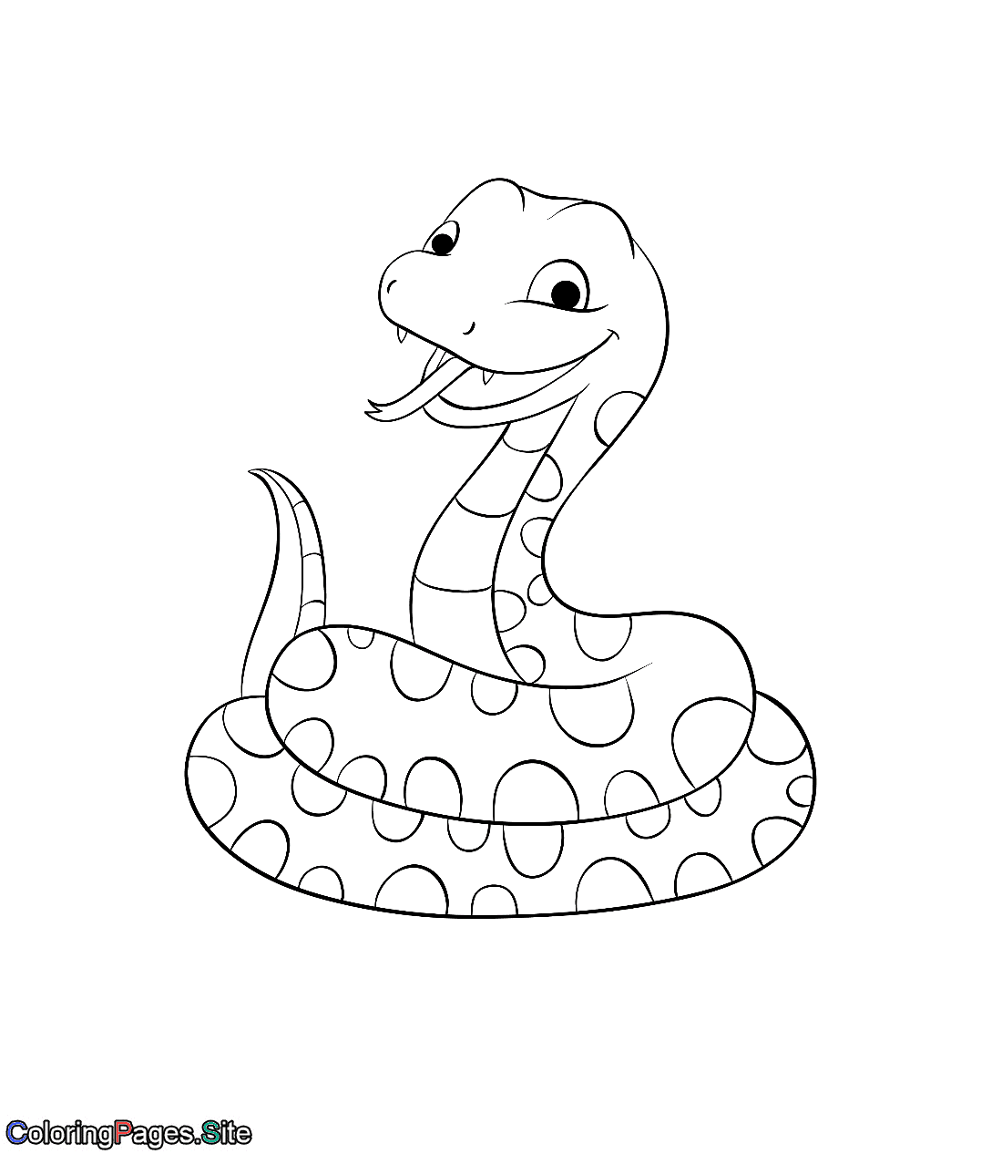
BÀI TẬP NÂNG CAO
Exercise 6: Odd one out.
1. A. black B. grey C. purple D. color
2. A. what B. long C. how D. who
3. A. small B. big C. brown D. large
4. A. he B. my C. she D. they
5. A. white B. crayon C. table D. computer
Exercise 7: Circle the correct answer.
1.What color is this bag?
A. It’s my bag. B. It’s blue.
C. It’s nice D. This is a small bag.
2. Are those blue pens?
A. Those are blue pens. B. They are my blue pens.
C. Yes, they are D. Yes, it is.
3. Who is that?
A. She is my friend, Hoa. B. Yes, it is.
C. It is a white eraser. D. My school is big.
4. What is your school’s name?
A. It is a big and nice. B. It is blue.
C. It is my school. D. It is Tran Hung Dao Primary School.
Exercise 8: Read and match.
a.It’s black and brown.
1.What colour are your pens?
b. It’s big.
2. How old is she?

c. No, it isn’t.
3. Are those her rulers?

d. His name is Hung.
4. May I write, sir?

e. She’s nine.
5. What colour is your bag?
f. Yes, they are.
6. What’s his name?

g. No, you can’t
7. Is your classroom big or small?

h. They are green and white.
8. Is this your desk?

1………..2……….3………..4………..5…………6………..7…………8…………
Exercise 9: Reorder.
1.notebook / Is / your / this /?
=>……………………………………………………………………………………
2. colour / What / pen / is / your /?
=>……………………………………………………………………………………
3. are / These / rulers / your /.
=>……………………………………………………………………………………
4. What / are / your pencil sharpeners / colour /?
=>……………………………………………………………………………………

5. is / rubber? / What / colour / your /
=>……………………………………………………………………………………
Exercise 10: Circle the correct answer.
1. They are my ……………………… . ( friend/ pen/ rulers/ rubber)
2. ……………………… is my bookcase. ( They/ Those/ These/ This)
3. Those……………………… my pencils. ( is/ am/ are/ do)
4. What colour ……………………… your book, Nam? ( is/ am/ are/ do)
5. What colour ……………………… your pens? ( is/ am/ are/ do)
6. Is ……………………… your desk? ( those/ these/ that/ they )
7. What colour ……………………… they? ( is/ am/ are/ do)
8. The bookcase is ……………………… . (seven/ colour/ orange/ not)
9. ……………………… are her rulers. ( This/ That/ Those/ It)
10. Is the gym ………………………? (stand/ large/ sit/ come)
11. May I ……………………… down? ( stand/ come/ ask/ sit)
12. ……………………… to meet you. ( Nine/ Nice/ Night/ Knife)
13. How do you spell ……………………… name? (you/ your/ they/ she)
14. May I go out? – No, you ………………………( can/ aren’t/ isn’t/ can’t)
15. How old are you? - ……… (Fine, thanks/ I’m fine,thanks/ I’m nine, thank you)
16. My school is big and ……………………… (stand/ new/ up/ sit)
17. The ……………………… are blue. (pen/ pencil/ bookcase/ rulers)
18. ……………………… is my notebook. (They/ She / He / It)
19. What ……………… are her books? – They are brown. (old/ this/ name/ colour)
20. Are they your ………………………? (friend/ pen/ pencil/ friends)

Name: …………………  Grade 3 | Unit 10: WHAT DO YOU DO AT BREAK TIME?

BÀI TẬP CƠ BẢN

Exercise 1: Write he missing letters.

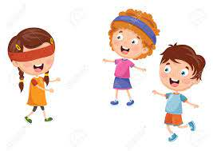 | 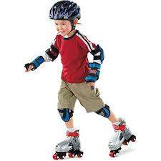 | 
  1.BL_N_M_N’S B_FF | 2. S_A_ _NG   | 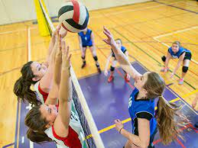  3. T_N_I_
4. B_SK_TB_LL  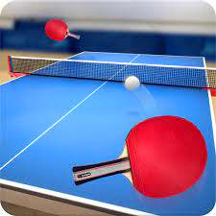 | 5.CO_P_T_R GA_ES   | 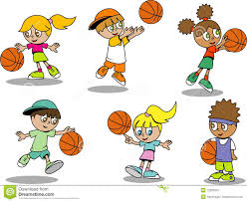  6. V_ _LE_ BA_L
7. T_B_ E T_ _NICS  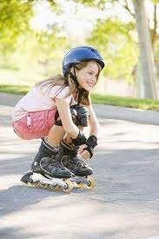  10. ROL_ER_L_DI_G  Exercise 2: Look and write. | 8.SW_M_ _N_ | 9. _A_K_T_ _LL
hfh
1) We play ……………………………… | 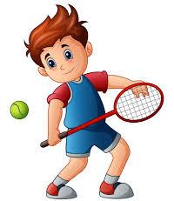
2) My friend and I play…………………. | 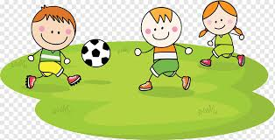
3) I like …………………………………. | 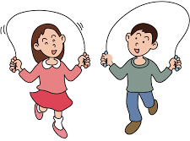
4) My friend and I like ………………….. | 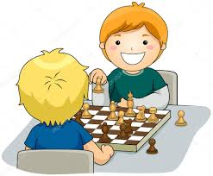

Exercise 3: Odd one out.
1) | A. tennis | B. football | C. sports | D. badminton
2) | A. ball | B. football | C. table tennis | D. volleyball
3) | A. play | B. read | C. swim | D. book
4) | A. cat | B. do | C. mouse | D. dog

Exercise 4: Fill in the blank.

like What do play don’t

Dung: (1) ………………….do you do at break time?
ggg
Nam: I (2)……………………blind man’s bluff.
ggg
Dung: Do you (3)………………………..it?
ggg
Nam: Yes, I (4) …………………………………..
ggg
Dung: Do you like hide- and – seek.
ggg
Nam: No, I (5)…………………………………….

BÀI TẬP NÂNG CAO

Exercise 5. Look and circle the correct answer.

- A. He likes playing with a yoyo.
B. He likes going swimming
C. They like playing volleyball.
D. They like playing chess.
2) A. Hung likes playing badminton, playing hide-and- seek, skipping rope and football.  B. Hung likes playing hide- and- seek, playing tennis and skipping rope.  C. Hung doesn’t like playing badminton and tennis.  D. Hung doesn’t like playing hide- and- seek and skipping rope. | 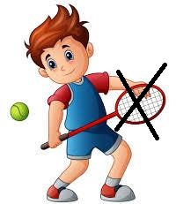
3) A. She likes playing soccer.  B. She likes flying kite.  C. She likes playing golf.  D. She likes playing tennis. | 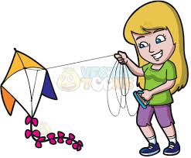
4) A. He doesn’t playing badminton.  B. He likes playing chess.  C. He likes playing volleyball and hide – and – seek.  D. He doesn’t like playing tennis and badminton. | 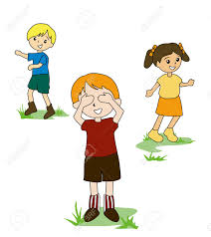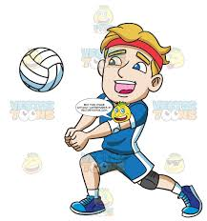

Exercise 6. Read and match.
- like ?
- Let’s

- What do you do
b) play chess

c) I don’t
- Do you like

d) hide- and – seek?
- What do you
- No,

e) in your free time?

Exercise 7. Reorder.
- Do/ table tennis/ like/ you ?
…………………………………………………………………………...
- play/ at/ I/ badminton/ break time.
…………………………………………………………………………...
- break time/ does/ play/ at/ she/ What ?
…………………………………………………………………………...

- at/ play/ break time/ hide- and – seek/ They/.
…………………………………………………………………………...
- skating/ He/ likes.
…………………………………………………………………………...

Exercise 8. Write question for the underline part.

- That’s the playground
ggg
………………………………………………………………………….......

- Yes, I do. I like playing chess.
ggg
………………………………………………………………………….......
- It is blue.

………………………………………………………………………….......
- No, it is not. The library is new.

………………………………………………………………………….......
- I play football at break time.

………………………………………………………………………….......

Exercise 9. Circle the correct answer.

- I………….. playing chess and my friend ……………playing football.

A.like – likes B. like – like C. likes – like D. likes – likes

- Do you like playing …………………….a yo-yo, Nga?

A. for B. with C. to D. of

- What …………….you do at break time? - I …………….soccer.

A. do – plays B. does – plays C. do –play D. does – play

- Let’s ……………………..swimming!

A. does B. do C. play D. go

- She…………………..reading books at break time.

A. like B. likes C. do D. does

