Name:………………..  Grade 3 | Unit 11: THIS IS MY FAMILY.

BÀI TẬP CƠ BẢN

Exercise 1: Write he missing letter.
 |  | 
1.F _M_ L _ | 2. F_T_ER | 3. _IST_R
 |  | 
4. A_N_ | 5. B_B_ | 6. GR_N_PAR_N_S
 | 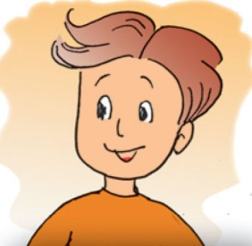
7. PA_E_TS | 8. B_O_HE_

Exercise 2: Fill the words.
son
sister
Mom
brother

grandma
grandpa
dad

D | A | D | A | S | D | E | F | Q | W
Z | X | C | G | R | A | N | D | M | A
V | B | M | N | M | Q | W | E | R | T
S | Y | O | B | R | O | T | H | E | R
O | U | M | A | S | I | S | T | E | R
N | I | O | P | A | S | D | F | G | H
N | G | R | A | N | D | P | A | P | Q

Exercise 3: Look and Write.
1. My ……….……………………is sixty-six years old. | 
2. My ……………………..……is sixty-two years old. | 
3. My …………………..is forty-four years old. | 
4. My …………………..is forty years old. | 
5. My …………………..is four years old. | 
Exercise 4: Fill the blank.

nice | she | mother | forty | Who

Tom: | (1)………………..is that, Mary?  fdfdf
Mary: | She is my (2)…………………….  fdfdf
Tom: | How old is (3)………………….?  fdfdf
Mary: | She is (4)…………………..years old.  fdfdf
Tom: | She look young and (5)…………………..  fdfdf
Mary: | Thank you.

Exercise 5: Look and write.
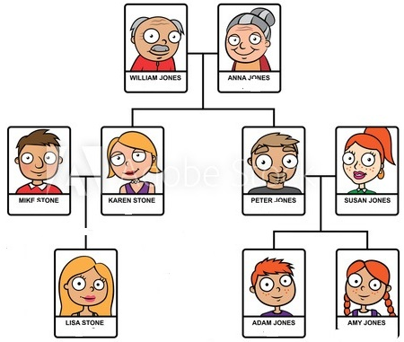

niece | parents | grandmother | Husband  cccnn
grandfather | cousin | daughter | Father  cccnn
mother | wife | sister | Uncle  cccnn

1. Susan is Amy’s ………………………………………………………
cccnn
2. William is Adam’s ……………………………………………………
cccnn
3. Mike is Amy’s ………………………………………………………..
cccnn
4. Anna is Amy’s………………………………………………………...
cccnn
5. Amy is Adam’s …………………………………………………………
cccnn
6. Mike is Karen’s ………………………………………………………..
cccnn
7. Lisa is Amy’s …………………………………………………………..
cccnn
8. Lisa is Susan’s …………………………………………………………
cccnn
9. Peter is Adam’s……………………………………………………….
cccnn
10. Susan is William’s …………………………………………………..
cccnn
11. Susan is Peter’s ……………………………………………………..
cccnn
12. Karen and Mike are Lisa’s……………………………………………

Exercise 6: Read and match.

1. This is | a. is your mother?  cccnn
2. How old | b. young.  cccnn
3. My father is | c. years old.  cccnn
4. My sister is five | d. my grandmother.  cccnn

1……….. 2………. 3……… 4……….

BÀI TẬP NÂNG CAO
cccnn
Exercise 7: Find the words.
Cccnn
grandfather, sister, uncle, wife, aunt, brother, cousin, father,

niece, grandmother, husband, mother, nephew

Y | P | F | C | X | M | L | R | H | I | N | L | A | W | S
O | Z | W | A | O | T | E | E | H | U | I | T | Z | W | H
E | D | Y | K | T | T | W | H | M | S | S | L | L | V | I
N | B | D | X | S | H | U | K | L | K | D | B | E | Z | B
C | R | T | I | K | D | E | E | C | R | Q | R | A | O | W
Q | O | S | R | C | L | J | R | V | B | E | R | Q | N | G
Q | T | J | J | J | Y | N | E | P | H | E | W | R | D | D
P | H | W | G | E | S | K | D | T | F | X | E | A | E | A
P | E | P | U | K | H | A | A | O | W | H | A | F | Q | X
Y | R | I | O | T | R | F | O | E | T | W | I | T | C | N
G | K | S | N | E | D | J | L | O | A | W | F | S | P | I
B | C | U | H | N | O | O | M | K | E | U | Q | G | Z | E
S | A | T | A | D | E | D | G | E | L | R | N | G | J | C
N | O | R | P | B | N | M | B | J | L | J | W | C | U | E
M | G | B | C | A | A | R | V | R | J | R |  | S | L | P
J | O | U | R | M | C | O | U | S | I | N | B | Q | N | E
K | X | G | E | A | N | N | L | O | Z | R | U | U | Y | T

Exercise 8: Reorder.
nff
1. woman / is / that / Who / ?
nff
=>………………………………………………………………………….
2. is / that / grandmother / my /.
nff
=>………………………………………………………………………….
3. my / is / young / mother /.
nff
=>………………………………………………………………………….
4. old / your / How / is / father / ?
nff
=>………………………………………………………………………….
5. sister / old / my / thirteen / is / years /.
nff
=>………………………………………………………………………….

Exercise 9: Write the questions for the underlined part.
nff
1. He is ten years old.
nff
=>………………………………………………………………………….
2. She is my sister.
nff
=>………………………………………………………………………….
3. Nam plays football at break time.
nff
=>………………………………………………………………………….
4. Her name is Huyen.
nff
=>………………………………………………………………………….
5. No, She isn’t. She is short.
nff
=>………………………………………………………………………….

Exercise 10: Fill in the blank with ONE word.
nff
1. My grandparents’ son is my ………………………………………………
nff
2. My parents’ daughter is my………………………………………………..
nff
3. My father’s / mother’s moher is my ………………………………………
nff
4. My father’s wife is my ……………………………………………………
nff
5. My mother’s nephew / niece is my ………………………………………

6. My father’s brother is my ………………………………………………..
nff
7. My mother’s sister is my ……………………………………………….
nff
8. My father’s son is my …………………………………………………
nff
9. My brother’s son is my ……………………………………………….
nff
10. My brother’s daughter is my ………………………………………..

Exercise 11: Circle the correct answer.

1. Let’s ……………………………a song.
sds
- Singing | B. sing | C. sings | D. to sing  sds
2. What does he do in……………………………
sds
- his | - my | C. your | D. he  sds
3. Don’t ………………………….noise, please.
sds
- do | - be | C. talk | D. make  sds
4. These pens ……………………………..brown.
sds
- is | - are | C. do | D. does  sds
5. …………………….is that? - She’s my mother.
sds
- How | - How old | C. Who | D. What  sds
6. What color are those pencils? - …………..……are black and yellow.
sds
- This | - She | C. They | D. I  sds
7. She likes ………………….TV.
sds
- watching | - to watching | C. watch | D. watches  sds
8…………………………..Hoa like basketball?
sds
- Do | - is | C. Does | D. Are

Name: ………………  Grade 5 | Unit 12: WHAT DOES YOUR FATHER DO?
BÀI TẬP CƠ BẢN

Exercise 1: Write the missing letter

 |  | 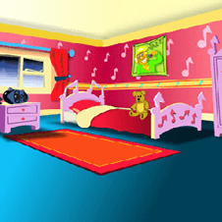
đg  1. H.......................... | đg  2. L .......................... | đg  3. B ..........................
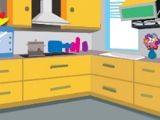 | 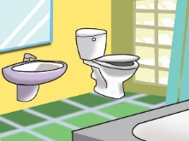 | 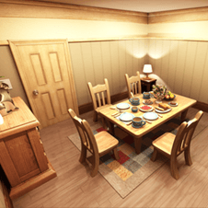
4. K .......................... | 5. B .......................... | 6. D ..........................
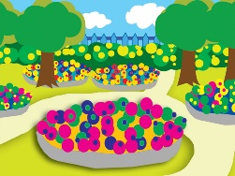 | 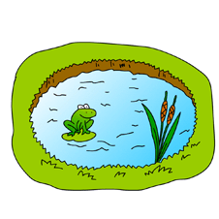 | 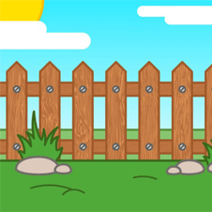
7. G .......................... | 8. P .......................... | 9. F ..........................

Exercise 2: Read and match

- This is my | - over there
- There is a garden | - garage?
- The living room | - house.
- Is there a | - is large.
1 .......... 2.......... 3. .......... 4..........

Exercise 3: Read and complete
behind house big there’s very

Tim: | This is my (1)………………………….
David: | Wow! It is (2)…………………! Is there a garage?
Tim: | No, there isn’t. But (3) ………………….garden. Come and see it.
David: | It is (4) ………………beautiful.
Tim: | There is a (5) ………………….the house
David: | Well, I like ponds. Let’s go and see it.
Exercise 4: Look and fill in the blank with THERE IS or THERE ARE

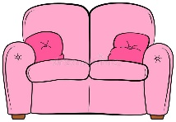 | 1............................a sofa. |  | 6. .......................a computer.
 | 2. ........................ bananas | 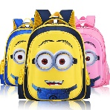 | 7. ......................school bags.
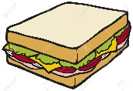 | 3.....................a sandwich. |  | 8....................................books
 | 4. .............................birds. |  | 9........................... a lemon.
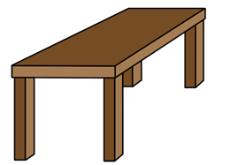 | 5. ..........................a table. | 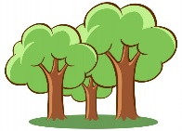 | 10. .............................trees.

Exercise 5: Change into negative sentences
- There is a garage.
=> ..............................................................................
- There are six books.
=> ..............................................................................
- There is a living room.
=> .............................................................................
- There are three dogs.
=> ..............................................................................
- There are flowers behind my house.
=> ..............................................................................

BÀI TẬP NÂNG CAO

Exercise 6: Fill in the blank with THERE IS or THERE ARE

1. ............................... a lamp. | 6. ...............................three windows.
2. ...............................a bed. | 7. ...............................a pillow.
3. ...............................five tables. | 8. ...............................a picture.
4................................six books. | 9. ...............................two sofas.
5. ...............................a flower. | 10. ...............................three ducks.

Exercise 7. Circle the correct answer

- My bedroom is ...............................(nice/ seven/ young/ long).
- There .............(is/ are/ am) a bedroom, a living room, a kitchen and a bathroom in my house.
- There .. .............(is/ are/ am) two bedrooms, a living room and a kitchen.
- ......................................(Is there/ Are there/ Are they) any ponds?
- There is a lake next ........................(of/ in/ to/ on) the house.

Exercise 8: Fill in the blank with one word.

This (1)................my house. (2)................There (3)................five rooms in my (4)................There (5)................a living room. It (6)................big (7)................nice. (8)................is a kitchen (9)................the house. It (10)................small and beautiful. (11)................ are (12)................ bedrooms in my house. They (13)................very large. There is (14)................ bathroom in my house. It (15)................clean.

Exercise 9: Reorder the words to make sentences.

1. is / This / house. / a / small
=> …………………………………………………………………………
2. This / a / large / is / living / room.
=> …………………………………………………………………………
3.house? / there / room / Is / a / the / bed / in
=> …………………………………………………………………………
4.pond / garden. / the / There / a / is / in
=> …………………………………………………………………………
5.The / is / old. / kitchen
=> …………………………………………………………………………
6. nice? / Is / living / the / room
=> …………………………………………………………………………
7. bathroom / beautiful. / is / The / and / big
=> …………………………………………………………………………
8. is / That / a / pong.
=> …………………………………………………………………………
9.garden / over / The / is / there.
=> …………………………………………………………………………
10. It / my / This / beautiful. / is / is / house.
=> …………………………………………………………………………
11. house. / my / There / in / two / bedrooms / are
=> …………………………………………………………………………
12. your / in / house? / front / Are / there / of / any / trees
=>…………………………………………………………………………
Exercise 10: Write questions for the underlined part.
1. This is my flat.
=>…………………………………………………………………………
2. My house is green.
=>…………………………………………………………………………
3. Yes, there is a kitchen.
=>…………………………………………………………………………
4. Yes, the bedroom is large.
=>…………………………………………………………………………
5. My grandfather is eighty years old.
=>…………………………………………………………………………

Name: ………………  Grade 3 | Unit 13: WHERE’S MY BOOK?
BÀI TẬP VẬN DỤNG CƠ BẢN
Exercise1: Write the missing letters.
  1.__N |   2.I__
  3.__N_E_ |   4. B_H_ _D
  5. _ _ FR_ _ _ OF |   6.N_ _ T TO
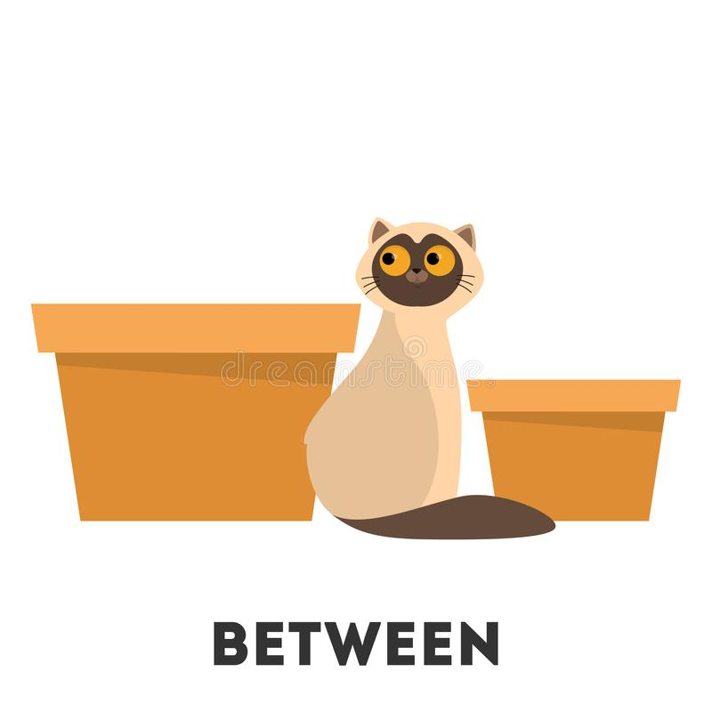  7. BE_ _E_ _ |   8. A_O_ _

Exercise 2: Look and fill in the blank.
boots
table (x2)
chair

(x2) -behind
In -under
car on (x2)

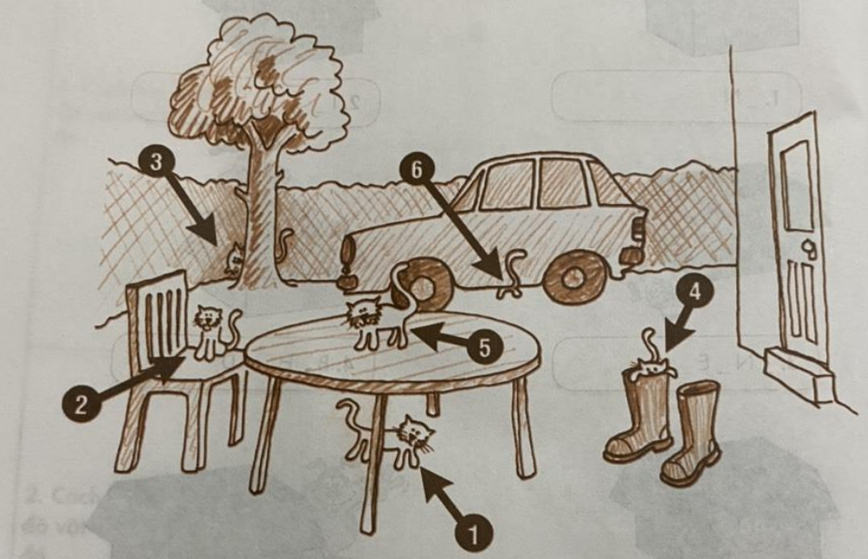

- Cat number one is………………….the………………………..
- Cat number two is………………….the………………………..
- Cat number three is………………….the………………………..
- Cat number four is………………….the………………………..
- Cat number five is………………….the………………………..
- Cat number six is………………….the………………………..

Exercise 3: Look and complete.
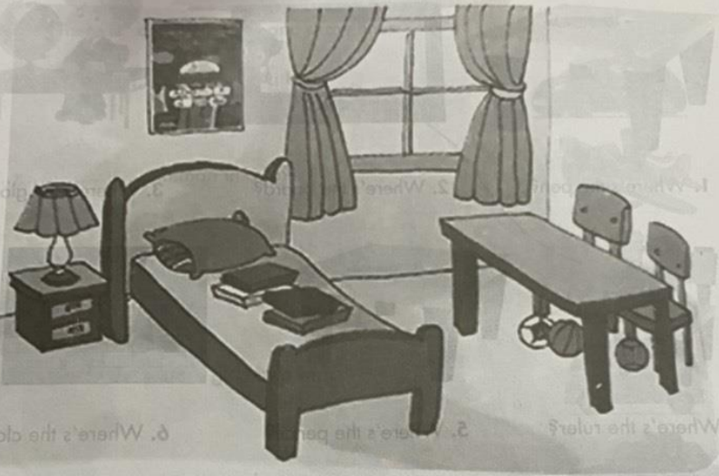
- This is my bedroom. There is a bed…………………….. the room.
- There is a table too. There are two chairs……………………to the table.
- There are some books………………….the bed.
- There are some balls……………………….the table.
- There is a poster………………………..the wall.

Exercise 4: Look and answer.
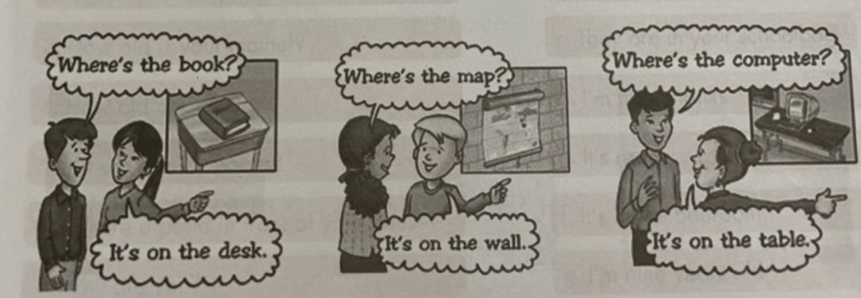
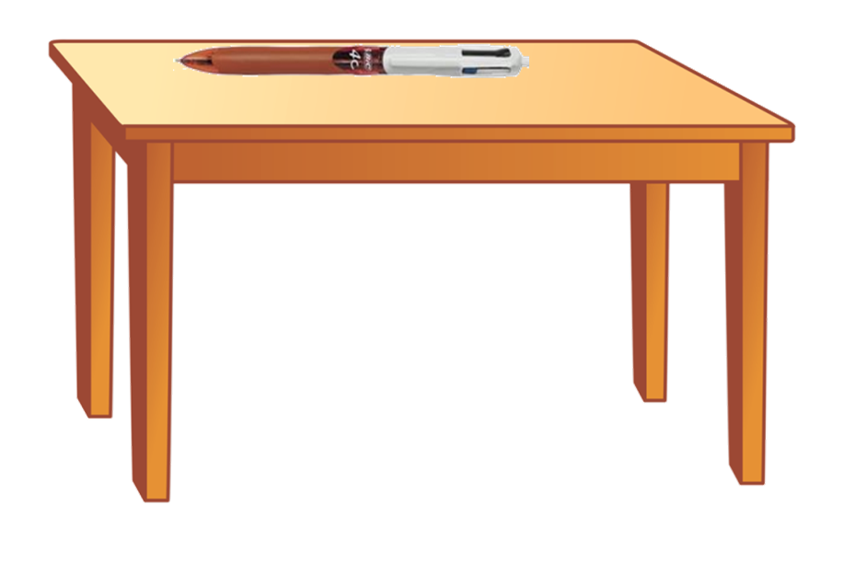 | 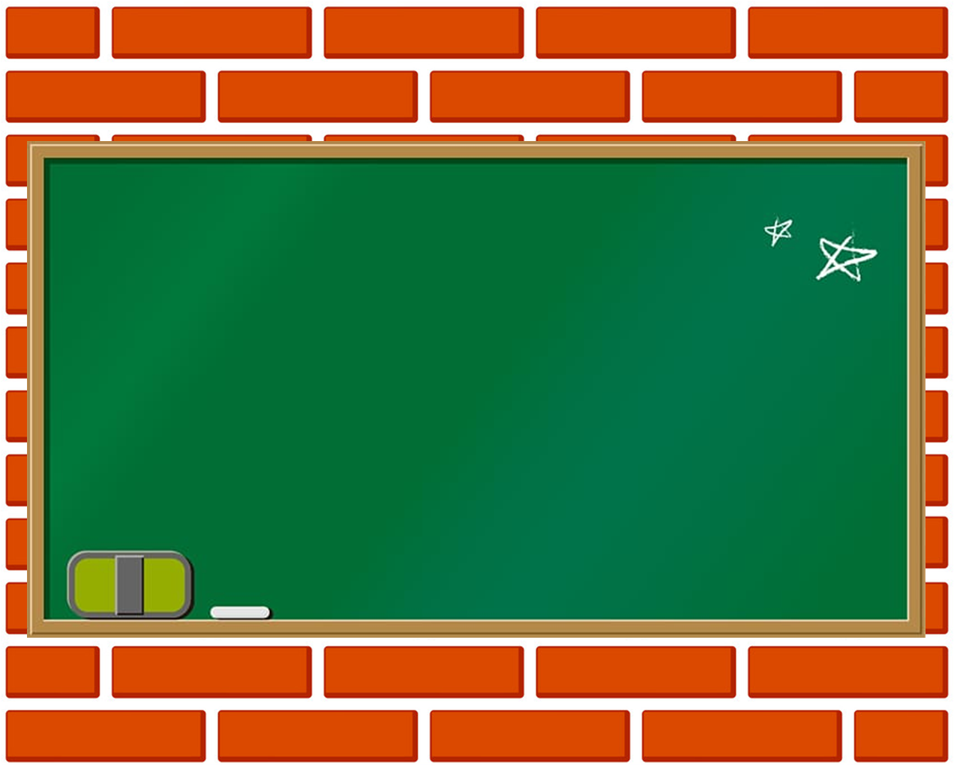 | 
- Where’s the pen? | 2. Where’s the board? | 3.Where’s the globe?
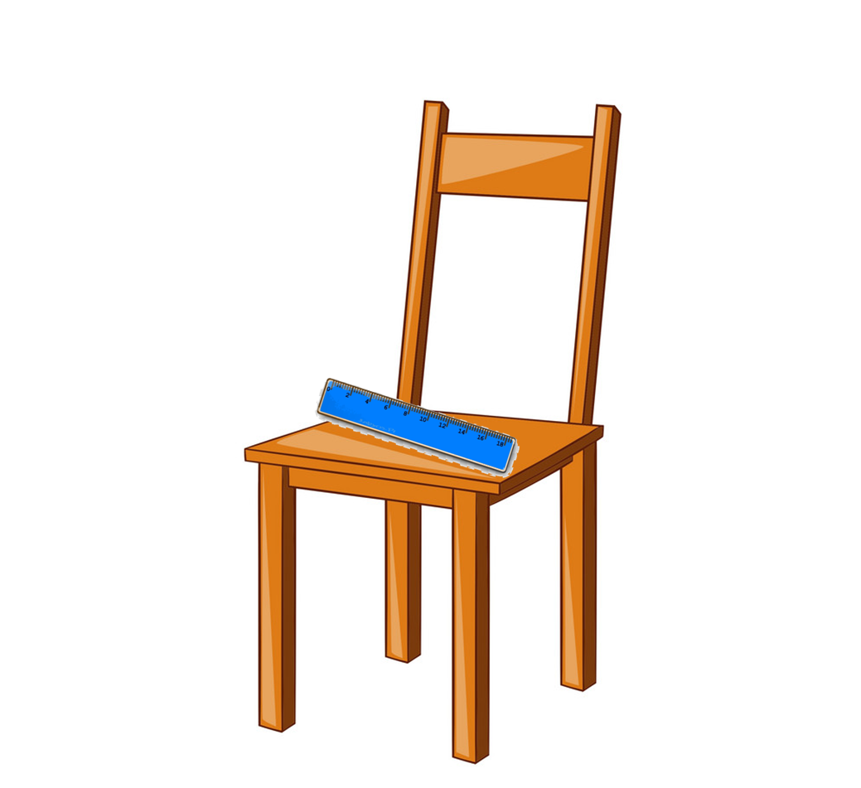 | 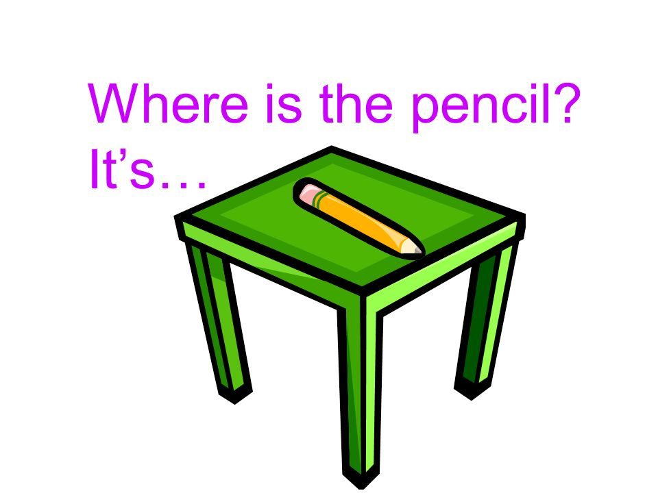 | 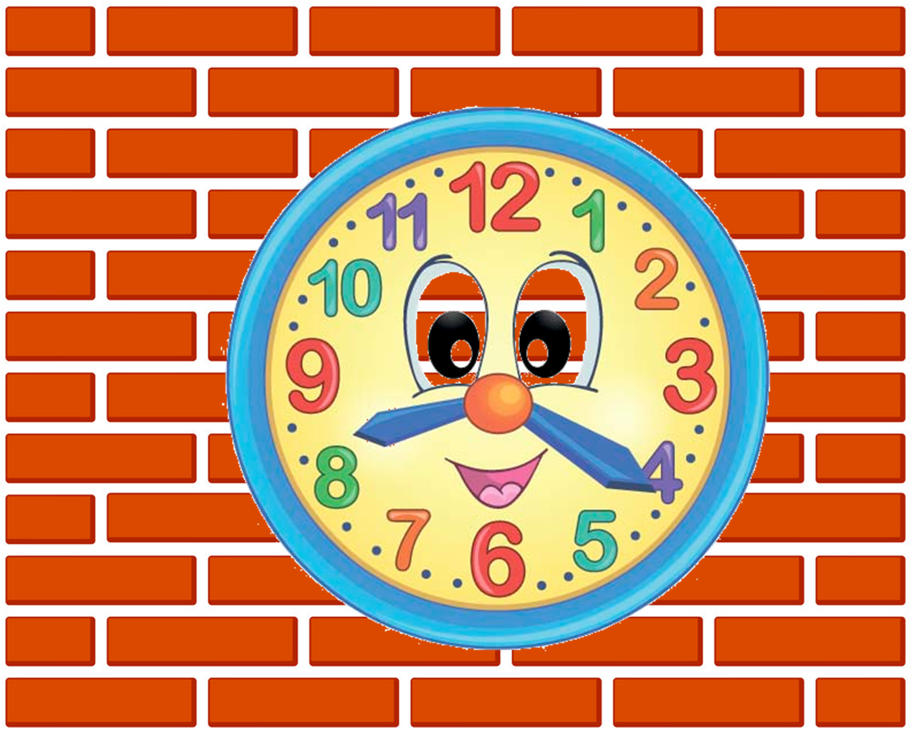
4.Where’s the ruler? | 5.Where’s the pencil? | 6.Where’s the clock?
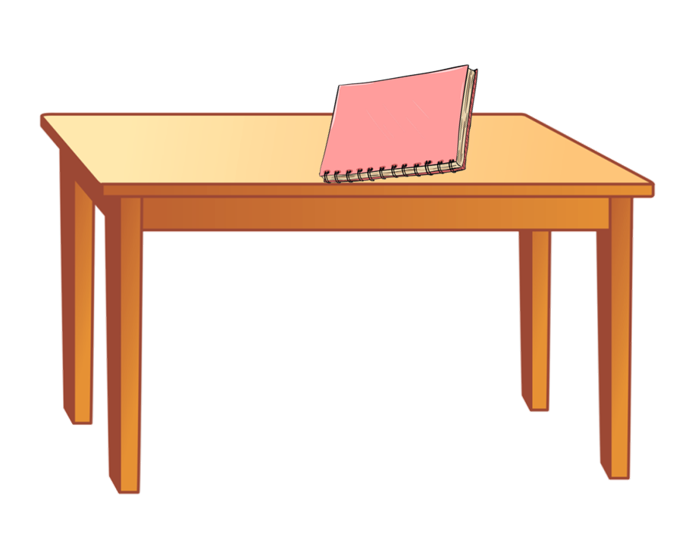 | 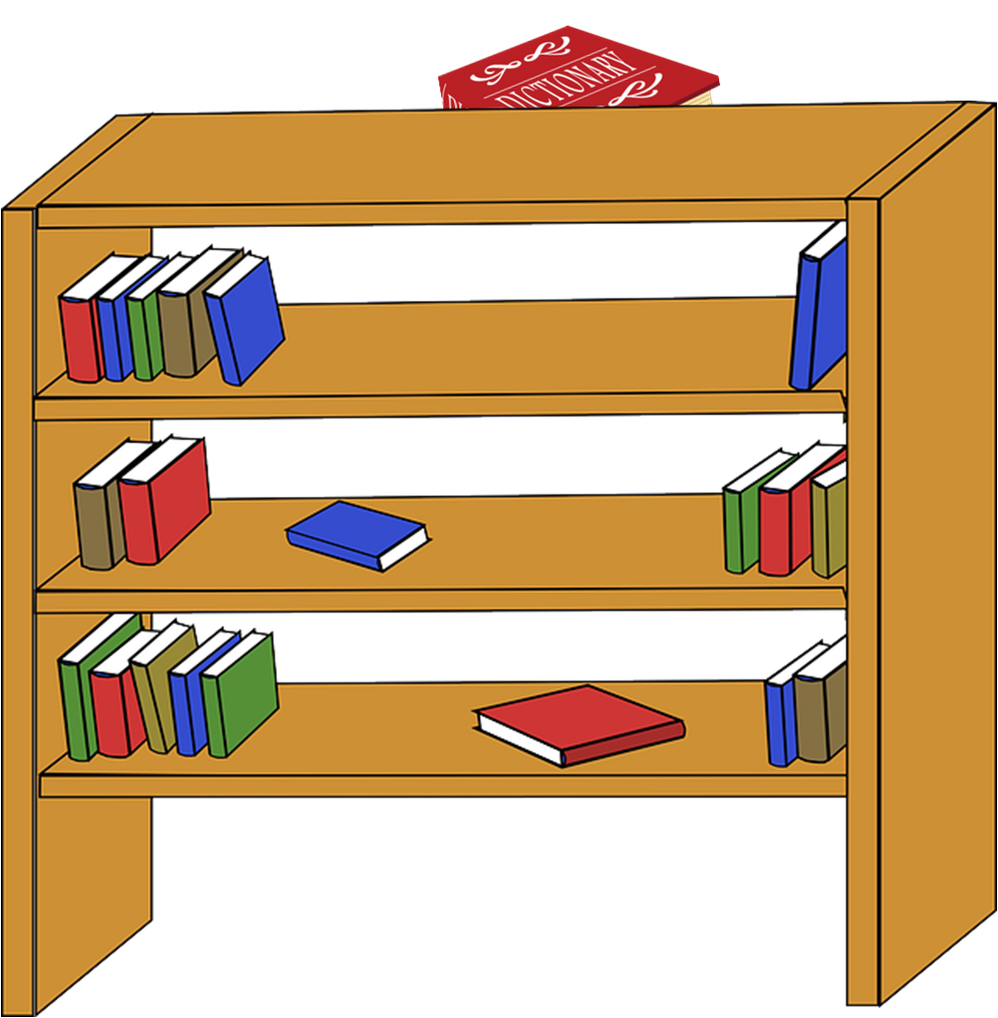 | 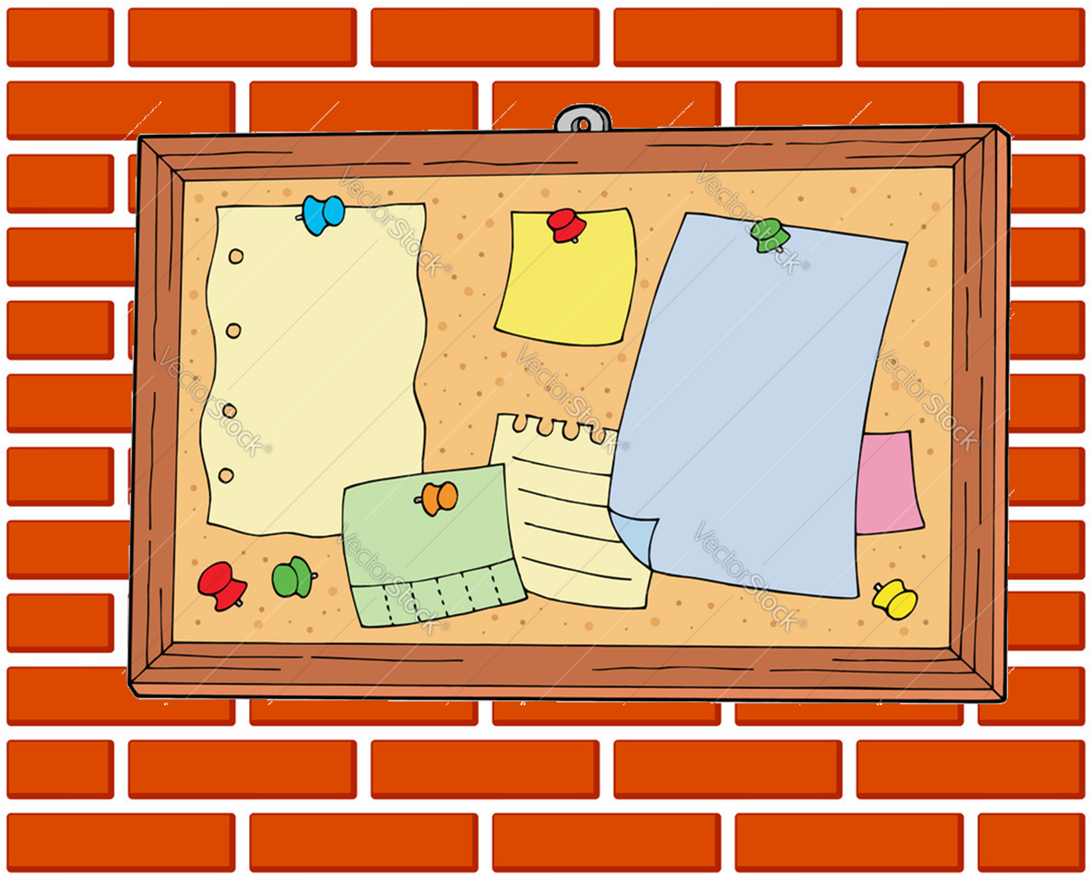
7.Where’s the notebook? | 8.Where’s the dictionary? | 9.Where’s the bulletin board?

Exercise 5: Write There’s or There are and draw lines.
1…………………………….a boy on a bike. | 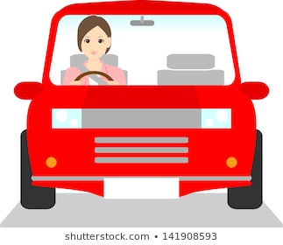
2…………………………… a man in a taxi. | 
3…………………………two goats in a van. | 
4…………………………two girls and a boy in a bus | 
5………………………….a woman in a car. | 
6……………………….a man in a plane. | 

Exercise 6: Read and match.
a.They are on the wall.
- Where’s the bed?
b.No, but there is a big tree.
- What colour is your coat?
c.They are in your school bag.
- How old is your mother?
d. I’m fine, thanks.
- How old are you?
- Where are my books?
e. It’s red.
- Is there a pond in front of your house?
f. It’s in the bedroom.
g. I’m nine years old.
- How are you?
h. She’s thirty years old.
- Where are her posters?

Exercise 7: Look and write sentences like the example.
1
2 | 3 | 4
5 | 6 | 7
- The cat is between two boxes.
- ……………………………………………………………………………………
- ……………………………………………………………………………………
- ……………………………………………………………………………………
- ……………………………………………………………………………………
- ……………………………………………………………………………………
- ……………………………………………………………………………………
Exercise 8: Read and complete.

Hi, my name is Huong. This is a picture of my (1)……………………There are (2)………………people in my family. They are: my (3)……………….., my (4)…………………, my (5)……………………, my (6)……………………, my (7)…………………… and me. My grandfather is 62 (8)…………………old. My (9)……………………..is 58 years old. They are not young. They are old. My father is 42 years old. My (10)……………is 40 years old. My brother (11)……………….ten years old. I am eight years old.
Exercise 9: Reorder.
- is/ of/ in/ there/ a/ tree/ house/ my/ front/.
=>…………………………………………………………………………………
- is/ fence/ around/ there/ a/ house/ her/.
=>…………………………………………………………………………………
- balls/ his/ where/ are/ ?//- are/ they/ under/ chair/ the/.
=>…………………………………………………………………………………
- is/ coat/ my/ where/ ?//- on/ wall/ it/ is/ the/.
=>…………………………………………………………………………………
- are/ four/ chairs/ near/ table/ the/ there/.
=>…………………………………………………………………………………
- cat/ a/ the/ chair/ is/ behind/ there/.
=>…………………………………………………………………………………
- a/ is/ living room/ there/ in/ house/ my/.
=>…………………………………………………………………………………
- seventy/ grandfather/ is/ years/ old/ my/.
=>…………………………………………………………………………………
- is/ gate/ front/ in/ of/ there/ a/ house/ my/ .
=>…………………………………………………………………………………
- bed/ the/ is/ where/? //-is/ in/ it/ bedroom/ the/.
=>…………………………………………………………………………………
Exercise 10: Write questions for the underlined part.
1. The posters are in my bag.
=>……………………………………………………………………………………
2. I’m OK, thank you.
=>……………………………………………………………………………………
3.The shirt is brown.
=>……………………………………………………………………………………
4.The picture is on the wall.
=>……………………………………………………………………………………
5.Yes, there is a living room.
=>……………………………………………………………………………………
UNIT 14: ARE THERE ANY POSTERS IN THE ROOM? (CÓ BẤT KÌ TẤM ÁP PHÍCH NÀO TRONG PHÒNG KHÔNG?)
BÀI TẬP VẬN DỤNG CƠ BẢN

I. Write the missing letters
 | 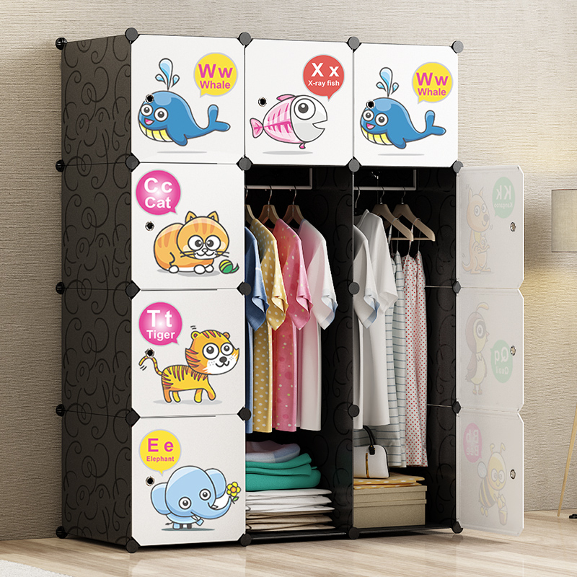
1. S_ _ A | 2. _ _R _RO _E
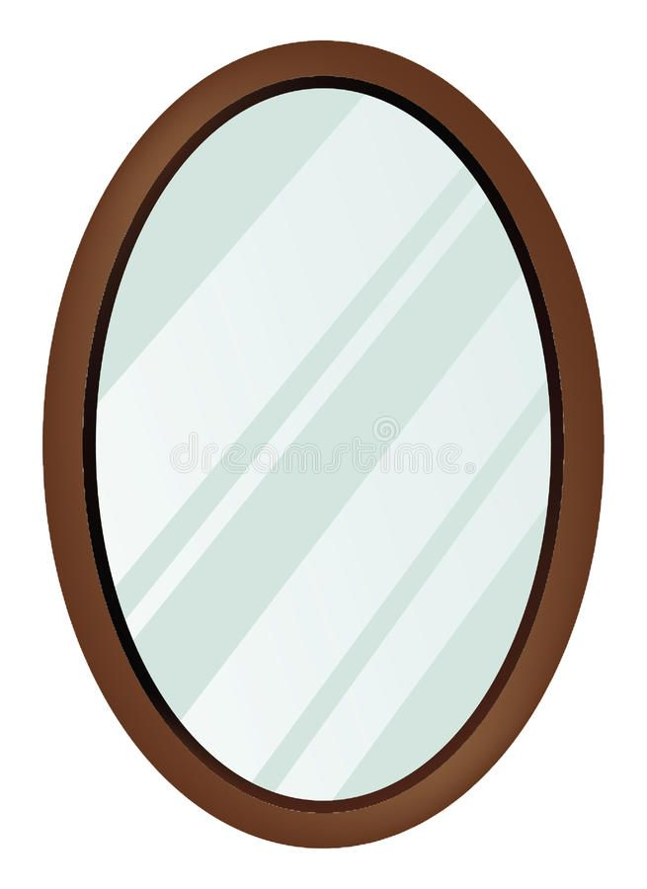 | 
3. M_R_O_ | 4. T _EV _SI_N
 | 
5. _R_DG _ | 6. W _SH_A_I_
 | 
7. A_RC_ND_TIO_ER | 8._A_
 | 
9. M_ _ | 10. _ _P

II. Read and match
a. Yes, there is.
b. No, there aren’t.
c. It is brown.
d. There are six.
e. It is in the garage.
5. Are there any cups on the table?
4. What color is the desk?
3. Is there a pictiure on the wall?
2. Where is the motorbike?
1. How many chairs are there in the room?

III. Look and complete
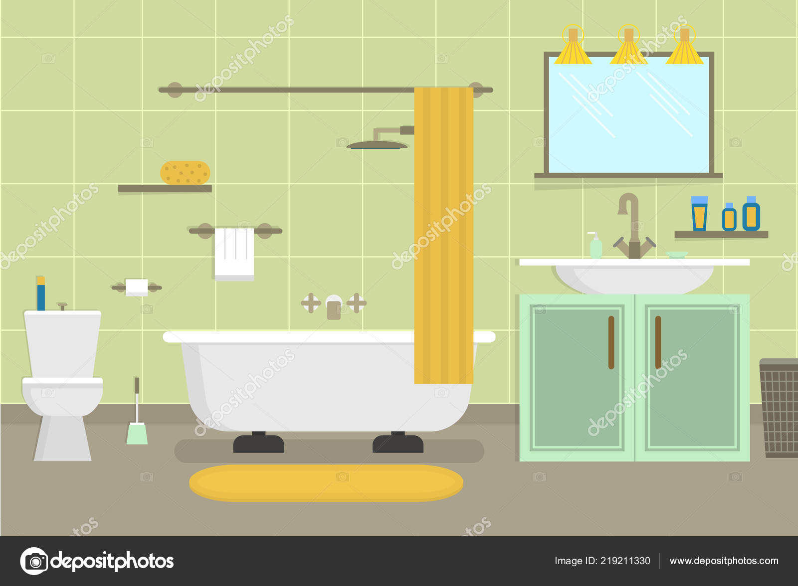

1. The toilet is …………………….the bath.
2. The curtain is …………………. the bath.
3. The mirror is ………………………..the wall.
4. The cupboard is …………………..the washbasin.
5. The mat is ……………………the bath.
IV. Answer the questions.
1. Are there three balls under the chairs?
Yes, ………………………..
2. Is there a dining room in your house?
No, ………………………..
3. Are there any pictures on the wall?
No, ………………………..
4. Is there a pencil in the box?
Yes, ………………………..
V. Look and answer


1. Where is the television?
……………………………………………………………………………………..
2. Where is the lamb?
……………………………………………………………………………………..
3. Is there a fridge in the kitchen?
……………………………………………………………………………………..
4. Are there any chairs in the kitchen?
……………………………………………………………………………………..
5. Where is the bath?
……………………………………………………………………………………..
6. Are there any sofa in the bedroom?
……………………………………………………………………………………..
7. How many chairs are there in the dining room?
……………………………………………………………………………………..
8. Are there two windows in the dining room?
……………………………………………………………………………………..
BÀI TẬP NÂNG CAO

VI. Reoder.
1. desk / among / are / the / the / chairs /.
……………………………………………………………………………………..
2. is / a / there / bed / bedroom / the/ in /.
……………………………………………………………………………………..
3. many/ are / the / lamps / desk/ how / on / there /?
……………………………………………………………………………………..
4. are / cups / where / ?./ the / they / table / are / on /.
……………………………………………………………………………………..
5. are / two / on / pictures / wall / the / there /.
……………………………………………………………………………………..
VII. Write questions for the underlined part.
1. There are two sofas in the living room.
……………………………………………………………………………………..
2. Yes, there are two posters on the wall.
……………………………………………………………………………………..
3. The coat is in the wardrobe.
……………………………………………………………………………………..
4. She is ten years old.
……………………………………………………………………………………..
5. There is a tree in front of the house.
……………………………………………………………………………………..

VIII. Look and complete the answer
1. How many pencils are there?  ………………………...pencil. | 
2. How many backpacks are there?  ………………………... backpacks. | 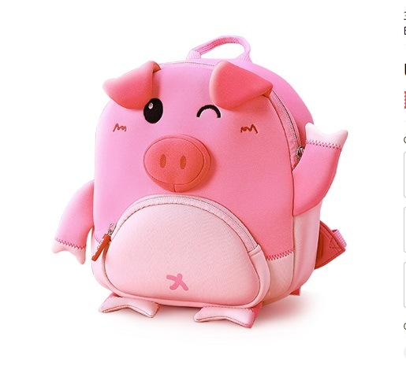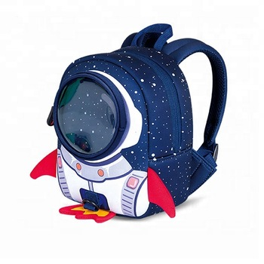
3. How many books are there?  ………………………... books. | 
4. How many students are there?  ……………………….............. | 
5. How many circles are there?  ………………………... ………. | 
6. How many computers are there?  ………………………... ……… | 
7. How many erasers are there?  ………………………... ……… | 
8. How many rectangles are there?  ………………………... ……… | 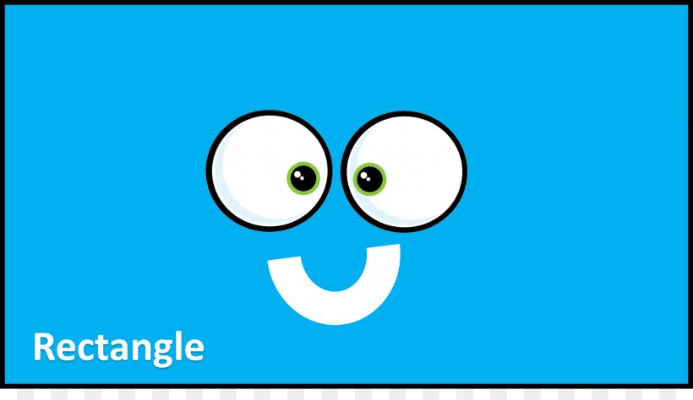

IX. Fill in the blank with THERE IS, THERE ARE, IS THERE or ARE THERE
1. …………………….one book on the desk?
2. . …………………….six flowers in the vase?
3. . …………………….three big trees in the garden.
4. . …………………….a beautiful girl in the room?
5. . …………………….a man in the garden?
6. . …………………….any chairs in the room?
7. . …………………….some books on the shelf.
8. . …………………….twenty students in my class.
9. . …………………….a clock on the wall?
10. . …………………….no chair in my bedroom.
X. Make the questions with “how many”.
1. There is one dog in the garden.
……………………………………………………………………………………..
2. There are four books in the bag.
……………………………………………………………………………………..
3. There are fifteen students in the classroom.
……………………………………………………………………………………..
4. There is an umbrella under the desk.
……………………………………………………………………………………..
5. There are nine tables in the room.
……………………………………………………………………………………..

Name: ………………  Grade 3 | Unit 15: DO YOU HAVE ANY TOYS?
BÀI TẬP CƠ BẢN
Exercise 1: Write the missing words.
  1. _ _BO_ | 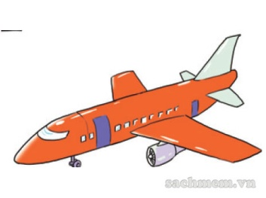  2. P__ __ N__
  3. S__ __ P | 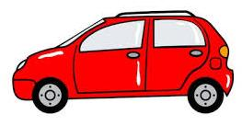  4. __ A__
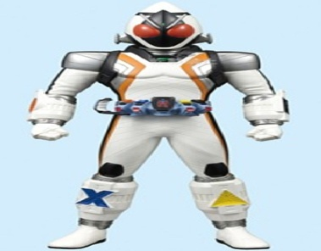  5. SU__E__M__ __ | 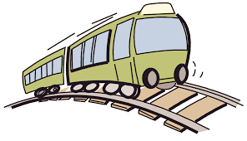  6. T__A__N
  7.D__ __ L | 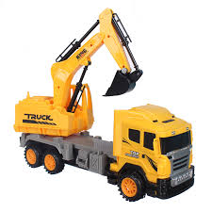  8. __ X___ AV___TO___
  9.K__ __ E | 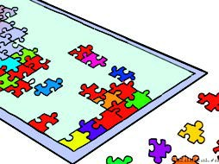  10. P __Z__ __E

Exercise 2: Look and answer.
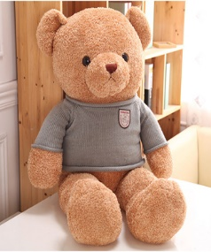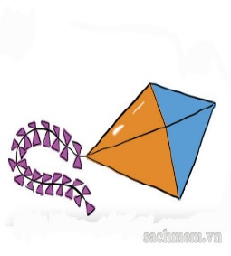
- Do you have a bear? ..…………………………………………………………………..
- Do you have a robot ? ……………………………………………………………………
- Do you have a doll ? …………………………………………………………………..
- Do you have a ball ? ……………………………………………………………………
- Do you have a train ? ………………………………………………………………….
- Do you have a yo - yo ? ………………………………………………………………….
- Do you have a kite ? …………………………………………………………………
Exercise 3: Read and Match.
1.Do you have a doll? | 1……… | A.It is in my room.
2.What’s that? | 2……… | B. No, there isn’t.
3.Where is your robot? | 3………. | C. It’s my puzzle.
4. Is there a train on the table? | 4………. | D. There are yellow, green and red.
5.What colour are your toys? | 5………. | E.Yes, I do.
Exercise 4: Reorder.
1. ACR …………………………… | 2. LALB ……………………………
3. DLOL …………………………… | 4. PHSI ………………………………
5. ITKE …………………………… | 6. LUZPZE …………..………………
7.OBROT ……………………………. | 8. LPAEN ….………………………
9. NMEUSPRA ……………………… | 10. YOT ……………………………

Exercise 5: Look and answer.
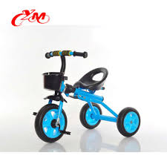
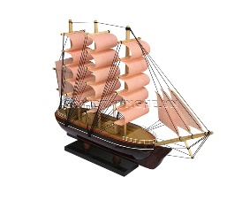

1.Do you have three balls? ……………………………………….
2.Are there four car ? ……………………………………….
3.How many bikes are there? ……..……………….….…………….
4.How many dolls are there? ……..…………………………………
5.How many boat are there? ……………………….………………
6.Do you have a plane? ………………………………………...

BÀI TẬP NÂNG CAO.

Exercise 6: Look and circle the correct answer.
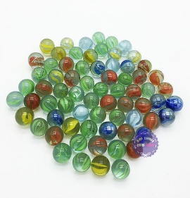
1. 2. 3. 4. 5.
a.marbles a.bicycle a.plane a.ball a.doll
b.kite b.drum b.car b.kite b.bicycle
c.superman c.puzzle c.train c.yo-yo c.rocking horse


6. 7. 8. 9. 10.
a.watering gun a.puzzles a.bike a.puzzle a.tricycle
b.building block b.yo-yo b.kite b.pinwheel b.plane
c.pin wheel c.doll c.robot c.doll c.excavator

Exercise 7: Fill the blank with the word given.
Shelf window table bed many
This is my bedroom. It is big and beautiful. There are many things in my bedroom. Here is my (1) ……………….. The bed is big. There are (2)………………….. balls under the bed. Next to the bed is a (3)…………………. All of my school things are on this table. There are two small (4) …………………behind the table.There is a (5)……………… near my bed. My planes and robots are on this shelf. There is a beautiful picture above the (6) …………………….

Exercise 8: Reorder the words.
1.my/ it / puzzle/ is/.
…………………………………………………………..………..……………….
2.are/ there/ balls/ two/ the/ bed/ near/.
………………………………………………………….…………………………..
3.you/ teddy have/ bear/ a/ do/ ?
……………………………………………………………………………………..
4.have/ Hoa/ a/ doesn’t/ robot/.
……………………………………………………...………………..…………….
5.sister/ doll/ a/ does/ your/ have/?
…………………………………………………………………………………….
6.Hung/ does/ a/ have/ robot/?
…………………………………………………………………………………..
Exercise 9: Fill in the blank with ONE word.
1.There ………….. a poster on the wall.
2……………….they your friend?
3.Where ………….my toys?
4.I ……………….a ship and two robots.
5.She ………… ten pretty dolls.
6.Are there any cars on the table? _No, there …………..not
7.Does she ……………..any toys? _No, she doesn’t.
8. There …………….a ball under the bed.

Exercise 10: Circle the correct answer.
1.-Are there any balls under the desk? -……………………
a. Yes, there is b.No, I don’t
c.No, there aren’t d.Yes, I do
2- Where is the sofa? -………………………..
a.It’s blue b.Yes, the sofa is over there.
c.It’s in the living room d.They are here,in the living room
3.-Are the posters on the wall? -…………………………………..
a.Yes, there are b.Yes, it is.
c.Yes, I do d.Yes, they are
4.-Where are my pencils? _.....................................
a.They are in the bag b.They are black and blue
c.It is on the table d. I have some pencils
5.What is there behind your house? _......................................
a.There is a lake b.Yes, there are.
c.My house is big d. No, I don’t

Name: ………………………  Grade 3 | Unit 16: DO YOU HAVE ANY PETS?
BÀI TẬP CƠ BẢN
Exercise 1: Look and complete

 |  |  |  | 
1. _ o _ |  | 2.G _ l _ f_ s_ |  | 3. C_ _
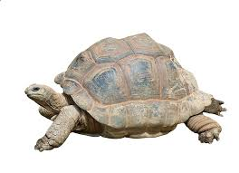 |  | 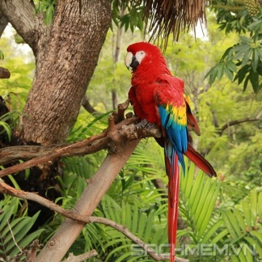 |  | 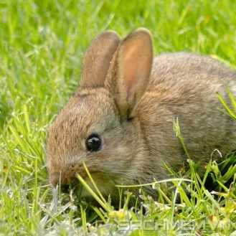
6. T _ _ t _ e |  | 7. P _ _ r_ _ |  | 8. _ a_bi_
Exercise 2: Fill in the blank with the word given
pets toys beautiful has have

My name is Thuong. I (1)…………….….. two pets: a dog and a cat. My sister, Lan (2)……..………..no pets. But she has many (3)…………..…….. She has ten dolls and six robots. My friend, Phuc has no toys. But he has many (4)…………….... He has six birds and ten fish. They are (5)…………..……..

Exercise 3: Circle the correct answer

1. ……………..old is your mother?
A. What B. Who C. How
2. Is your bag nice? - ………………
A. Yes, it is B. Yes, there is C. No, it is
3. There are ……………..in my bag.
A. a pen B. two pens C. the pen
4. They……………..a ship and a doll.
A. has B. are C. have
5. ……………..is a Tv in the living room.
A. There B. They C. This
6. How ……………..books do you have?
A. old B. the C. many
7. I have……………..cat and ………… dogs.
A. a/two B. a/ an C. one/ one
8. Kelly……………..some toys.
A. have B. has C. is

Exercise 4: Read and match
1. Do you have any pets? | a. They’re in the cage.
2. That’s my cat. | b. Yes, I do. I have one bird and one cat.
3. Where is the dog? | c. No, she doesn’t.
4. Where are the birds? | d. It’s cute.
5. Does she have any parrots? | e. It’s next to the table.

1…… 2…… 3…… 4…… 5……

Exercise 5: Reorder.
1. IDRB | → …………………………………….
2. TLRETU | → …………………………………….
3. BRBTIA | → …………………………………….
4. FGDHOISL | → …………………………………….
5. APRTOR | → …………………………………….
6. ODG | → …………………………………….
7. EPT | → …………………………………….
8. ATC | → …………………………………….

BÀI TẬP NÂNG CAO

Exercise 6. Fill in the blank with “DO/ DOES/ HAVE/ HAS”.

- I ………….you like animals? – Yes, I ………..………….
- She ……………….. a cat. Its name is Nick.
- …………….. Lan have a robot? – No, she ……………….. not.
- My house ……….……..five rooms: living room, dining room, kitchen, bathroom and bedroom.
- ……….….. Linda have any rabbits? – Yes, she ………………..
- They ………………….. two dogs and three cats.
- She doesn’t ………………….... any toys.
- We……………..…….. not have any parrots.
Exercise 7: Look and answer
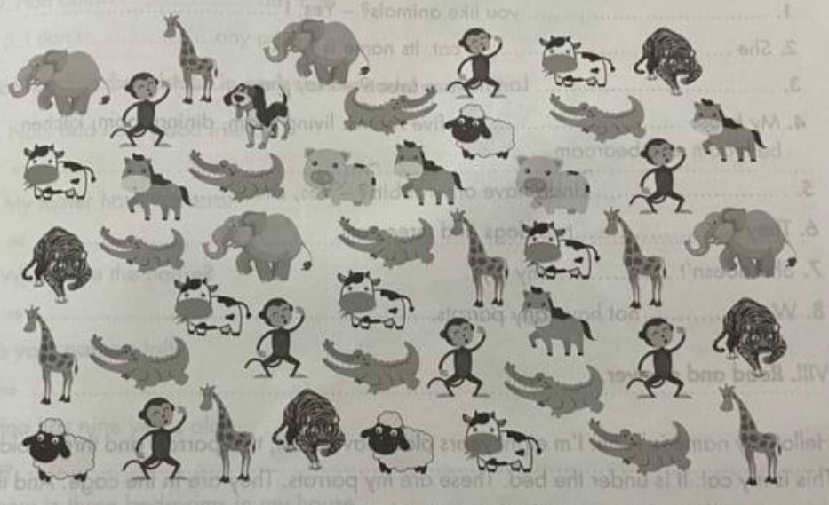
1. How many elephants are there?
=> .………………………………………………………………………
2. How many sheep are there?
=> .………………………………………………………………………
3. How many giraffes are there?
=> .………………………………………………………………………
4. How many monkeys are there?
=> .………………………………………………………………………
5. How many tigers are there?
=> .………………………………………………………………………
6. How many crocodiles are there?
=> .………………………………………………………………………
7. How many cows are there?
=> .………………………………………………………………………
8. How many dogs are there?
=> .………………………………………………………………………

Exercise 8: Read and answer.
Hello. My name is Tuan. I’m eight years old. I have a cat, two parrots and three goldfish. This is my cat. It is under the bed. These are my parrots. They are in the cage. And those are my goldfish. They are in the fish tank. I love my pets very much.
1. How old is Tuan? ……………………………………..………………
2. Does he have any pets? ………………………………………………
3. What pets does he have? …………………………………..……………
4. Where is his cat? ……………………………….……………………
5. Where are his parrots? ………………………………..………………
6. Where are his goldfish? ……………………………….………………
Exercise 9: Fill in the blank with HAVE or HAS.
1. I ……………………two dogs.
2. My house……………………many pets.
3. My sister……………………three goldfish.
4. They ……………………four cats.
5. Nam…………………a dog.
6. Does she ……………………two parrots?
7. Do you……………………any pets?
8. We……………………a dog and two cats.
9. Hoa doesn’t ……………………any cats.
10. I don’t ……………………any pets.

Exercise 10. Underline the mistake in each sentence and correct it.

1. Nam and I am good friends.
=> ………………….………………………………………
2. My father have a parrot.
=> ………………….………………………………………
3. Where are the house?
=> ………………….………………………………………
4. Is your parents tall?
=> ………………….………………………………………
5. Hoa has nine years old.
=> ………………….………………………………………
6. There is three bedrooms in my house.
=> ………………….………………………………………
7. Does they have any parrots?
=> ………………….………………………………………
8. My sister don’t have any pets.
=> ………………….………………………………………
9. How many students three are in your classroom?
=> ………………….………………………………………
10. What color have your pencil?
=> ………………….………………………………………

Name: …………………  Grade 3 | Unit 12: WHAT TOYS DO YOU LIKE?

BÀI TẬP CƠ BẢN

Exercise 1: Write he missing letter.
 | 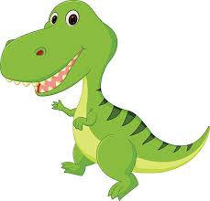 | 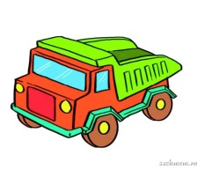
1.G _ I _ A _ | 2. D _ _ OS _ U _ S | 3. _ R _ _ K
 | 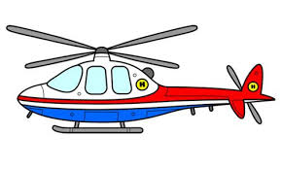 | 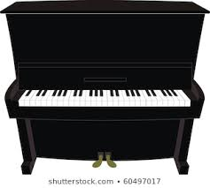
4. _ PA _ _ SH _ P | 5.H _ L _ C _ P _ E _ | 6. _ I _ _ O

Exercise 2: Fill in the blank with the word given.
triangle
truck
for
little

1. This is a yellow ……………………
2. Are these ……………………. kites?
No, they aren’t. They are square kites.
3. This guitar is …………………you.
4. Is this a ……………….doll?
Yes, it is.

Exercise 3: Circle the correct answer.

1. Who’s ………………….?
A. that | B. his | C. her
2. May I ………………out?
A. open | B. go | C. close
3. Howmany books………………..you have?
A. do | B. does | C. are
4. ……………..is the ball? - It’s on the table.
A. What | B. How | C. Where
5. Mary ……………….two dogs.
A. have | B. do | C. has
6. My room is ……………….big. It’s small.
A. no | B. not | C. too
7. What’s ……………name? - It’s Le Loi school.
A. it | B. your | C. its
8. She’s my friend, ……………….
A. sure | B. too | C. do

Exercise 4: Read and Match.

1. Do you have any toys? | a. No, it isn’t.
2. How many books do you have? | b. Yes, I do.
3. What toys do you have? | c. I have six.
4. Is your school big? | d. It’s Tran Hung Dao school.
5. What’s its name? | e. I have a ball and a robot.

1…… 2…… 3…… 4…… 5……

Exercise 5: Reorder.

1. RTKCU | ……….………………………
2. RUGAIT | ……….………………………
3. SDNOIRUAS | ……….………………………
4. PSICASEHP | ……….………………………
5. OAPIN | ……….………………………
6. LHOETIRCPE | ……….………………………

BÀI TẬP NÂNG CAO

Exercise 6. Look and answer.

1. What toys does she like?  ……………………………………………. | 
1. What toys do you like?  ……………………………………………. | 
1. What toys does he like?  ……………………………………………. | 
1. What toys do you like?  ……………………………………………. | 
1. What toys does your brother like?  ……………………………………………. | 

Exercise 7. Complete the table.
Singular Noun (Danh từ số ít) | Plural Noun (Danh từ số nhiều)
cat
 | parrots
sheep
 | people
pig
mouse
 | feet
man
woman
horse
fish
 | teeth

Name: ………………  Grade 3 | Unit 18: WHAT ARE YOU DOING?
BÀI TẬP CƠ BẢN

Exercise 1: Write the name of action.

 |  |  |  |  |  |  |  | 
1… .………….. |  | 2…....……….. |  | 3.…………….. |  | 4. ……………… |  | 5……..……….
 |  |  |  |  |  |  |  | 
6….………….. |  | 7.…………… |  | 8.…………….. |  | 9…….…..…… |  | 10………………
Exercise 2: Fill in the black with the word given.

reading
cooking
doing
in
am

My name is Tuan. Today, I (1) …………… at home with my family. We are
(2) …………….. the living room. My father is (3) ……………… newspaper. My mother is (4) ………………. dinner. My sister is (5) ……………… her homework, and I am watching TV programs.

Exercise 3: Complete.
swimming | running | walking | skiing
shopping | dancing | sitting | painting
talking | climbing | surfing | sleeping

1. I am  ……..…………… |  | 2. I am  ………….……… | 

3. I am  ……….………... |  | 4. I am  ……… ……….. | 
5. I am  ……………….. |  | 6. I am  ……….……….. | 
7. I am  ………..……….. |  | 8. I am  ………….……….. | 
9. I am  ……….……….. |  | 10. I am  ………………….. | 
11. I am  ………………… |  | 12. I am  ………….……….. | 

Exercise 4: Circle the correct answer.

- My father is ……………………..
- cook | - cooker | - cooking
- She’s ……………… the kitchen.
- on | - in | - there
- What is Hoa …………………. ?
- doing | - does | - do
- I am ……………….. a book.
- listening | - reading | - watching
- He’s ……………….. football with his friends.
- doing | - plays | - playing

Exercise 5: Reorder.

- is / singing / she / a song/ .  - ……………………………………………….. | 
- a car / is / Mr. David / driving / .  - ………………………………………………. | 
- eating / They / dinner / together / are / .  - ……………………………………………… | 
- fishing / are / Tom and Jenny / .  - ……………………………………………… | 
- He / laughing / is / .  - ………………………………………………. | 
- Henry / drawing / is / flowers / .  - ……………………………………………… | 
- is / in / sleeping / his / bedroom / Tim / .  - ……………………………………………… | 
- are / running / my friends / .  - ………………………………………………. | 

BÀI TẬP NÂNG CAO

Exercise 6: Fill in the blank.
reading | I’m fine, thanks | see you later | are you doing
playing tennis | Where | are | Are you going

A: Hello, Linda. Nice to meet you. How (1)………………. you?
B: Hello, Mary. (2)……………………… And you?
A: Fine, thanks. (3)……………………. is Nick?
B: He is (4) ……………….. in the library. What (5) ……………………….?
A: I’m (6)……………………… with my friends.
B: (7)………………….. to the gym?
A: No, I’m not. I’m going to my classroom.
B: Goodbye, (8)………………….
A: Bye, see you later.

Exercise 7: Look and answer.
- What is he doing?  - ……………………………………………….. | 
- What is Mr. Robinson doing?  - ………………………………………………. | 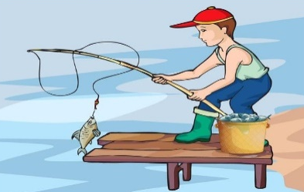
- What is Hoa doing?  - ……………………………………………… | 
- What is she doing?  - ……………………………………………… | 
- What are Jenny and Tim doing?  - ………………………………………………. | 
- What is Mrs. Lan doing?  - ……………………………………………… | 
- What is Mr. Smith doing?  - ……………………………………………… | 
- What is your mother doing?  - ………………………………………………. | 

Exercise 8. Reorder.
1. you/ are / parents / What / doing / ?
=> ………………………………………………………………………………
2. mother / My / cooking / is / dinner / .
=> ………………………………………………………………………………
3. playing / I / volleyball / like / don’t / .
=> ………………………………………………………………………………
4. Friend / My / is / homework / her / doing / .
=> ………………………………………………………………………………
5. I / music / am / listening / to / .
=> ………………………………………………………………………………

Exercise 9: Fill in the blank with DO, DOES, AM, IS or ARE.
1. I …………… reading books.
2. ………………….. lan cooking in the kitchen? – Yes, she ……………
3. ……………. Huy and Hoa skating in the park? – Yey, they …………
4. Mr. Brown and Mrs. Brown …………… watching TV in the living room.
5. Where …………… your dogs? …………….. they in your bedroom?
6. What pets …………… you like? – I like dogs. My dogs ……………. playing with its ball in the garden.
7. How many pupils ………………. there in your classroom? – There ……… fifty pupils.
8. ……………… this your dog? – Yes, it is.
9. What ………… Lan doing? She and her mother ……………. watching a football match on TV.
10. What …………… Nga do at break time?

Exercise 10: Write questions for underlined part.

- I’m reading a book.
- ………………………………………………………………………..
- He likes robots and kites.
- ………………………………………………………………………..
- Yes, she has a dog.
- ………………………………………………………………………..
- I have three dogs and four parrots.
- ………………………………………………………………………..
- She is my mother.
- ………………………………………………………………………...
- The cats are in the box.
- ………………………………………………………………………..
- Hoa is skipping rope.
- ……………………………………………………………………….
- The picture is on the wall.
- ………………………………………………………………………..
- No, I don’t like planes.
- ……………………………………………………………………….
- They are skating in the park.
- ……………………………………………………………………….
Name: ……………………..  Grade 3 | UNIT 19: WHAT IS THE WEATHER LIKE?

BÀI TẬP CƠ BẢN
Exercise 1: Complete.
What is the weather like?.
  1. H………………..  rrr |   2. C…………………
  3. C…………………….  rrr |   4. R………………………
  5. S……………………..  rrr |   6. S……………………..
  7. S……………………… |   8. W………………..

Exercise 2: Complete the table.
Verb | Verb-ing
cycle
sleep
study
skate
skip
rain
run
swim
lie
shop

Exercise 3: Fill in the blank with the word given.
reading cooking sunny flying cycling
sleeping five goldfish living room young

My family has ( 1) ……………………………….. people, including my grandmother, my parents, my brother and me. It is warm and (2) ………………………….. today. My grandmother is (3) ………………………… in the bedroom. She is eighty – eight years old. My father is ( 4) …………………… in the (5)……………………….. . He is a teacher. He is forty – six years old, but he is quite (6)……………………. . My mother is (7)…………… in the kitchen . She is forty years old but she is beautiful. My brother is (8) …………. in the park. He is fourteen years old. He likes pets. He has a (9)……………………………. and two cats. And I am nine years old. I am (10)……………………….. kites with my friends in the park.
Exercise 4. Look and complete.
1. What is she doing?  She ……………………….………………. her teeth. | 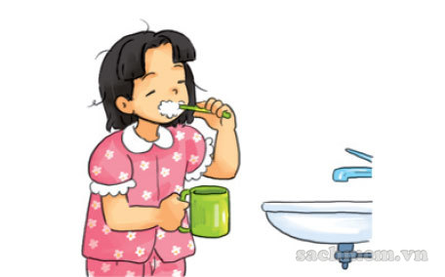
2. What is your father doing?  He ………………………………………………. his old car. | 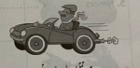
3. What are they doing?  They…………………………. a song. | 
4. What is Mr. John doing?  He ……………………… in the office. | 
5. What is your brother doing?  He ……………………… a newspaper. | 
Exercise 5: Look and reoder.
1) | YIANR …………………………………
2) | RAMW ………………………………… | 
3) | REEZFNIG  ………………………………… | 
4) | OOLC ………………………………… | 
5) | TYMORS  …………………………………
6) | UNSNY …………………………………
7) | OGGYF ………………………………… | 
8) | CIY ………………………………… | 
Exercise 6: Look and answer.
1. What’s the weather like in Ho Chi Minh city?.

…………………………………………………………….

2.What the weather like in Russia?.  …………………………………………………………………. | 

3. What’s the weather like in Ha Noi City?.
…………………………………………………………………

4. What’s the weather like in New York?.
……………………………………………………………….

5. What’s the weather like in France?.
………………………………………………………………

BÀI TẬP NÂNG CAO

Exercise 7: Look and answer.
1. What are they doing?  ………………………………………………………… | 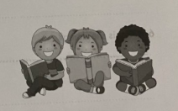
2. What is he doing?.  ………………………………………………………… | 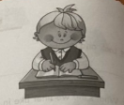
3. What is Mai doing?  ………………………………………………………… | 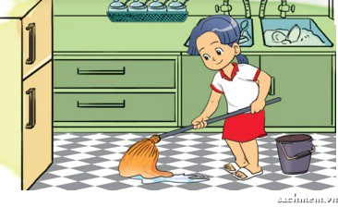
4. What is your sister doing?  ………………………………………………………… | 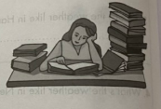
5. What is he doing?  ………………………………………………………… | 
6. What is she doing?  ………………………………………………………… | 
fgfg
Exercise 8: Circle the correct answer.
- What are they doing?. – They are……………………….. their homework.
- doing B. making C. playing
- Does she have any pets?. – No, she……………………………………………………
- don’t B. doesn’t C. haven’t
- How many…………………. Are there in your bedroom?. – There are two.
- chair B. chairs C. a chair
- What’s Hoa doing? – She……………………………………………. .
- Is cycling B. cycling C.cycles
- How old is your mother?. – She’s …………………………………………..
- nice B.old C. thirty
- What is the…………………………. like today?
- Toys B. colour C. weather
- ………………………….. many cats do you have?.
- Why B. How C. What
- What………………….. are your cats?. – They are black and white.
- Yellow B. sunny C. colour

Exercise 9: Underline the mistake and correct it.
- He are playing computer games in his bedroom.
hhh
……………………………………………………………………………………
- Do Huy like dogs?. Yes, he does.
- hhh
……………………………………………………………………………………
- We has many toys and pets.
- hhh
……………………………………………………………………………………

- It is rainy at Da Nang today?.
- hhh
……………………………………………………………………………………
- They like parrots and dogs.
- hhh
…………………………………………………………………………………….
X. Write the questions.
1. Nam is in the garden.
………………………………………………………………………………………
2.There are four cats in the room.
…………………………………………………………………………………………
3.Tuan has two parrots.
………………………………………………………………………………………
4. It is rainy today.
………………………………………………………………………………………
5. Linda is flying kites in the park.
………………………………………………………………………………………
6. I play badminton in my free time.
………………………………………………………………………………………

Name:……………………………….  Grade 3 | Unit 20: WHERE’S SAPA?

BÀI TẬP VẬN DỤNG CƠ BẢN
Exercise 1. Complete.
  1. M………………… |   2. B………………… |   3. C………………….
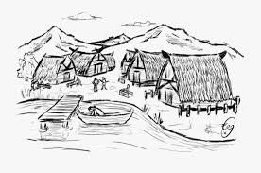  4. V………………… |   5. E…………………… |   6. C………………….

Exercise 2. Odd one out.

- A. city B. town C. village D. near
- A. nice B. beautiful C. wonderful D. place
- A. this B. where C. how D. what
- A. north B. earth C. south D. east
- A. mountain B. river C. compass D. sea

Exercise 3. Look and answer.
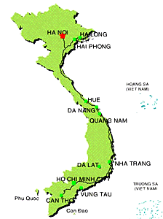
- Where is Ha Noi?
……………………………………
- Where is Hue?
……………………………………
- Where is Ho Chi Minh City?
……………………………………
- Is Sa Pa near Nha Trang?
……………………………………
- Is Ha Long bay near Cu Chi?
……………………………………
- Is Cu Chi near Ho Chi Minh City?
……………………………………
- Is Hue near Ha Long Bay?
……………………………………
- Is Hoi An near Hue?
……………………………………
- Is Hoi An near Sa Pa?
……………………………………
- Is Nha Trang near Ha Noi?
……………………………………

Exercise 4. Circle the correct answer.
- What's …....... name? - Her name is Truc.
A. my B. his C. her D. Your
- How is she? - She's ….................
A. five B. fat C. short D. OK
- How old is your mother? - She is …..............
A. forrty B. nice C. tall D. Old
- My parents …......... in the living room.
A. do B. does C. are D. Is
- She is …........ kites with her friend.
A. playing B. skipping C. Doing D. Flying
- What's that? - It's …......... ink-pot.
A. an B. a C. some D. Any
- How many …........... are there? - There is one.
A. ball B. table C. desks D. Chair
- The weather is …..... today.
A. cold B. far C. too D. Near
- …............. is Hung from? - He's from Hai Phong.
A. What B. Who C. Where D. How
- Who is Nam? - …............ is my friend.
A. His B. He C. I D. Its

Exercise 5. Reorder.

- is/ Nghe An/ Where/ ?
=> …................................................................................................................................

- Thai Nguyen/ from/ is/ Nam Dinh/ ? / far
=> …................................................................................................................................

- Can Tho/ Viet Nam/ south/ in/ is/.
=> …................................................................................................................................

- from / Hue/ far/ is/ it/ ?
=> …................................................................................................................................

- Ha Long/ like/ very/ bay/ much/ I/ .
=> …................................................................................................................................

BÀI TẬP NÂNG CAO

Exercise 6. Read and answer.

Hello. My name's Huong. I am nine years old. There are four people in my family. They are my father, my mother, my brother and me. My family is in Ha Tinh province. It is in central Viet Nam. Ha Tinh is between Nghe An and Quang Binh. It is far from Ha Noi and Ho Chi Minh City. There are rice fields, mountains and rivers. Ha Tinh is a beautiful place.

- What is her name?
=> …................................................................................................................................
- Where is Ha Tinh?
=> …................................................................................................................................
- How old is she?
=> …................................................................................................................................
- Is Ho Chi Minh City near her place?
=> …................................................................................................................................
- How many people are there in her family?
=> …................................................................................................................................
- Are there mountains and rivers in her hometown?
=> …................................................................................................................................
- Is it a bad place?
=> …................................................................................................................................
- Where is Huong family?
=> …................................................................................................................................

Exercise 7. Underline the mistake and correct it.

- Hai Phong is far with Ho Chi Minh City.
=> …................................................................................................................................
- Where are Hue City?
=> …................................................................................................................................
- Lao Cai is at North Viet Nam.
=> …................................................................................................................................
- How many is it from Ha Noi to Ho Chi Minh City?
=> …................................................................................................................................
- There is some interesting places in Viet Nam.
=> …................................................................................................................................
- Are there any book on the table?
=> …................................................................................................................................

Exercise 8. Write the answers for the underlined part.

- Yes, there are two beds in the bedroom.
=> …................................................................................................................................
- There is a tree in front of the house.
=> …................................................................................................................................
- Quang Binh is in central Viet Nam.
=> …................................................................................................................................
- Yes, Thai Nguyen is near Ha Noi.
=> …................................................................................................................................
- No, he doesn't like playing volleyball.
=> …................................................................................................................................
- My sister likes planes and puzzle.
=> …................................................................................................................................
Exercise 9. Use the words given to make complete sentences.

- Where/ your father?
=> …................................................................................................................................
- How many/ computer/ in the room?
=> …................................................................................................................................
- What/ your mother/ doing?
=> …................................................................................................................................
- Hoa and Mai/ not/ have/ dogs.
=> …................................................................................................................................
- she/ read/ a book / now.
=> …................................................................................................................................
- there/ a/ book/ the desk?
=> …................................................................................................................................
- these/ her penncil?
=> …................................................................................................................................
- there / any/ poster/ the wall?
=> …................................................................................................................................

Exercise 10. Write questions for the answers.

- My family is in south Viet Nam.
=> …................................................................................................................................
- Yes, my place has a mountain.
=> …................................................................................................................................
- It is cold in Ha Noi.
=> …................................................................................................................................
- There are twenty teachers in my school.
=> …................................................................................................................................
- The sofas are in the living room.
=> …................................................................................................................................

