Name:………………..  Grade 5 | UNIT 11: WHAT’S THE MATTER WITH YOU?
BÀI TẬP CƠ BẢN
Exercise 1. Look and complete.

 | - I have a …………………………………………
 | - I have a …………………………………………
 | - I have a …………………………………………
 | - I have a …………………………………………
 | - I have a …………………………………………
 | - I have a …………………………………………
 | - I have an …………………………………………

Exercise 2: Look and anwer.
 | - What’s wrong with him?  ……………………………………………………………
 | - What’s the matter with you?  ……………………………………………………………
 | - What is the matter with him?  ……………………………………………………………
 | - He is sick.  He should take…………………………………………
 | - She has a sore throat.  She shouldn’t …………………………………………

Exercise 3: Read and complete.
sore throat backache toothache stomach ache fever

1. Nam has a pain in his throat. He has a ……………………………
2. Hoa’s mother took her to the dentist this morning because she had a ………………..
3. Linda feels very hot. She has a ……………………………
4. My father has a …………………………He can’t carry heavy things
5. I had a …………………………..because I ate too much yesterday

Exercise 4: Match.
- What’s the matter with him? |  | - She shouldn’t eat a lot of sweets
- What’s the matter with you? |  | - He has a high fever
- You should drink warm water |  | - Oh, poor you!
- She has a stomach ache |  | - I have a headache
- What’s the matter with your mother? |  | - He’s at home
- I have a bad toothache |  | - Yes, I will
- Where’s Tim? |  | - I’m going to the dentist
- Where are you going now? |  | - She has a backache

1……….2……….3………..4………..5…………6………..7………..8………….

Exercise 5: Look and write.

No | Name | Health problem | Advice
1 | Hoa | toothache | go to the dentist
2 | Nam | sore throat | not talk too much and not drink cold water
3 | Hung | headache | take a rest and some medicine
4 | Phong | backache | not carry heavy things
5 | Huong | stomach ache | go to the doctor

Example:
0. Mai has an earache. She shouldn’t eat ice cream.
1. ……………………………………………………………………………………
2. ……………………………………………………………………………………
3. ……………………………………………………………………………………
4. ……………………………………………………………………………………
5. ……………………………………………………………………………………

BÀI TẬP NÂNG CAO

Exercise 6: Fill in the blank with ONE word.

Hoa: | You didn’t go to school today morning. What’s the (1)………………with you?
Nga: | I had a (2) ……………………………..
Hoa: | Oh, really? Did you (3) ……………………..to the dentist?
Nga: | Yes, I did. He (4) …………………….me some medicine and told me to (5) …………… a rest for a few days.
Hoa: | Poor you! I will see you after school. Goodbye!
Nga: | OK. Bye

Exercise 7: Underline one mistake in each sentence and correct it.

- You shouldn’t to go out now
…………………………………………………………….
- Why don’t we going and see her after school?
…………………………………………………………………
- You should go to bed early because it is good at your health
…………………………………………………………………
- He usually brush his teeth twice a day
…………………………………………………………………
- My sister should takes a rest and drink warm water
……………………………………………………………………
- My big brother have an earache
…………………………………………………………………….
- Where didn’t you go to school yesterday?
……………………………………………………………………
- He can’t speak loudly because he has an sore throat.
.....................................................................................................
- He is standing over there, to the corner of the classroom
…………………………………………………………………..
- I have a bad headache, because I can’t go to school today
……………………………………………………………………

Exercise 8: Re-order the words to make sentences.

1. heavy / and / take / should / / rest / a / shouldn't / things. / carry / You
………………………………………………………………………………………
2. too / shouldn't / ice / He / eat / cream. / much
………………………………………………………………………………………
3. to / doctor's / You / the / should / go
………………………………………………………………………………………
4. days. / had / play / few / a / for / better / You / sports / not
………………………………………………………………………………………
5. son / a / Does / fever? / high / your / have
………………………………………………………………………………………
6. father / His / things / heavy / carry / not / should
………………………………………………………………………………………
7. because / the / dentist / a / has / Nam / toothache / he / to / should / go
………………………………………………………………………………………
8. cold / to / bad / so / She / go / a / school / had / didn't / she
………………………………………………………………………………………
9. to / her / work / She / daughter / the / doctor / will / after / take
………………………………………………………………………………………
10. early / you / and / feel / unwell / Did / go / yesterday? / home
………………………………………………………………………………………

Exercise 9: Use the words given to make sentences.

1. What/ matter/ mother/, Nam/?
………………………………………………………………………………………
2. She/ bad/ headache/ yesterday/ , so/ she / stay/ home
………………………………………………………………………………………
3. You/ should/ take/ rest/ eat/ healthy food
………………………………………………………………………………………
4. Will/ mother/ take/ you/ the dentist/ after school/?
………………………………………………………………………………………
5. Eat/ a lot/ fruit/ good/ our health/.
………………………………………………………………………………………
6. He/ not/ eat/ lots/ sweets/ because/ they/ bad/ his teeth/.
………………………………………………………………………………………
7. You/ sick/ yesterday/?
………………………………………………………………………………………
8. Hoa/ absent/ class/ yesterday morning/ because/ she/ ill
………………………………………………………………………………………

Exercise 10: Read and answer.
Hoa doesn’t go to school today because she is sick. Yesterday was her birthday. She invited a lot of friends to her party. They ate sweets and cakes, and drank fruit juice. They had a good time at the party. However, she felt unwell at night. She had a stomach ache because she ate too much. She took some medicine, but she felt still bad. Her mother took her to the doctor this morning. Some of her classmates will visit her after school.

1. Why doesn’t Hoa go to school today?
………………………………………………………………………………………
2. Was it her birthday yesterday?
………………………………………………………………………………………
3. What did they do at the party?
………………………………………………………………………………………
4. Did she have a pain in her tooth?
………………………………………………………………………………………
5. Did she take medicine last night?
………………………………………………………………………………………
6. Who took her to the doctor?
………………………………………………………………………………………

Name: ………………  Grade 5 | Unit 12: DON’T RIDE YOUR BIKE TOO FAST
BÀI TẬP CƠ BẢN
Exercise 1: Look and complete
 |  |  |  |  |  |  |  | 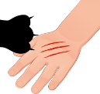
1.F………..…... |  | 2.K………..…... |  | 3.S………..…... |  | 4. T………..….. |  | 5. S………..…...
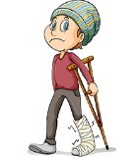 |  |  |  | 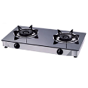 |  | 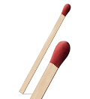 |  | 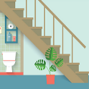
6.B………..…... |  | 7.C………..…... |  | 8.S………..…... |  | 9. M………..…... |  | 10.S………..…...
Exercise 2: Look and use the word(s) given to complete

 | - - Why shouldn’t I swim in this river?  - Because ………………………………………(drown)
 | - - Don’t ………………………………….(play).  - OK, I won’t.
- - Why shouldn’t I play with the cat?
- Because ……………………………………(scratch)
- - Why shouldn’t I run down the stairs?
- Because ……………………………………….(fall).
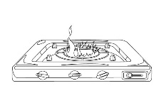 | - – Don’t …………………………….(stove).  - OK, I won’t.

Exercise 3: Match
1. Don’t play with the cat. | a. Because you may fall.
2. Where are you, Nam? | b. He’s riding his bike too fast.
3. Should she play with the match? | c. I’m cooking dinner.
4. Why shouldn’t I run down the stairs? | d. OK, I won’t.
5. What is he doing? | e. Because she may fall off her bike and break her arm.
6. Why shouldn’t he play with the stove? | f. I’m fall down stairs, Mum.
7. What are you doing, Hoa? | g. No, she shouldn’t
8. Why shouldn’t she ride her bike too fast? | h. Because he may get a burn.

1…… 2…… 3…… 4…… 5…… 6…… 7…… 8……
Exercise 4: Complete the dialogue
use apples sharp kitchen cut not

Dad: | Where are you?
Hoa: | I’m in the (1)………………………….
Dad: | What are you doing?
Hoa: | I’m cutting the (2)………………………….
Dad: | Don’t (3) ………………….that knife.
Hoa: | Why (4) ………………….?
Dad: | Because it is very (5) …………….. You may (6) ………. yourself!
Hoa: | OK, I won’t

Exercise 5: Choose the correct answer
1. You shouldn’t …………………………(swim/ to swim/ swimming) too far.
2. Tomorrow he …………………………(visit/ will visit/ visited) his classmate.
3. Don’t …………………………(play/ to play/ playing) with the sharp knife.
4. He is …………………………(playing/riding/climbing) wall.
5. What …………………………(is/ are/ will) the students going to do?

BÀI TẬP NÂNG CAO
Exercise 6: Fill in the blank with ONE word
1. What are you …………………now? – I’m cutting apples.
2. Don’t play…………………matches! – OK, I won’t.
3. He shouldn’t climb the wall because he may ……………and break his arm.
4. You may fall …………………your bike.
5. You shoulrn’t play with fire because you may get a …………………
6. Don’t …………………your car too fast.
7. Be carefully! The cat may …………………your face.
8. You shouldn’t play with that sharp knife because it’s very…………………
Exercise 7. Reorder the words to make sentences
1. I / shouldn't / climb / Why / tree? / that
=> ………………………………………………………………………………
2. run / Nga / Is / going / the / to / down / stairs?
=> ………………………………………………………………………………
3. scratch / Don't / the / neighbour's / it / because / cat / you. / may / play / with
=> ………………………………………………………………………………
4.too / her / Why / fast. / ride / bike / sister / shouldn't / your
=> ………………………………………………………………………………
5. ride / shouldn / wear / you / motorbike. / your / helmet / You / when / a
=> ………………………………………………………………………………
6. drown. / lake / the / she / She / into / shouldn't / may / because / jump
=> ………………………………………………………………………………
7. his / He / off / and / his / bike / broke / fall / leg.
=> ………………………………………………………………………………
8. to / his / driving / he / car / Is / cirty / the / centre?
=> ………………………………………………………………………………
9.the / pick / grapes. / to / to / climb / She / is / same / tree / going
=> ………………………………………………………………………………
10. for / river. / is / to / this / dangerous / in / It / very / you / swim
=> ………………………………………………………………………………
Exercise 8: Use the words given to make sentences
1. she/ cut/ the fruit/ the kitchen/ now/.
=> ………………………………………………………………………………
2. you/ shouldn’t/ go out alone/ evening.
=> ………………………………………………………………………………
3. not/ play/ the stove/ because/ you/ get/ burn
=> ………………………………………………………………………………
4. he/ climb/ neighrbor’s/ apple tree/ yesterday/?
=> ………………………………………………………………………………
5. not/ let/ your children/ play/ the/ kitchen/.
=> ………………………………………………………………………………
6. what/ you/ doing/ the/ knife/?
=> ………………………………………………………………………………
7. your son/ going/ run/ down/ stairs/?
=> ………………………………………………………………………………
8. the children/ their/ bikes/ the town/ now/?
=> ………………………………………………………………………………
Exercise 9: Give the correct form of the verbs in the brackets.
- Don’t (play) ………………..over there.
- She (cook) ………………. lunch in the kitchen at the moment.
- Look! He (climb) ……………….the tall tree over there.
- You may (fall) ……………….off your motorbike.
- My sister (go) ……………….to the doctor yesterday because she broken her arm.
- Where is Nam now? – He (watch) ………………. TV in the living room.
- ……………….she (break) ……………….her leg yesterday?
- Where (be) ……………….you last weekend?

Exercise 10. Rewrite the sentences, beginning with the words given
- He has a pain in his tooth.
=> He has………………………………………………………………………
2. What’s wrong with your mother?
=> What’s ………………………………………………………………………
3. My brother often goes to school on foot.
=> My brother …………………………………………………………………
4. They took a bus to the city centre.
=> They went to .………………………………………………………………
5. He had better not ride his bike too fast.
=> He ….………………………………………………………………………

Name: ……………  Grade 5 | Unit13: WHAT DO YOU DO IN YOUR FREE TIME?
BÀI TẬP CƠ BẢN
Exercise 1: Look and complete
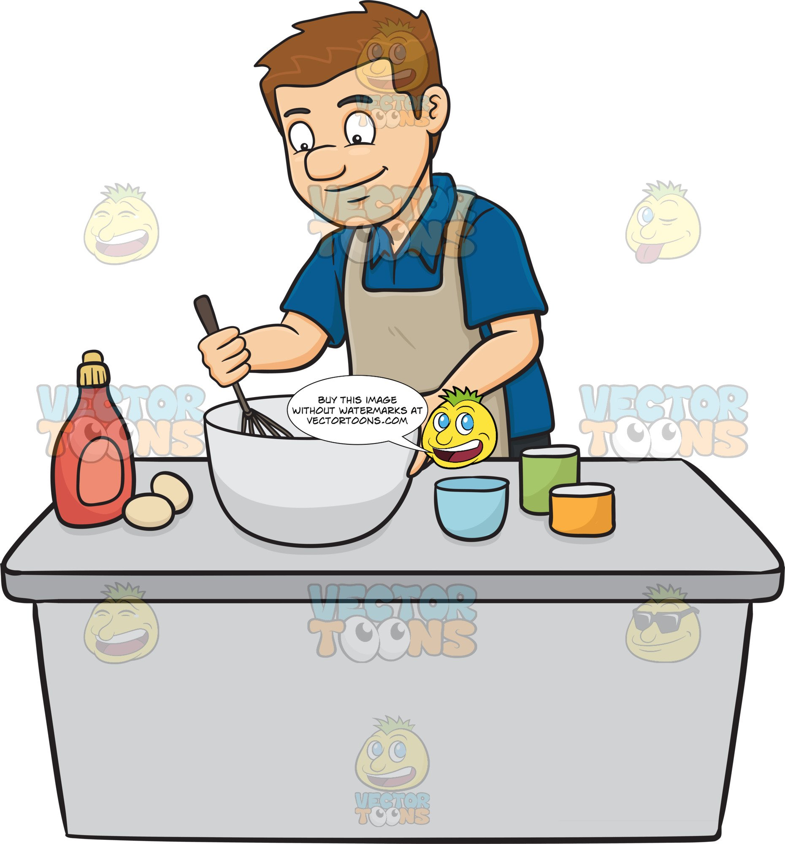
1. r_ _d a m_ _ _z_ _e 2. m_ _ _c_ _ _s

3. _ _ _ y b_ _ _ _ _ b_ll 4. W_ _ _h ca_ _ _ _ _s

5. _ _ _ w pi_ _ _ res 6. I _ _ _ en to m_ _ _ _
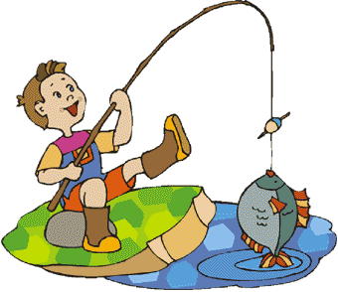
7. p_ _ y c_ _ _ uter g_ _ es 8. G_ fi_ _ _ _g
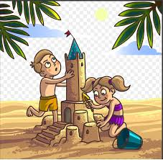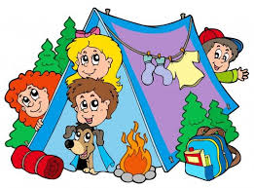
9. b_ _ _ d sa_ _ _ _ _ _ _ _s 10. g_ c_ _ _ _ng
Exercise 2: Look and answer.
 | 1.What do you often do in your free time ?  => ………………………………………….
 | 2.Does he often go skating in his free time?  =>………………………………………………
 | 3. What does she often do in her free time?  =>………………………………………………
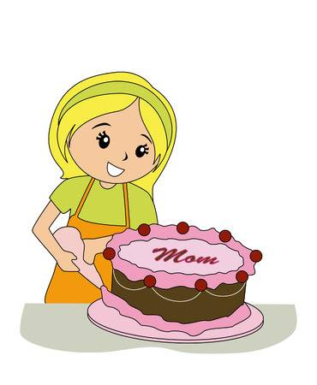 | 4. What does your mother do when she has free time? =>……………………………………………………………
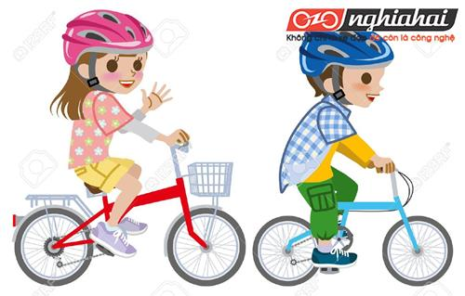 | 5.Do they often fly kites in the park in their free time? =>……………………………………………………………..
Exercise 3: Match.
.1.How often do you go camping? | A. She is working in the garden.
2.Do you like reading books? | B. I played football.
3.What did you do yesterday? | C.She goes skating twice a week.
4.What are you doing now? | D. Once a month
5,What is she doing? | E. No, she doesn’t
6.What do you do in your free time? | F. Yes, I do.
7.What does she do in her free time? | G. I usually play football
8. Does she often watch TV? | H. Yes. He is very sporty
9. Does your father pay sports in his free time? | I. She often goes shopping with her mother.
10.How often does Hoa go skating? | J. I’m reading comic books.

1………2…….3………4……..5……..6……...7………8………9……….10………
Exercise 4: Complete the diaglogue..
ride | time | Comic books | listen | twice
Nam: What do you do in your free (1)……………………….?
Nga: I often (2) …………………………my bike in the park. What about you?
Nam: I (3) ……………………..……to music and read books.
Nga: How often do you read books?
Nam: (4) ………………….……a week.
Nga: what book do you like reading?
Nam: I like reading (5)………………….….
Exercise 5: Underline one mistake in each sentence and correct it.
1.She usually doesn’t go to the zoo.
=>……………………………………………………………………………………
2. Is your brother late never for school?
=>……………………………………………………………………………………
3. They enjoy to go hiking in the forest.
=>……………………………………………………………………………………
4. My father and I often plays badminton in the afternoon.
=>……………………………………………………………………………………
5. How often does your father and mother watch TV?
=>……………………………………………………………………………………
6. She often plays gardening in her free time.
=>……………………………………………………………………………………
7. My brother never does baseball in his free time.
=>……………………………………………………………………………………
8. They worked on the garden yesterday.
=>……………………………………………………………………………………
9. Do you play tennis with your friend last weekend?
=>……………………………………………………………………………………
10. My family go to the park last week.
=>…………………………………………………………………………………….

BÀI TẬP NÂNG CAO
Exercise 6: Fill in the blank with ONE word.
- I often ……………..TV programs in my free time.
- She is……………..karate now.
- My mother often ……………shopping with my sister.
- ………….the weekends, we go on a picnic.
- He often …………..the Internet to chat with his friends.
- What ………………your father often do in the evening?
- ……………you play chess with Nam yesterday?
- ………………..to music is my hobby.
Exercise 7: Use the given words to make sentences.
- She / not / often / go / fishing / free time/.
=>…………………………………………………………………………………
- You / usually / go / music / club / Sunday/?
=>……………………………………………………………………………..……
- She / like / watch / animal / programs.
=>…………………………………………………………………………………
- My mother / clean / house / every day /.
=>…………………………………………………………………………………
- Your sister / read / comic books / her room / now /?
=>…………………………………………………………………………………
- How often / Hoa / go / skate /?
=>…………………………………………………………………………………
- My parents / like / watch TV / listen / music /.
=>…………………………………………………………………………………
- She / ride / bike / park / twice / week /?
=>…………………………………………………………………………………

Exercise 8: Reorder the words to make sentences.
- Do/ how/ go/ your/ the/ sisters/ cinema/ often/to /?
=>……………………………………………………………………………….
- Does/ in/ your/ mother/ what/ do/ free/ her/ time/?
=>……………………………………………………………………………….
- At/ your/ karate/ was/ brother/ club/ the/ yesterday/?
=>…………………………………………………………………………………
- Do/ your/ when/ grandparents/ what/ often/ do/ free/ time/ they/ have/?
=>…………………………………………………………………………………
- Nam/ in/ pictures/ draws/ free/ usually/ his/ time/.
=>………………………………………………………………………………..
- You/ may / some/ I/ my/ questions/ survey/ ask/ for/?
=>…………………………………………………………………………………
- In/ they/ did/ yesterday/ the/ work/ field/ morning/?
=>…………………………………………………………………………………
- You/ what/ were/ the/ you/ do/ music/ did/ when/ at/ club/?
=>………………………………………………………………………………….
- Play/ I/ my/ badminton/ friends/ free/ in/ my/ often/ with/ time/.
=>……………………………………………………………………………………
- Your/ computer/ sister/ games/ does/ sometimes/play/?
=>………………………………………………………………………………..

Exercise 9: Write questions for the underlined parts.
- My mother often reads newspapers in her free time.
=>…………………………………………………………………………………..
- I usually play football because I want to stay healthy and keep fit.
=>…………………………………………………………………………………..
- His father likes going fishing in the river.
=>……………………………………………………………………………………
- They go to the zoo once a week.
=>……………………………………………………………………………………
- Yes. She often watches cartoons in the evening.
=>……………………………………………………………………………………..
- Ba did his homework yesterday afternoon.
=>……………………………………………………………………………………
- No. they didn’t play football in the schoolyard.
=>……………………………………………………………………………………
- My mother is going to take me to the zoo this weekend.
=>……………………………………………………………………………………

Exercise 10 : Read and answer.
My name is Huong . I’m ten years old. In my free time, I often read story books. My favourite story is Snow White and the Seven Dwarfs. I like reading books because it helps me widen knowledge. My father often watches sports programs on TV because he is a big fan of football. My mother likes cooking. She usually cooks meals for our family. My brother, Phong likes playing sports. He often does karate in his free time. At weekends, my family goes camping or goes for a picnic. We go for a picnic once a month.
- What does Huong do in her free time?
=>………………………………………………………………………………..
- What is her favourite story?
=>………………………………………………………………………………..
- Why does she like reading books?
=>…………………………………………………………………………………
- What does her father often do?
=>………………………………………………………………………………….
- What does her mother like doing?
=>……………………………………………………………………………………
- What does her brother do in his free time?
=>………………………………………………………………………………….
- What do they do at weekends?
=>………………………………………………………………………………….
- How often do they go for a picnic?
=>……………………………………………………………………………………

Name: …………………..  Grade 5 | UNIT 14: WHAT HAPPENED IN THE STORY?
BÀI TẬP CƠ BẢN
Exercise 1: Look and Complete.
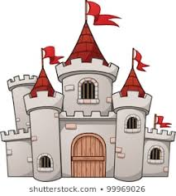  1. C_ _ _ _ E |  |   2. _ _ _ G |  |   3. _ _ _ ERM _ _ _ N
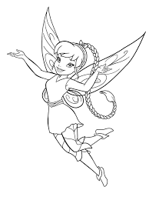  4. F _ _ _ Y |  |   5. _ _ _ N _ _ |  |   6.p _ _ _ C _ _ _
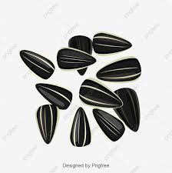  7. _ _ _ D |   8. Q _ _ _ _ |  | 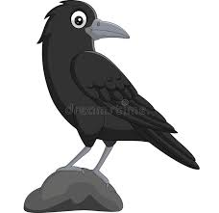  9. _ _ _ W |  |   10. w_ _ _ _
Exercise 2: Look and use the word(s) given to answer.
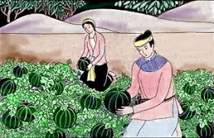 | 1. What do you think of Mai An Tiem in the story of Mai An Tiem?  (hard-working)  …………………………………………………..
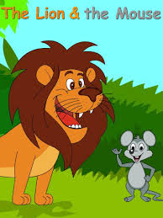 | 2. What does he think of the mouse in The Lion and The Mouse?  (intelligent)  ………………………………………………….
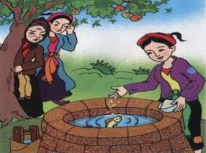 | 3. What do you think of Cam in the story of Tam and Cam?  (cruel)  …………………………………………………..
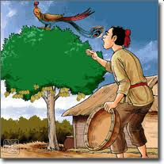 | 4. What does your sister think of the younger brother in The Golden Starfruit Tree?  (honest and gentle)  …………………………………………………….

Exercise 3: Match.
1. What do you think of the main character? | A. I’m reading The story of Mai An Tiem.
2. What is she doing? | B. They think she is cruel.
3. What are you reading, Hoa? | C. He likes comic books and sory books.
4. What do they think of Cam? | D. I like A Cinderella Story.
5. What kinds of book does your brother like? | E. Because it is interesting.
6. Who is the main character in his story? | F. She is reading a story.
7. Why does he like that story? | G. I think he’s honest.
8. What story do you like? | H. It is Aladdin.
dgg
1………2………3……….4……….5……….6………..7……….8………..
Exercise 5: Read and complete the dialogue.
cruel | story | right | gentle | like | read
ggrsg
Tom: | What are you doing?
Mai: | The (1) ……………………….of Tam and Cam.
Tom: | I (2) ………….it yesterday. I like it so much. What do you think of Tam?
Mai: | I think she is (3) ………………………..
Tom: | Yeah, You’re (4)…………………..How about Cam?
Mai: | She’s very (5)………………………
Tom: | Do you (7)……………………it?
Mai: | Yes, I do.
Exerxise 5: Fill in the blank with ONE word.
1. The main ……………..in this story are the two brothers.
2. We can learn a useful lesson …………………this story.
3. In the ……………………, they got married.
4. What do you think ………………….the older brother?
5. My hobby is …………………………………books.
6. They live ……………………..an island.
7. He ……………………….generous and kind.
8. Mai An Tiem ………………….the watermelons for food and drink.
BÀI TẬP NÂNG CAO
Exercise 6: Circle the correct answer.
1. They lived …………………..(happy/ happily/ unhappy) forever.
2. Is he ………………………(a/an/ this) honest man?
3. A long time ago, there …………………(is/ are/ was/ were) a fox and a crow.
4. He……………………her a bunch of flowers yesterday. (gived/ gives/ gave)
5. One day, King Hung became …………with Mai An Tiem.(angry/ angrily/ anger)
6. She ……………………..it last week. (reads/ is reading/ read)
Exercise 7: Reorder the words to make sentences.
1. gentle/ she/ very/ thinks/ the/ is/ man/ younger/ .
…………………………………………………………………………………
2. fairy/ like/ do/ comic/ you/ books/ or/ tales/ reading/ ?
…………………………………………………………………………………
3. be/ us/ greedy/ all/ so/ of/ shouldn’t/.
…………………………………………………………………………………
The/ What/ story/ main/ of/ Nam/ this/ character/ does/ think/ in/ ?
…………………………………………………………………………………
5. big/ she/ a/ she/ castle/ was/ lived/ but/ unhappy/ very/ in/.
…………………………………………………………………………………
6. your/ Which/ does/ like/ sister/ character/ best/ ?
…………………………………………………………………………………
7. did/ read/ story/ week/ she/ this/ last/?
…………………………………………………………………………………
8. reading/ I/ because/ are/ fairy/ like/ interesting/ tales/ they/.
…………………………………………………………………………………
Exercise 8: Use the words given to make sentences.
1. can/ you/ learn/ lesson/ this story/?
…………………………………………………………………………………
2. she/ read/ interesting/ story/ her/ room/ now/ .
…………………………………………………………………………………
3. your brother/ think/ fox/ stupid/ ?
…………………………………………………………………………………
4. What/ kinds/ stories/ your mother/ like/ read/ free time/ ?
…………………………………………………………………………………
5. her/ step-mother/ ordered/ her/ do/ a lot/ housework/.
…………………………………………………………………………………
6. long/ time/ ago/ there/ beautiful/ princess/ Who/ lived/ big/ castle/.
…………………………………………………………………………………
7. it/ Vietnamese story/ two brothers/ ?
…………………………………………………………………………………

8. fairy tales/ interesting/ because/ they/ often/ give/ us/ a lot/ surprises/.
…………………………………………………………………………………
Exercise 9: Write about you.
1. What do you often do in your free time?
…………………………………………………………………………………
2. Do you like reading fairy tales?
…………………………………………………………………………………
3. What is your favourite fairy tales?
…………………………………………………………………………………
4. What do you think of the main character(s)?
…………………………………………………………………………………
5. Why do you like it ?
…………………………………………………………………………………
Exercise 10: Read and Complete.
Once upon a time, there was a beautiful and gentle girl named Tam. Her mother died when she was very young. She lived with her father, who loved her very much. However, things changed when her father remarried. Her step-mother and her step-sister named Cam treated her badly. Cam was as cruel as her mother. They made her do a lot of housework. Then one day, Tam met the king thanks to a fairy’s help. He king married Tam. Next, Cam and her mother found many different ways to kill Tam bu they didn’t succeed. In the end, Tam and the king lived happily ever after.
1. Tam was a ……………………………………………………………….
2. Cam and her mother are very……………………………………………
3. They forced Tam to……………………………………………………..
4. A fairy helped Tam see……………………………….…………………
5.Cam and her mother failed to ……………………..…………………….
6. Tam and the king finally ………………………………………………..

Name: ………………  Grade 5 | UNIT 15: WHAT WOULD YOU LIKE TO BE IN THE FUTURE ?
BÀI TẬP CƠ BẢN
Exercise 1: Look and complete.
Spaceship Writer Planet Designer flight

Artist patient Astronaut architect gardener

  1………………………….. |   2……………………………..
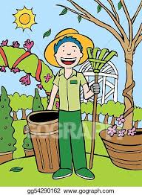  3………………………………. |   4……………………………..
  5………………………………… |   6………………………………….
  7……………………………….. |   8…………………………………
  9………………………………. | 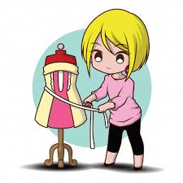  10…………………………..

Exercise 2: Look and answer.
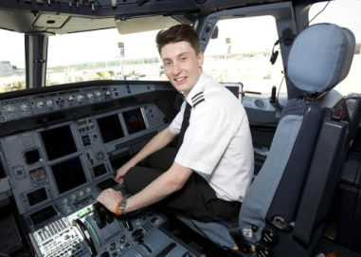 | 1.What would you like to be in the future?  ………………………………………………………
 | 2. What would you like to be in the future?  ………………………………………………………
 | 3. What would you like to be in the future?  ………………………………………………………
 | 4. What would you like to be in the future?  ………………………………………………………
5. What would you like to be in the future?
………………………………………………………

Exercise 3: Match.
1.What would you like to be in the future? | A. Because I’d like to travel in space.
2.What would she like to be in the future? | B. I think it is great.
3.Would you like to be a designer? | C. I would like to be an engineer.
4.Why would you like to be an astronaut? | D. Yes, I would
5. I would like to become a doctor.  What do think of it? | E. She would like to be teacher

1………..2………..3……….4………..5…………
Exercise 4; Fill in the blank with ONE word.
1.She likes writing stories. She wants to be a/an ……………………………
2.My brother wants to fly a plane. He’d like to become a/an ………………………
3.She wants to teach children. She wants to become a/ an…………………………..
4.Nam likes drawing and designing buildings. He would like to be a/ an
…………………………………when he grows up
5.My cousin enjoys playing football. He wants to become a /an ……………………..
6.He’d like to fly in space and work with other people in a spaceship. He’d like to be
a / an…………………………
7.She would like to look after patients. She would like to be a /an………………….
8.My daughter likes singing. She would like to be a/ an……………………….

Exercise 5: Complete the dialogue with ONE word.
Trung : What would you (1) ……………………………….to be in the future?
Huong: I would like to be a (2)………………………………………………..
Trung : Why ?
Huong: (3)……………………………………………. I would like to teach young children.
Trung: Working (4)…………………………………a teacher is hard word.
Huong: Yes, I know. But it is a rewarding job. How about you?
Trung : I would like to become a (5)…………………………………because I like playing soccer so much.

BÀI TẬP NÂNG CAO.
Exercise 6: Write questions for the underlined parts..
- I would like to be an engineer
………………………………………………………………………………
2.My brother would like to be a pilot because he loves flying a plane.
………………………………………………………………………………
3.Yes. My son would like to be a doctor.
………………………………………………………………………………
4.He would like to be a taxi driver.
…..…………………………………………………………………………
5.No.I don’t want to be a singer.
………………………………………………………………………………
Exercise 7: Give the correct form of the verbs.
- Linda would like ……………………………………..(be) a nurse.
- I…………………………….(write) short stories now.
- They like ……………………………………… (work) on a farm.
- What………………………he………………………(do) in his free time?
- She usually……………………………………….(read) comic books.
- What would your sister like ………………………(do) in her free time?
- …………………..they ………………………(want) to become teachers?
- You should ………………………………………..(study) hard.
Exercise 8: Reorder the words to make sentences.
1.like/ future/ to/ would/ in/ she/ what/ be/ the/ ?
………………………………………………………………………………
2.you/ like/ what/ grow/ would/ to/ up/ be/ you/ when/?
………………………………………………………………………………
3.like/ vegetables/ would/ grow/ and raise/ Nam/ cattle/ to/ ?
…………………………………………………………………………………
4.my/ English/ parents/ to/ teacher/ want/ become/ me/ an/.
……………………………………………………………………………………
5.would/ when/ leaves/ he/ to/ a/ doctor/ school/ be/ engineer/ he/ like/ or/ an/ ?
…………………………………………………………………………………
…………………………………………………………………………………..
6.I/ to/ would/ short/ become/ stories/ a/ writing/ I/ like/ like/ write/ because/.
…………………………………………………………………………………
…………………………………………………………………………………
7.like/ free/ what/ in/ to/ your/ hoa/ would/ you/ time/,/ do/ ?
……………………………………………………………………………………
8.travel/ he/ world/ the/ like/ to/ would/ around/.
……………………………………………………………………………………
Exercise 9: Use the given words to make sentences.
1.you/ like/ be/ teacher/ doctor/ Nam/?
………….……………………………………………………………………….
2.why/ your brother/ like/ be/ pilot/?
…….……………………………………………………………………………
3.she/ would/ like/ take/ care/ sick/ people/
………………………………………………………………………………….
4. what/ would/ she/ like/ be/ future/ ?
……………………………………………………………………………………..
5.would/ she/ like/ accountant/ when/ grow/ up/?
……………………………………………………………………………………
6.would/ they/ like/ drink/ coffee/ tea/?
…………………………………………………………………………………….
7. he/ want/ work/ factory/?
……………………………………………………………………………………
8.my friend/ want/ design/ bridges/ his town/ so/ he/ would/ like/ be/ architect/
……………………………………………………………………………………
Exercise 10: Read and circle True (T) or False (F).
My name is Tuan. I come from Da Nang. When I grow up, I would like to be a doctor.I want to help poor patients and disables people.I would like to work with other people to find cures for serious illnesses such as cancer. I know that working as a doctor is hard work, but I would like to do it.I think it is a rewarding job. I’m studying hard now. I hope that I will make my dream come true in the future.

1.Tuan would like to become a nurse | T | F
2.He would like to do that job because he wants to make a lot of money | T | F
3.He would like to help poor people | T | F
4.He would like to work in a team to find cures for seriuos illnesses | T | F
5.He doesn’t know that it is a difficult job | T | F

Name: ………………  Grade 5 | Unit 16: WHERE’S THE POST OFFICE?
BÀI TẬP CƠ BẢN

Exercise 1: Look and complete.
 |   1. p _ _ _ |  |  |   2._ _ _ _ ma_ _ |  |  |  |   3.c_ _ _ m_
 |   4. _ _ _d_ _ _ |  |  |   5. m _ _ k _ _. |  |  |  |   6._ _sp_ _ _ _
 | 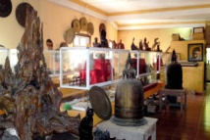  7.m _ _ _ _m |  | 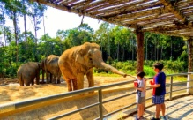  8. z_ _ |  |  |   9. t _ _ _t_ _ |  |  |  | 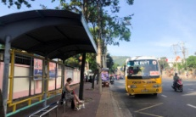  10.b_ _ s _ _ _
Exercise 2: Look and answer.

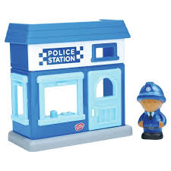 | - Excuse me, where’s the police staion?  ………………………………………………….
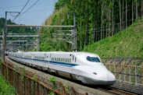 | - How can I get to the stadium?  ………………………………..……………….
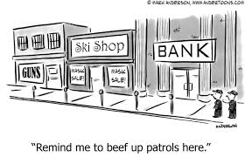 | - Excuse me, where’s the bank?  ………………………………………………….
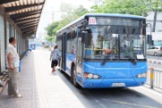 | - How can I get to the museum?  ……………………………….…..……………….
 | - How are you going to Ho Chi Minh city, Nam and Hoa?  ………………………………………………..….

Exercise 3: Match
1. How can I get there? | a. Yes, quite far.
2. Excuse me. Where’s the souvenir? | b. I’m going to Ho Chi Minh city.
3. Is it far from here? | c. You can take bus number 3.
4. Are you going to get there by plane, Nam and Phong? | d. Yes, there is one at the end of this street.
5. Is there a restaurant around here? | e. Yes, we are.
6. Where are you going next week? | f. It’s between the bank and the pharmacy.

1…… 2…… 3…… 4…… 5…… 6…… 7…… 8……

Exercise 4: Read and Complete.

At the end plane walk straight take opposite on foot between

- You can …….…………... bus number 07 to get there.
- Turn right and then go …………….……...ahead.
- The cinema………………….……the school and the supermarket.
- Korea is far from Vietnam, so you should go by ……………………….
- The post office is near here. We can ……………………..…
- It is ………………………... of the street.
- The park is …………………….….. the museum.
- You can go ……………………………….

Exercise 5: Complete the dialogue with on word

Passer-by: | Excuse (1)…………, where (2)…………. the pharmacy, please?
Mai: | First, (3) ………… straight ahead. Then take the first turning (4) ……………the right. It is (5) …………the bank and the post office.
Passer-by: | How can I get there?
Mai : | You can (6)………………a taxi.
Passer-by: | Thank a lot.
Mai: | You’re (7) ………………

BÀI TẬP NÂNG CAO

Exercise 6: Circle the correct answer
1.The bakery is …………………of the pharmacy.
A. next to B. opposite C. behind D. in front
2. …………………can I get there? – By train.
A. Where B. Who C. How D. How often
3. Would you like ……………these letters.
A. send B. sending C. to send D. to sending
4. Could you tell me how …………………to the bank?
A. get B. to get C. getting D. to getting
5. The restaurant is on the corner ……….. the street.
A. on B. at C. of D. to
6. His house is…………………to the school.
A. opposite B. behind C. next D. between
7. The bank is …………………the restaurant and the hotel.
A. between B. right C. in front of D. next
8. Let’s go …………………foot.
A. by B. on C. at D. with
9. The bus stop is …………………from here.
A. near B. opposite C. next D. far
10. …………………don’t we take a bus?
A. What B. Why C. How D. When
11. Going by plane is …………………than going by coach.
A. fast B. fastest C. more fastly D. faster

Exercise 7. Underline one mistake in each sentence and correct it.

1. There is a bank next our school.
=> ………………………………………………………………………………
2. The supermarket is on the end of the street.
=> ………………………………………………………………………………
3. You can go a taxi.
=> ………………………………………………………………………………
4. Go out from the building and then turn right.
=> ………………………………………………………………………………
5. You can take a coach get to the cinema.
=> ………………………………………………………………………………
6. I’m going by plane so I don’t have much time.
=> ………………………………………………………………………………
7. The post office is behind of the bank.
=> ………………………………………………………………………………
8. There is two department stores in my neighborhood?
=> ………………………………………………………………………………
Exercise 8: Reorder the words to make sentences.

1. there/ take/ you/ get/ can/ number 5/ to/ bus.
=> ………………………………………………………………………………
2. Street/ the/ turn/ of/ right/ end/ at/ the/.
=> ………………………………………………………………………………
3. to/ / go/ the/ to/ I/ buy/ food/ want/ supermarket/ to/ some/.
=> ………………………………………………………………………………
4. corner/ street/ of/ the/ stadium/ the/ is/ on/ the/?
=> ………………………………………………………………………………
5. Island/ have/ to/ next/ we/ trip/ are/ weekend/ a/ going/ to/ Phu Quoc/.
=> ………………………………………………………………………………
6. Taxi/ it/ I/ take/ going/ think/ is/ a/ we/ than/ bus/ by/ cheaper/ should/ because/.
=> ………………………………………………………………………………
7. bank/ the/ it/ to/ of/ street/ next/ is/ the/ the/ at/ end/,/ .
=> ………………………………………………………………………………
8. the/ post office/ please/ could/ way/ you/ to/ show/ me/ the/, /?
=> ………………………………………………………………………………
Exercise 9: Fill in the blank with ONE word.
- The museum is in front ………………..the cinema.
- The bus number 32 stops right ………………. The cinema entrance.
- They can go ……………….foot.
- We are going to take ……………….train to our hometown.
- Going by plane is ……………….expensive then going by coach.
- Is it far ……………… the city centre?
- She wants……………….visit Ha Long Bay.
- You will see a hotel ……………….the right.

Exercise 10. Read and answer.
Hoa: | Good morning! Can I speak to Mai, please?
Mai: | Speaking! It’s Mai.
Hoa: | Are you going to visit me?
Mai: | Yes, I’m going to Hanoi next weekend.
Hoa: | I’m happy to hear that.
Mai: | Can you show me the way to your house?
Hoa: | First, you can take a train to the railway station. From here, you can take bus number 32 and get off at the eighth stop in Ho Tung Mau street. Then walk along this street for 5 minutes and you will see a big supermarket, next to the bank. My house is opposite the supermarket. It is between the pharmacy and the bakery.
Mai: | Thank you. When I get there, I’ll call you.
Hoa: | See you!

1. When is Mai going to visit Hoa?
=> ………………………………………………………………………………
2. What bus should Mai take?
=> ………………………………………………………………………………
3. Where should she get off the bus?
=> ………………………………………………………………………………
4. What’s the name of the street that she will get off the bus?
=> ………………………………………………………………………………
5. What is next to the supermarket?
=> ………………………………………………………………………………
6. Is Hoa’s house behind the supermarket?
=> ………………………………………………………………………………

Name: ………………  Grade 5 | Unit 17: WHAT WOULD YOU LIKE TO EAT?
BÀI TẬP CƠ BẢN

Exercise 1: Look and complete
 |  |  |  |  |  | 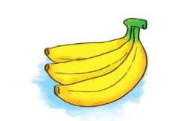 |  | 
1.………..…... |  | 2.………..…... |  | 3….………..…... |  | 4. ………..….. |  | 5. ………..…...
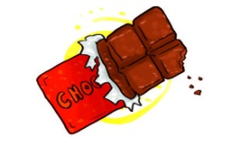 |  |  |  | 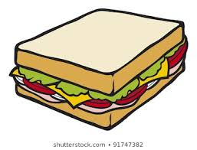 |  | 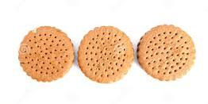 |  | 
..…………..…... |  | 7…………..…... |  | 8….………..…... |  | 9. ………..…... |  | 10…………..…...
Exercise 2: Look and use the word(s) given to complete

 | - What would you like to drink?  =>……………………………………………………..
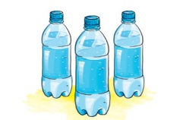 | - How many water do you drink every day?  =>……………………………………………………..
 | - What would you like to eat?  =>……………………………………………………..
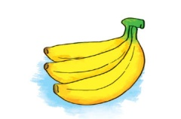 | - How many bananas does she eat every day?  =>……………………………………………………..
 | - What would you like to eat?  =>……………………………………………………..

Exercise 3: Match

1. How many oranges do you eat every day? | a. Yes, please.
2. What would you like to drink? | b. I drink two bottles.
3. Would you like to drink coffee? | c. She eats two bowls.
4. How many water do you drink every day? | d. I would like a glass of water.
5. How much rice does she eat every day? | e.I eat three oranges.

1…… 2…… 3…… 4…… 5……

Exercise 4: Complete the dialogue

bottles glass rice like How much How many

Nga: | How much (1)……………………..do you eat every day?
Huong: | I eat three bowls.
Nga: | (2)……………………… water do you drink every day?
Huong: | I drink two (3)……………………..
Nga: | (4) ……………………….sausages do you eat every day?
Huong: | Two sausages.
Nga: | Do you (5) ……………… milk?
Huong: | Yes, I do.
Nga: | How much milk do you drink every day?
Huong: | Two cartons.
Nga: | I aslo like milk. I drink a big (6) ………………. every day.

Exercise 5: Circle the correct answer.
1. What would you like to eat? - A bowl of ………………, please.
A. water | B. noodles | C. soda | D. coffee
2. I’m very thirsty. I want some……………….
A. orange juice | B. rice | C. fish | D. seafood
3. What’s your favourite food? - It’s …………………...
A. bread | B. apple juice | C. lemonade | D. milk
4. …………………. chocolate do you eat every day? - Two bars.
A. How | B. How much | C. How many | D. How often
5.………………..do you go out for dinner? - Once a month.
A. When | B. How much | C. How many | D. How often
6. We want two…………………
A. water | B. milk | C. apples | D. rice
7. He would like …………………..apples.
A. a | B. an | C. some | D. much
8. How many ………………….of biscuits do you want?
A. packets | B. bowls | C. bottles | D. carton
9. ……………………fruit do you like best? - Grapes.
A. How | B. Where | C. Who | D. What
10. Vegatables are good ……………you.
A. to | B. at | C. for | D. with

BÀI TẬP NÂNG CAO
eger
Exercise 6: Fill in the blank with ONE word
1. I usually ………………………four eggs every week.
2. I would like to eat a…………………….of chocolate.
3. How……………..butter do you eat every day?
4. You may fall …………………your bike.
5. What would you like to drink? - A……………….of tea, please.
6. How……………….bananas does she eat every day? - Two bananas.
7. I would like to buy ……………….packet of biscuits.
8. …………………you like cheese? - No, I don’t.
eger
Exercise 7. Reorder the words to make sentences
eger
1. and / I / drink / of / eat / a / two / carton / milk / apples / every day.
=> ………………………………………………………………………………
2. has / she / of / breakfast / usually / a / eggs / bread / with / loaf / for /.
=> ………………………………………………………………………………
3. your / How / brother / orange / every day / much / juice / does / drink /?
=> ………………………………………………………………………………
4. of / to / he / glass / a water / would / drink / like / big /.
=> ………………………………………………………………………………
5. to / the / let’s / apples / go / buy / market / some / and /.
=> ………………………………………………………………………………
6. eat / many / too / teeth / you / your / sweets / for / because / good / shouldn’t / they / not / are /.
=> ………………………………………………………………………………
eger
Exercise 8: Use the given words to make sentences.
eger
1. I / like / big / bowl / noodles / please / .
=> ………………………………………………………………………………
2. Would / you / like / drink / glass / orange juice /?
=> ………………………………………………………………………………
3. How / milk / he / drink / every day ?
=> ………………………………………………………………………………
4. Hoa / eat / two / sausage / a / packet / biscuits / every day / .
=> ………………………………………………………………………………
5. He / like / two / egg / drink / cup / coffee / please / .
=> ………………………………………………………………………………
6. She / usually / eat / bread / with / sausages / milk / breakfast /.
=> ………………………………………………………………………………
7. How / bananas / your sister / eat / every day /?
=> ………………………………………………………………………………
8. What / your brother / food / drink /?
=> ………………………………………………………………………………

Exercise 9: Find and correct the mistakes.
eger
1. How much chocolate bars do you eat everyday?
=> ………………………………………………………………………………
2. She eats two big glasses of water every day.
=> ………………………………………………………………………………
3. Do you usually drink milks in the morning?
=> ………………………………………………………………………………
4. He likes eating some sausages and egg every morning.
=> ………………………………………………………………………………
5. How many biscuit do you eat every day?
=> ………………………………………………………………………………
6. What shouldn’t you eat too much chocolate?
=> ………………………………………………………………………………
7. What would you like drink, Nam? – Orange juice, please.
=> ………………………………………………………………………………
8. I drink four bottle of water every day.
=> ………………………………………………………………………………
eger
Exercise 10. Read and answer.
eger
My name’s Huong. I’m from Hanoi, Vietnam. I’m in grade 5. I like eating bread, so I usually eat bread with sausages, butter and eggs, and drink a carton of milk for breakfast. My sister, Hoa often has a bowl of noodles and a glass of orange juice for breakfast. We never skip breakfast because we know that it is a very important meal. We go to school from 7.30 a.m to 4.30 p.m, so we don’t have lunch at home. We eat lunch at the school canteen. We often have rice with fish or meat and fruit juice. Fruit juice is my favourite drink.

1. What’s her sister’s name?
=> …………………………………………………………………………………
2. What does Huong like eating for breakfast?
=> …………………………………………………………………………………
3. What is Huong’s favourite drink?
=> …………………………………………………………………………………
4. What time do they go to school?
=> …………………………………………………………………………………
5. Do they eat lunch at home from Monday to Friday?
=> ……..….………………………………………………………………………
Name: ………………  Grade 5 | Unit 18: WHAT WILL THE WEATHER BE LIKE TOMORROW?

BÀI TẬP CƠ BẢN

Exercise 1: Look and complete.

  1.S_ _ _ _ |  | 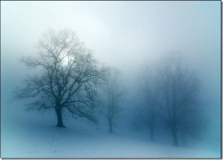  2._ _ _ _ Y |  |   3.S _ _ _ Y
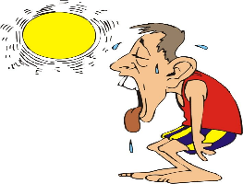  4. _ _ T |  |   5. _ _ _ _ Y |  |   6. C _ _ _
  7. _ _ _ _ DY |   8. _ _ Y |  |   9. W _ _ _ Y |  |   10.S _ _ _ _ Y

Exercise 2: Look and answer.

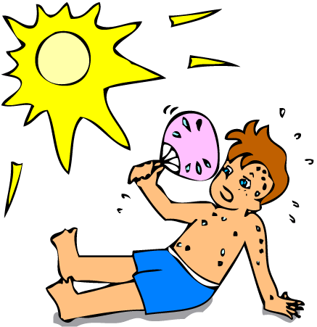 | - What summer like in your country?  …………..………………………………………
 | - What will the weather be like tomorrow?  ………...………………………………………..
 | - What is the weather like today?  …………………………………………………
 | - What’s winter like in your country?  ……………….………………………………..
 | - What’s spring like in your country?  ………..………………………………………..

Exercise 3: Match.

1. What’s the weather like in Hanoi? | A. There are four.
2. What’s your favourite season? | B. No, there isn’t.
3. How many season are there in a year? | C. It will be hot and sunny.
4. What will the weather be like tomorrow? | D. It is rainy.
5. Is there snow in winter in your country? | E. It is summer.

1…… 2…… 3…… 4…… 5……

Exercise 4: Circle the correct answer.

- It’s usually ……………. in summer.
- cold B. hot C. cool D. warm
- What do you do ……….. winter?
- on B. in C. at D. of
- I like spring because the ………… is warm.
A. sport B. seasons C. weather D. activities
- …………….. is the weather like today?
A. What B. Where C. When D. How
- There ……….. often a lot of rain in summer in my country.
A. is B. are C. was D. will be
- …………… the weather fine today?
A. Is B. Are C. Was D. Will

- What ………… you often do in summer?
- are B. do C. did D. will
- Her family ………………. Skiing this winter.
- go B. goes C. went D. is going
Exercise 5: Read and complete.
four
hot
seasons
season
capital
summer

Linda: Where do you live, Mai?
Mai: I live in Hanoi, the (1)…………………. of Vietnam.
Linda: How many (2)………………… are there?
Mai: There are (3)………………………
Linda: What are they?
Mai: They’re spring, summer, autumn and winter.
Linda: What’s your favourite (4)…………………..
Mai: It’s (5)………………. I often go swimming with my parents.
Linda: What’s summer like in your country?
Mai: It’s usually (6) …………………….

Exercise 6: Odd one out.

- A. spring B. summer C. season D. autumn
- A. windy B. cloudy C. sunny D. rain
- A. cold B. sun C. hot D. warm
- A. waether B. snowy C. stormy D. foggy
- A. sports B. trees C. plants D. flower

BÀI TẬP NÂNG CAO

Exercise 7: Fill in the blank with ONE word

1. What will the weather …………………like tomorrow morning?
2. Summer…………………in my season.
3. There is a lot ……………wind in winter.
4. Do you …………………winter? No, I like spring.
5. The …………………is cool in Hanoi today.

Exercise 8. Reorder the words to make sentences

1. will / like / Ho Chi Minh / the / City / weather / in / be / tomorrow / What/ ?
=> ………………………………………………………………………………
2. summer / our / it / and hot / is / country / sunny / usually / in / in / .
=> ………………………………………………………………………………
3. like / What / country / is / in / autumn / your / ?
=> ………………………………………………………………………………
4. in / It / foggy / spring / is / and / usually / my / cool / country / in / .
=> ………………………………………………………………………………
5. only / my / There / in / two / are / hometown / seasons / .
=> ………………………………………………………………………………
6. you / summer / parents / in / go / Do / swimming / your / with / often / ?
=> ………………………………………………………………………………

Exercise 9: Write questions for the underline part.

1. There are four seasons in a year in her country.
=> ………………………………………………………………………………
2. The rain season is usually hot and wet.
=> ………………………………………………………………………………
3. Her favourite season is autumn.
=> ………………………………………………………………………………
4. He likes summer because he can go camping with his friends.
=> ………………………………………………………………………………
5. They often go swimming in summer.
=> ………………………………………………………………………………
ddaad
Exercise 10: Rewrite the sentences beginning with the given words.
ddaad
- Summer in my country is cooler than that in her country.
=> ……………………………………………………………………
- There are a lot of trees in my garden.
=> ……………………………………………………………………
- She like summer best.
=> ……………………………………………………………………
- It’s very hot, so we don’t go out.
=> ……………………………………………………………………
- Why don’t we go for a picnic tomorrow.
=>……………………………………………………………………
Name: …………………  Grade 5 | UNIT 19: WHICH PLACE WOULD YOU LIKE TO VISIT?
BÀI TẬP CƠ BẢN
Exercise 1: Look and complete.
  1. t_ _ _ l _ | 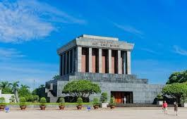  2. _ _ _ are |   3. s _ _ t _ _
  4. b_ _ _ g _ |   5. l _ _ _ |   6. _ _ _ o _ a
  7. th _ _ _ _ e | 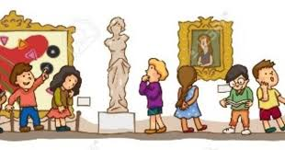  8. m_ s_ _ |   9. am_ s _ment p _ r k
_
Exercise 2: Look and answer.
 | 1. Which place would you like to visit?  …………………………………………………….
 | 2. Which place would you like to visit?  …………………………………………………….
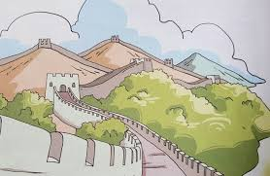 | 3. Which place would you like to visit?  …………………………………………………….
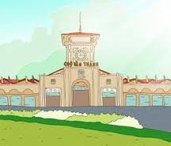 | 4. Which place would you like to visit?  …………………………………………………….
 | 5. Which place would you like to visit?  …………………………………………………….

Exercise 3: Match.
1. Which place would he like to visit? | A. I’d like to visit Ha Long Bay.
2. How can I get there?. | B. I think it is more exciting than I expected.
3. Is it far from here. | C. He would like to visit Thien Mu pagoda.
4. Which place would you like to visit, Ha Long Bay or Bai Dinh Pagoda? | D. You can take a taxi.
5. What do you think of Dam Sen Park?. | E. No, It isn’t.

1………2………..3……….4……….5………..
Exercise 4: Circle the correct answer.
- ………………. place would you like to visit, Thu Le Zoo or Thong Nhat Park?.
- Where B. When C. Which D. How
- He think it is more than…………….. he expected.
- attractive B. taller C. larger D. old
- ……………….. go to Ha Noi last week?.
- Are B. Do C. Did D. Were
- ……………….. did you go last month?. – I went to Nha Trang.
- Which B. What C. How D. Where
- ………………… did you go to Ho Chi Minh City?. – By plane.
- Which B. Why C. How D. Where
- She would like……………….. Hoi An Ancient Town.
- visit B. visiting C. to visit D. to visiting
- This pagoda is………………. an island in the middle of West Lake.
- at B. on C. in D. of
- I ……………………. Da Nang last weekend.
- visit B. am visiting C. will visit D. visited

exercise 5: Complete the dialogue.
get
again
family
interesting
saw

Hoa: | Where did you go yesterday?
Nam: | I went to Thu Le Zoo with my (1)……………………
Hoa: | How did you (2)…………………. there?.
Nam: | We took a bus.
Hoa: | What do you think of it?
Nam: | It’s more (3)……………………. than I expected. I (4)……………….. a lot of animals.
Hoa: | Do you want to go their (5)………………… ?.
Nam: | Yes, I do.

BÀI TẬP NÂNG CAO
Exercise 6: Reoder the words to make sentences.
- than/ Nam/ he/ Da Nang/ more/ is/ expected/ exciting/ thinks/.
……………………………………………………………………………………….
- Bay/ did/ Ha Long/ you/ coach/ go/ by/ to/ ?.
……………………………………………………………………………………….
- are/ I/ get/ and/ the/ is/ would/ to/ the/ delicious/ people/ there/ like/ friendly/ because/ food/.
..……………………………………………………………………………………..
- Phu Quoc/ is/ next/ will/ think/ go/ I/ to/ year/ Island.
………………………………………………………………………………………
- Ho Chi Minh/ he/ City/ week/ Ben Thanh Market/ visited/ in/ last/.
……..………………………………………………………………………………..
- of/ what/ does/ Bat Trang/ he/ village/think/ Pottery/ ?.
.……………………………………………………………………………………..
- my/to/ Bay/ one/ visit/ mother/ day/ Ha Long/ wants/.
……………………………………………………………………………………..
- summer/ we/ Da Lat/ our/ went/ holiday/ to/ friends/ with/ last/.
……………………………………………………………………………………..
Exercise 7: Use the words given to make sentences.
1. they/ visit/ Dong Xuan Market/ yesterday/?.
……………………………………………………………………………………..
2. we/ learnt/ more/ history/ Hue/after/ visit/.
……………………………………………………………………………………..
3. which/ place/ would/ you/ like/ visit/ Trang Tien Bridge/ Thien Mu Pagoda/?
……………………………………………………………………………………..
……………………………………………………………………………………..

4. I/ hope/ I/ visit/ Hoi An/ Ancient Town/ one day/.
……………………………………………………………………………………..
5. They/ taxi/ West/ lake/ yesterday/ morning.
……………………………………………………………………………………..
6. He/ met/ some/ of/ old/ friends/ when/ he/ visit/ Ha Long/ Bay/.
……………………………………………………………………………………..
7. my brothers/ I/ Suoi Tien/ Park/ yesterday/.
……………………………………………………………………………………..
8. Nam/ think/ Ha Long Bay/ beautiful/ than/ he/ expected/. ……………………………………………………………………………………..
Exercise 8: Fill in the blank with one word.
1. I think that Ha Noi is busier………………….. my home town.
2. I like living here…………………………… people are friendly.
3. What do they think …………………. that place? .
4. What are you………………………… to do this summer?.
5. You can go ……………………………… foot.
6. ……………………………………. did you visit it?. - Last week.
7. …………….. place would you like to visit?, Ben Thanh Market or the City Theatre?
8. Let’s …………………… camping.
Exercise 9: Give the correct form of the verbs.
1. Where ……………….. you ( go) ………………………. last summer?.
2. What place would you like to (visit)…………………………?.
3. I (go)…………………………….. to the zoo with my family now.
4. He (meet) ……………………..some friends there yesterday.
5. You can (take)…………………. The bus to the cinema.
6. Where ( be) ………………………….. you last weekend?.

Exercise 10: Read and answer.
I’m Hoa. Last weekend, my parents and I took a trip to Hue. We had a good time there. First, we visited Trang Tien Bridge. It is more attractive than I expected. Then, we walked along Huong River bank and took a lot of photos. After that, we took a taxi to Thien Mu Pagoda. It is not far very far from Trang Tien Bridge. The pagoda is very quiet. I think it is more than beautiful than I expected. Finally, we visited Hue Imperial City before we went back home. We stayed in a luxurious hotel near Trang Tien Bridge. I learned more about the history of Hue after the trip. I also enjoyed the delicious food and met a lot of people. I think that I will go there again one day.

1. When did Hoa and her parents go to Hue?.
……………………………………………………………………………………
2. What place did she and her parents visit first?
……………………………………………………………………………………
3. What does she think of Trang Tien Bridge?
……………………………………………………………………………………
4. How did they go to Thien Mu Pagoda?
……………………………………………………………………………………
5. What does she think of Thien Mu Pagoda?
……………………………………………………………………………………
6. Did they visit Hue Imperial City ?
……………………………………………………………………………………
7. Where did they stay?
……………………………………………………………………………………
8. What did she learn about after the trip?
……………………………………………………………………………………

Name: …………………..  Grade 5 | Unit 20: Which one is more exciting, life in the city or life in the countryside?
BÀI TẬP CƠ BẢN
Exercise 1: Look and complete.
 |  | 
1. b _ _ _ |  | 2. n_ _ _ y
 |  | 
3. _ _ _ y |  | 4. s _ _ _
 |  | 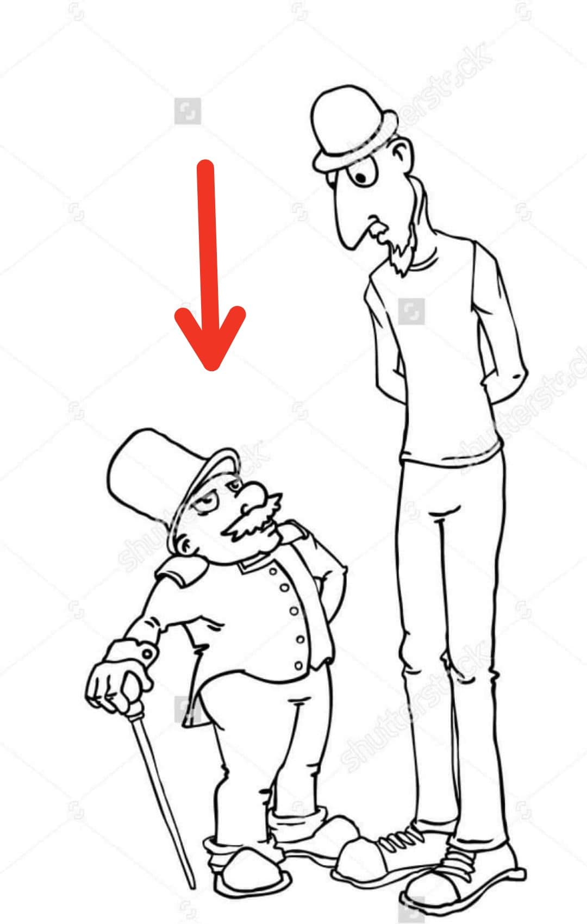
5. m _ _ _ t _ _ _ |  | 6. s _ _ _ _
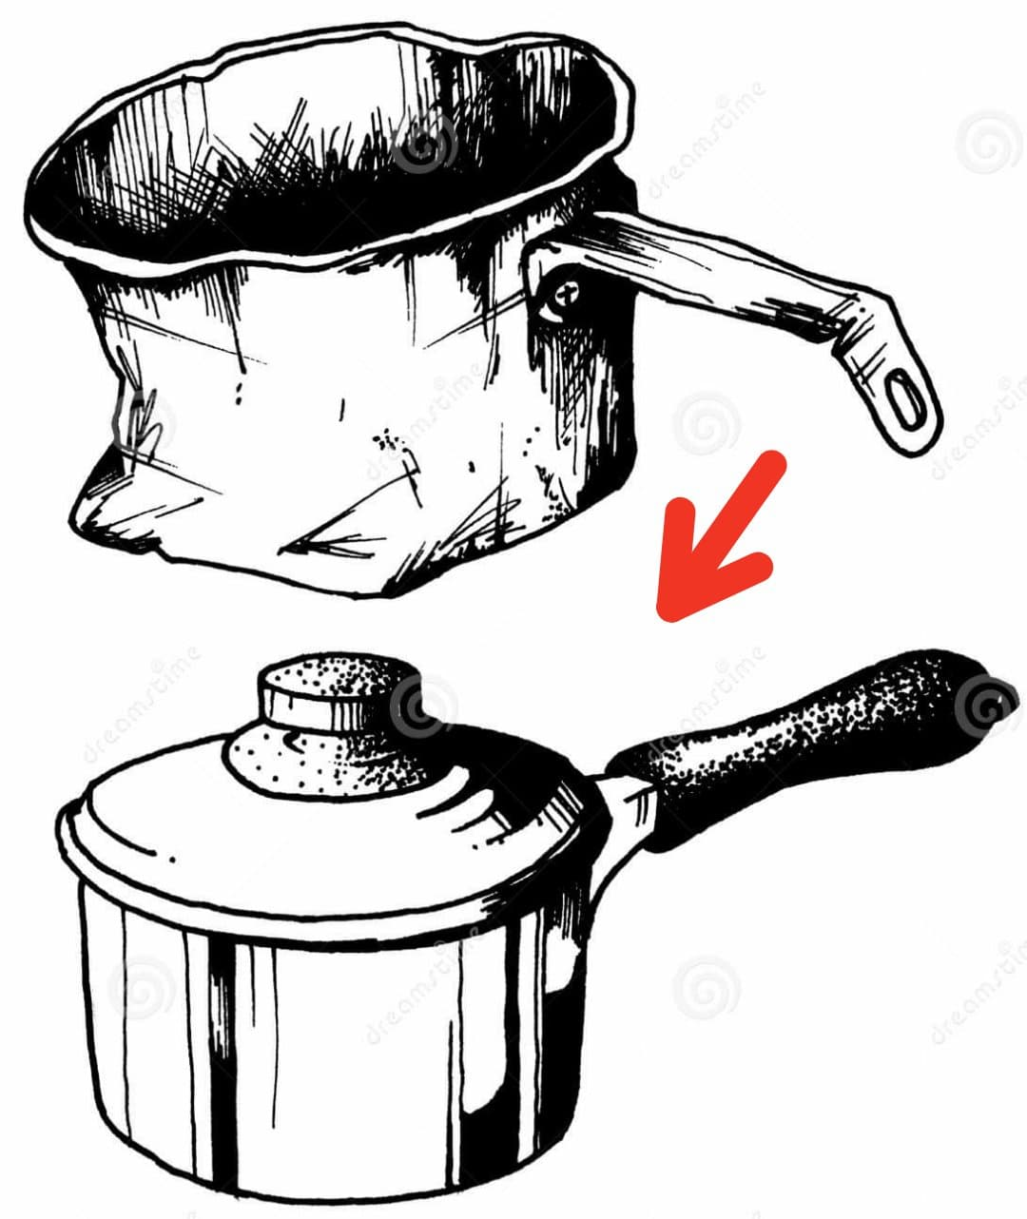 |  | 
7. _ _ w |  | 8. q _ _ _ t
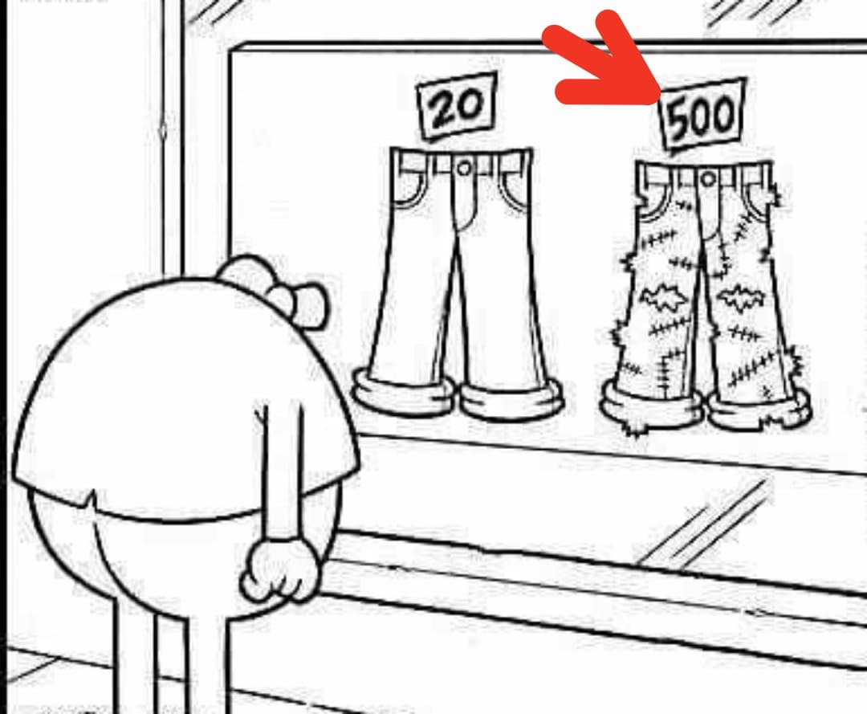 |  | 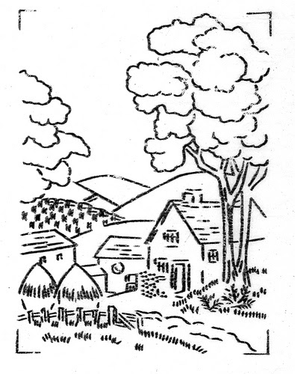
9. e _ _ _ns_ _ _ |  | 10. _ _ _ntry_ _ _ _

Exercise 2: Look and answer.
 | 1. Which one is more expensive, the new car or the old car?  =>…………………………………………………………
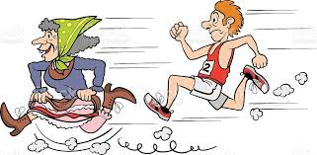 | 2. Who is faster, the woman or the man?  =>…………………………………………………………
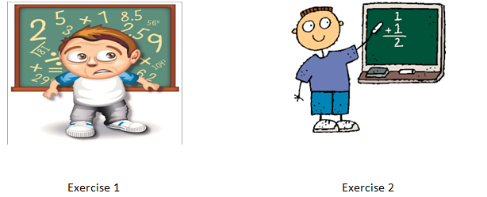 | 3. Which one is more difficult, Exercise 1 or Exercise 2?  =>………………………………………………………..
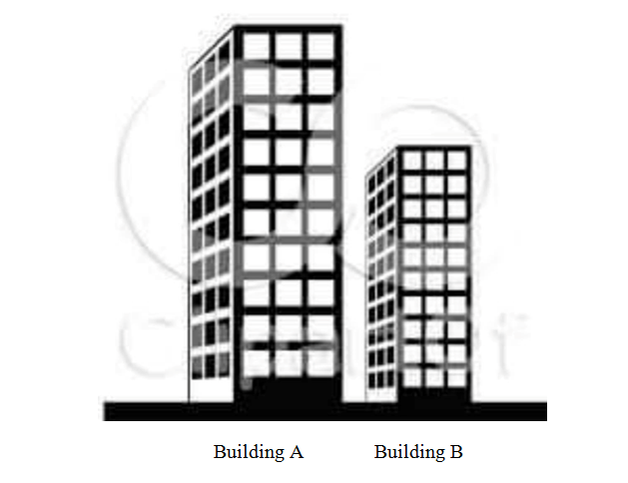 | 4.Which one is higher, Building A or Building B?  =>……………………………………………………….
 | 5. Who is weaker, the man or the boy?  =>…………………………………………………………

Exercise 3: Match.
1. What’s Hue Imperial City like? | A. I’m going to Da Lat.
2. Which one is more exciting, Hanoi or Ho Chi Minh City? | B. It’s very beautiful.
3. Which one is smaller, New York or Sydney? | C. I live in Nha Trang.
4. Where are you going this summer? | D. I think Ho Chi Minh City is.
5. Where do you live? | E. I think Sydney is.
DGGGD
1………2……….3………..4…………5………….
Exercise 4: Read and complete.
 | beautiful | visit | like | three
larger
Hoa: | Where are you going this summer?
Nam: | I’m going to (1)………………. Nha Trang.
Hoa: | What’s it (2)………………?
Nam: | It’s very (3)………………..?
Hoa: | Who are you going (4)………………………with ?
Nam: | I’m going there with my parents.
Hoa: | Which one is (5)………………… Nha Trang or Ho Chi Minh City?
Nam: | I think Ho Chi Minh City is

Exercise 5: Circle the correct answer.

1. This house is……………………..than that one. (big / biger / bigger / more big)
sfsfs
2. Which one is……………………….…..……the shirt or the skirt?
(expensive / expensive / more expensive)
sfsfs
3. She’s going to stay…………………. Home. (at / in / on)
sfsfs
4. Da Lat is more……………………..….than Hanoi.(bigger / narrow /peaceful)
sfsfs
5…………………………do your grandparents live? (What / When / Where)
sfsfs
6……………………………place do you want to visit? ( Which / Where / How)

BÀI TẬP NÂNG CAO

Exercise 6: Complete the table.

ADJECTIVE | COMPARATIVE
good
polluted
intelligent
high
short
attractive
nice
quiet

Exercise 7: Give the correct form of the adjectives in brackets.

1. New York City is (large) …........................................ than Sydney.
fggfb
2. Ha Long City is (beautiful) ….................................... than Nha Trang.
fggfb
3. Nam is (young) ….................................... than Hung.
fggfb
4. Is she as (tall) ….................................. as her sister?
fggfb
5. This lesson is (boring) …............................ than that one.
fggfb
6. The food here is ( delicious) …................................ than that in my hometown.

7. Her shirt is (cheap) …................................ than my shirt.
fggfb
8. Which one is (good) …............................ life in Ha Noi or life in Ho Chi Minh City?

Exercise 8: Use the words given to make sentences.

1. Which/ one/ noisier/ Hanoi/ Da Nang/ ?
……………………………………………………………………………………
2. Ho Chi Minh City/ big/ city/ your country/ ?
……………………………………………………………………………………
3. What/ he/ going/ do/ next week/ ?
……………………………………………………………………………………
4. Where/ Vietnam/ your parents/ live/ ?
……………………………………………………………………………………
5. I think/ life / the city/ busy/ life/ countryside/ .
……………………………………………………………………………………
6. she/ want/ live/ this city/ because/ it/ big/ exciting/ .
……………………………………………………………………………………

Exercise 9: Rewrite the sentences beginning with the given words.

1. Life in the city is noisier than life in the countryside.
fff
=> Life in the countryside .......................................................................................
fff
2. Hanoi is smaller than Ho Chi Minh City.
fff
=> Ho Chi Minh City ...............................................................................................
fff
3. Nam is taller than Hung.
fff
=> Hung ...................................................................................................................
fff
4. The ruler is longer than the pencil.
fff
=> The pencil ...........................................................................................................
fff
5.This house is newer than that house.
fff
=> That house…..........................................................................................................

Exercise 10: Read and answer.

My name's Nam. I live with my parents in Ho Chi Minh City, a very big city in Vietnam. There are a lot of people living here, so it is very crowded and noisy. It also has lots of high building. Life in this city is more exciting than life in my hometown.
During summer holidays, my parents and I often go back to our hometown, Nghe An.
It is central Vietnam. It is smaller than Ho Chi Minh City. Life here is more quiet than life in the city because there are not so many people and much traffic. I think that living in the countryside is easier than living in a big city because things are cheaper and people are friendly.

1. Where does Nam lives?

=>.................................................................................................................................

2. What is Ho Chi Minh City like?

=>.................................................................................................................................

3. Where does he often go during summer holidays?

=>.................................................................................................................................

4. Which one is bigger, Ho Chi Minh City or Nghe An?

=>.................................................................................................................................

5. Which one is more quiet, Ho Chi Minh City or Nghe An?

=>.................................................................................................................................

6. Does he think that life in a big city is easier than in the countryside?

=>.................................................................................................................................

