Exercise 1: Look and write:
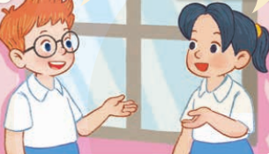 | 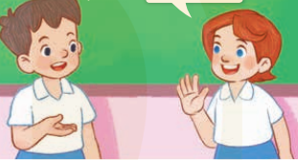
………………….., I’m Ben  Hi, Ben…………………Mai | Hi, ……………Minh  …………., Minh. I’m Lucy
 | 
……………., Ben……………Mai | Hi, Lucy. ……………Minh

Exercise 2: Look and write

 | 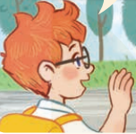
……….., Mai. How………….you?  ……………, thank you. | …………..bye, Mai
 | 
Hi. ……………..are you?  I’m………………, thank……………… | Good………...........  Bye.

Exercise 3: Complete the conversation:

Ben: Hello. I __________ Ben.
Lucy: ______. I am ________
Ben: Nice_________ _______ you.
Lucy: _______ to ________ _______, too.
Ben: How ______ you?
Lucy: I am _________, Thank _______. And _______?
Ben: ___________, thanks.
Lucy: Goodbye.
Ben: Bye.

Exercise 4: Rearrange the words to make a correct sentence.
1. Mai/ Hello/ ,/ ………………………………………………………………………..
2. Minh/ Hi/, / I’m/. ………………………………………………………………………….
3. I’m/ Ben/ Hi/, / Lucy/. ………………………………………………………………….
4. meet/ to/ Nice/ you/. …………………………………………………………………...
5. you/ are/ How/? ………………………………………………………………………
6. Mai/ Hi/ are/ how/ you/ ?/, …………………………………………………………….
7. fine/ thanks/ I’m/. …………………………………………………………………….
8. Ben/ bye. …………………………………………………………………………………
9. Lucy/ Goodbye/. …………………………………………………………………………
10. fine/ I’m/ thanks/ you/, /. …………………………………………………………..

Exercise 5: Odd one out:
1. a. Mai | b. Lucy | c. Hi
2. a. Hi | b. Bye | c. Hello
3. a. I’m | b. I | c. I am
4. a. Goodbye | b. Bye | c. Hi
5. a. Hello, I’m Mai | b. Thank you | c. Hi, I’m Mai
6. a. Lucy b. How c. Ben
7. a. yellow b. nine c. pink
8. a. bee c. ten c. two

Exercise 6: Number the sentence in the correct order.

Bye, Ben.

Hello, I’m Minh.

Hi, Minh. I’m Ben.

Goodbye, Minh.

Exercise 7. Match A with B.

A | B | Answer
1. How are you? | a. Hi. | 1. ________
2. Hi, I’m Mai. | b. Bye. See you later. | 2. ________
3. Goodbye. | c. Hello. I am Minh. | 3. ________
4. Hello. | d. Nice to meet you, too. | 4. ________
5. Nice to meet you! | e. Fine, thank you. | 5. ________

Exercise 8: Look and write
1 | 2 | 3 | 4 | 5
one | ……………….. | ……………….. | ……………….. | ………………..
6 | 7 | 8 | 9 | 10
……………….. | ……………….. | ……………….. | ……………….. | ………………..

Exercise 9. Circle the correct answer.
1) What is your name?
a. It is a hat.
a. My name is Minh.

2. How are you?
b. I’m fine, thanks.
a. Hello!

3. Hi!
b. Goodbye
a. Hello!

4. Nice to meet you.
b. Nice to meet you, too.
a. I’m Ana.

5) Goodbye.
b. Hi
a. Bye

Exercise 10: Write about you:
1. Name: ………………………………………………...
2. School: ……………………………………………….
3. Class: …………………………………………………
4. Teacher: ………………………………………………
5. Best friends: ………………………………………….
6. Favorite colors: ………………………………………
7. Favorite animals: …………………………………….
8. Favorite toys: ………………………………………..

Exercise 11: What letter is missing?
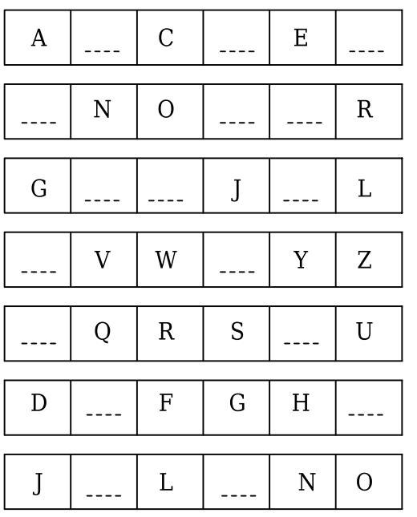
Exercise 12: Write the missing letters.






Ho__ are you ?
N_ ce to m_ et you
G_ _ d by_
He_ _o

Listening:
Part 1: Listen and number the picture, there is one example.



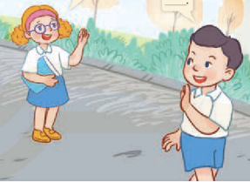

………………… ……………… ………………… 1 …………………

Part 2: Listen and circle. There is one example:
1. Hi, I’m Marry. Nice to meet you.

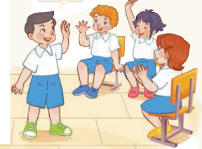
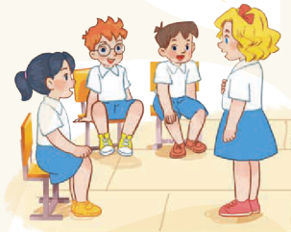

A B

2.



A B



3.

A B

4.
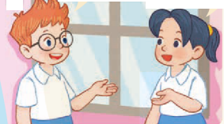


A B

5.

A B

