Ex1. Look and write
Play badminton | Chat with friends | Play basketball | Play football
Play volleyball | Play table tennis | Do word puzzles | play chess

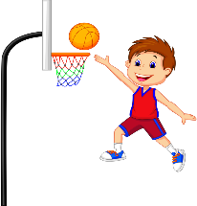 | 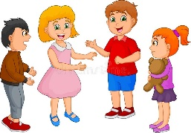 |  | 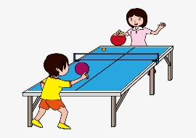
…………………………….. | …………………………….. | ……………………………. | ………………………..
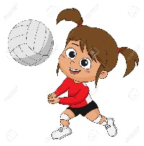 | 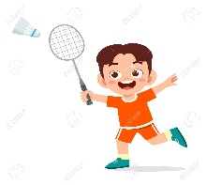 |  | 
…………………………….. | …………………………….. | …………………………… | ……………………………

Ex 2: Look and write the missing letters

P_ _y ta_l_ te-n_s
Pl_ _ ba_mi_t_n
_l_y ba_k_tb_ll
P_a_ f_ot_al_

C_at wi_h f_i_n_s

_la_ c_e_s
_l_y v_l_eyba_l
_o w_ _d pu_zl_s

Ex 3: Make and answer the questions:
- What do you do at break time?  - I play basketball | …………………………….  …………………………….. | ……………………….  ………………………. | ………………………..  …………………………
……………………………..  …………………………… | ……………………………..  …………………………….. | …………………………………………………… | ……………………………  ……………………………

Ex 4.Odd one out
- table tennis | - football | - pen | - volleyball
- teacher | - nose | - ear | - hand
- speak | - sit | - open | - blue
- ruler | - chess | - eraser | - pencil
- red | - black | - football | - orange
- playground | - gym | - art room | - stand up
- ruler | - mouth | - school bag | - pencil
- walking | - fine | - swimming | - drawing
- green | - white | - brown | - notebook
- is | - they | - are | - am
- school | - your | - my | - our
- touch | - table tennis | - close | - open
- play chess | - play badminton | - music room | - chat with friends

Ex 5: Look and write:
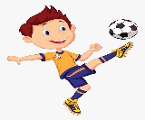  I like playing…………………… | ->  ->  ->  ->  ->  ->  ->  -> | I……….…………..at break time.
  I like ……………………………. | ->  ->  ->  ->  ->  ->  ->  -> | ……………………………………….
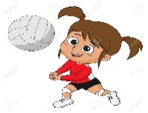  I like ……………………………. | ->  ->  ->  ->  ->  ->  ->  -> | ……………………………………….
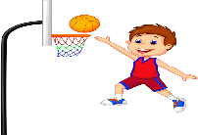  I like …………………………… | ->  ->  ->  ->  ->  ->  ->  -> | ……………………………………….
  I like ……………………………… | ->  ->  ->  ->  ->  ->  ->  -> | ……………………………………….
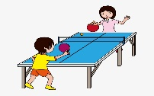  I like ………………………………. | ->  ->  ->  ->  ->  ->  ->  -> | ……………………………………….
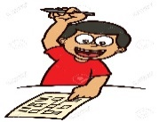  I like doing ……………………….. | ->  ->  ->  ->  ->  ->  ->  -> | ……………………………………….
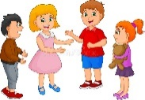  I like chatting …………………….. | ->  ->  ->  ->  ->  ->  ->  -> | ……………………………………….

Ex 6: Write sentences.
 | Ben | Lucy | Minh | Bill | Mai | Mary | Lan | Tom
Play chess
Play table tennis
play football
Play badminton
Play volleyball
Play basketball
Chat with friends
Do word puzzles

Ben | I play chess and do word puzzles at break time.
Lucy | …………………………………………………………..................
Minh | …………………………………………………………..................
Bill | …………………………………………………………..................
Mai | …………………………………………………………..................
Mary | …………………………………………………………..................
Lan | …………………………………………………………..................
Tom | …………………………………………………………..................

Ex7: Put the words in the correct order to make sentences.
- are – They – red - ……………………………………………………………….
- are – color – What – they? ………………………………………………………….
- you – What – at- do- break – do – time? ………………………………………
- is – It – blue ………………………………………………………………….
- play- I - football- time - at – break ……………………………………………………
- playing – like – badminton - I ………………………………………………………..
- have – Do – a – you - ruler ……………………………………………………………
- I - walking – like ………………………………………………………………………….
Ex8: Choose the right option.
1.What’s _________ name? My name is Hoa?
A. My B. our C. your
2. How are you? I’m _________ .
A. five B. nine C. fine
3. How old is your grandmother? she is eighty _________ old.
A. years B. year C. yes
4. _________ too meet you.
A. nine B. nice C. good
5. Bye. See You _________ .
A. late B. nice C. later
6. What’s it? It’s _________ pen.
A. an B. a C. some
7. Do you have an eraser? _______________
A. No, I do B. Yes, I don’t C. Yes, I do
8. What color _________ it?
A. are B. is C. am
9. _________ is Nam from? He’s from Hai Phong.
A. What B. How C. where
10. What _________ you do at break time?
Ex 9. Read and circle the corrct words.
I play football/ play chess at break time. | 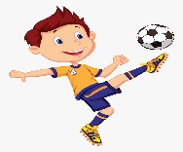
I play volleyball/ badminton at break time. | 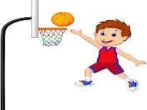
I play football/ chat with my friends at break time. | 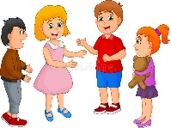
I play chess/ play basketball at break time. | 
I do word puzzles/ play table tennis at break time.
I play football/ play volleyball at break time.
I play badminton/ play chess at break time. | 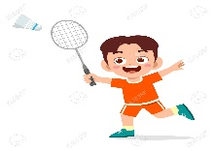
I play chat with my friends/ do word puzzles at break time. | 

Ex 10.Make questions for these sentences:
1. Ilike cooking
…………………………………………………………….
2. It’s green.
…………………………………………………………….
3. Yes, it’s our school.
…………………………………………………………….
4. My school bag is yellow.
…………………………………………………………….
5. They are brown.
…………………………………………………………….
6. My name is Mai
…………………………………………………………….
7. I’m seven years old.
…………………………………………………………….
8. Yes, it is. It’s Lucy.
…………………………………………………………….
9. Yes, you can. Come in, please!
…………………………………………………………….
10. OK, let’s go to the music room.
…………………………………………………………….
11. Yes, I do. I have a ruler.
…………………………………………………………….

Listening:
Part 1: Listen and draw line. There is one example:

1. |  |   a
2. |  |   b
3. |  | 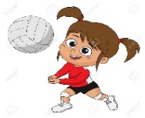  c
4. |  | 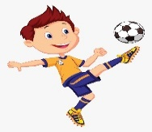  d
5. |  | e
6. |  | 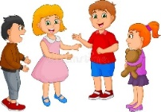  f
7. |  | 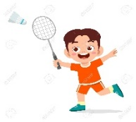  g
8. |  | 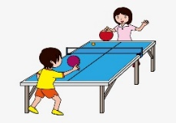  h
9. |  | 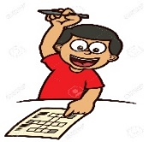  i
10. |  |   j

Part 2: Listen and complete the text, the first one is done for you:
My name is Ben. I’m (1) nine years old. I have many school things: two (2)…………………………… school bags, (3)…………………………… books, five (4)……………………………, three (5)…………………………… pencils, a pencil case, four (6)…………………………… and two red (7)………………………. I like (8)…………………………… and (9)……………………………. At break time I play (10)……………………………and (11)……………………………. I also (12) …………………………… and (13)……………………………with my brother.

