Exercise 1 Look and write
driver | worker | farmer | cook
teacher | singer | doctor | nurse

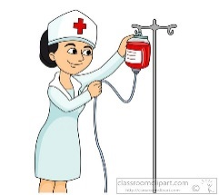 | 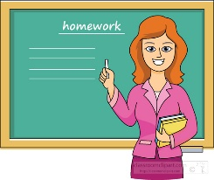 |  | 
……………………. | ……………………. | ……………………. | …………………….
 |  |  | 
……………………. | ……………………. | ……………………. | …………………….
Exercise 2: Look and circle the correct words
 | 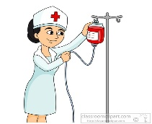 |  | 
a)  He’s teacher/worker. | b)  She’s a nurse/doctor. | c)  He’s a doctor/ cook. | d)  He’s a driver/farmer.
 |  | 
e)  He’s a cook/ farmer. | f)  She’s a singer/ farmer. | g)  He’s a worker /doctor. | h)  She’s a teacher/ cook.

Exercise 3: Write his or her and answer the questions
his | her



a) What’s his job? b) What’s………. job? c) What’s………... job?
He’s a driver. ……………………… ………………………..
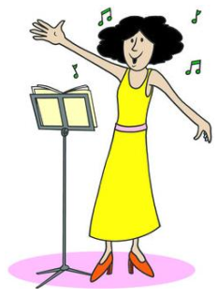

d) What’s………... job? e) What’s………... job? f) What’s………... job?

………………………. ………………………… …………………………


g) What’s………... job? h) What’s………... job?
…………………………….. ……………………………….
Exercise 4: Put the words in the correct order
a) She – nurse – is – a
……………………………………………………………………………….
b) farmer – He – a - is
……………………………………………………………………………….
c) a – is – He - driver
……………………………………………………………………………….
d) She – a – teacher – is
……………………………………………………………………………….
d) My – worker – father – is – a
……………………………………………………………………………….
e) sister – a – singer – My – is
……………………………………………………………………………….
f) brother – doctor –a – is – My
…………………………………………………………………………
g) a – is – mother – My – cook
Exercise 5: Look at the pictures and write
Yes, he is. | No, he isn’t. | Yes, she is. | No, she isn’t.

 | 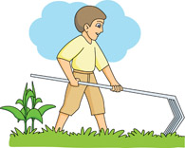 | 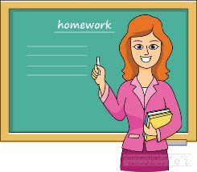
- Is she a singer? | - Is he a farmer? | - Is she a teacher?
…………………………….. | …………………………….. | ……………………………..
 |  | 
c. Is he a worker? | d. Is she a cook? | e. Is he a doctor?
…………………………….. | …………………………….. | ……………………………..
 |  | 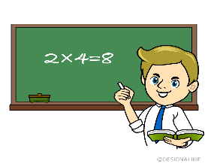
f. Is he a singer? | g) Is she a worker? | h) Is he a doctor?
…………………………… | …………………………… | ……………………………
Exercise 6: Read and write Yes or No
My name is Jim. I’m eighteen years old. I’m a student. There are four people in my family. They are my father, my mother, my sister and me. My father is a worker. My mother is a cook, she likes cooking. My sister is twenty-two years old. She is a singer. She likes singing. I love my family.
1) Jim is eight years old. | No
2) Jim is a student.
3) There are six people in his family.
4) His father is a doctor.
5) His mother is a cook.
6) His mother likes swimming
7) His sister is twenty years old.
8) His sister is a nurse.
9) His sister likes singing

Exercise 7: Read and complete the sentences
a) What’s her job? She ……………..a cook.
b) What’s …………job? He’s a farmer.
c) Is he a worker? Yes, he ……………..
d) ………………. your job? I’m a singer.
e) Is she a nurse? ……………., she isn’t.
f) What’s……………. job? She is a teacher.
g) Is your sister a doctor? ……………., she is.
h) What’s his job? ………….. is a driver.
i) ……………. your brother a cook? Yes, he is.
j) This ……………. my nose.
k) What’s her job? ………….. is a nurse.
l) How old are you? I’m seven years ……………..
m) Is your father a driver? Yes, ………… is.
Exercise 8: Read and match
1) What’s your name? | a) Yes, he is .
2) How old are you? | b) My name’s Bill.
3) How are you? | c) No, she isn’t.
4) What colour is it? | d) They’re orange.
5) What colour are they? | e) It’ black.
6) What’s your job? | f) I’m fine, thank you.
7) Is she a doctor? | g) I’m eight years old.
8) Is he a worker? | h) I’m a teacher.
9) What’s his job? | i) She’s a nurse.
10) What’s her job? | j) He’s a cook.

Exercise 9: Read and write

red – bag – teacher – art room – green – pencil – doctor – music room- worker - pen – yellow – brown – eraser – nurse – cook – playground- driver – book - black – white – notebook – farmer - classroom

Colors | School things | Jobs | School
red  ……………………….  ……………………….  ……………………….  ………………………  ………………………. | bag  ……………………….  ……………………….  ……………………….  ………………………  ……………………….. | teacher  ……………………….  ……………………….  ……………………….  ……………………….  ……………………… | art room  ……………………….  ……………………….  ……………………….  ……………………….  ………………………
Exercise 10 Make questions for the underlined part
a) My name is David.
……………………………………………………………….
b) I’m eight years old.
……………………………………………………………….
c) I’m fine, thank you.
……………………………………………………………….
d) Yes, she is. She’s a teacher.
……………………………………………………………….
e) He is a driver.
……………………………………………………………….
f) She is a nurse.
……………………………………………………………….
g) Yes, he is. He’s a farmer.
……………………………………………………………….
h) It’s my mother.
……………………………………………………………….

Exercise 11 Circle the odd one out
a) eyes | b) nose | c) ears | d) mother
a) teacher | b) sister | c) nurse | d) doctor
a) mother | b) farmer | c) brother | d) father
a) classroom | b) music room | c) art room | d) ruler
a) yellow | b) green | c) hair | d) blue
a) eraser | b) face | c) nose | d) hand
a) Tony | b) John | c) Anna | d) Hello
a) singer | b) orange | c) driver | d) cook
a) stand up | b) chess | c) come in | d) sit down
a) badminton | b) football | c) volleyball | d) pencil
a) worker | b) running | c) cooking | d) walking
a) pencil case | b) library | notebook | School bag

Exercise 12: Find and correct the mistakes.
a) She is a doctors.
……………………………………………………………........
b) This are my mother.
……………………………………………………………........
d) Is it a eraser? Yes, it is.
……………………………………………………………........
e) This is my father. She is a worker
……………………………………………………………........
f) Yes, it isn’t. She is a nurse.
……………………………………………………………........
g) My brother is a teachers.
……………………………………………………………........
h) What’s his job? She is a singer.
……………………………………………………………........
i) What colour is it? They’re red.
……………………………………………………………........
j) That is my sister. He is a doctor.
……………………………………………………………........
k) What’s her job. He is a farmer.
……………………………………………………………........
Listening
Part 1: Listen and tick  or cross . The first sentence is done for you:
1. 2.


3. 4.

5. 6.

7. 8.

Part 2: Listen and complete the sentences. There is one example:
1. She is a cook.
2. He is a ……………………..
3. My (a)…………………….. is a (b)……………………..
4. This is my (a)……………………... She is a (b)……………………...
5. What is his job? He is a ……………………...
6. Is she a (a)……………………..? No, she isn’t. She is a ……………………...
7. She is a ……………………...
8. He isn’t a (a)……………………... He is a (b)……………………...

