Exercise 1: Write the words
on | bathroom | kitchen | in | living room
house | table | bedroom | lamp | chair

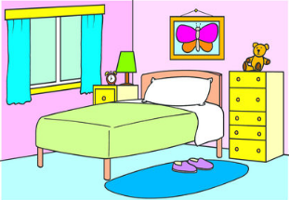 | 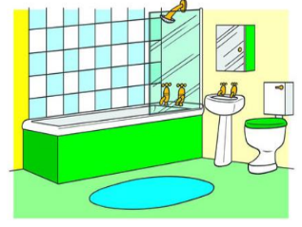 | 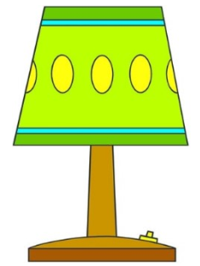 | 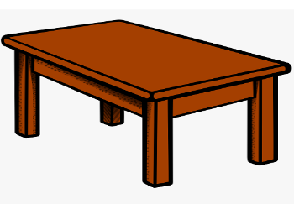
…………………………….. | …………………………….. | …………………………….. | ……………………………..
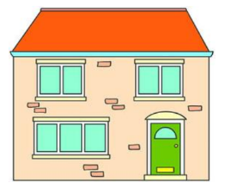 | 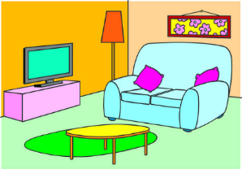 | 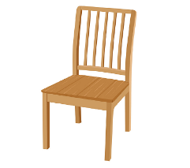 | 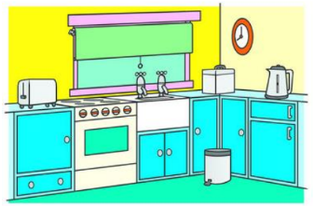
…………………………….. | …………………………….. | …………………………….. | ……………………………..
 |  | 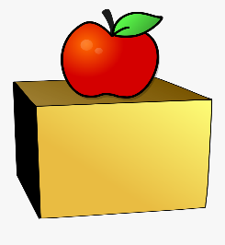
…………………………….. |  | ……………………………..

Exercise 2: Circle the correct answer.
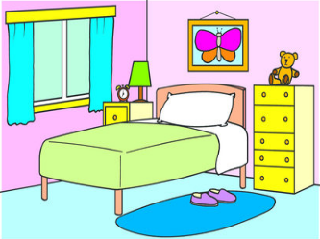
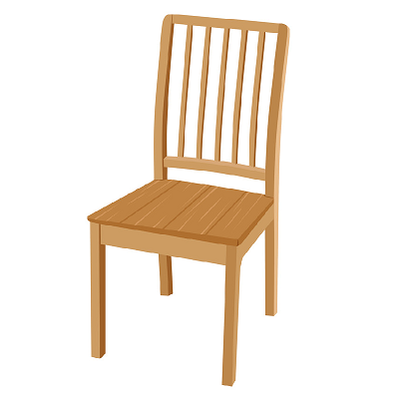
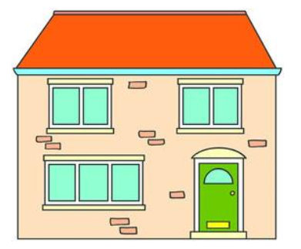

- It’s a bedroom.
- It’s a bathroom.

- It’s a school.
- It’s a house.
a. It’s a chair. b. It’s a table.
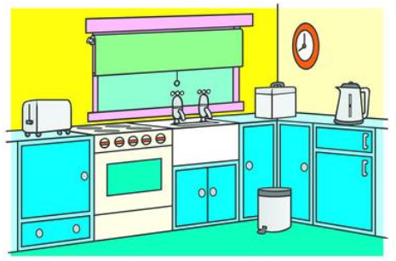
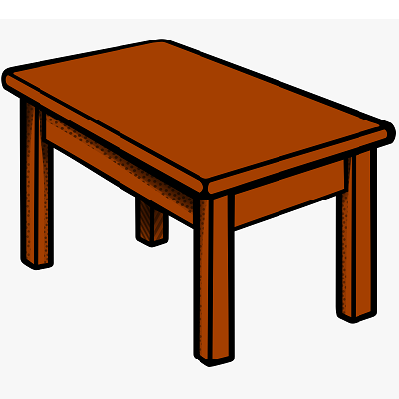
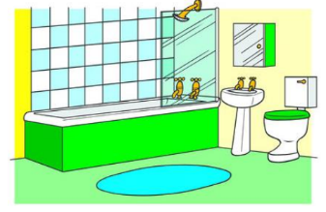

- It’s a living room.
- It’s a kitchen.
- It’s a lamp.
- It’s a table.
- It’s a kitchen.
- It’s a bathroom.

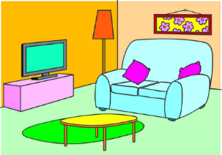

- It’s a chair.
- It’s a lamp.

- It’s a living room.
- It’s a bedroom.

Exercise 3: Look and write the missing letters
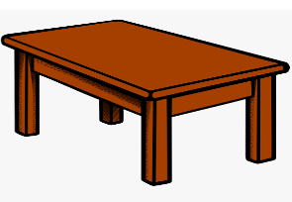 | 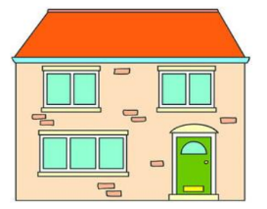 | 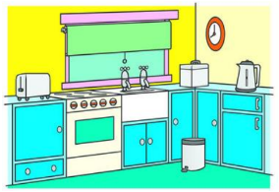
t_b_e | _ _u_e | K_ _c_e_ | _iv_ _g _o_m
 | 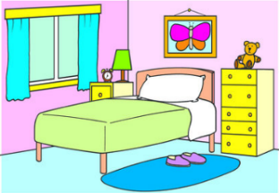
b_ _hr_om | _ _dro_ _ | l_m_ | _h_ _r

Exercise 4: Number the rooms in the picture.
1. bathroom | 2. bedroom | 3. dining room | 4. kitchen | 5. living room
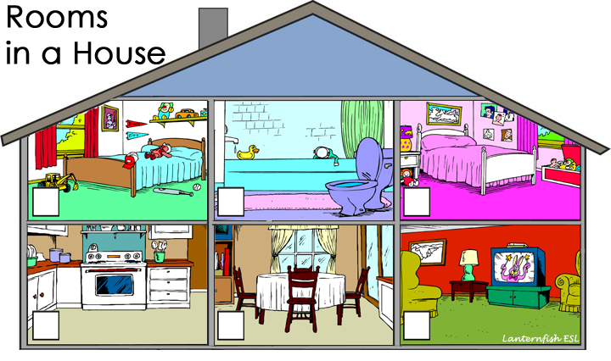

3.Look at the pictures and complete the sentences.

Exercise 5: Make and answer questions
It’s here. | It’s there

  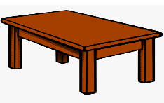 | 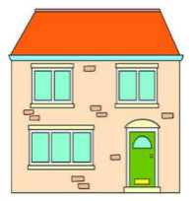 |  | 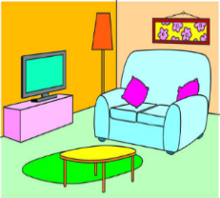
Where’s the table?  - It’s there. | ………………………………….  …………………………………. | …………………………………  …………………………………. | …………………………………  ………………………………..
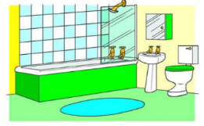 | 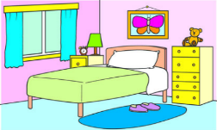 | 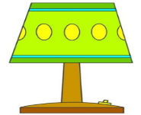
………………………………….  …………………………………. | ………………………………….  …………………………………. | ………………………………….  …………………………………. | ………………………………….  ………………………………….
Exercise 6: Look and write, using on - in
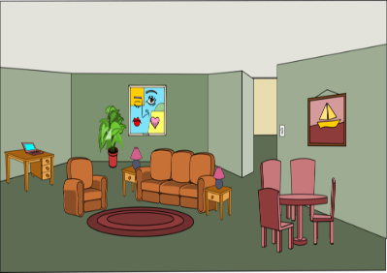 | 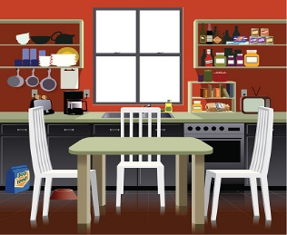 | 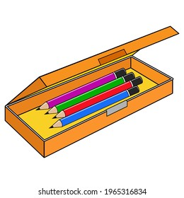 | 
tables | chairs | pencils | books
The tables are in the  living room. | …………………………..  ………………………….. | …………………………..  ………………………….. | …………………………..  …………………………..
 | 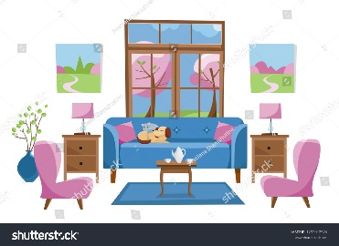 | 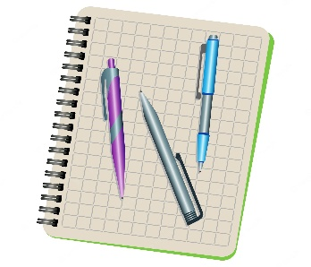 | 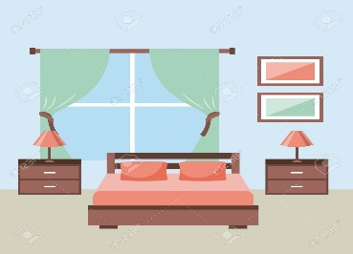
books | lamps | pens | lamps
…………………………..  ………………………….. | a)  …………………………..  ……………………………….  e) | …………………………..  ………………………….. | …………………………..  …………………………..
Exercise 7: Make and answer the questions:

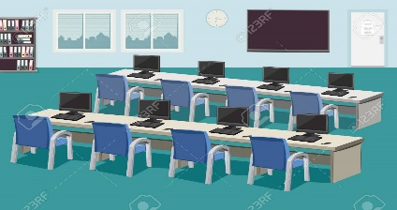

a) Where/ chairs? b) Where/ tables?
…………………………………….? …………………………………?
…………………………………….. …………………………………
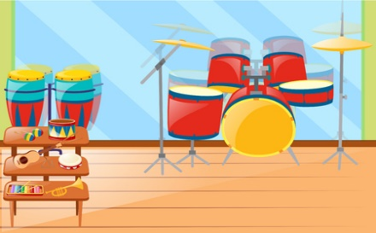
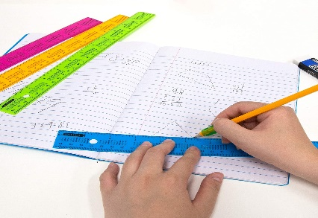

c) Where/ rulers? d) Where/ tables?
…………………………………? ………………………………?
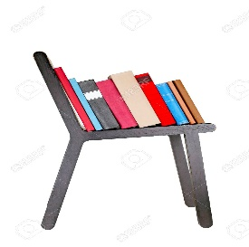
………………………………… …………………………………


e) Where/ books? f) Where/ pencils?
…………………………………? ………………………………….?
………………………………… …………………………………..
Exercise 8: Put the words in the correct order
a) bedroom – is – Where – the?
……………………………………………………………….
b) It’s – the – table – on
……………………………………………………………….
c) The – are – chairs – kitchen – in
……………………………………………………………….
d) is – Where – bathroom – the?
……………………………………………………………….
e) lamps – The – in – are – the living room.
……………………………………………………………….
f) The – school bag – on – the – is – table
……………………………………………………………….
g) Where – the - is – kitchen. here – It – is
………………………………………………………………………………..
h) are – the – They – on – chair
………………………………………………………………………………..
i) pens – Where – the – are? in – They – pencil case – are
………………………………………………………………………………..
j) bedroom – are – The – the – in – lamps
………………………………………………………………………………..
k) My – kitchen – sister – is – the – in
……………………………………………………………………………………
l) Where – she - is?
……………………………………………………………………………………
m) My – the – is – living room – father – in
……………………………………………………………………………………
Exercise 9 Read and underline the correct words.
a) Where / What is the book? It’s on the chair.
b) Where are the chairs? They are on / in the living room.
c) Where / What is she? She’s in the kitchen.
d) Where is your brother? She / He is in the bedroom.
e) The pens is / are in the pencil case.
d) Where is/ are the living room?
e) Where are the lamps? They / It are in the bedroom
f) Where is/ are the chairs? They is / are in the living room
g) What is her job? She / He is a nurse.
h) The rulers is/ are in the school bag.
i) Where are the books? They are in/ on the table.
j) Where is your mother? She is on/ in the bathroom.
Exercise 10: Find the mistakes and correct them
a) They are on the living room. ………………………………………
b) The chairs is in the kitchen. ………………………………………
c) Where is the lamps? ………………………………………
d) She is on the dining room. ………………………………………
e) Is the lamp in the bedroom? No, it is. ………………………………………..
f) Where are the chairs? It’s in the living room ………………………………………
g) My brother is the kitchen. ………………………………………
h) Is he a doctor? No, he is. ………………………………………
h) Where is the bathroom? They’re there. ………………………………………
i) What is this ? It’s my mother. ………………………………………
Exercise 11: Complete the sentences
a) Where is the lamp? It ……………… in the living room.
b) Is she in the bedroom? Yes, she ………………
c) ……………… are the tables? They’re in the living room.
d) Where is the bathroom? ……………here.
e) Where is your mother? ……………… is in the bedroom.
f) Is the chair in the bedroom? No, it………………
g Where …………. the pens? …………. are on the table.
h) Where is the table? It’s in ……kitchen.
i) Where is your brother? …………… is in the bathroom
k) ……………. they in the kitchen? No, they aren’t.
l) Where is your father? He ……………… in the bathroom.
Exercise 12: Make questions for these answers
1) This is my book.
What is this ?
2) The chairs are in the living room.
………………………………………………………………..
3) The ball is on the chair.
………………………………………………………………..
4) The table is in the kitchen.
………………………………………………………………..
5) The bedroom is here.
………………………………………………………………..
6) He is a cook.
………………………………………………………………..
7) She is nineteen years old.
………………………………………………………………..
8) They are on the table.
………………………………………………………………..
9) She is a singer.
………………………………………………………………..
10) The book is in the school bag.
………………………………………………………………..
11? The lamps are in the bedroom.
………………………………………………………………..
Exercise 13: Read and match
a) Where are the lamps? | - He is a worker.
b) Is she in the living room? | - No, it isn’t. It’s in the bedroom.
c) Where is your mother? | - They are in the bedroom.
d) Is he a farmer? | - No, she isn’t.
e) Where is the bathroom? | - Yes, he is.
f) Is the chair in the bathroom? | - She’s in the kitchen.
g) What’s her job? | - She is a nurse.
h) What’s his job? | - It’s here.

Listening:
Part 1: Listen and fill in the blanks:
1. The chairs are in the ……………...
2. The (a)…………….. are on the (b)……………...
3. The (a)…………….. is on the (b)……………..
4. The table is in the ……………..
5. Where are the (a)……………...? They’re in the (b)……………...
6. Is the ruler on the table? No, it’s in the ……………...
7. Where is your (a)……………..? She is in the (b)……………...
8. The (a)…………….. isn’t in the school bag. It’s on the (b)……………...
Part 2: Listen and draw line. There is one example:
1. |  | a.
2. |  | b.
3. |  | c.
4. |  | d.
5. |  | e.
6. |  | f.
7. |  | g.
8. |  | h.

