Exercise 1: Write the words
new | room | small | desk | pillow
window | bed | old | big | door

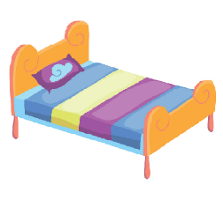 | 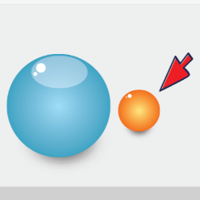 | 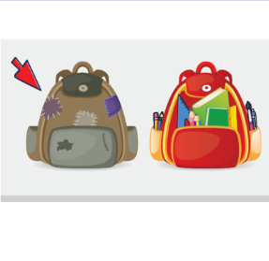 | 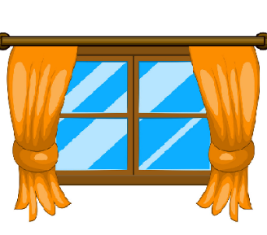
……………………….. | ……………………….. | ……………………….. | ………………………..
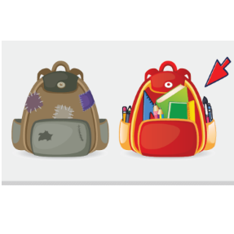 | 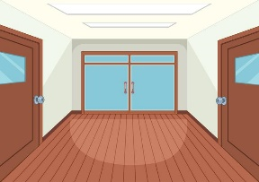 | 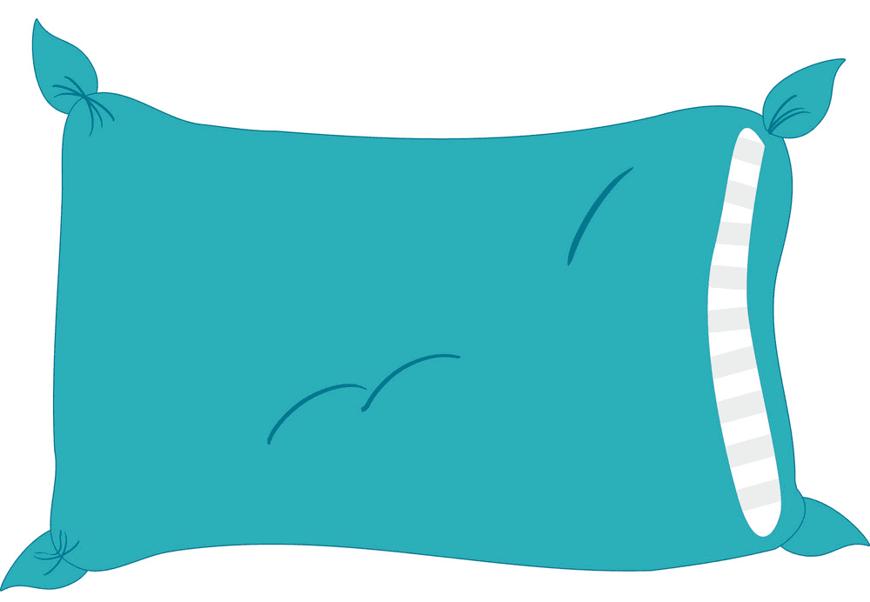 | 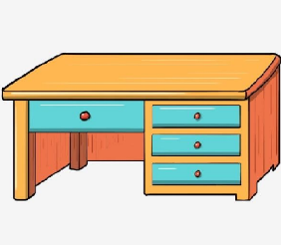
……………………….. | ……………………….. | ……………………….. | ………………………..
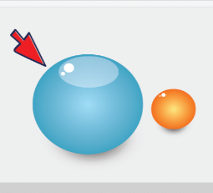 |  | 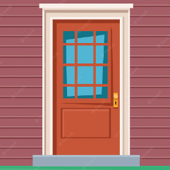
……………………….. |  | ………………………..
Exercise 2: Look and write, using There is - There are

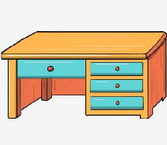 | 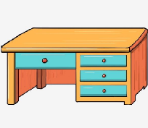
There is a desk. | There are two desks.
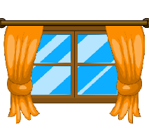

a) ………………………………………. | b)…………………………………………
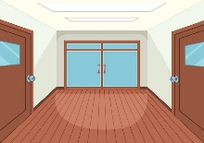
…………………………………………………………………. | …………………………………………………………………
c) | 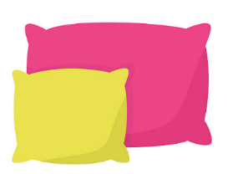  d)
………………………………………………………………… | …………………………………………………………………
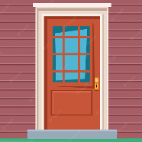
………………………………………………………………… | …………………………………………………………………
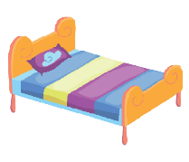
………………………………………………………………… | …………………………………………………………………
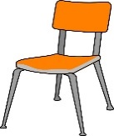
………………………………………………………………… | …………………………………………………………………
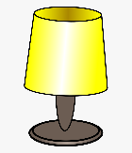
………………………………………………………………… | …………………………………………………………………

Exercise 3: Write the sentences:
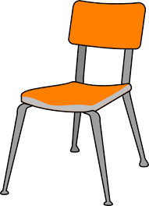 |  | 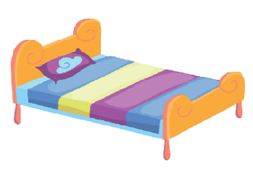  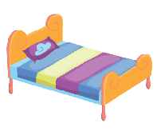
chair/ big  - The chair is big. |  | bed/ small  - ……………………………………….
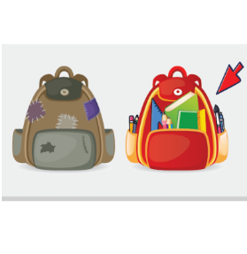 |  | 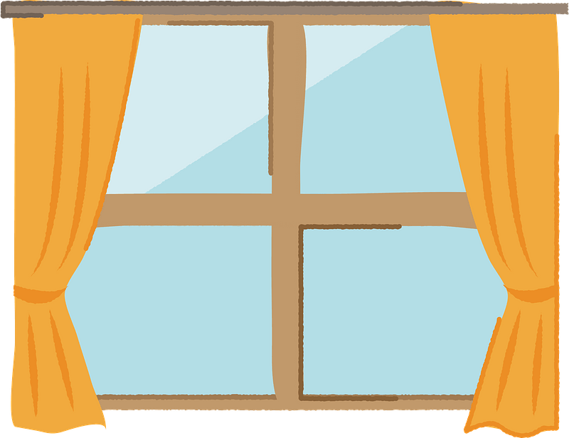
school bag/ new  - …………………………………….. |  | Window/ big  - …………………………………………………..
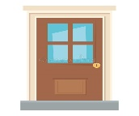  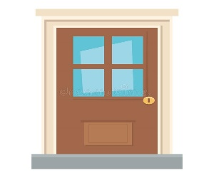 |  | 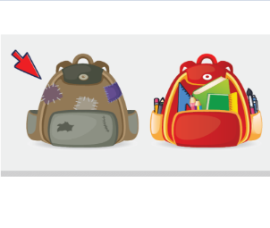
door/ small  - ……………………………………………….. |  | school bag/ old  - ……………………………………….
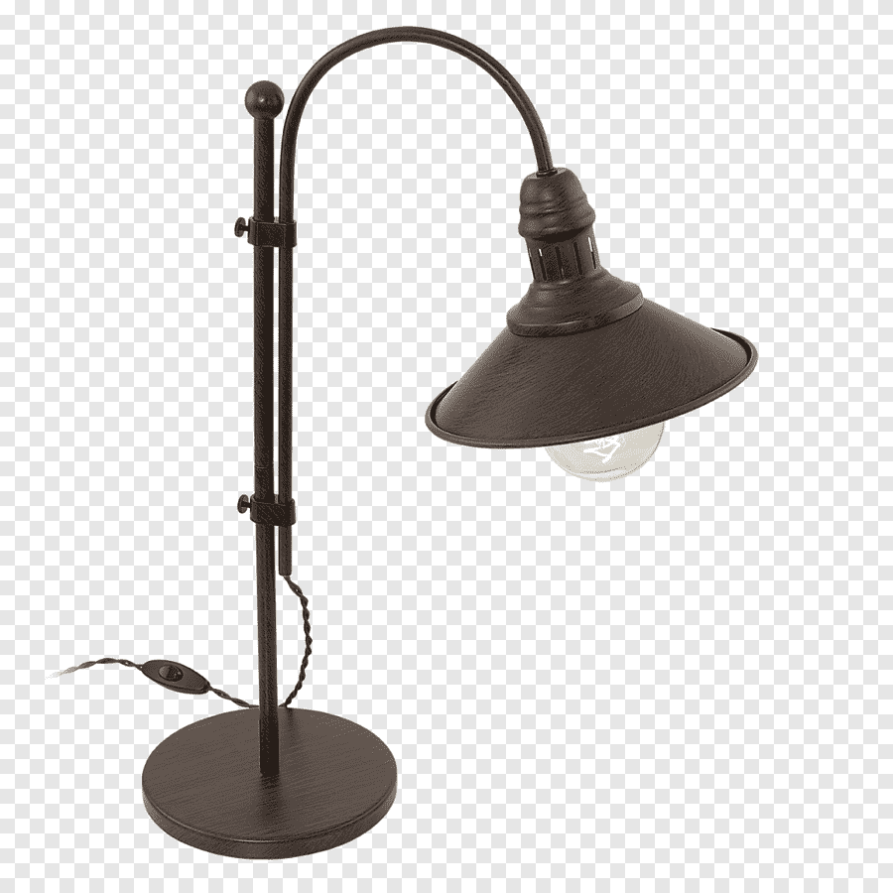 |  | 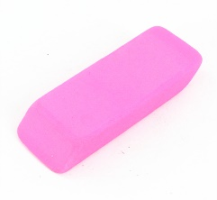
lamp/ old  - …………………………………………………………….. |  | eraser/ pink  - ………………………………………..
 |  | 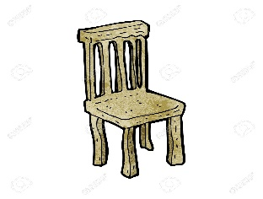  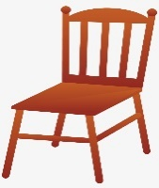
ruler/ yellow  - ……………………………………………………………… |  | chair/ old  - ………………………………………………………
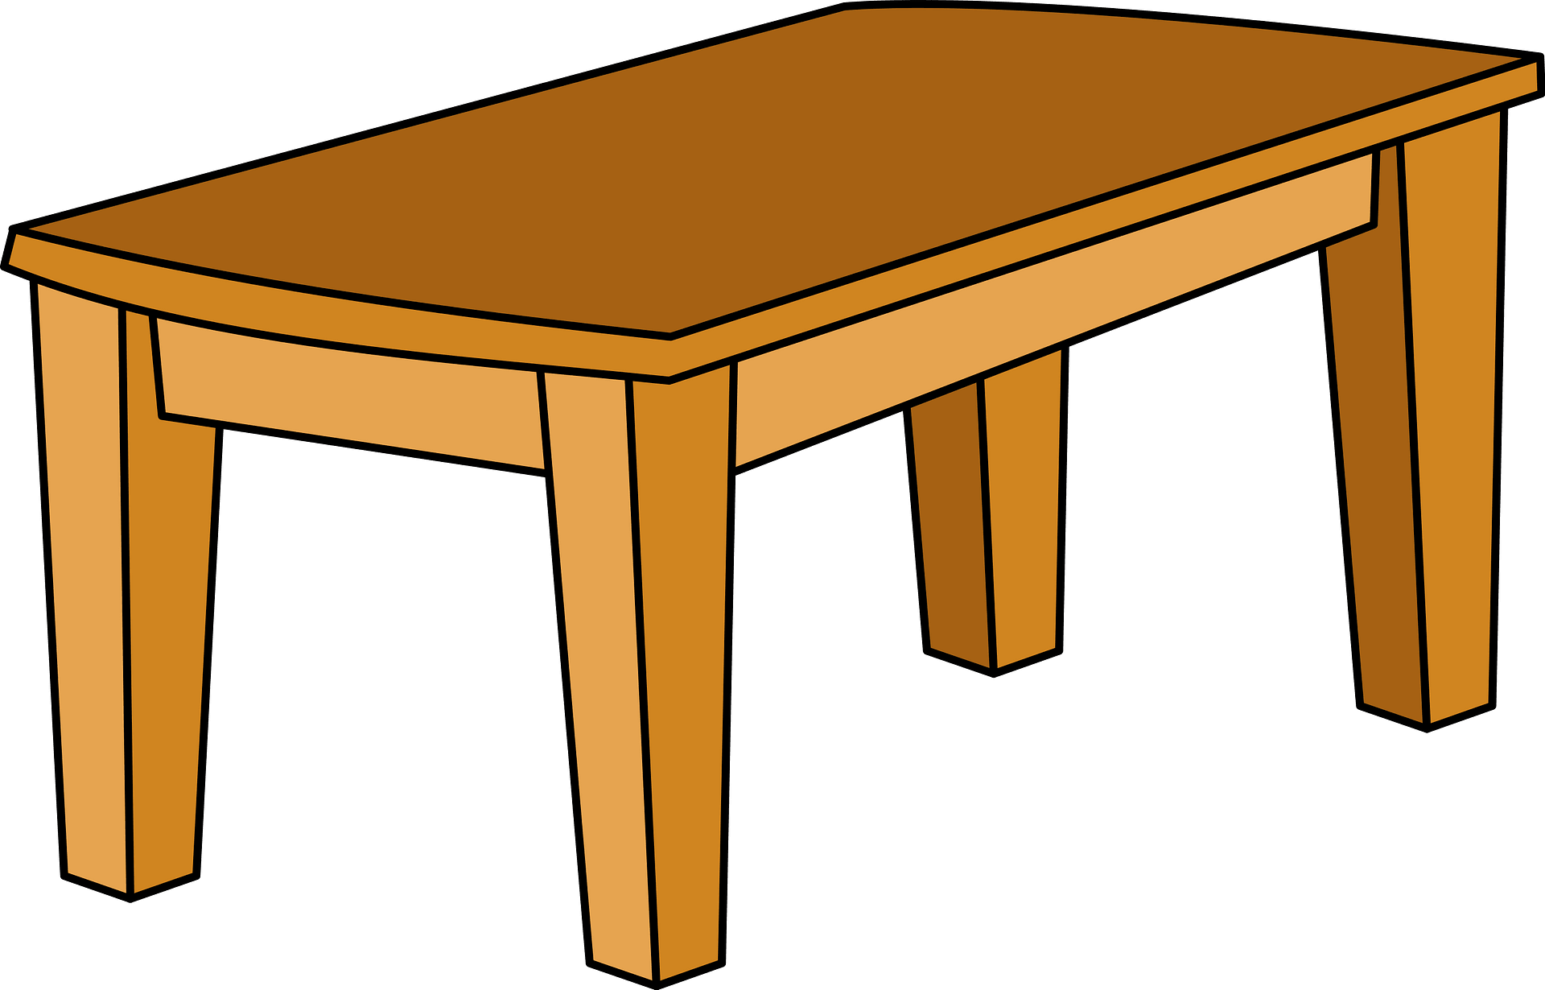 | 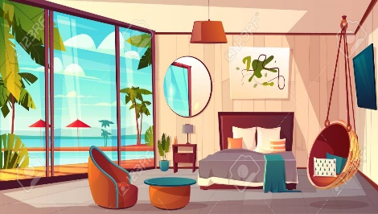  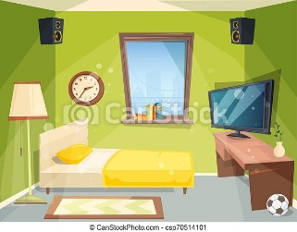
table/ small  - ……………………………………………. | bedroom/ big  - ……………………………………………
 |  | 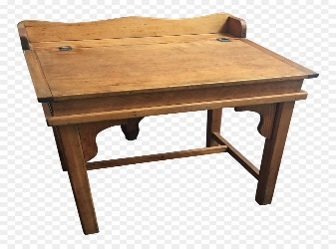
pen/ blue  - ……………………………………………………… |  | desk/ old  - ………………………………………………………….

Exercise 4: Circle the correct answer.

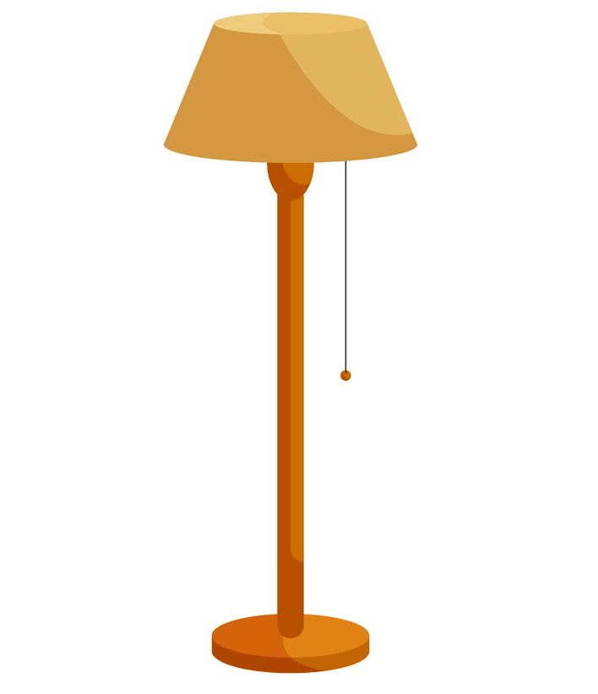 | There is/ There are a lamp.
 | There is/ There are three beds.
 | There is/ There are two chairs.
How many doors are there?
There is/ There are a door.
How many windows are there?
There is/ There are two windows .
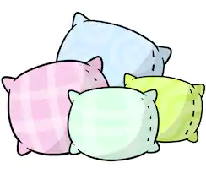 | How many pillows are there?  There is/ There are four pillows.
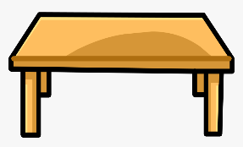 | How many tables are there?  There is / There are a table.
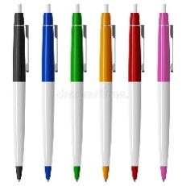 | How many pens are there?  There is / There are six pens.
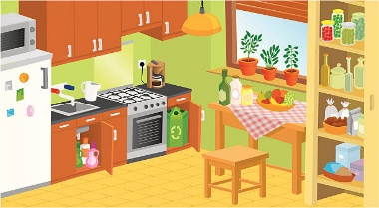 | How many kitchens are there?  There is / There are a kitchen.
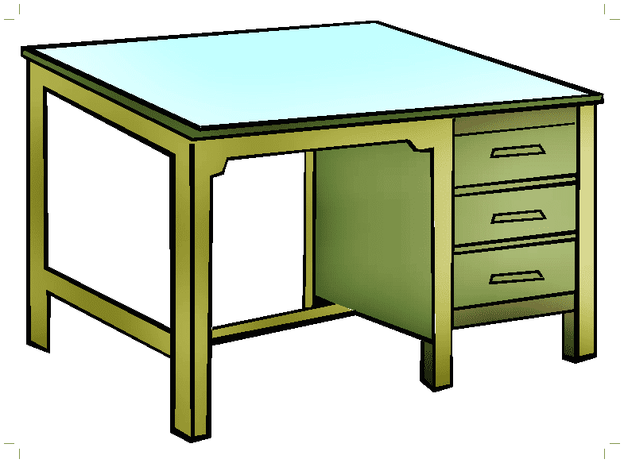 | How many desks are there?  There is / There are three desks.

Exercise 5: Write there is/ there are
1. ………………………………. a chair.
2. ………………………………. four bedrooms.
3. ………………………………. a school bag.
4. ………………………………. two tables.
5. ………………………………. three lamps.
6. ………………………………. two beds.
7. ………………………………. a ruler.
8. ………………………………. two bathrooms.
9. ………………………………. eight pens
10. ………………………………. a door.
11. ………………………………. seventeen pencils.
12. ………………………………. a living room.
13. ………………………………. five desks.
Exercise 6: Make questions for these answer
a) There is a bed in the bedroom.
How many beds are there in the bedroom?
b) There are two pillows on the bed.
………………………………………………………………………………………..
c) There is a lamp on the table.
………………………………………………………………………………………..
d) There are four books in the school bag.
………………………………………………………………………………………..
e) There is a table in the living room.
………………………………………………………………………………………..
f) There are four bedrooms on my house.
………………………………………………………………………………………..
g) There are three windows in the bedroom.
………………………………………………………………………………………..
h) There is a desk in the bedroom.
………………………………………………………………………………………..
i) There are five chairs in the kitchen.
………………………………………………………………………………………..
j) There is a kitchen in the house.
………………………………………………………………………………………..
k) There are two bathrooms in the house.
………………………………………………………………………………………..
l) There are nine pencils in the pencil case.
………………………………………………………………………………………..
m) There is an eraser on the desk.
………………………………………………………………………………………..
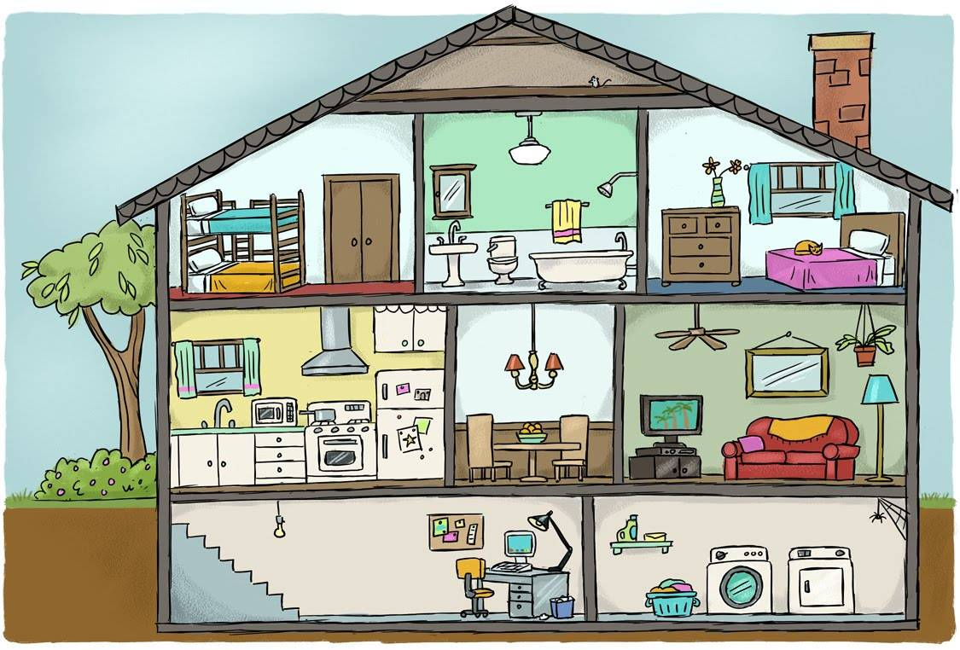
Exercise 7: Answer the questions:

- How many bedrooms are there in the house?
…………………………………………………………………………..
- How many bathrooms are there in the house?
…………………………………………………………………………..
- How many kitchens are there in the house?
…………………………………………………………………………..
- How many living rooms are there in the house?
…………………………………………………………………………..

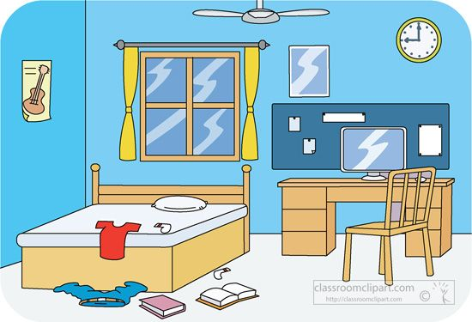

- How many windows are the in the bedroom?
………………………………………………………………….
- How many desks are there in the bedroom?
………………………………………………………………….
- How many chairs are there in the bedroom?
………………………………………………………………….
- How many beds are there in the bedroom?
………………………………………………………………….
- How many books are there on the floor?
…………………………………………………………….......
10. How many pillows are there on the bed?
………………………………………………………………….

Exercise 8: Make and answer questions, using How many, there is, there are



- book
- ………………………………………………………………………..
……………………………………………………………………….
- notebook
- ……………………………………………………………………….
……………………………………………………………………….
- eraser
- ……………………………………………………………………….
……………………………………………………………………….
- ruler
- ……………………………………………………………………….
……………………………………………………………………….
- school bag
- ……………………………………………………………………….
……………………………………………………………………….
- pencil
- ……………………………………………………………………….
……………………………………………………………………….

Exercise 9: Complete the sentences, using It’s - They’re
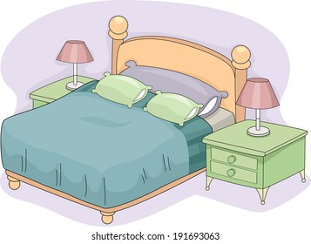 | 0. bed/bedroom/ big  -> There is a bed in the bedroom. It’s big.  1. lamp/ bedroom/ new  ->…………………………………………………………………….  2. pillow/bed/ green  ->…………………………………………………………………….
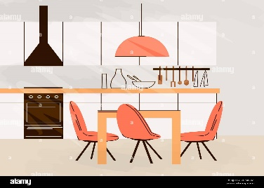 | 3. table/ kitchen/ yellow  ->………………………………………………………………….  4. chair/ kitchen/ orange  ->…………………………………………………………………….
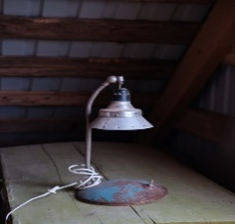 | 5. lamp/ table/ old.  ->…………………………………………………………………….
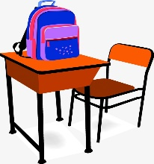 | 6. School bag/ desk/ new  -> ……………………………………………………………………
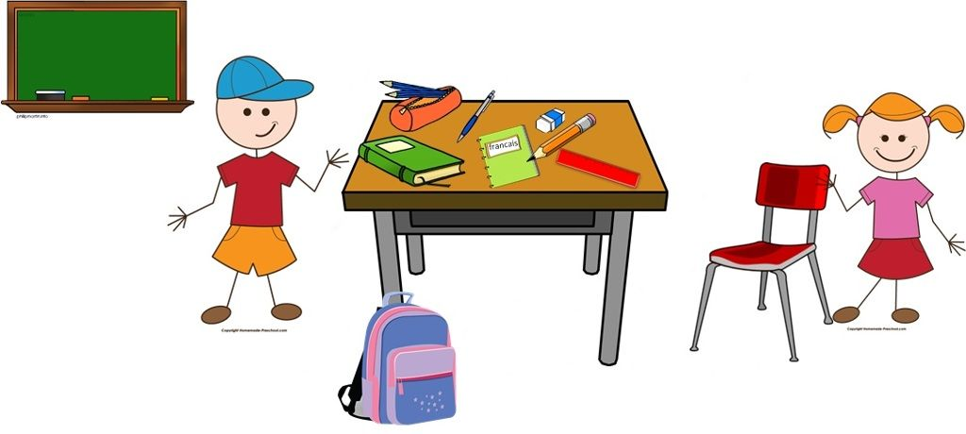 |  | 7. book/ desk/ green  -> ……………………………………………………  8. ruler/ desk/ red  -> ………………………………………………….  9. pencil/ desk/ orange  -> ………………………………………………….  10. pencil case/ desk/ orange.  -> …………………………………………………
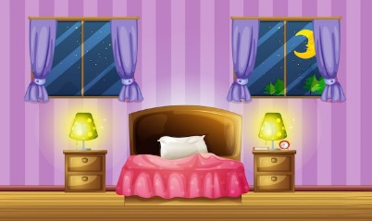 |  | 11. window/ bedroom/ small  -> ………………………………………………………………………..  12. lamp/ bedroom/ big  -> ……………………………………………………………………….
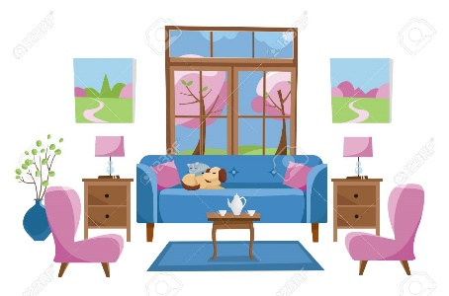 |  | 13. table/ living room/ small  -> ……………………………………………………  14. window/ living room/ big  -> ……………………………………………………

Exercise 10: Read the text and answer the questions:
My name is Ben. I’m eight years old. I like swimming. There are four people in my family. My father is a doctor, my mother is a nurse, my sister is a student, and I’m a student too. My house is new. There are four bedrooms, they’re small. There is a living room. it’s big. There are three bathrooms, they’re small. There is a kitchen, it’s big. My bedroom is blue. There is a bed in my bedroom, it’s small. There are two chairs and one desk. They’re old. There is a window in my bedroom, it’s new. I love my bedroom.
- How old is Ben?
……………………………………………...........................................
- What is his hobby?
……………………………………………...........................................
- How many people are there in his family?
……………………………………………...........................................
- Is his father a doctor?
……………………………………………...........................................
- Is his mother a cook?
……………………………………………...........................................
- What is his job?
……………………………………………...........................................
- Is his house new?
……………………………………………...........................................
- How many rooms are there in his house?
……………………………………………...........................................
- How many bedrooms are there in his house?
……………………………………………...........................................
10. Are the bedrooms big?
……………………………………………...........................................
11. How many bathrooms are there in his house? How are they?
….……………………………………………………………………………..
- What color is his bedroom?
……………………………………………………………………………….
- How many chairs are there in his bedroom?
……………………………………………………………………………….
- Is the bed big?
……………………………………………………………………………….
- How many windows are there in his bedroom?
………………………………………………………………………………
Exercise 11: Put the words in the correct order
a) There – a bed – is – in – the bedroom.
………………………………………………………………………………………….
b) two – the bed – There are – pillows – on
………………………………………………………………………………………….
c) a table – There – living room – is – the – in
………………………………………………………………………………………….
d) are – There – ten – books – the – on – desk
………………………………………………………………………………………….
e) There – in – the kitchen – are – five chairs
………………………………………………………………………………………….
f) How many – the – lamps – in - are – there – bedroom?
………………………………………………………………………………………….
g) is – The – big – door.
………………………………………………………………………………………….
h) new – My – is – house.

Listening:
Part 1: Listen and circle. There is one example:
1.

A B

2.

A B

3.
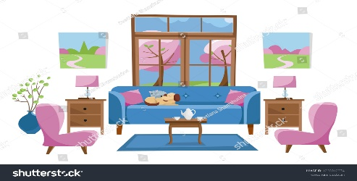
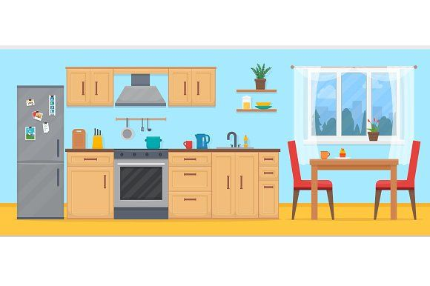

A B
4.
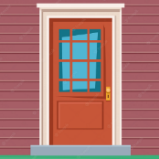

A B

5.

A B
6.

A B

Part 2: Listen and tick  or cross . There are two examples
1. | 2.
  3. | 4.
 | 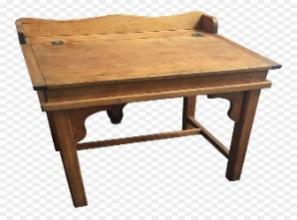
5. | 6.
7. | 8.
9. | 10.

