Exercise 1: Write the words:
egg | bread | milk | rice | juice
water | meat | fish | bean | chicken

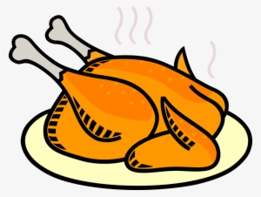 | 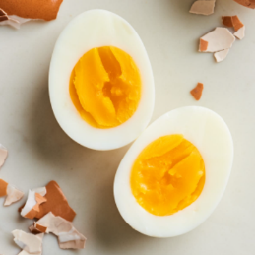 | 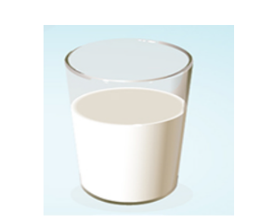 | 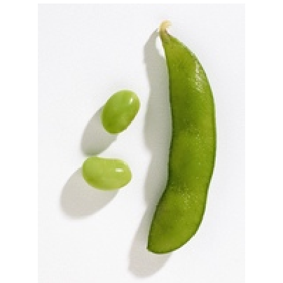
………………………. | ………………………. | ………………………. | ……………………….
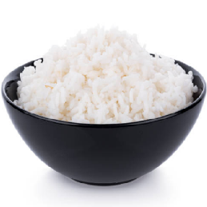 | 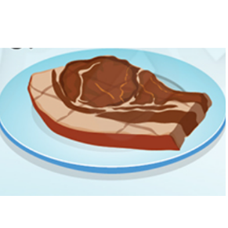 | 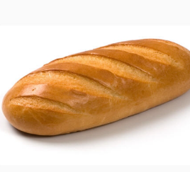 | 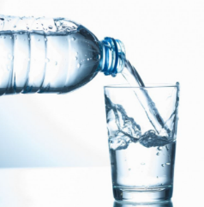
………………………. | ………………………. | ………………………. | ……………………….
 |  | 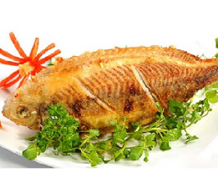
………………………. |  | ……………………….
Exercise 2: Write the missing letters
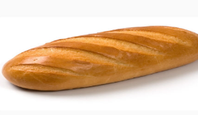 | 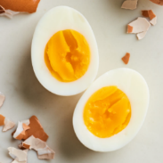 | 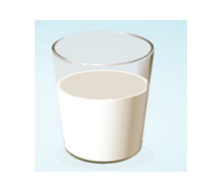 | 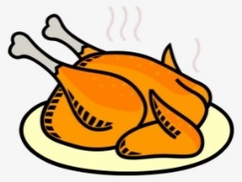 | 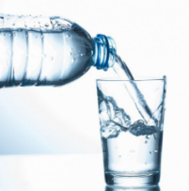
b_ _ad | eg_ | _i_k | c_ic_e_ | w_t_r
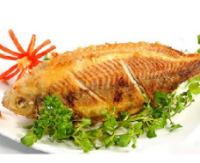 | 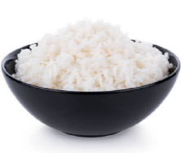 | 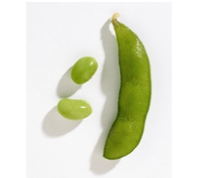 |  | 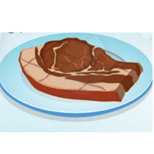
Fi_ _ | _i_e | b_a_ | j_ _ce | _e_t

Exercise 3: Look and write:
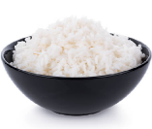 |  | Would you like some rice? | Yes, please.
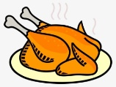 |  | …………………………………….. | ……………………………….
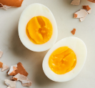 |  | …………………………………….. | ……………………………….
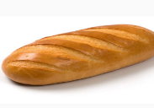 |  | …………………………………….. | ……………………………….
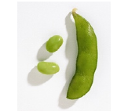 |  | …………………………………….. | ……………………………….
 |  | …………………………………….. | ……………………………….
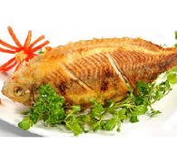 |  | …………………………………….. | ……………………………….
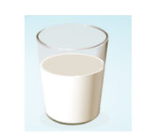 |  | …………………………………….. | ……………………………….
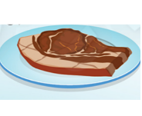 |  | …………………………………….. | ……………………………….
 |  | …………………………………….. | ……………………………….

Exercise 4: Read and complete
 | 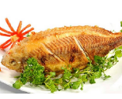 | a) Would you like some fish? ………………
 | 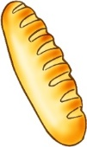 | b) Would you like some ……………? No, thanks
 |  | c) …………you like some rice? ………………
 | 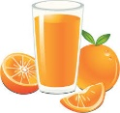 | d) Would you like some ……………? Yes, please.
 | 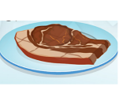 | e) Would you like some meat? ………………
 | 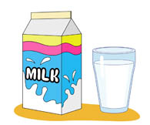 | f) Would you like some ……………? …….., thanks.
 |  | e) Would you ……. some ………? ………………
 | 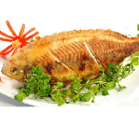 | f) ........... you like some ……………? …….., thanks.
 |  | e) Would ………. like some …………? ………………
 | 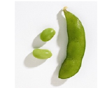 | f) Would you like some ……………? …….., thanks.
 | 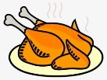 | e) Would you like ………. chicken? …………, please.

Exercise 5: Read and write
meat – fish – juice – rice –– bread – water – eggs – milk – chicken – bean

Food | Drinks
meat  ……………………….  ……………………….  ……………………….  ……………………….  ……………………….  ………………………. | juice  ……………………….  ……………………….  ……………………….  ……………………….  ……………………….  ……………………….

Exercise 6: Read and circle
a) What would you like to eat? b) What would you like to eat?
I’d like some …………, please? I’d like some …………, please?
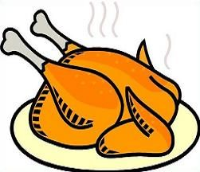 | - fish  - chicken  - eggs |  |  | 1) rice  2) bread  3) fish

c) What would you like to eat? d) What would you like to eat?
I’d like some …………, please? I’d like some …………, please?
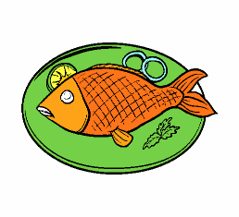 | 1) fish  2) bread  3) eggs |  |  | 1) chicken  2) rice  3) eggs

e) What would you like to eat? f) What would you like to drink?
I’d like some …………, please? I’d like some …………, please?
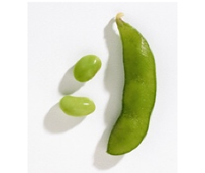 | 1) bread  2) beans  3) chicken |  | 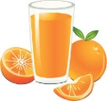 | 1) water  2) juice  3) milk

g) What would you like to drink? h) What would you like to eat?
I’d like some …………, please? I’d like some …………, please?
 | 1) milk  2) water  3) juice |  | 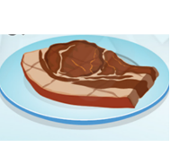 | 1) beans  2) rice  3) meat

i) What would you like to drink? j) What would you like to eat?
I’d like some …………, please? I’d like some …………, please?
 | 1) milk  2) juice  3) water |  | 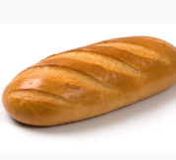 | 1) eggs  2) rice  3) bread

Exercise 7: Circle the correct words.
bread and eggs
eggs and milk
a) I’d like some , please?

 | rice and fish  fish and milk  b) I’d like some , please?
chicken and water
bread and juice
c) I’d like some , please?

 | chicken and rice  chicken and bread  d) I’d like some , please?
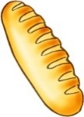 | bread and eggs  bread and milk  e) I’d like some , please?
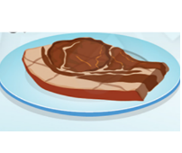   | meat and milk  meat and water  e) I’d like some , please?
beans and eggs
beans and chicken
e) I’d like some , please?

Exercise 8: Look and write:
 | 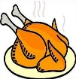 | 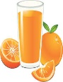 | 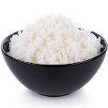 | 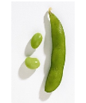 | 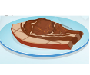 |  | 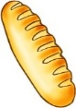 | 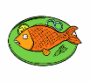 |  | 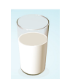
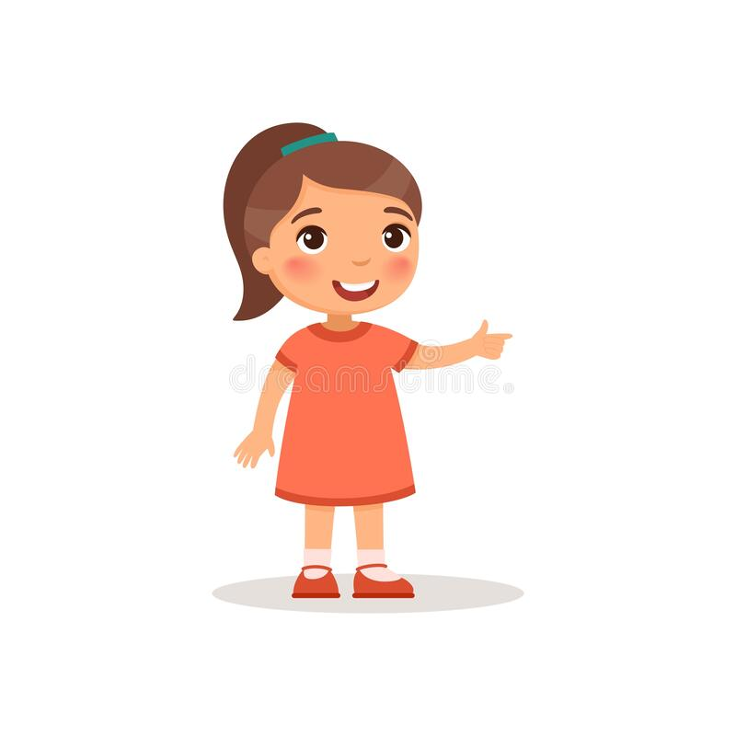Mai
 Bill

May
Ken
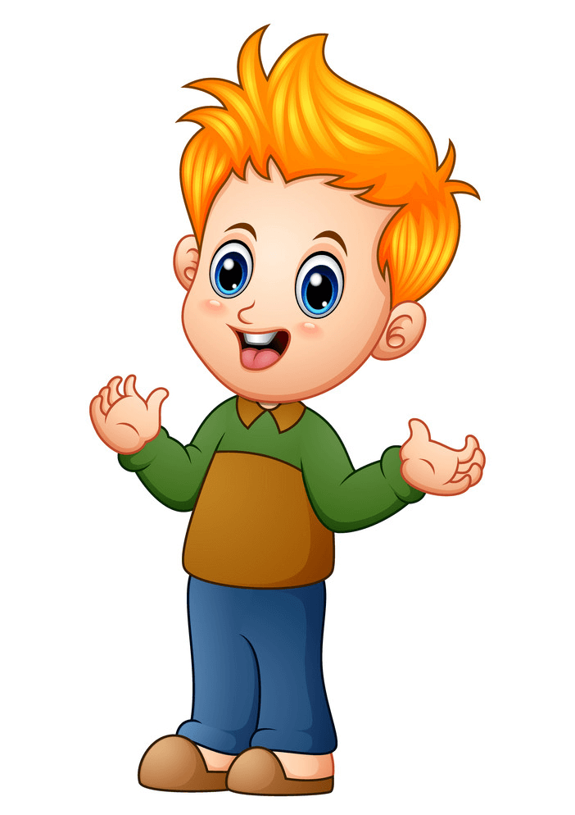 Ben
Lisa

Lan
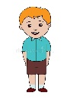Nam
Sam
Jim
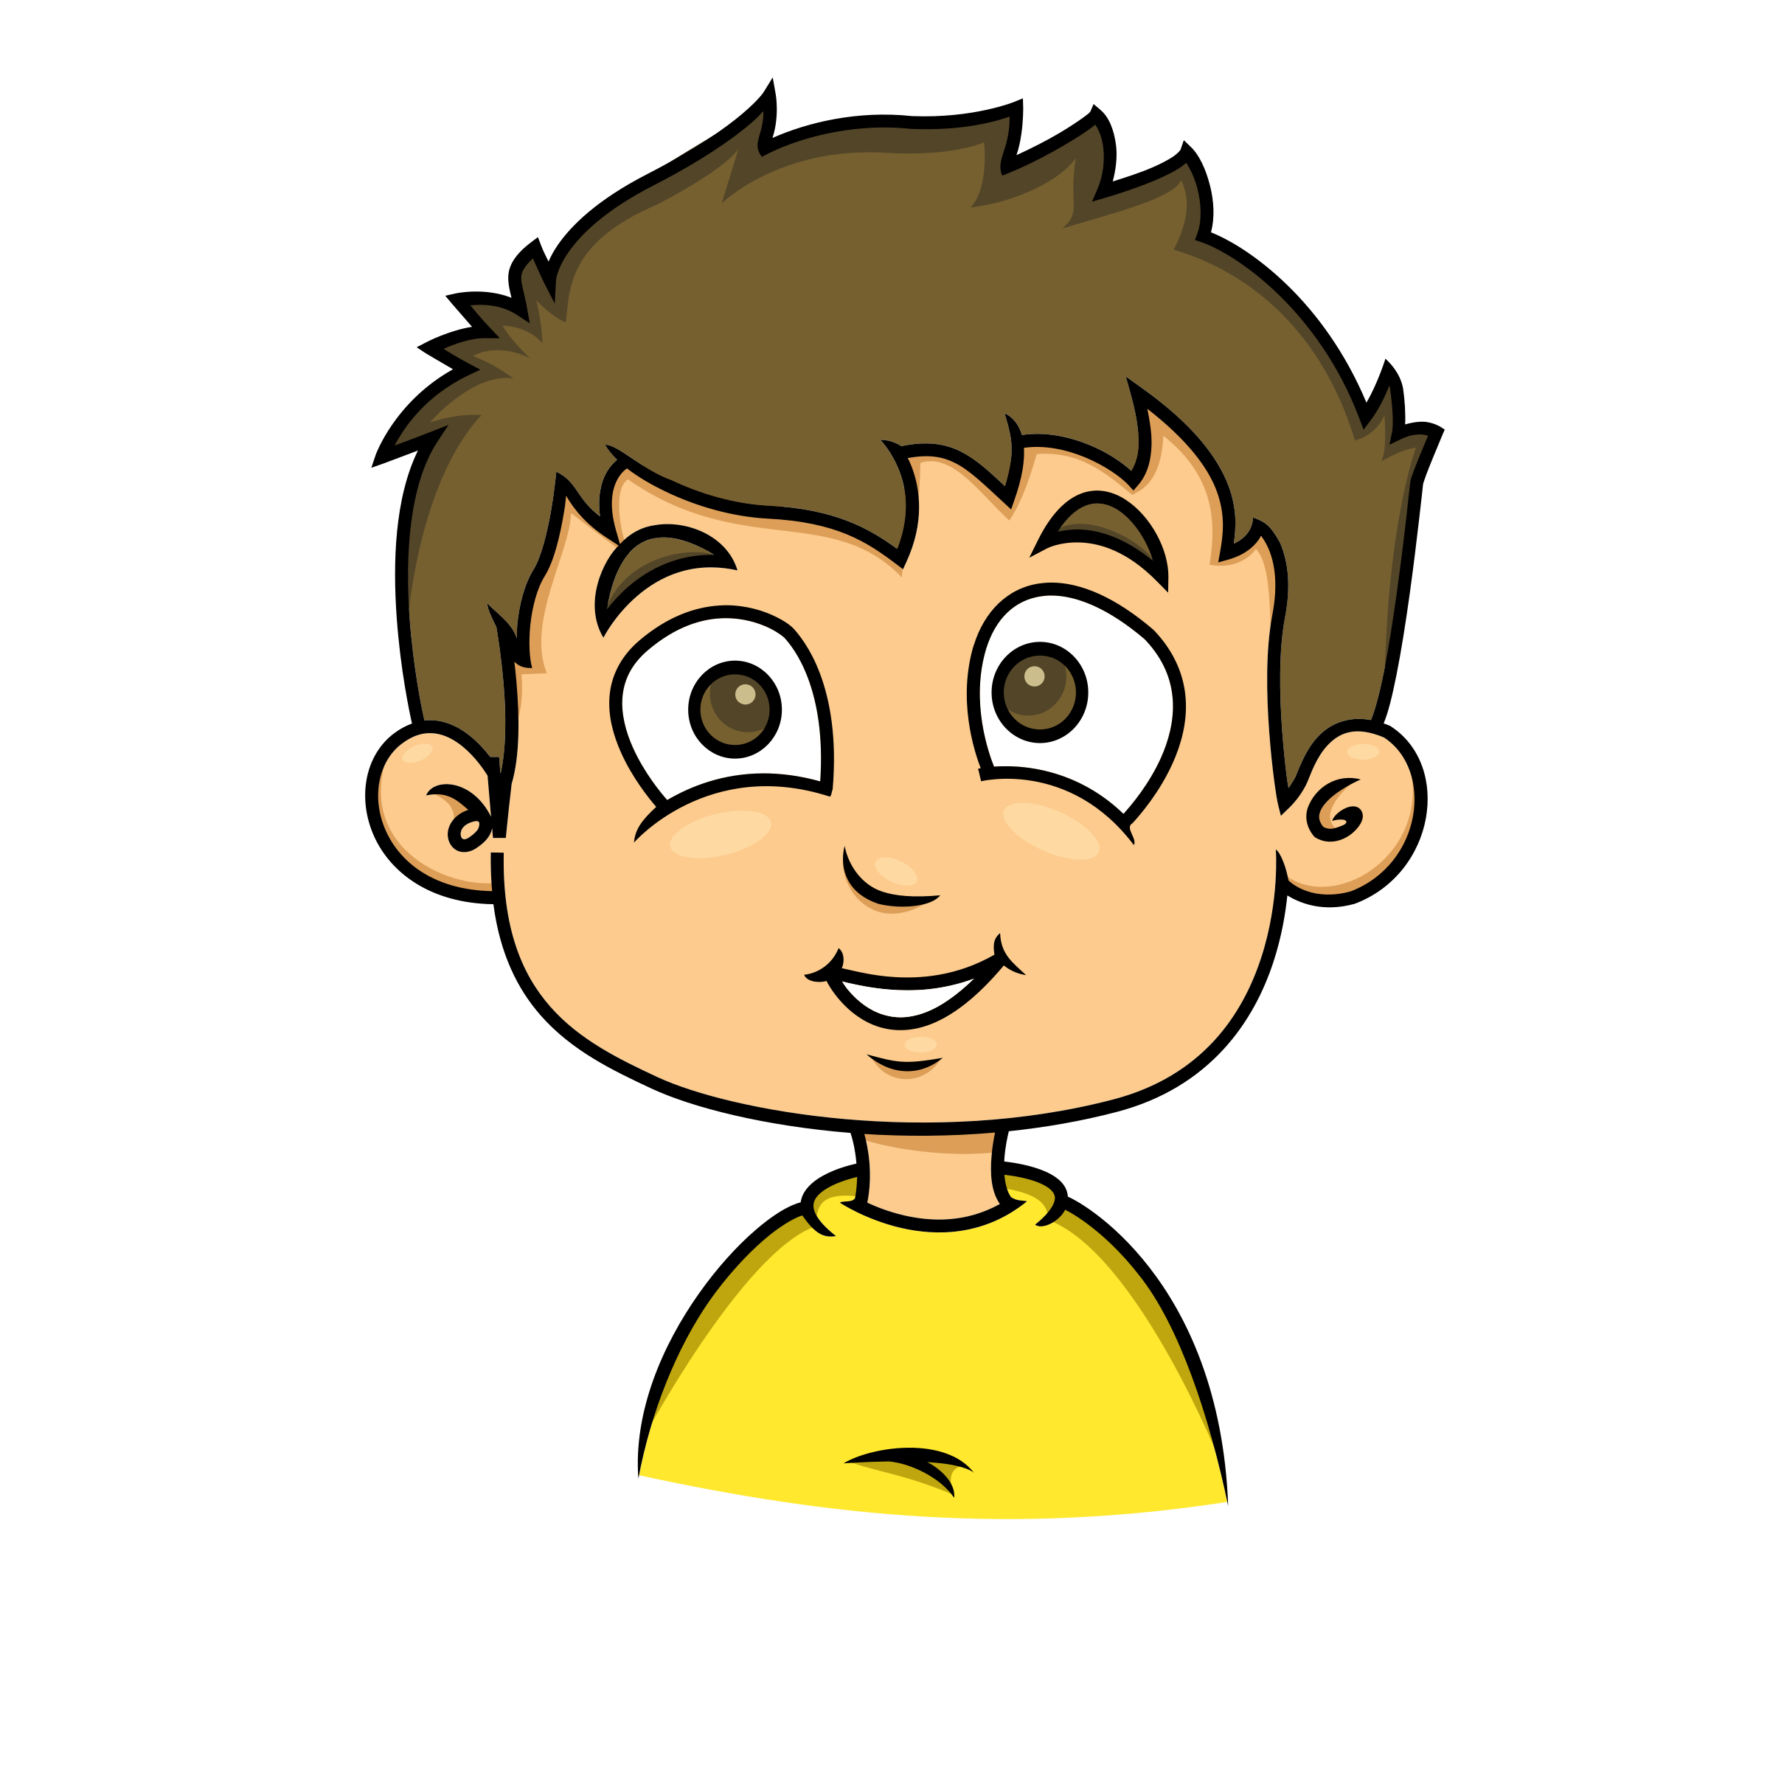Alex
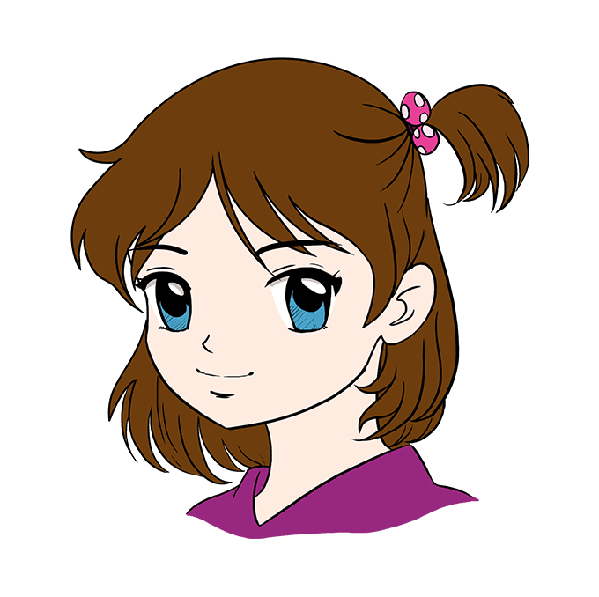Anna

- Mai would like some chicken, rice and water.
- ……………………………………………………………………….
- ………………………………………………………………………
- ………………………………………………………………………
- ………………………………………………………………………
- ………………………………………………………………………
- ………………………………………………………………………
- ………………………………………………………………………
- ………………………………………………………………………
10. ………………………………………………………………………
11. ………………………………………………………………………
12. ………………………………………………………………………
Exercise 9: Odd one out:
1. a. fish b. meat c. chicken d. juice
2. a. bread b. bean c. rice d. milk
3. a. bedroom b. kitchen c. chair d. living room
4. a. doctor b. fish c. farmer d. singer
5. a. egg b. milk c. water d. juice
6. a. lamp b. bed c. table d. bathroom
7. a. old b. new c. window d. small
8. a. mother b. nurse c. father d. brother
9. a. cooking b. walking c. meat d. running
10. a. pen b. ruler c. eraser d. big
Exercise 10: Find and correct the mistakes.
a) What would you like to eat? I’d like some egg and juice.
………………………………………………………………………….
b) Would you likes some water? Yes, please.
………………………………………………………………………….
c) What would you like eat? I’d like some chicken.
………………………………………………………………………….
d) Would you like some fish? No, please.
………………………………………………………………………….
e) Who would you like to drink? I’d like some milk.
………………………………………………………………………….
f) Would you like some milks? Yes, please.
………………………………………………………………………….
g) Would you like some beans? Not, thanks.
………………………………………………………………………….
h) What would like you to drink? I’d like some juice.
………………………………………………………………………….
i) Would you do some bread? No, thanks.
…………………………………………………………………………
k) What would you like for eat? I’d like some beans
…………………………………………………………...................
l) would you like a meat? No, thanks.
…………………………………………………………………………………………………..
Exercise 11: Complete the questions and answers.
a. you/milk/like/Would /some /
Would you like some milk ? Yes, please.
b. like/some/Would/you/ bread
________________________________________ Yes, _______________.
c. beans/ you/Would /some /like /
________________________________________ _______________,thanks.
d. you /chicken? /some /like /Would/
________________________________________ Yes, _______________.
e. some/Would /like/you/fish/
________________________________________ No,_______________.
f. some/you/Would/like/rice /
________________________________________ No,_______________.
g. you /water? /some /like /Would/
________________________________________ Yes, _______________.
h. some/Would /like/you/juice/
________________________________________ No,_______________.
i. some/you/Would/like/meat/
________________________________________ No,_______________.
h. some/Would /like/you/eggs/
________________________________________ Yes, _______________.

12: Match
- What would you like to eat ? | - I’d like some milk. | 1-
- Would you like some juice? | - I’d like some eggs. | 2-
- What would you like to drink ? | - No, thanks. | 3-
- How many chairs are there in the kitchen? | It’s here. | 4-
- What is his job ? | - There are four chairs in the kitchen. | 5-
- Where is the bedroom? | - She is in the living room. | 6-
- Where is your sister? | - He is a driver. | 7-

Listening:
Part 1: Listen and circle. There is one example:
1.


A B
2.

A B

3.

A B
4.

A B
5.

A B
6.

A B
7.

A B

Part 2: Listen and write, the first one is done for you.
Name | Food/ drinks
1. Nam | Fish, eggs
2. Ben | …………………………………………………………………….
3. Anna | …………………………………………………………………….
4. Marry | …………………………………………………………………….
5. Minh | …………………………………………………………………….
6. Linda | …………………………………………………………………….
7. Bill | …………………………………………………………………….

