Exercise 1: Write the words:
goldfish | some | cat | parrot
rabbit | bird | many | dog

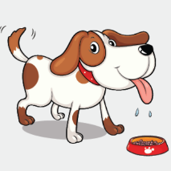 | 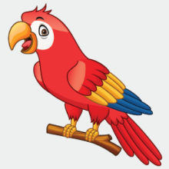 | 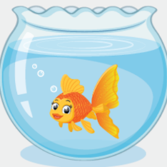 | 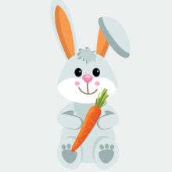
…………………. | …………………. | …………………. | ………………….
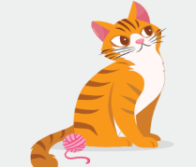 | 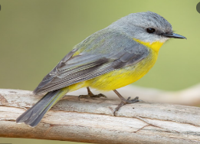 | 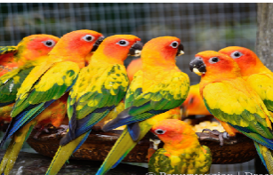 | 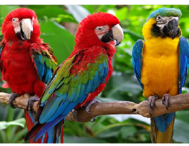
…………………. | …………………. | …………………. | ………………….

Exercise 2: Look at the pictures and write
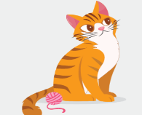
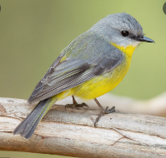
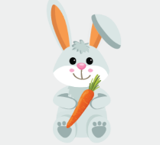

a) I have one rabbit. b) ………………………. c) ………………………..
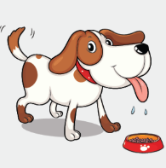
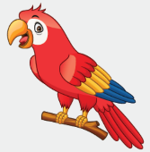
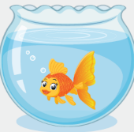

d) …………………………. e) ………………………… f) ……………………………

Exercise 3: Look and write:
one | two/ three | some | many

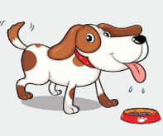 | 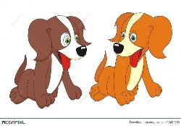 | 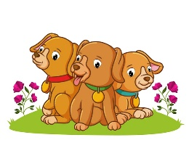 | 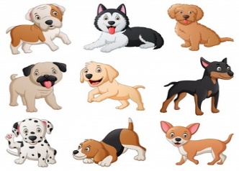
I have one dog. | I have two dogs. | I have some dogs. | I have many dogs.
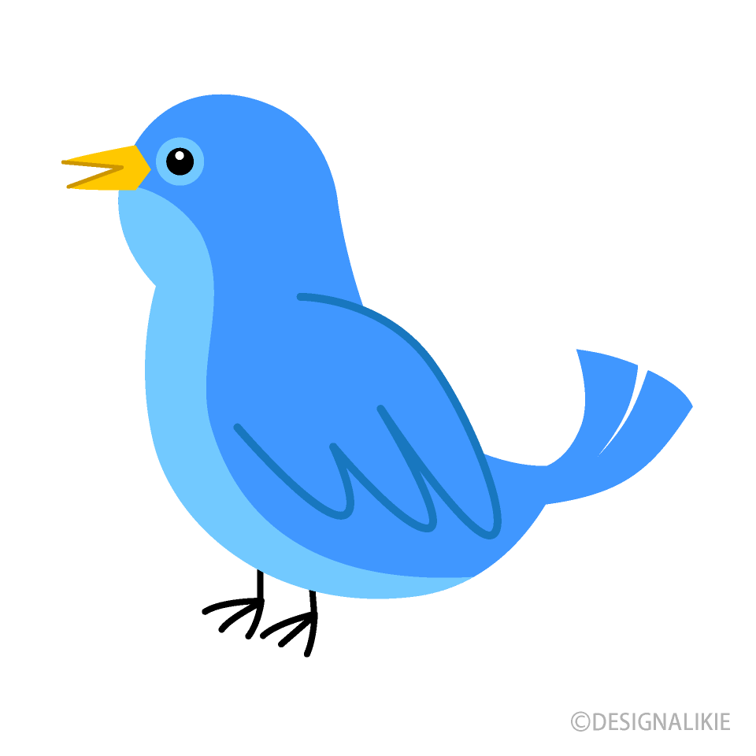 | 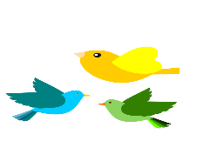 | 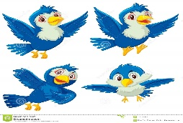 | 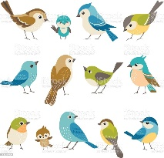
…………………….. | …………………….. | …………………….. | ……………………..
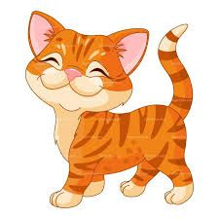 | 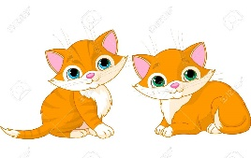 | 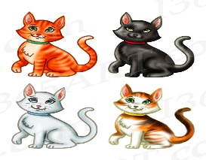 | 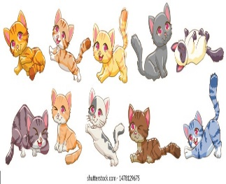
…………………….. | …………………….. | …………………….. | ……………………..
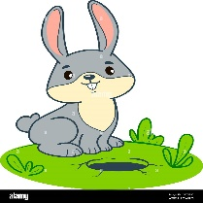 |  | 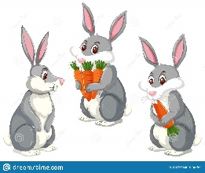 | 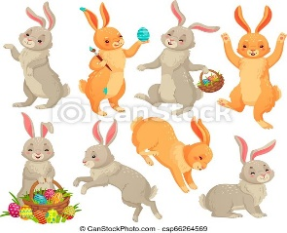
…………………….. | …………………….. | …………………….. | ……………………..
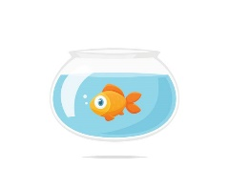 | 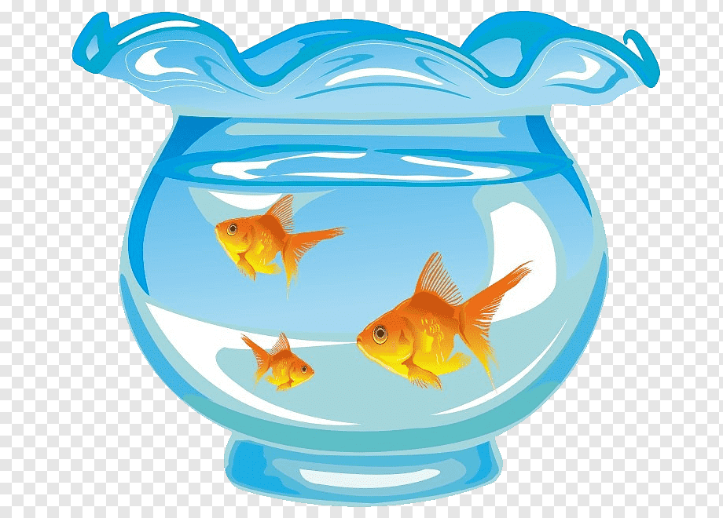 | 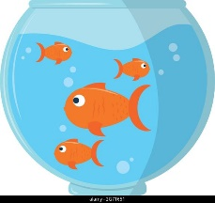 | 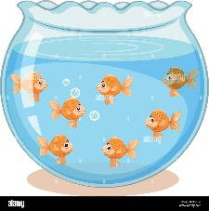
…………………….. | …………………….. | …………………….. | ……………………..
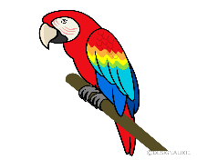 | 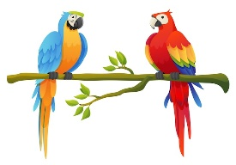 | 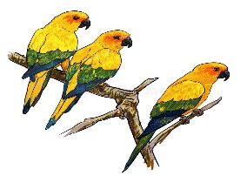 | 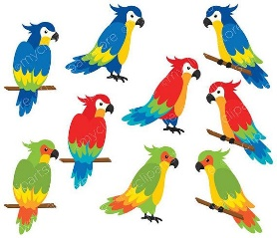
…………………….. | …………………….. | …………………….. | ……………………..
Exercise 4: Read and tick ( ) or cross ()
 |  | 
- I have one cat. | - I have two goldfish. | - I have one book. | - I have some dogs.
 | 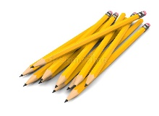 |  | 
- I have two parrots. | - I have many pencils. | - I have some birds. | - I have many rabbits.
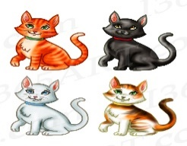 | 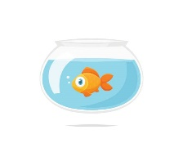 | 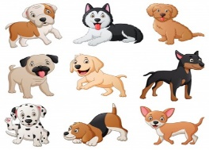
- I have three cats. | - I have some goldfish. | - I have many dogs. | - I have some birds.
Exercise 5: Look and write
Yes, I do. | No , I don’t

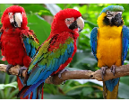 | 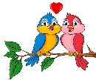 | 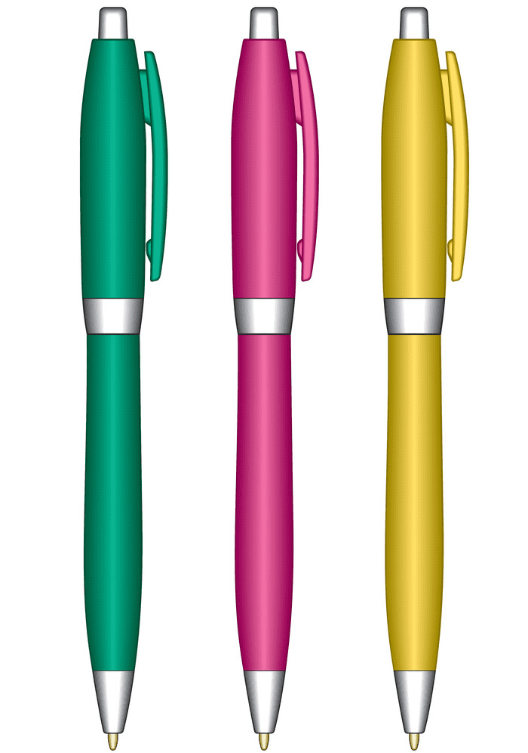
a) Do you have any parrots ? | b) Do you have any cats? | c) Do you have any pens?
……………………………………. | ……………………………………. | …………………………………….
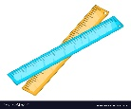 | 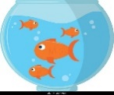 | 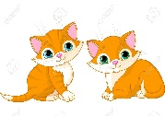
e) Do you have any pencils? | f) Do you have any dogs ? | g) Do you have any cats ?
……………………………………. | ……………………………………. | …………………………………….
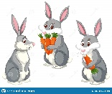 | 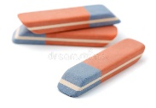 | 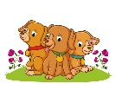
h) Do you have any goldfish ? | i) Do you have any erasers? | j) Do you have any birds?
……………………………………. | ……………………………………. | …………………………………….

Exercise 6: Look and write:
  Yes, I do |   No , I don’t

a) Do you have any…………? b) ……………………? c) ……………………….? ………………………. …………………………. ………………………..
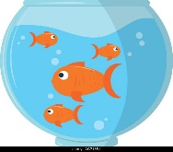

d) …………………………? e) ………………………… ? f) …………………………?

…………………………. …………………………. ………………………….

Exercise 7: Look at the pictures and write:
Mai | Lucy | Ben | Mary | Bill | Minh
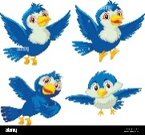 | 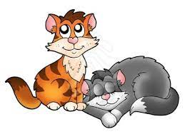 | 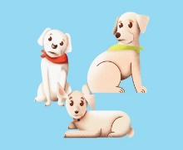 | 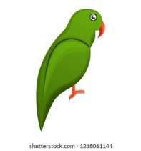 | 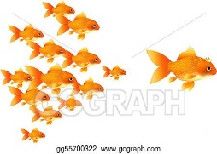 | 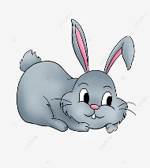

 | Questions | Answers
Mai | How many birds do you have? | I have………………………………
Lucy | ……………………………………… | ………………………………………
Ben | ……………………………………… | ………………………………………
Mary | ……………………………………… | ………………………………………
Bill | ……………………………………… | ………………………………………
Minh | ……………………………………… | ………………………………………
Exercise 8: Complete the sentences, using How many- there is- there are

1. How many chairs………………………………?
……………………………….a chair.
2. How many tables……………………………….?
……………………………….three rugs.
3. How many rabbits……………………………….?
……………………………….one rabbit.
4. How many pillows ……………………………?
……………………………….six pillows.
5. How many lamps …………………………….?
……………………………….two lamps.
6. How many beds……………………………….?
……………………………….three beds.
7. How many bedrooms ………………………….?
………………………………. four bedrooms.
8. How many rulers…………………………….?
………………………………. a shelf.
9. How many parrots ………………………………?
………………………………. eight parrots.
10. How many goldfish ……………………………….?
………………………………. goldfish.
11. How many cats ……………………………….?
………………………………. thirteen cats.
12. How many pencils ………………………………...?
………………………………. three pencils in the pencil case.
13. How many dogs ……………………………….?
………………………………. six dogs.
14. How many birds ……………………………….?
………………………………. seven…………...

Exercise 9: Read and answer these questions
a) How many dogs do you have?  ………………………………………  b) How many cats do you have?  ………………………………………  c) How many parrots do you have?  …………………………………………  d) How many rabbits do you have?  ………………………………………  e) How many goldfish do you have?  ………………………………………  f) How many birds do you have?  …………………………………….. | 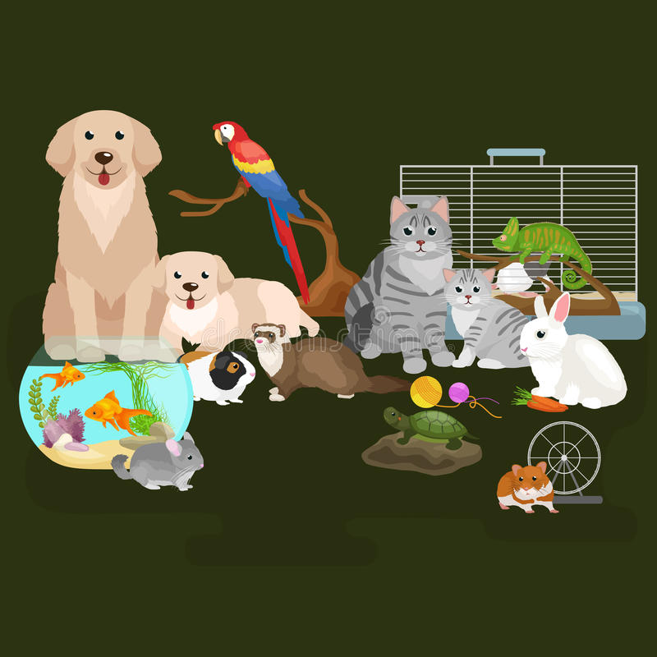  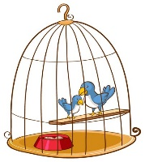
Exercise 10: Circle the correct answer.

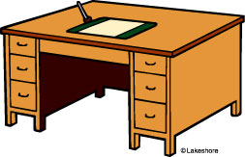 | a) How many desks are there?  There is/ There are one desk.
 | b) How many rabbits do you have?  I have many/ two rabbits..
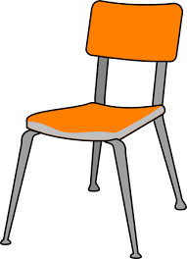 | c) How many chairs do you have?  There is/ I have two chairs.
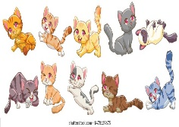 | d) How many cats do you have?  I have many/ some cats.
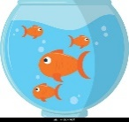 | e) How many goldfish do you have?  I have one/ some goldfish.
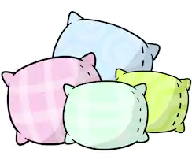 | f) How many pillows are there?  There is/ There are four pillows.
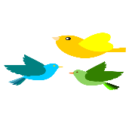 | g) Do you have any birds?  Yes, I don’t/ do
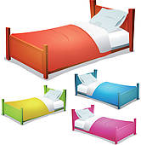 | h) How many beds are there?  There is / There are four beds.
 | i) How many lamps are there?  There is / There are a lamp.
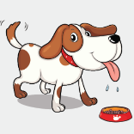 | j) How many dogs do you have?  I have some dogs/ one dog.

Exercise 11: Make questions for these answers
0) There is a desk in the classroom.
How many desks are there in the classroom?
1) I have two dogs.
…………………………………………………………….
2) There are five pens in the pencil case.
…………………………………………………………….
3) I have some cats.
…………………………………………………………….
4) Yes, I do. I have one parrot.
…………………………………………………………….
5) I’d like some meat.
…………………………………………………………….
6) I’d like some juice
…………………………………………………………….
7) Milk? No, thanks.
…………………………………………………………….
8) I like cooking.
…………………………………………………………….
9) He is a driver.
…………………………………………………………….
10) The kitchen is there.
…………………………………………………………….
Exercise 12: Choose the best answer
a) Where is the book? It ………… on the table.
am | is | are | in
b) There …………… a bag on the chair.
is | are | am | an
c) Do you have any birds?
No, I do. | Yes, I am. | Yes , I do. | No, thanks.
d) The pen is…………..the table
in | on | to | here
e) ……………. bedrooms are there in your house?
How | When | How many | What
f) Do you have any cats? Yes, I……………….
have | am | do | don’t
g) ……………….would you like to eat?
Who | What | How | Do
h) There ……... six chair in the kitchen.
have | is | are | do
i) I have………….dog.
two | one | some | many

Exercise 13: Circle the odd one out.
 | cat | dog | meat | rabbit
 | juice | water | milk | goldfish
 | his | my | she | her
 | school | schoolbag | notebook | pencil case
 | What | parrot | Who | How many
 | eat | drink | speak | mother
 | old | some | big | small
 | yellow | twenty | black | grey
 | bedroom | kitchen | egg | living room
 | teacher | driver | singer | drawing
 | Sit down | Stand up | beans | Go out
 | is | do | am | are
 | any | one | six | nine
 | father | rabbit | sister | mother
 | water | bread | egg | chicken
 | swimming | singing | painting | hobby
 | nose | red | ear | hand
 | window | kitchen | bedroom | bedroom

Listening:
Part 1: Listen and tick ( ) or cross () . There are two examples:
1. | 2. | 3. | 4.
 |  |  | 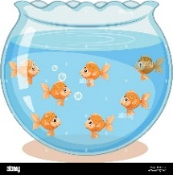
5. | 6. | 7. | 8.
9. | 10. | 11. | 12.

Part 2: Listen and rewrite the following sentences:
1. I have a dog and two cats | -> ……………………………………………
2. I have a goldfish | -> ……………………………………………
3. I have many birds | -> ……………………………………………
4. I have a bird and many parrots | -> ……………………………………………
5. I have two goldfish and a dog | -> ……………………………………………
6. Do you have any cats? No, I don’t | -> ……………………………………………
7. How many parrots do you have? | -> ……………………………………………
8. I have a goldfish and some birds | -> ……………………………………………

