Exercise 1: Look and write
kite | train | plane | truck | car
doll | toy | bus | teddy bear | ship

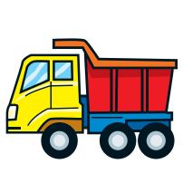 | 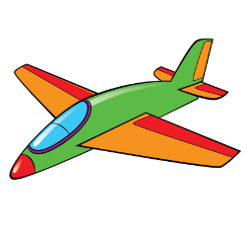 | 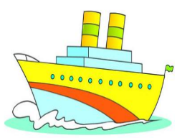 |  | 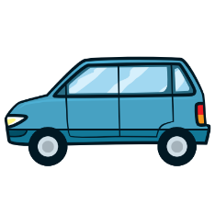
………………. | ………………. | ………………. | ………………. | ……………….
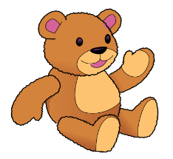 | 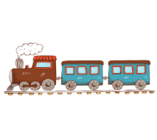 | 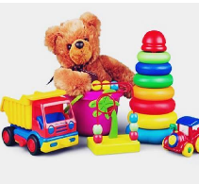 |  | 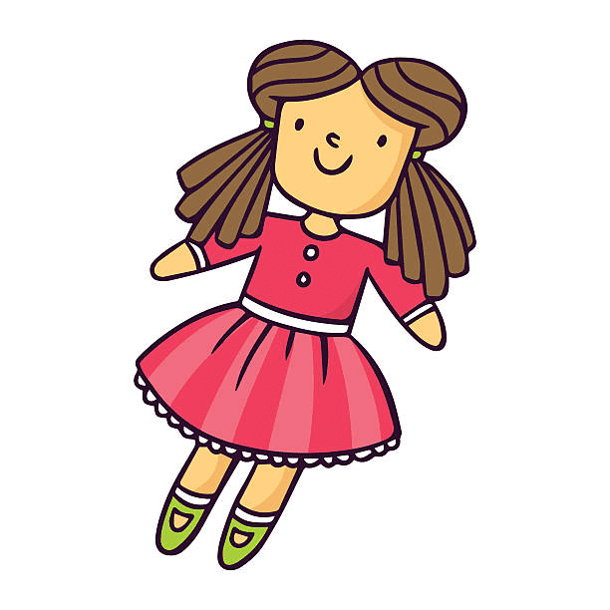
………………. | ………………. | ………………. | ………………. | ……………….
Exercise 2: Circle the right sentence.
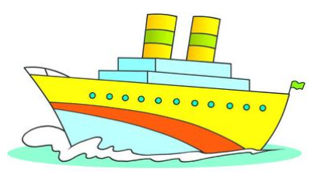

a) I have a kite. a) I have a ship. a) I have a bus.
b) I have a plane. b) I have a truck. b) I have a teddy bear.
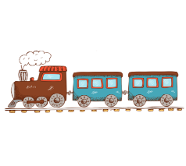

a) I have a car. a) I have a train. a) I have a train.
b) I have a kite. b) I have a bus. b) I have a car.

a) I have a teddy bear. a) I have a truck. a) I have a doll.
b) I have a bus. b) I have a plane. b) I have a teddy bear.
Exercise 3: Complete the sentences and match
Have | Has

1. She ………. a plane. |  | 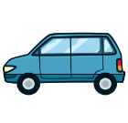
2. I …………. a truck. |  | 
3. Ben ……….a car. |  | 
4. He …………a teddy bear. |  | 
5. They………..a bus.
6. My sister………….a kite. |  | 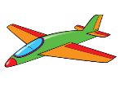
7. Jack and Peter …………..a ship. |  | 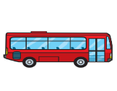
8. My brother……….a train. |  | 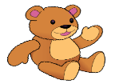
9. She…………..a doll. |  | 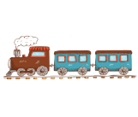
Exercise 4: Look and write, using have- has
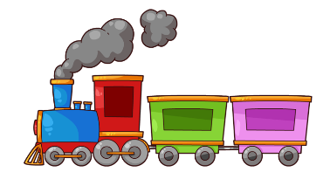
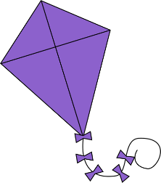
4. Jim
1. Lucy

2. Bill and Tom
3. Mary

7. My brother
8. My sister
5. My friends
6. I

6. My sisters
7. They

1. Lucy has a plane.
2. ……………………………………………………..
3. ……………………………………………………..
4. ……………………………………………………..
5. ……………………………………………………..
6. ……………………………………………………..
7. ……………………………………………………..
8. ……………………………………………………..
9. ……………………………………………………..
Exercise 5: Look at the number of toys, write: She/ He has …. – They have….
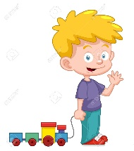 | 1. He has a train | 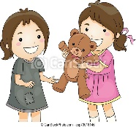 | 2. ………………………………
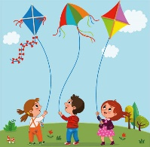 | 3. …………………………….. | 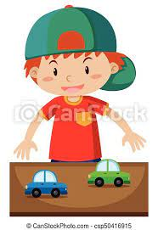 | 4.……………………………..
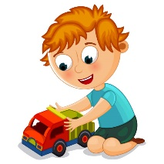 | 5. …………………………….. | 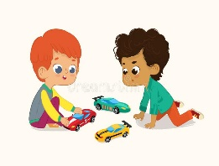 | 6. ……………………………..
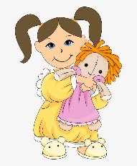 | 7. …………………………….. | 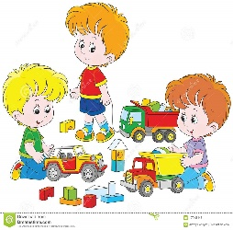 | 8. ……………………………..
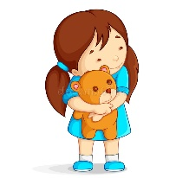 | 9. …………………………….. | 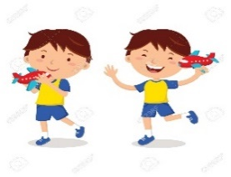 | 10. ……………………………..
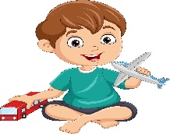 | 11. …………………………….. |  | 12. ……………………………..
 | 13. …………………………….. | 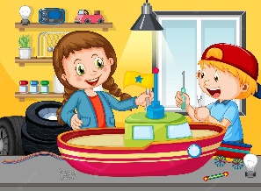 | 14. ……………………………..

Exercise 6: Find the mistakes and correct them.
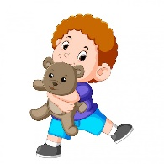 | 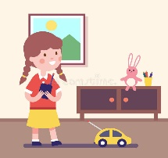 | 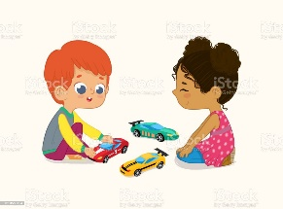
- She has a teddy bear. | - She have a car. | - They has three cars.
He has a teddy bear. | ………………………… | ………………………..
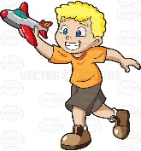 | 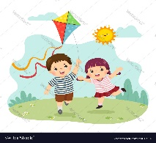 | 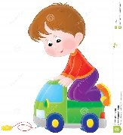
d. He has a planes. | e. He have a kite. | f. They has a truck.
………………………….. | ……………………….. | …………………………..
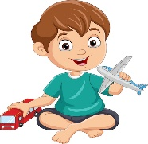 | 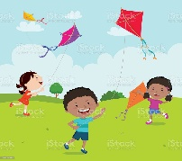 | 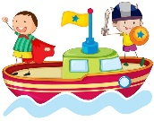
g. He has a plane and a kite. | They have four kite. | h. They have a truck.
………………………………  .. | ……………………………  .. | ……………………………  ..
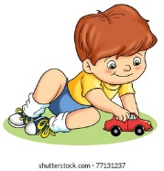 | 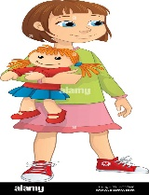 | 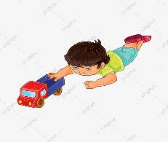
i. He has a yellow car. | k. He has a doll. | l. He has some trucks.
……………………………..  .. | …………………………….  .. | …………………………….  ..

Exercise 7: Read and Tick (√ ) or cross ( X )
Hello. I’m Mary. I’m seven years old. I have many toys. I have two big kites. I like flying kites. I have two trains, they’re blue. I have four teddy bears, they’re brown. I have a small car and a blue ship. My plane is orange and blue, it’s new. I have a truck, it’s old. I have two dolls, they’re pink. I love my toys. | 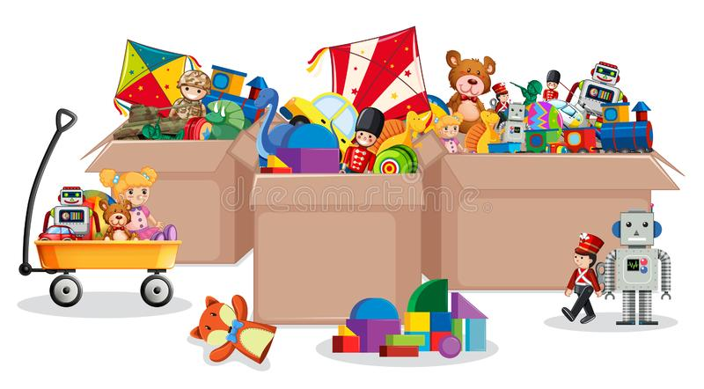  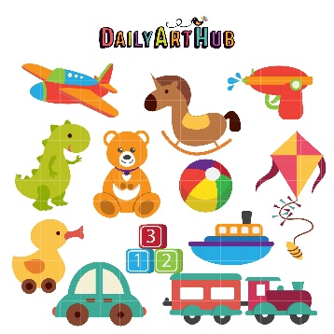

- What is her name?
..................................................................
- How old is she?
..................................................................
- How many kites does she have?
..................................................................
- What color are the kites?
..................................................................
- How many train does she have?
..................................................................
- Are the trains red?
..................................................................
- How many teddy bears does she have?
..................................................................
- What color are the teddy bears?
..................................................................
- How many cars does she have?
..................................................................
10- Is her car big or small?
..................................................................
11- How many ships does she have?
..................................................................
12- Is the ship yellow?
..................................................................
13- How many planes does she have?
..................................................................
14- What color is the plane?
..................................................................
15- Is the plane new?
..................................................................
16- How many trucks does she have?
..................................................................
17- Is the truck new or old?
..................................................................
18- How many toys does she have?
..................................................................
Exercise 8: Read and match
- Where is the cat? | - Yes, I do. I have two kites.
- What is this? | - The cat is on the table.
- How many goldfish do you have ? | - They’re on the bed.
- Is the train on the chair ? | - No, it isn’t. It’s small.
- Where are the cars ? | - I have five goldfish.
- Do you have any kites ? | - Yes, it is.
- What is his job ? | - They have three parrots.
- Are your trucks in the living room? | - He’s a worker.
- Is your ship big? | - It’s a train.
- How many parrots do they have? | 10) No, they are in the bedroom.

Exercise 9: Write about your friends:
 | School things | Toys | Pets
Phong | 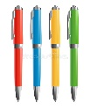  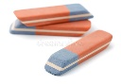  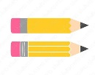  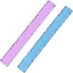  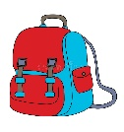 | 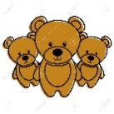    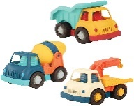  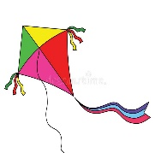  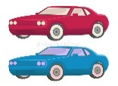 | 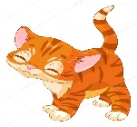  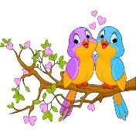  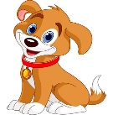
Phong | This is my friend. His name is Phong. He has one school bag, two pencils, two rulers, three erasers and four pens. | He has…………………….  ………………………………  ………………………………  ………………………………  ……………………………… | ……………………………  …………………………  ……………………………  ……………………………  ……………………………
Lan and Mai | 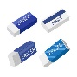  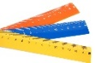  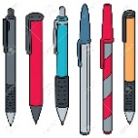  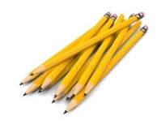  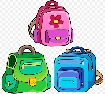 | 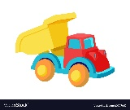  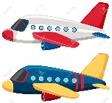    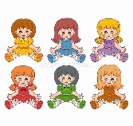  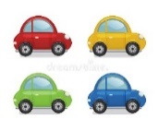 | 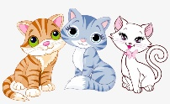  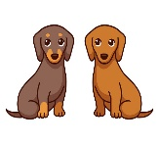  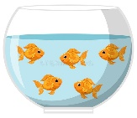
Lan and Mai | ………………………………  ………………………………  ………………………………  ………………………………  ……………………………… | ………………………………  ………………………………  ………………………………  ………………………………  ……………………………… | ……………………………  ……………………………  ……………………………  ……………………………  ……………………………
Chi | 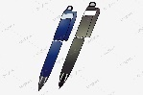  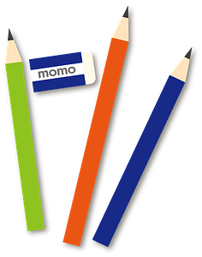  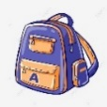  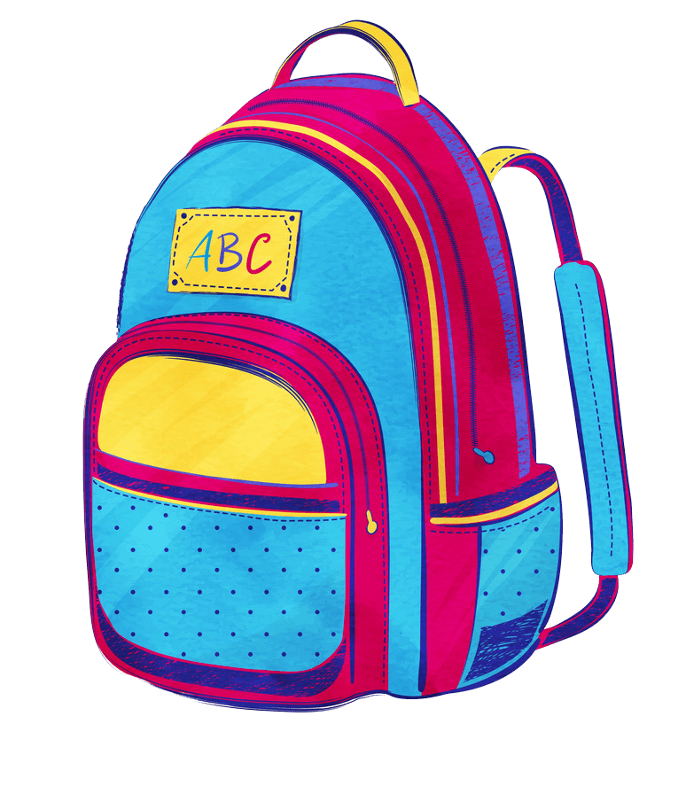  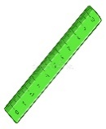 |   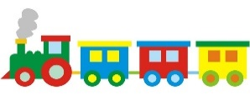  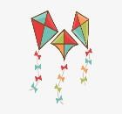  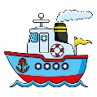  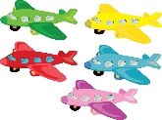 | 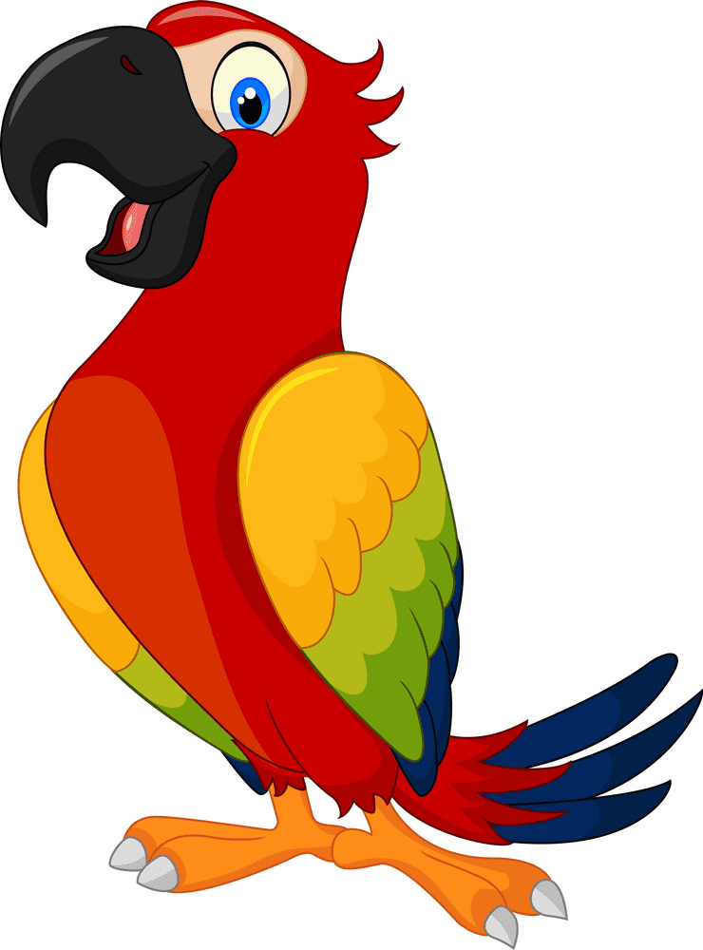  
Chi | ………………………………  ………………………………  ………………………………  ………………………………  ……………………………… | ………………………………  ………………………………  ………………………………  ………………………………  ……………………………… | ……………………………  ……………………………  ……………………………  ……………………………  ……………………………
My brothers | 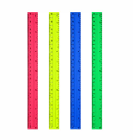  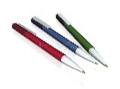  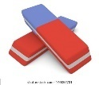    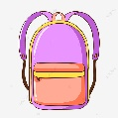  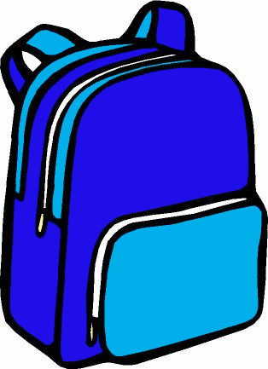 |   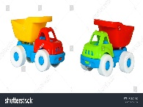    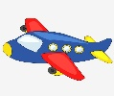  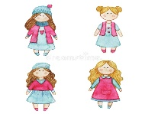 | 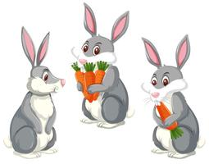  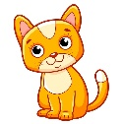  
My brothers | ………………………………  ………………………………  ………………………………  ………………………………  ……………………………… | ………………………………  ………………………………  ………………………………  ………………………………  ……………………………… | ……………………………  ……………………………  ……………………………  ……………………………  ……………………………
Exercise 10: Put the words in the correct order
a) I – two – have – birds.
I have two birds.
b) blue – She – a – has – ship.
………………………………………………………………………….
c) Tony – three – cats – small – has.
………………………………………………………………………….
d) Peter – five - Ben – cars – have – and
………………………………………………………………………….
e) ten– They – goldfish - have
………………………………………………………………………….
f) Rose – dolls – new – has - two
………………………………………………………………………….
g) brown – your – Is – teddy bear?
………………………………………………………………………….
h) dogs – How – have – many- do – you?
………………………………………………………………………….
h) rabbit – have – any – hair – you?
………………………………………………………………………….
i) father – My – parrot – a – has – big.
………………………………………………………………………….
j) red – a – has – Alice – truck.
………………………………………………………………………….
k) small – and – They – planes – a – have – ship – three.
………………………………………………………………………….
l) is – his – What – have – color – train.
………………………………………………………………………….
Exercise 11: Look and write
have | has
a) I ………………. four teddy bears. b) Tony and Ben …………. many toys.
c) She …………… a plane. d) Anna …………..some goldfish.
e) Rosy …………… two kites. e) Lily ………………. a small cat.
f) My father ……………. a big dog. f) My brother …………..two new ships.
g) My sisters ……………some dolls. g) My grandma ……………a parrot.
h) She ……………a new bus. i) John………………. a green car.
Listening:
Part 1: Listen and complete the following sentences:
1. I have a ……………...
2. (a)……………... has a (b)……………... kite.
3. My (a)……………...has a (b)……………... and a (c)……………....
4. (a)……………... have two (b)……………....
5. He has a (a)……………... doll and a red (b)……………....
6. She has a (a)……………... and three (b)……………...
7. Lucy has a (a)……………... (b)……………....
8. They have two (a)……………... dolls and a (b)……………... (c)……………....
Part 2: Listen and number the picture. There is one example:
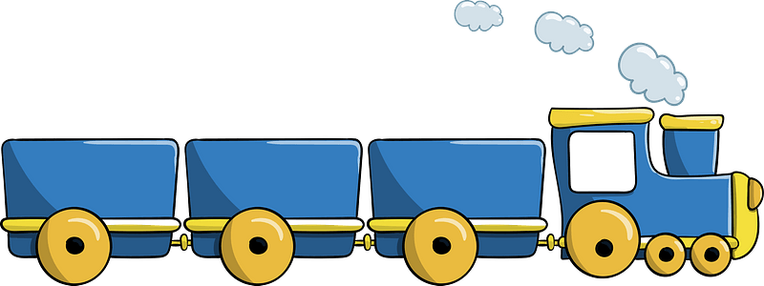 | 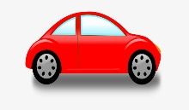

 | 
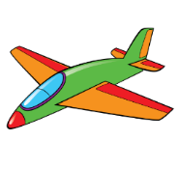
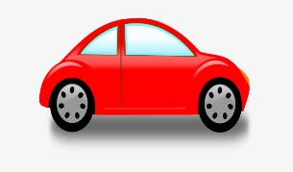
1

