Exercise 1: Write the words
Peacock | swinging | elephant | counting
monkey | climbing | tiger | horse

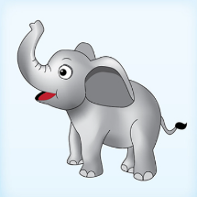 | 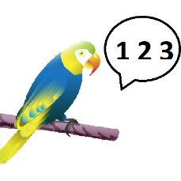 | 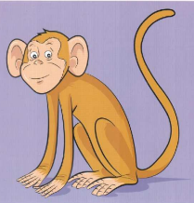 | 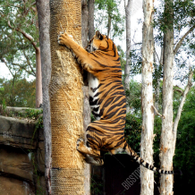
………………….. | ……………………. | ……………………. | ……………………..
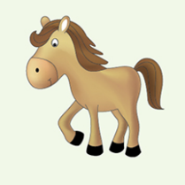 | 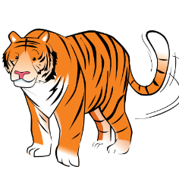 | 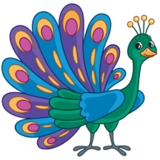 | 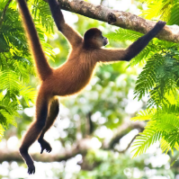
…………………… | ………………….. | …………………….. | ……………………..

Exercise 2. Look and answer
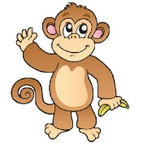 |  | 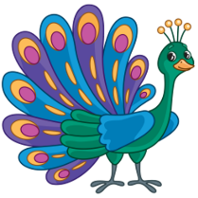
What animal is it? | What animal is it? | What animal is it?
It’s a…………………………. | ………………………………. | ……………………………….
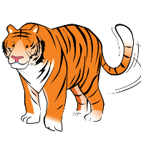 |  | 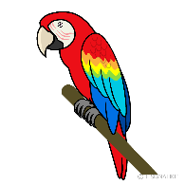
What animal is it? | What animal is it? | What animal is it?
………………………………. | ………………………………. | ……………………………….

Exercise 3: Look, read and match
- I can see a monkey. |  | 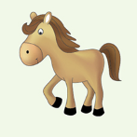
- I can see a horse. |  | 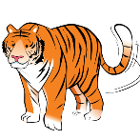
- I can see an elephant. |  | 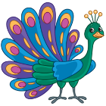
- I can see a tiger. |  | 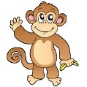
e) I can see a parrot. |  | 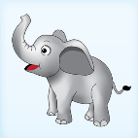
f) I can see a peacock. |  | 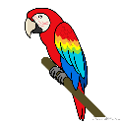

Exercise 4: Look and circle the right sentence.

a) I can see a parrot. a) I can see a horse. a) I can see an elephant.
b) I can see a peacock. b) I can see a monkey. b) I can see a tiger.
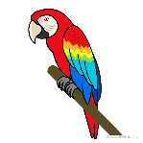
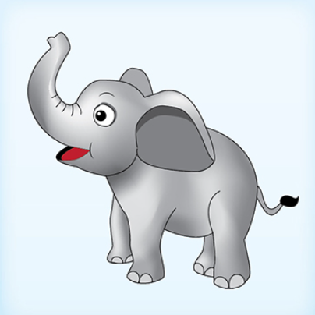

a) I can see a horse. a) I can see a parrot. a) I can see a peacock.
b) I can see an elephant. b) I can see a tiger. b) I can see a monkey.
Exercise 5: Look and write

a) What can you see? b) What can you see? c) What can you see?
…………………………….. …………………………….. ……………………………..

d) What can you see? e) What can you see? f) What can you see?
…………………………….. …………………………….. ……………………………..
Exercise 6: Put the words in the correct order
 | 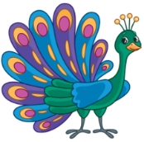
a) tiger – a – can – see- I | b) a– see – peacock – I – can | c) see – can – a – I – horse
……………………………………. | ……………………………………. | ……………………………………
 |  | 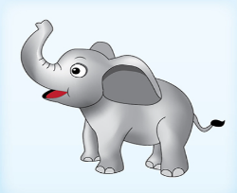
d) parrot – a – I – see - can | e) I – see – a - can – monkey | f) I – elephant – see – can - an
……………………………………. | …………………………………… | ……………………………………

Exercise 7.Write
Yes , it is. | No, it isn’t

 | 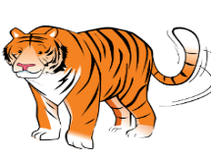
Is it a mokey? | Is it an elephant? | Is it horse ?
…………………………… | …………………………… | ……………………………
 | 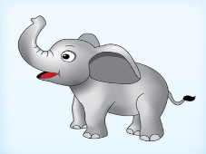 | 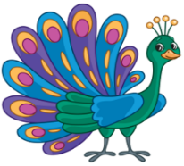
Is it a peacock ? | Is it a tiger? | Is it a peacock?
…………………………… | …………………………… | ……………………………
Exercise 8.Look and write
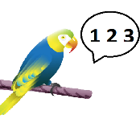 | 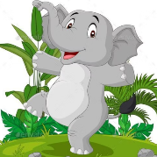 | 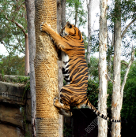
What is the parrot doing ? | What is the elephant doing ? | What is the tiger doing?
…………………………………. | ………………………………… | …………………………………
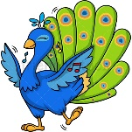 | 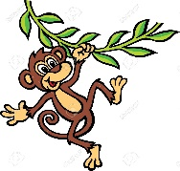 | 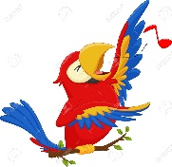
What is the peacock doing? | What is the monkey doing? | What is the parrot doing?
………………………………… | ………………………………… | …………………………………
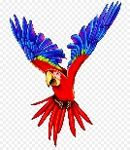 |  | 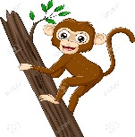
What is the parrot doing? | What is the fish doing? | What is the monkey doing?
………………………………… | ………………………………… | …………………………………
Exercise 9. Rewrite the right sentences:

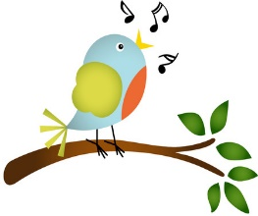 | The bird is flying. | -> …………………………….
 | The tiger is running. | -> …………………………….
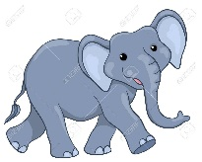 | The elephant is dancing. | -> …………………………….
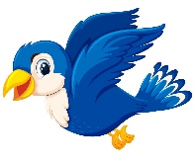 | The bird is walking | -> …………………………….
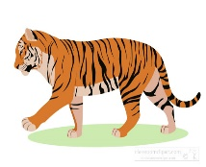 | The tiger is climbing. | -> …………………………….
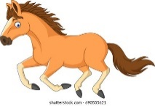 | The horse is walking | -> …………………………….
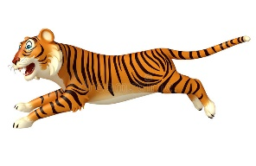 | The tiger is walking | -> …………………………….

Exercise 10. Look and write:
Yes, it is. | No, it isn’t

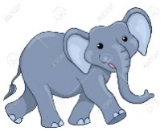 | 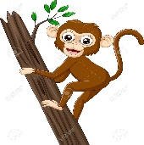 | 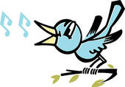
Is the elephant walking ? | Is the monkey swinging? | Is the bird singing?
…………………………………… | …………………………………… | …………………………………
 | 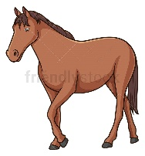
Is the parrot flying? | Is the horse running ? | Is the monkey swinging?
…………………………………… | …………………………………… | …………………………………
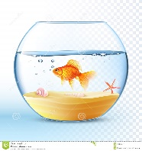 | 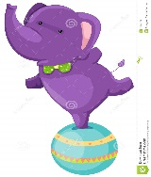
Is the goldfish swimming? | Is the elephant dancing ? | Is the parrot singing ?
…………………………………… | …………………………………… | ………………………………

Exercise 11. Put the words in the correct order to make sentences
flying/The /parrot/is | horse/The/ walking/is/ | climbing/The /monkey/is
………………………………… | ………………………………… | …………………………………
 | 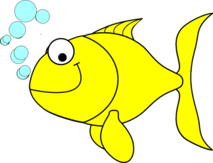
singing/The/parrot/is | swimming./The/fish/is | walking/The/ is/elephant/
………………………………… | ………………………………… | …………………………………
 |  | 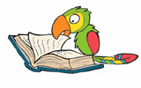
horse/The/running/is | swinging/The /monkey/is | The/reading/is/ a /book/parrot
………………………………… | ………………………………… | …………………………………
 | 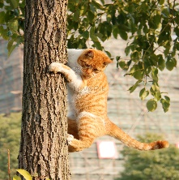
flying/The/bird/is | /cat/The/climbing/is | is/The/ counting/ parrot
………………………………… | ………………………………… | …………………………………

Exercise 12: Read and fill in the blanks.
a) Is the duck swimming? Yes, ………………
b) What is the horse ……………… ? It’s running.
c) Is the monkey climbing? No, …………..
d) What …………..the tiger doing? It’s walking
f) .................is the horse doing? It’s running.
g) What……………you see? I can see a peacock.
h) What is the peacock doing? It……………dancing.
i) What can you see? I can…….. a tiger.
j) What is the elephant doing? …………………walking
k) What do you see? I see …………… elephant.
l) What is the tiger…………………….? It’s running.
m) What can you see? I can see ……………. monkey
Exercise 13: Read and match.
- Is the horse running? | - The monkey is swinging.
- What is the monkey doing? | - Yes, it is.
- What animals do you like? | - I can see a peacock.
- Do you like monkeys? | - Yes, it is dancing.
- What can you see? | - No, I don’t. I like parrots.
- Is the tiger walking? | - I like elephants.
- Is the peacock dancing? | - I see six monkeys.
- How many monkeys can you see? | - No, the tiger is climbing.
- Where are the tigers? | - It’s flying.
10) What is parrot doing? | - They’re there.
Exercise 14: Write questions for the underlined parts.
A) The cat is running. B) The duck is swimming in the pond.
…………………………………………. ……………………………………………..
C) No, the tiger is walking. D) The bird is singing. …………………………………………. ……………………………………………..
E) The monkey is climbing. F) The parrot is counting.
…………………………………………. ……………………………………………..
G) I can see a peacock. H) The horse is running.
…………………………………………. ……………………………………………..
I) My sister is skipping. J) There are seven peacocks in the zoo.
…………………………………………. ……………………………………………..
K) The dog is running. L) I can see four elephants in the zoo.
…………………………………………. ……………………………………………..
M) I’m watching TV. N) He is singing
…………………………………………. ……………………………………………..
Exercise 15: Circle the odd one out.
 | - monkey | - dog | - elephant | - tiger
 | - swing | - run | - climb | - horse
 | a) walk | b) climbing | c) running | d) counting
 | a) How many | b) Do | c) What | d) Where
 | a) basketball | b) football | c) tiger | d) chess
 | a) trucks | b) cars | c) kite | d)planes
 | a) basketball | b) badminton | c) volleyball | d) play
 | a) big | b) new | c) peacock | d) old
 | a) fly | b) swim | c) walk | d) small
 | a) This | b) am | c) is | d) are
Exercise 16: Find the mistakes and correct them.
- What animals see can you? | ……………………………………………….
- The monkey are swinging. | ……………………………………………….
- Is the horse runing? Yes, it is. | ……………………………………………….
- What the tiger doing? It’s running. | ……………………………………………….
- I can see three monkey. | ……………………………………………….
- There is a elephant in the zoo. | ……………………………………………….
- I can see a parrot big. | ……………………………………………….
- What is the horse do? | ……………………………………………….
Exercise 17: Look, read and tick () or cross ()
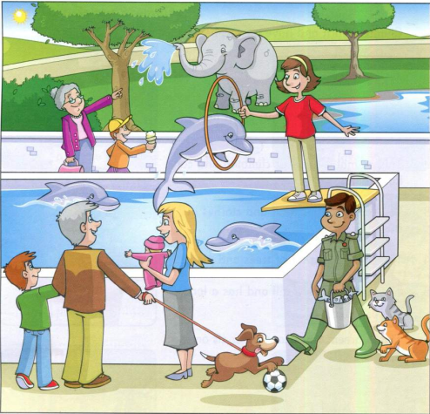 | a) A dog is playing with a ball.  b) Two dolphins are swimming  and one is jumping.  c) The woman in the blue T-shirt  has longer hair than the woman in  red T-shirt.  d) The weather is wet and we can  see a rainbow.  e) The boy who is wearing a hat  is eating a sandwich.  f) A man is giving some fish to  two cats.  g) A woman with grey hair is  pointing to an elephant.  h) The elephant is jumping.
Exercise 18: Look , read and answer these questions.
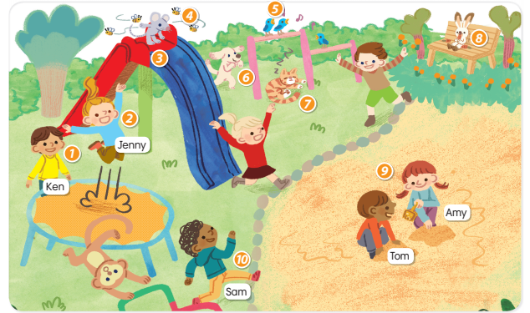
1)What is Ken doing? 2) What is Jenny doing?
He’s standing. …………………………………………
3) What is the mouse doing? 4) What are the bees doing?
………………………………………… …………………………………………
5) What are the birds doing? 6) What is the dog doing?
………………………………………… …………………………………………
7) What is the cat doing? 8) What is the rabbit doing?
………………………………………… …………………………………………
9) What are Tom and Amy doing? 10) What is Sam doing?
………………………………………… …………………………………………
11) Is there a monkey in the playground?
…………………………………………
Listening:
Part 1: Listen and number the picture. There is one example:

1

Part 2: Listen and circle, there is one example:
1.

A B
2.

A B
3.

A B
4.

A B

5.

A B

6.

A B

7.

A B

8.

A B
9.

A B

