Exercise 1: Look and write:
hair | nose |  | mouth |  | eye
face |  | hand |  | ear

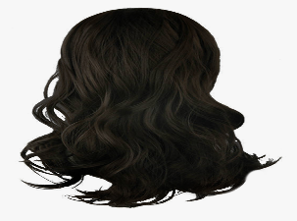 |  | 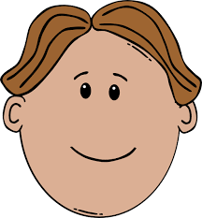 |  | 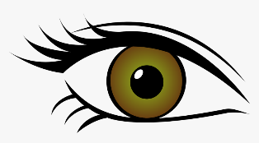
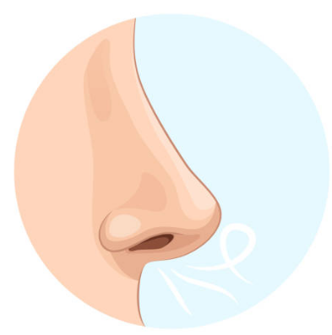 | 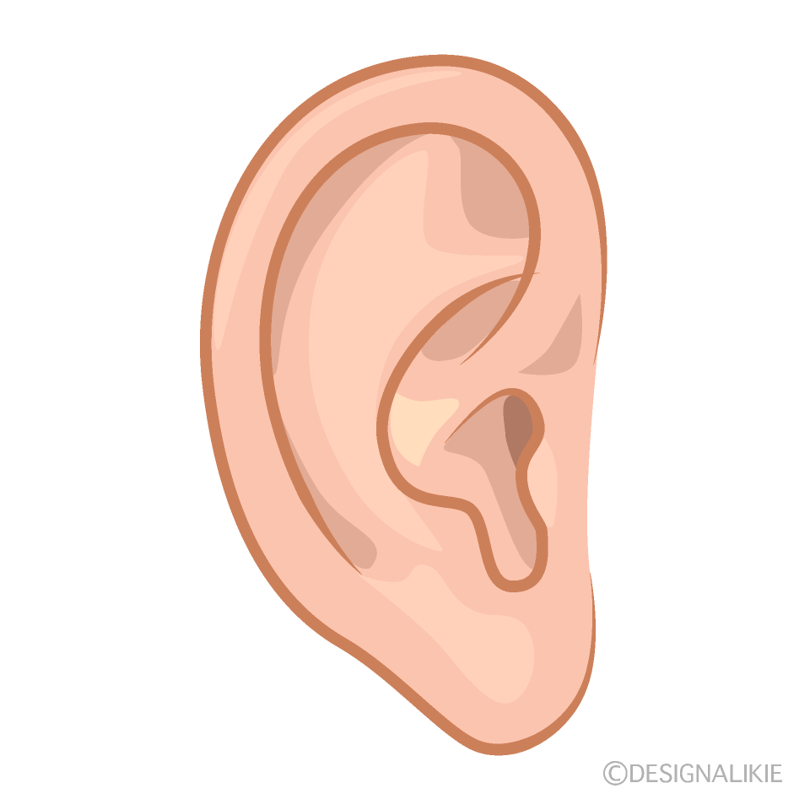 |  | 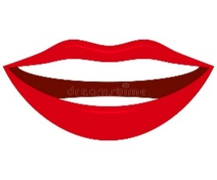 |  | 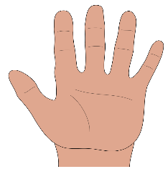

Exercise 2: Look and circle the correct words:
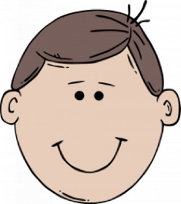
a) It’s a hand / face. b) It’s a mouth/ nose.

c) It’s a hand/ mouth. d) It’s a hand / mouth.
Exercise 3: Answer the questions:
 | What’ this?  It’s………………………….. |  | What’ this?  It’s…………………………..
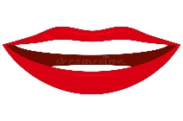 | What’ this?  It’s………………………….. |  | What’ this?  It’s…………………………..
 | What’ this?  It’s………………………….. |  | What’ this?  It’s…………………………..
Exercise 4: Tick (V) or (X):

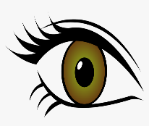 | 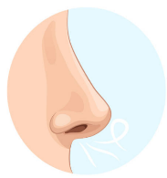 |  | 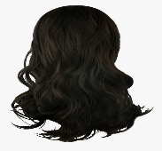 |  | 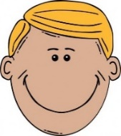 | 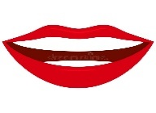
󠄉 eye | 󠄉 mouth | 󠄉 ear | 󠄉 hand | 󠄉 ear | 󠄉 hand | 󠄉 󠄉mouth
󠄉 nose | 󠄉 nose | 󠄉 face | 󠄉 hair | 󠄉 eye | 󠄉 face | 󠄉 nose
󠄉 hand | 󠄉 hair | 󠄉 hand | 󠄉 nose | 󠄉 mouth | 󠄉 eye | 󠄉 ear

Exercise 5: Choose the best answer.
1. What ………………... your name ? | 2. How old ………………...you ?
a) is b) am c) are | a) is b) am c) are
3. What is ………………... ? | 4.It’s…………………….eye
a) this b) these c) those | a) a b) an c) is
5. It ………………...a nose. | 6. How ………………... you?.
a) is b) am c) are | a) is b) am c) are

Exercise 6: Circle the right picture:
Touch your nose |  |  | 
Open your eyes | 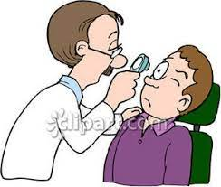 | 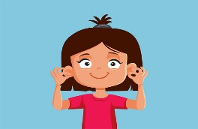 | 
Touch your hair |  |  | 
Touch your ears |  | 
Open your mouth

Exercise 7: Find and circle the words.
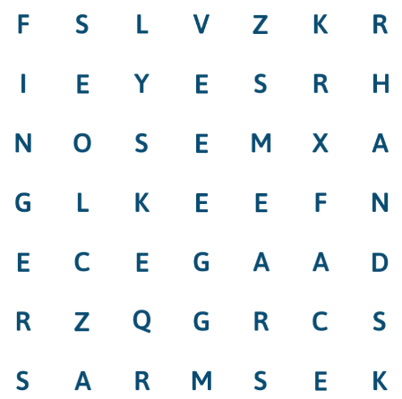
Word list
nose
face
arms
fingers
legs
ears
eyes

Exercise 8: Look at the picture and write
7.It’s ______________.
1.It’s a face.
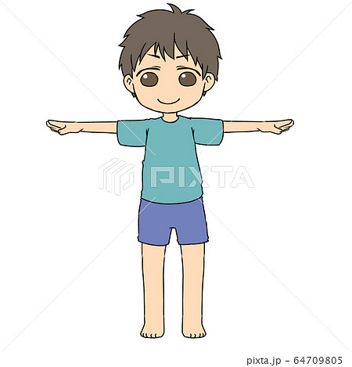
5. It’s _____________.
2. It’s ______________.

4. It’s my_______________.
3. It’s _______________.

Exercise 8: Match:
1. What’s your name ? | a) It’s a nose.
2. How old are you ? | b) It’s blue.
3. How are you ? | c) I’m nine years old.
4. What color is it? | d) I’m fine. Thank you.
5. What’s this? | e) My name’s Ben.
Exercise 9: Put the words in the correct order:
a) a – It – is – face
…………………………………………………………………..
b) name – Mary – My – is
…………………………………………………………………..
c) old – you – How – are?
…………………………………………………………………..
d) nose – a – It – is
…………………………………………………………………..
e) mouth – your – Open
…………………………………………………………………..
f) is – That – teacher – my
…………………………………………………………………..
g) Mai – this –Is?
…………………………………………………………………..
Exercise 9: Reorder the sentences to make a complete conversation.
1. I’m fine, thank you! And you?
2. Hi, Tram. How are you?
3. I’m fine, thank! This is Thuy. She is my friend.
4. Hello, Thang.
5. Good morning, Tram. Nice to meet you, too.
6. Good morning, Thuy. Nice to meet you.
Listening:
Part 1: Listen and circle, question 1 is done for you.

1.

A B

2.

A B
3.

A B
4.

A B

5.

A B
6.

A B
7.

A B

Part 2: Listen and number. There is one example.

1

