Exercise 1: Look and write
Computer room | Art room | Music room | classroom
playground | school | gym | library

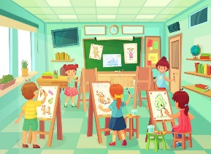 | 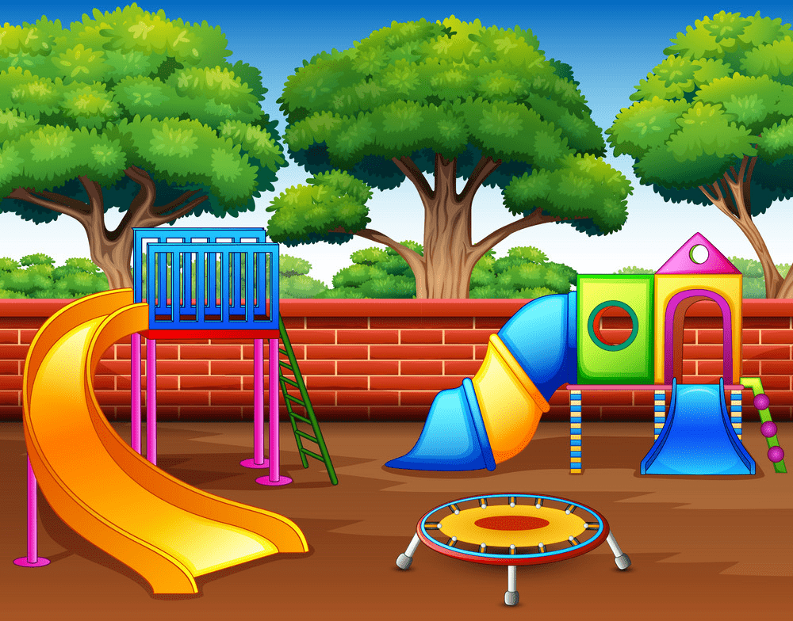 | 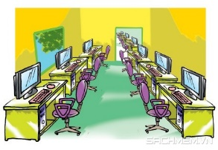 | 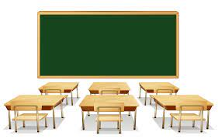
………………….. | ………………….. | ………………….. | …………………..
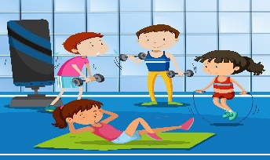 | 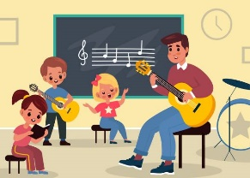 | 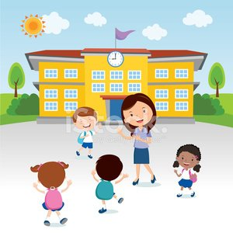 | 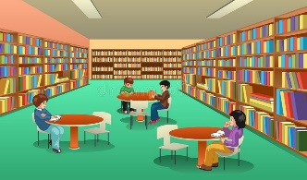
………………….. | ………………….. | ………………….. | …………………..

Exercise 2: Look and read. Put a tick () or cross () in the box.
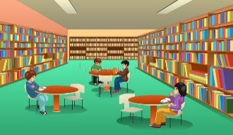
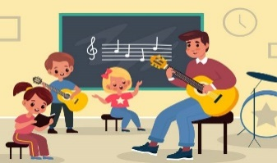
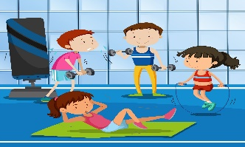

a) It’s our art room. b) It’s our music room. c) It’s our computer room

d) It’s our school. e) It’s our class room. f) It’s our playground.

Exercise 3: Look and write. There is an example.
Yes, it is. | No, it isn’t.



a) Is this our school? b) …………………………….? c) ………………………….?
Yes, it is. ……………………… ………………………
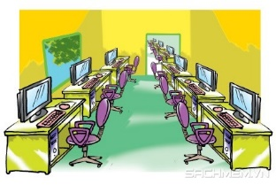

d) …………………………? e) ……………………… ? f) ………………………….. ?
……………………… ……………………… ………………………

g) ………………………….. ? h) ………………………….. ?
……………………… ……………………..
Exercise 4: Look and write the missing letters
C_mp_te_ roo_
_ym
P_a_gro_nd
Li_ra_y

_u_ic _oom
S_h_o_
A_t r_om
Cl_ss_ro_m

Exercise 5: Look at the pictures and complete the sentences.
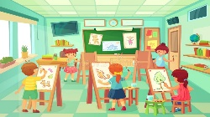 | a) Let’s go to the art room.
 | b) …………………………………
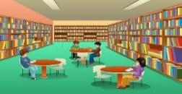 | c) ………….. …………………….
 | d) ……………………………...
 | e)………………………………
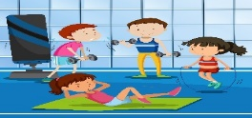 | f) ………………………………
 | g) ………………………………
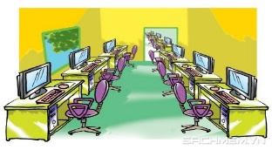 | h) ………………………………

Exercise 6: Put the words in correct order:
1. the/ that/ computer/ Is / room/?
………………………………………………………………….
2. the/ library/ This/ is/.
………………………………………………………………….
3. my/ is/ school/That.
………………………………………………………………….
4. That/ music/ the/ room/ is/.
………………………………………………………………….
5. to/ Let’s/ the/ gym/go
………………………………………………………………….
6. my/ is/ This/ friend/ new/.
………………………………………………………………….
7. classroom/ is/ our/ It
………………………………………………………………….
8. this/ playground/ Is/ our?
………………………………………………………………….
Exercise 6: Write and match:
I like reading | Let’s go to the……………
I like drawing | ………………………………
I like singing | ………………………………
I like dancing | ………………………………
I like painting | ………………………………
I like sliding | ………………………………

Exercise 7. Odd one out
- black | - eye | - pink | - blue
- dancing | - cooking | - swimming | - library
- mouth | - nose | - ear | - friend
- teacher | - two | - six | - nine
- classroom | - art room | - face | - music room

Exercise 8: Look and circle the correct words
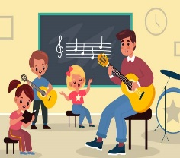 | 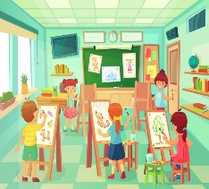 | 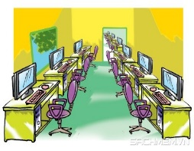 | 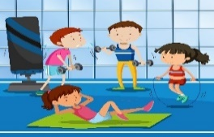
a) classroom  b) music room  c) art room | a) art room  b) computer room  c) gym | a) library  b) playground  c) computer room | a) playground  b) gym  c) classroom

Exercise 9: Look and circle
 | It’s our computer room / class room. |  | It’s our gym/ playgroud
 | It’s our school / playground | 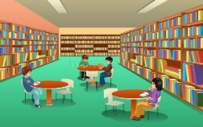 | It’s our music room/ library
Exercise 10: Rewrite the right sentences:
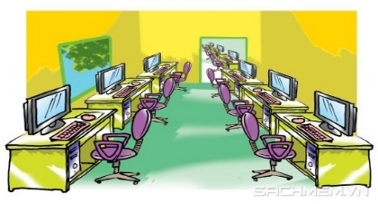

A) Let’s go to the art room. B) Let’s go to the classroom.

………………………… ………………………….
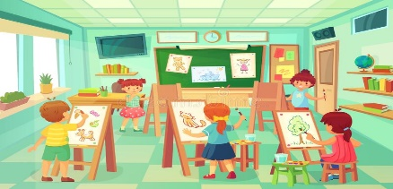

C) Let’s go to the computer room. D) Let’s go to the music room.

…………………………………….. ………………………………….

E) Let’s go to the art room. F) Let’s go to the playground.

…………………………………….. …………………………………….

G) Let’s go to the library. H) Let’s go to the gym

……………………………………… ……………………………………..

Listening:
Part 1: Listen and draw line, there is one example:

1. |  | 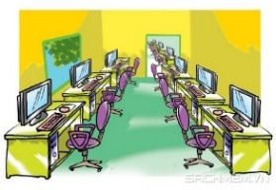  a.
2. |  | 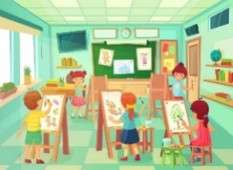  b.
3. |  | c.
4. |  | 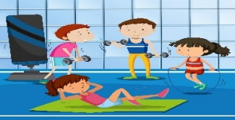  d.
5. |  | 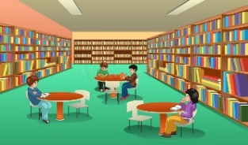  e.
6. |  | f.
7. |  | g.
8. |  | h.
Part 2: Listen and tick. The first sentence is done for you.
1.

A.  | B. 

2.

A. | B.

3.

A. | B.

4.

A. | B.

5.

A. | B.
6.

A. | B.
7.

A. | B.
8.

A. | B.

