Exercise 1: Look and write
Close your book | go out | sit down | Come in
good morning | Open your book | speak | stand up

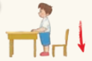 |  | 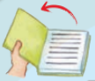 | 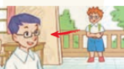
……………………. | ……………………. | ……………………. | …………………….
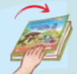 | 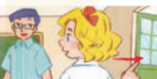 | 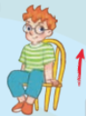 | 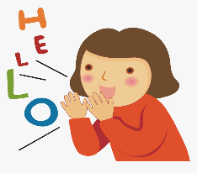
……………………. | ……………………. | ……………………. | …………………….

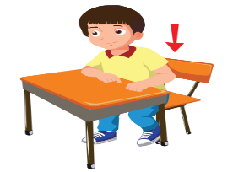
Exercise 2: Put a tick () or cross () in the box.

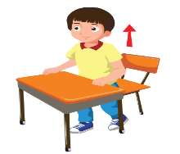
a) Stand up, please! b) Close your book, please!

d) C, Sit down, please! e) Stand up, please!
Exercise 3: Look at the pictures. Complete the missing words

- Sit …………..,please! b) …………… your book, please!

c) ……………. up, ……….….! d) open………...book, ……………..
Exercise 4: Complete the word.

1. 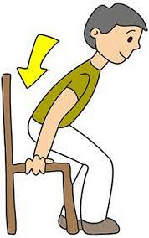 2. 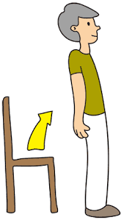 3.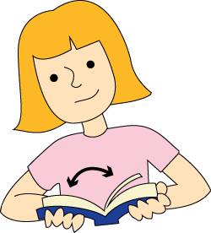
S…t d…wn S...a…d u… O…en your b……k
4. 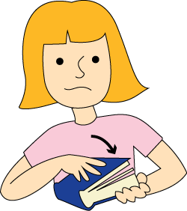 5. 6.
C…o…e y…ur b……k G… o…t C…m… i…
Exercise 5: Odd one out.
1. A. my B. her C. he D. her
2. A. hello B. how C. what D. who
3. A. nine B. fine C. six D. eight
4. A. are B.am C. you D. is
5. A. bye B. hello C. goodbye D. good night
6. A. classroom B. go out come in speak
Exercise 6: Look and write:
 |  |  |  |  |  | 
May I come in?  - Yes, you can. | May I……………?  ……………………… |  | May I……………?  ……………………… |  | May I……………?  ………………………
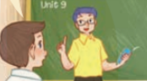 |  | 
May I………………?  ……………………… |  | May I………………?  ……………………… |  | May I……………………?  …………………………..

Exercise 7. Choose the correct answer.
Example: Is that Linda? – No, it__________
A.is B. not C. isn’t D. are
1.Are they your friends? – Yes, they ______
A. are B. aren’t C.am D.is
2. How do you spell________name? – C-U-O-N-G
A.you B. they C. your D. he
3.Nice to ___________you.
A. it B. old C. meet D. this
4. How old are you? – I’m ________ years old.
A. fine B. nine C. friend D. nice
5. Tony and Linda are my ___________.
A. friend B.name C. these D. friends

Exercise 8: Fill in the missing words.
1. ______________ your book, please!
2. Close ______________ book, please!
3. May I go ______________ ?
4. Sit ______________ , please!
5. ______________ up, please!
6. Be ______________ , please!
7. May I ____________Vietnamese , please!
8. _______I sit down?
9. May_______ come in?
Exercise 9: Reorder the words to make sentences
1. May//come/in/I//? __________________________________________________
2. book/Open/please/your ______________________________________________
3. quiet/Be/please/,/. ________________________________________________
4. out/May/I/go/?/ ___________________________________________________
5. Vietnamese/I/May//speak/___________________________________________
6. not/No/can/you/,/./. ________________________________________________
7. can/,/Yes/you/./ ____________________________________________________
8. is/name/your/What/? _______________________________________________
Exercise 10: Read and match.
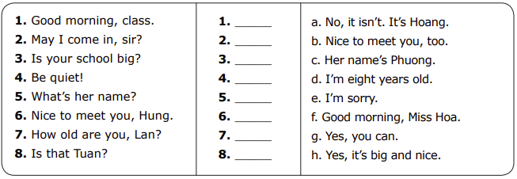
Listening:
Part 1: Listen and circle. There is one example:
1.

A B
2.

A B
3.

A B
4.

A B
5.

A B
6.

A B

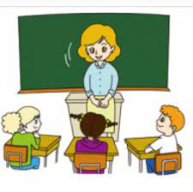
7.

A B
Part 2: Listen and complete the following sentences, the first sentence is done for you.
1. Hello, my name is Jack. I’m ten years old.
2. - What is your hobby?
- I like ………………………………
3. Open your ……………………………… please?
4. - Is your hobby walking?
- No, it isn’t. I like ………………………………
5. ………………………………, please!
6 - Is that our ………………………………
- Yes, it is.
7. May I ………………………………, please!
8. ……………………………… your book.

