Exercise 1: Look and write
eraser | pen | School bag | book | Pencil case | notebook | ruler | pencil

 |  | 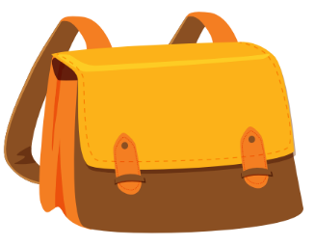 | 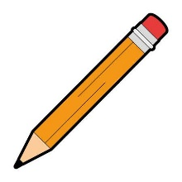
.……………………. | .……………………. | .……………………. | .…………………….
 | 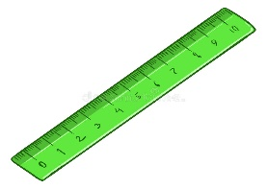 | 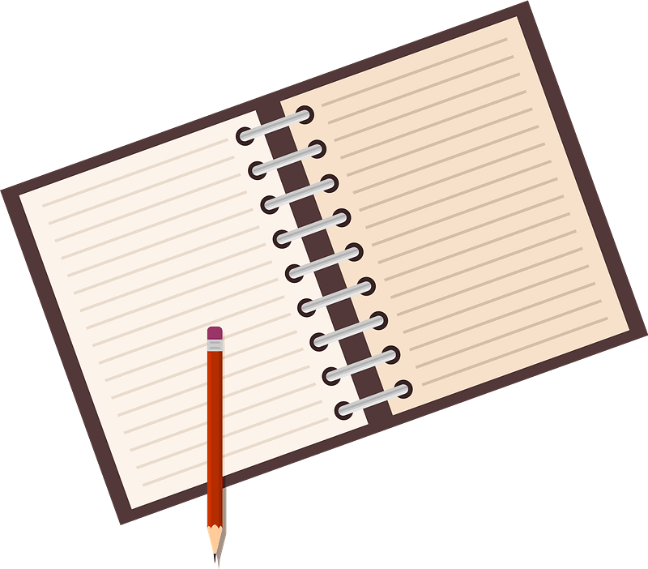 | 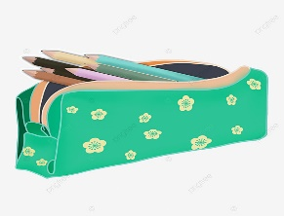
.……………………. | .……………………. | .……………………. | .…………………….

Exercise 2: Look and write the missing letters.

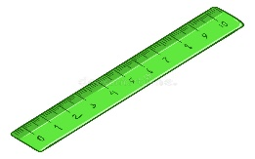

P_nc_l c_s_e
B_o_
er_se_
R_l_r


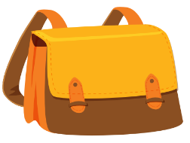
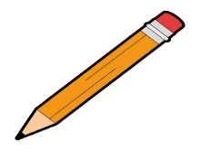

_e_
P_n_il
n_t_boo_
S_ho__ b_g

Exercise 3: Rearrange the letters to make a word

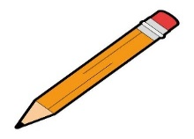 |  |  |  |  |  | 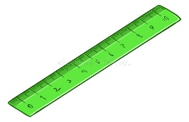
P/n/e | b/o/k/o |  | r/e/a/e/r/s |  |  | l/r/e/r/u
 |  |  |  |  | 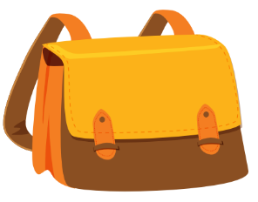
o/n/o/k/e/b/ot |  | e/p/c/l/n/i e/c/s/a |  | e/p/n | h/s/o/l/c/o a/g/b

Exercise 4: Look and write
Yes, it is. | No, it isn’t.
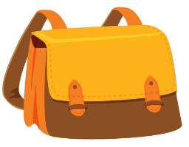
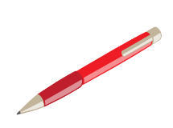


a) Is this an eraser? b) Is this a pen? c) Is this a pencil? d) Is this a notebook?
…………………… ……………………… ………………… ……………………..
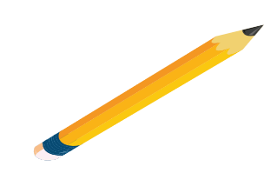

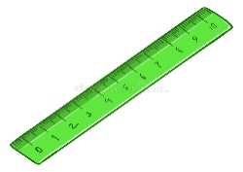
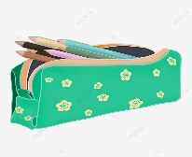

e) Is this a school bag? f) Is this a book? g) Is this a pen? h) Is this a ruler?
………………………… ………………… ……………………… ……………………..

Exercise 5: Look and write:

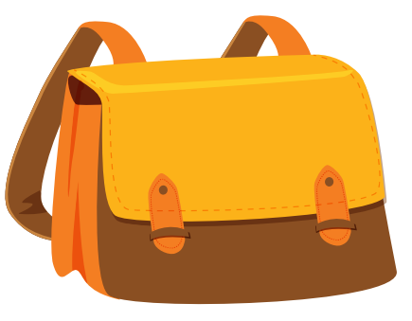
I have a school bag | …………………….. | ……………………… | ……………………..
 |  |  | 
……………………….. | ……………………… | ………………………. | ………………………
Exercise 6: Put the words in the correct order to make sentences.

a) ruler – I – have – a b) eraser – I – have – an c) I – a – pen - have
………………………………… ………………………………… …………………………………

d) I – a – book – have e) pen – a – I – have f) school bag – a – I – have
………………………………… ………………………………… …………………………………

g) a – I – notebook – have h) pencil case – a – have – I
………………………………. …………………………….
Exercise 7: Look and write:
Yes, I do | No , I don’t
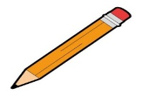
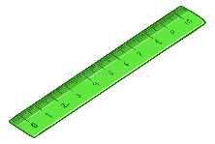
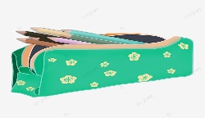

a) Do you have a ruler? b) Do you have a pencil? c) Do you have a pencil case?

No, I don’t. ………………………. ………………………….


d) Do you have a notebook? e) Do you have an eraser? f) Do you have a pen?

……………………………. …………………………. ………………………….

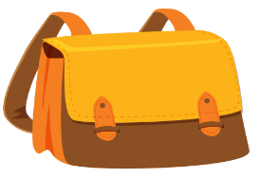

g) Do you have a school bag? h) Do you have a book?

………………………………… ……………………………

Exercise 8: Read and tick or cross

a) I have a pencil. b) I have book. c) I have a ruler.

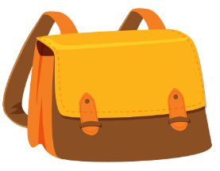

d) I have a pen. e) I have pencil. f) I have a noteboook.

g) I have a school bag. h) I have an eraser

Exercise 9: Look and circle
1)  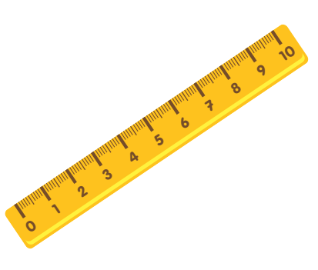 | It’s a ruler / book. | 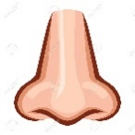  6) | It’s a nose / mouth
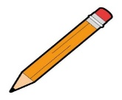  2) | It’s a pen/ pencil. | 7)   | It’s a pencil / book
3)  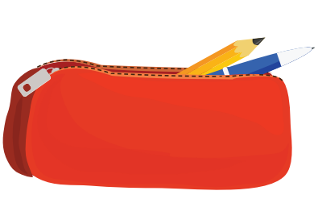 | It’s a pencil case / school bag | 8)  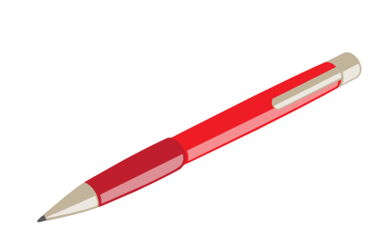 | I have a ruler / pen
4) | It’s a book / school bag. |   9) | It’s the music room /art room
5) | It’s an /a eraser | 10) | It’s a pencil case / notebook.
  11) | I like drawing / singing |   12) | I like swimming/ running
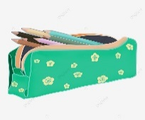  13) | I have a pen/ pencil case |   14) | It’s our classroom/ computer room

Exercise 10: Look and write
       | 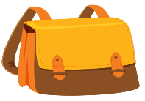    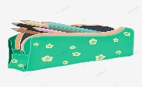
Do you have a pen?  ……………………………. | Do you have a book?  ……………………………….
  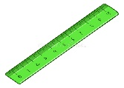 | 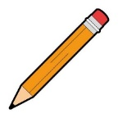  
Do you have a ruler?  ………………………….... | Do you have a pencil case?  ………………………………...
Do you have a school bag?  ………………………………. | Do you have an eraser?  ………………………………

Exercise 11: Odd-One-Out
a. apple | b. banana | c. mango | d. bear
a. bird | b. hippo | c. notebook | đ. tiger
- Nose | - mouth | - swimming | - eye
a. school bag | b. fine | - pen | - ruler
- speak | b. art room | - classroom | c. music room
- green | - red | - blue | - one
- Lucy | - teacher | - Bill | - Mary
a. eraser | - running | - singing | d. painting

Exercise 12: Put the words in the correct order to make sentences.
a) a – is – hand – It.
………………………………………………………………………
b) I – a- have – pen
………………………………………………………………………
c) cooking – like - I
………………………………………………………………………
d) art room – is – our - It
………………………………………………………………………
e) a – you – Do – have- ruler?
………………………………………………………………………
f) I – pencil – a – have
………………………………………………………………………
g) name – My – Ben – is
………………………………………………………………………
h) Do – have – an– you - eraser?
………………………………………………………………………
i) go – the – Let’s– playground - to
………………………………………………………………………
j) down – I – sit – My?
………………………………………………………………………
k) book – Open – your
………………………………………………………………………
l) school – Is – our – it?
………………………………………………………………………
m) pen – That – my – is
………………………………………………………………………
Listening:
Part 1: Listen and tick  or cross . There are two examples.


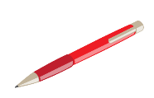
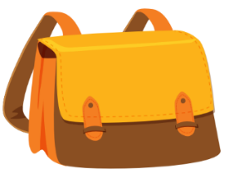
1. 2.

3. 4.




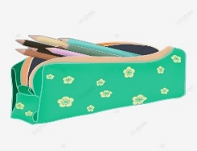
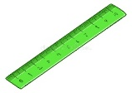
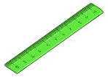
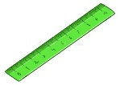
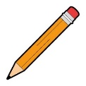
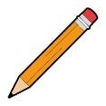
5. 6.

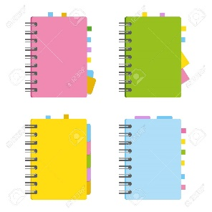
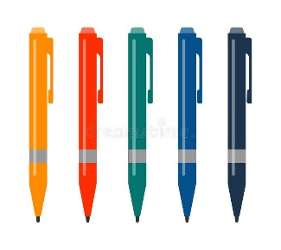
7. 8.

9. 10.
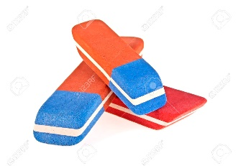

Part 2: Listen and circle, there is one example:

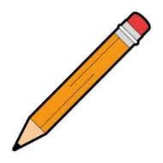
1. I have a pencil.

A B

2.
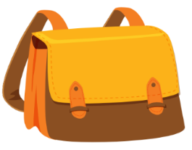

A B
3.

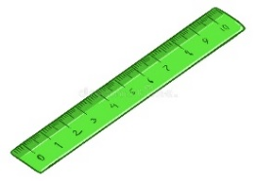

A B
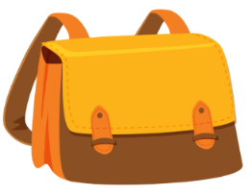
4.

A B
5.

A B

6.
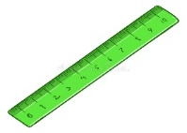


A B
7.

A B

8.

A B

