Exercise 1: Look and write
green | red | blue | yellow | color
black | orange | white | brown | color

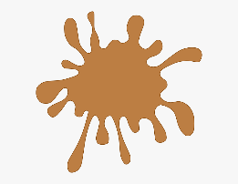 | 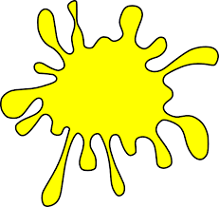 |  |  |  |  |  | 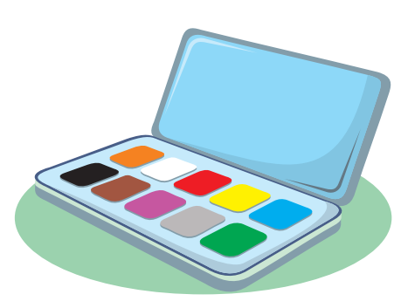
……………… | ……………… |  | ……………… |  | ……………… |  | ………………
 |  |  |  | 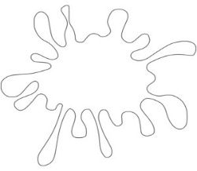 |  | 
………………… |  | ………………… |  | ………………… |  | …………………

Exercise 2: Put the words in the correct order
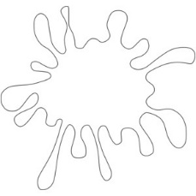
a) black – It – is b) It – blue – is c) is – It - white
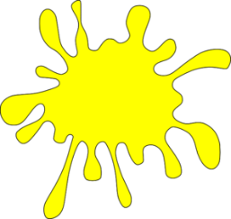
It is black ……………………………… ………………………………

d) is – It – green e) It – red – is f) yellow – is - It
…………………………… ……………………………… ………………………………
Exercise 3: Look and write
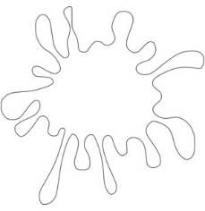


a) What color is it? b) What color is it? c) What color is it? d) What color is it?
…………………… …………………….. …………………….. …………………….
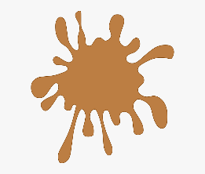
.

e) What color is it? f) What color is it? g) What color is it? h) What color is it?
……………………… ………………….. ………………….. …………………
Exercise 4: Look and write:
Yes, it is. | No, it isn’t.
a) Is it red? b) Is it red? c) Is it blue? d) Is it yellow?
………………….. ………………….. ………………….. …………………..
Exercise 5: Look, read and write the missing letters
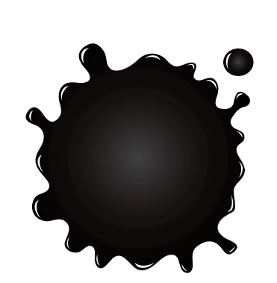

bl _ _ _
y_l_o_
g_ _en

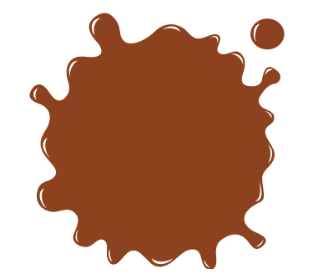

_r_n_e
r_d
_ _ own

Exercise 6: Make and answer the questions, there is an example:
 | 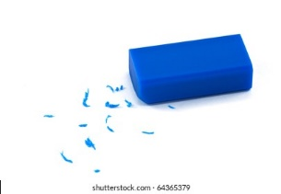 | 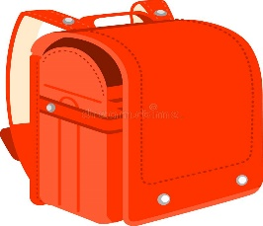 | 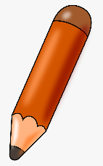
- What color is the pen?  - It’s black. | ……………………..  .……………………. | .……………………..  ……………………… | .…………………….
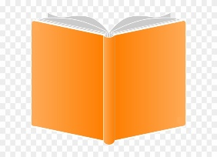 | 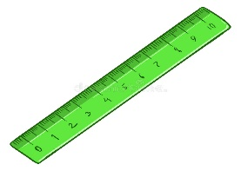 | 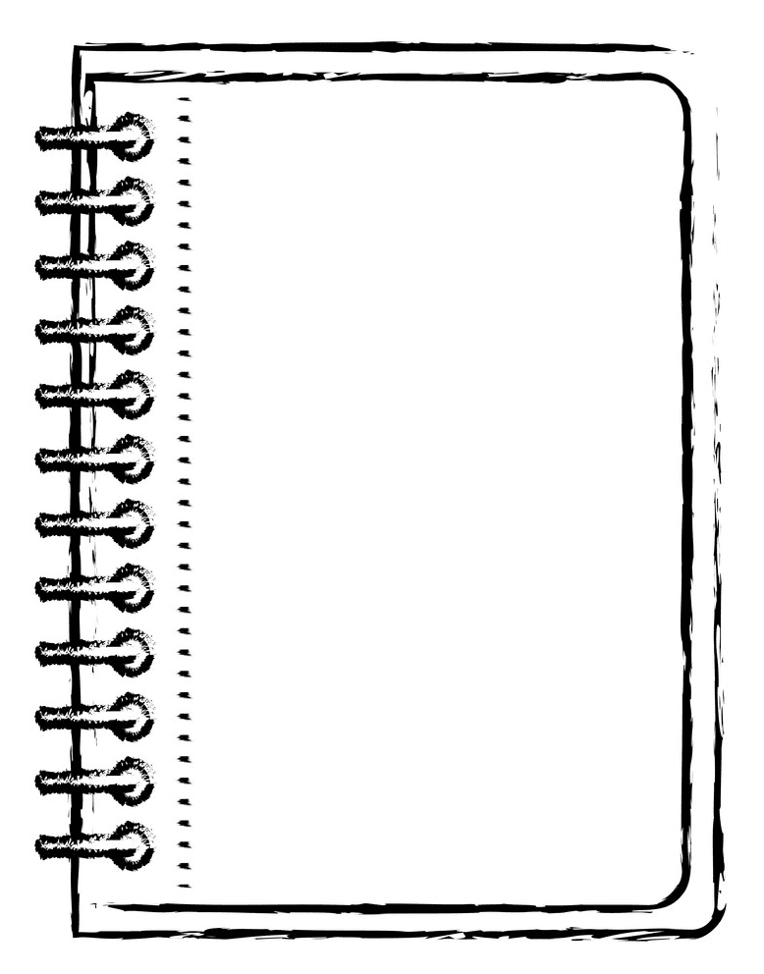 | 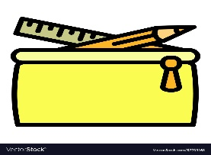
……………………..  .……………………. | ……………………..  .……………………. | ……………………..  .……………………. | ……………………..  .…………………….

Exercise 7: Write the school thing and the color
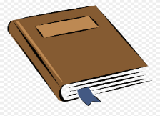 | I have a……………………………..  It’s …………………………………..
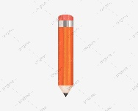 | …………………………………………  …………………………………………
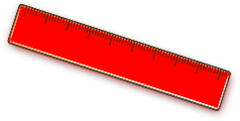 | …………………………………………  …………………………………………
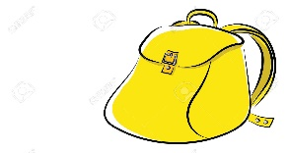 | …………………………………………  …………………………………………
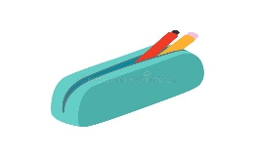 | …………………………………………  …………………………………………
 | …………………………………………  …………………………………………
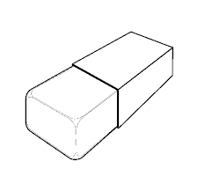 | …………………………………………  …………………………………………
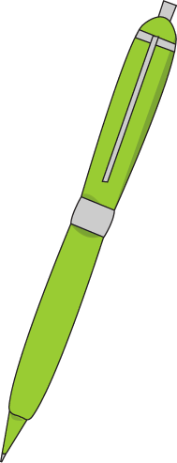 | …………………………………………  …………………………………………
Exercise 8: Read and color.
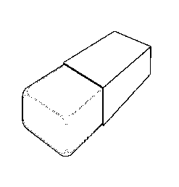
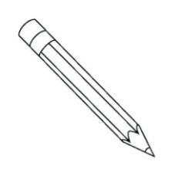
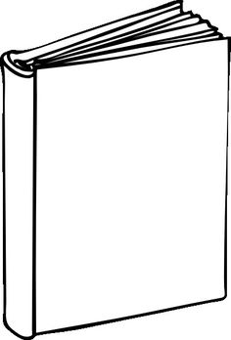
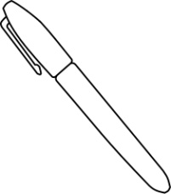

It’s a black book.
It’s a blue eraser.
It’s a green pen.
It’s a brown pencil.
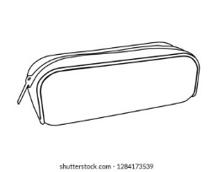
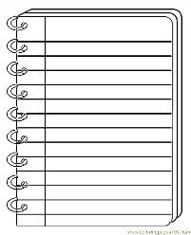
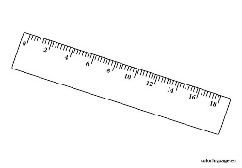
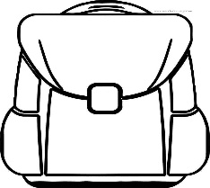

It’s a yellow
notebook
notebook pen.
It’s a green pen.
It’s an
orange eraser pen.
It’s a red school bag.

Exercise 9: Read and match
- What color is it? | - Yes, you can.
- Do you have a ruler? | - It’s green.
- How old are you ? | - Let’s go to the art room.
- May I come in ? | - Yes, I do.
- I like drawing. | - It’s a nose.
- What’s your hobby ? | - I’m ten years old.
- What’s this ? | - I like swimming.

Exercise 10: Write the school things and color
 | 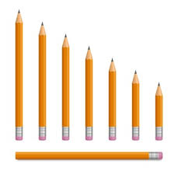 | 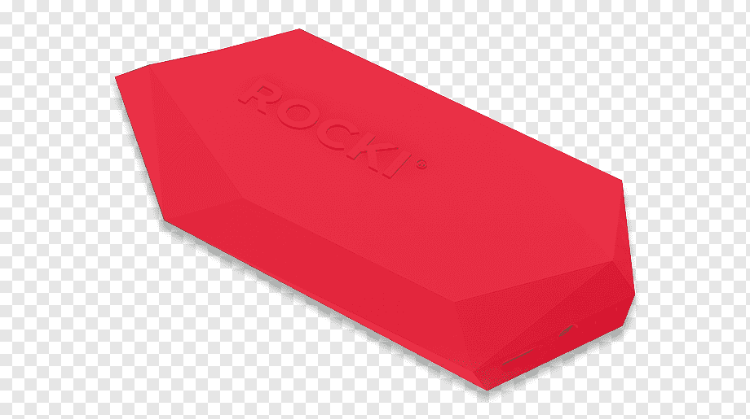 | 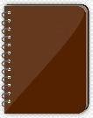
What color are they?  They’re blue. | ………………………  ……………………… | ………………………  ……………………… | ………………………  ………………………
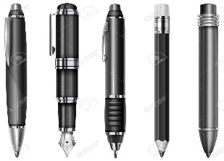 | 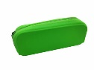 | 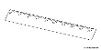 | 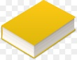
………………………  ……………………… | ………………………  ……………………… | ………………………  ……………………… | ………………………  ………………………
Exercise 11: Circle:
1. I have a pen. It’s/ They’re blue.
2. I have four pencils. It’s/ They’re brown.
3. I have a school bag. It’s/ They’re red.
4. Mai: I have three pencil cases.
Minh: What color is it/ are they? It’s/ they’re green.
5. It’ a book. It’s/ they’re black.
6. What color is/ are they?
7. What color is/ are the rulers
9. What color is/ are your eraser?
10. What color are they? It’s/ They’re white.
11. What/ How color is it?
12: My school bag is/ are orange.
13. My pencils is/ are brown.
14. This is/ are my notebook.
Exercise 12: Look and write:
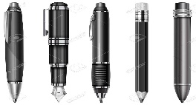 | I have five pens. They’re black.  - My pens are black
……………………………………………………
……………………………………………………
……………………………………………………
……………………………………………………
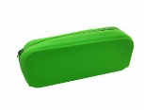 | ……………………………………………………  ……………………………………………………
……………………………………………………
……………………………………………………
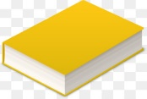 | ……………………………………………………  ……………………………………………………
……………………………………………………
……………………………………………………
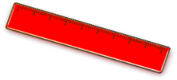 | ……………………………………………………  ……………………………………………………

Exercise 13: Odd one out
a) book | b) flower | c) rubber | d) pencil
a) red | b) green | c) light blue | d) eight
a) boy | b) father | c) mother | d) grandfather
a) sit down | b) stand up | c) open your book | d) ruler
a) He | b) She | c) his | d) I
a) nine | b) black | c) six | d) five
a) blue | b) yellow | c) ear | d) gray
a) like | b) cooking | c) running | d) walking
a) computer room | b) painting | c) art room | d) classroom

Listening:
Part 1: Listen, number and color. There is one example:
 |  | 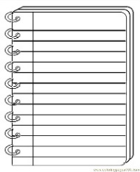 | 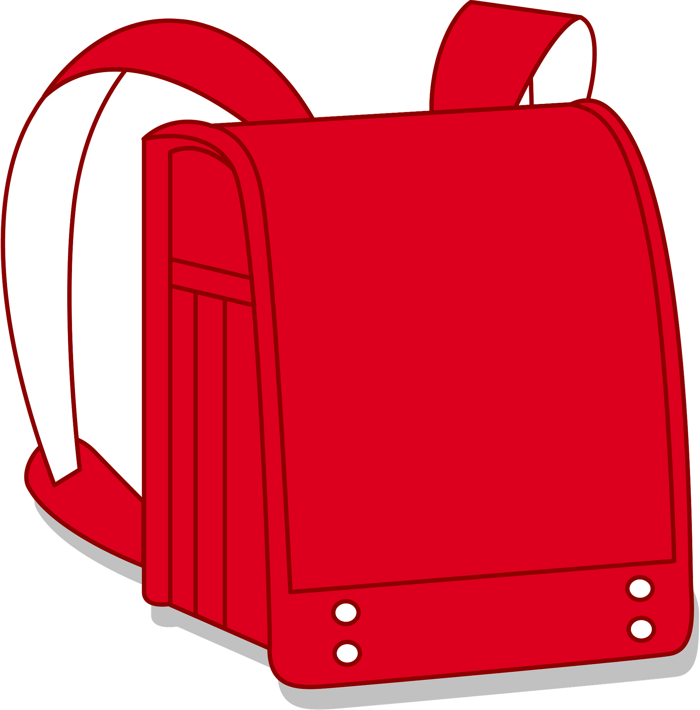
 |  |  | 1
 |  |  | 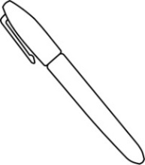

Part 2: Listen and complete the sentences. There is one example:
1. I have a pen. It’s black
2. I have (a)……………………. pencils. They’re (b) …………………….
3. I have a (a)……………………..It’s (b) …………………….
4. I have three (a)……………………..They’re (b) …………………….
5. Do you have a (a)………………….?
Yes, I do. I have four. They are (b)………………….
6. I have a (a)……………………. school bag. What color is your school bag?
It’ (b)…………………….
7. I have six books. They are(a) …………………….and(b) …………………….
8. Is your (a)…………………….red?
No, it isn’t. It’s (b)……………………..

