GRADE 4 – TEST
THEME 6: SPORTS AND LEISURE

Full name:………………………….…………………...  School:…………………… …………………………….  Class:……………………………………………………... | Mark
LISTENING
Part 1
Listen and match:



Can you play the guitar?

Yes, pretty well No, not very well

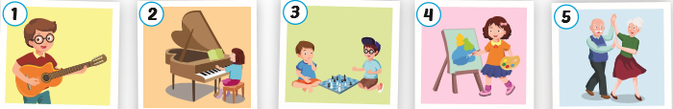

Part 2
Listen and complete:

- Tom can play chess very well.
- Alfie can play…………………………………………….
- I love ……………………because I like……………..
- I don’t like……………………………………………….
- Let’s ………………………………………………………..
Part 3
Listen and draw the lines. There is on example:
 |  |  |  | 

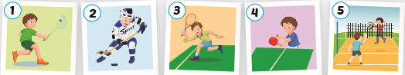
READING AND WRITING
Part 1

Look at the picture and write down the words:

 | catch
 | …………………
 | ……………………
 | ………………………
 | ……………………..

Part 2
Read and tick (v) or cross (x):
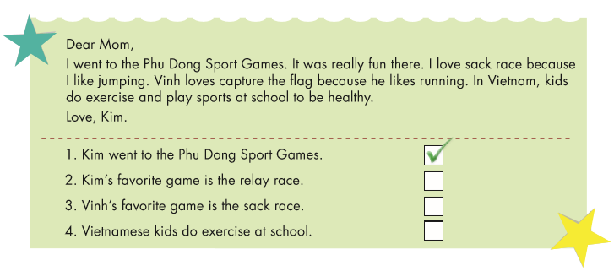
Part 3
Answer the questions:
- Can you play table tennis?
..............................................................................................
- What can you do?
............................................................................................
- Which game is your favorite?
…..........................................................................................
4. Can you play the guitar well?
.............................................................................................

