SEMESTER 1 TEST
GRADE 1
Full name: …………………………………… | Mark: /10
School: ……………………………………… | Listening | Reading | Writing
Class: ………………………………………… | /3.5 | /3.25 | /3.25

LISTENING
PART 1
4 questions (1pt)
Listen and draw lines. There is one example.
Bobby | Bill | Sue | Kim | Vinh
• | • | • | • | •
 |  |  |  | 

PART 2
4 questions (1.5pts)
Listen and tick (√) the box. There is one example.
Example:
 |  | 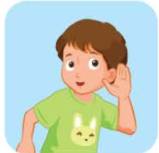  A. | 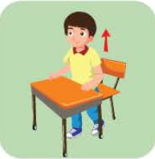  B.  √ | 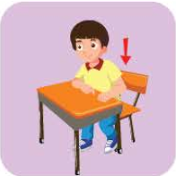  C.
5. | A. |  |   B. |   C.
6. | 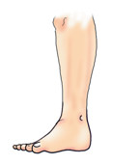  A. |  | 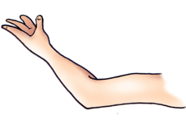  B. |   C.
7. |   A. |  | 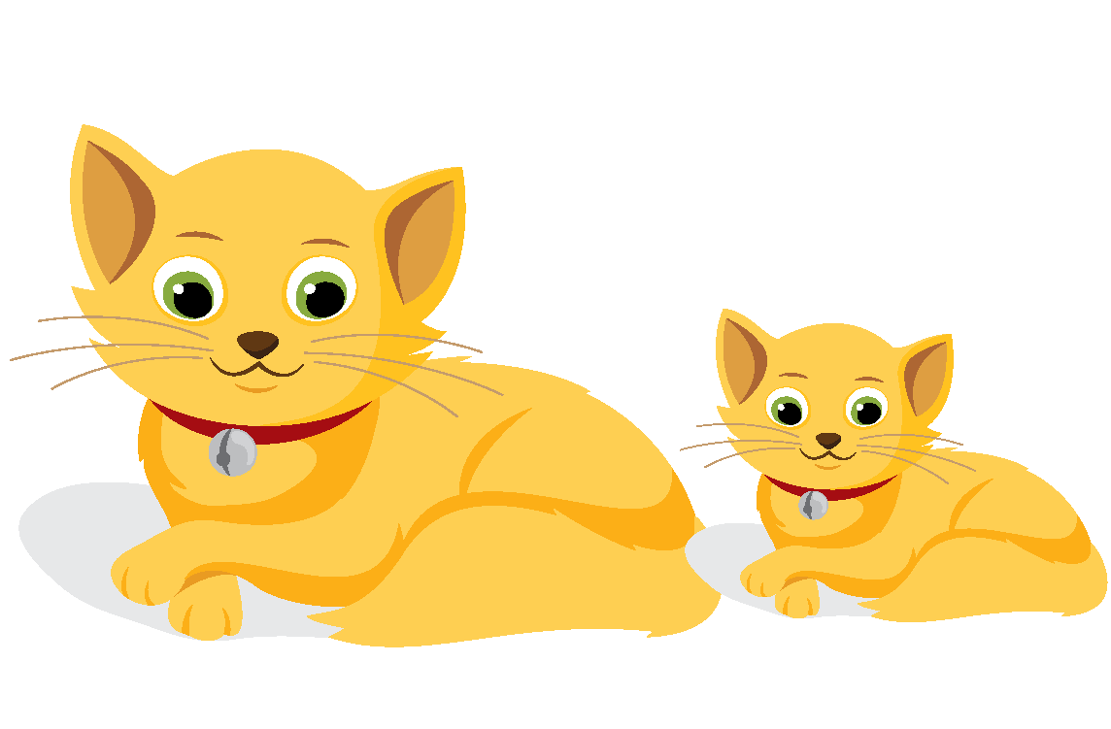  B. | 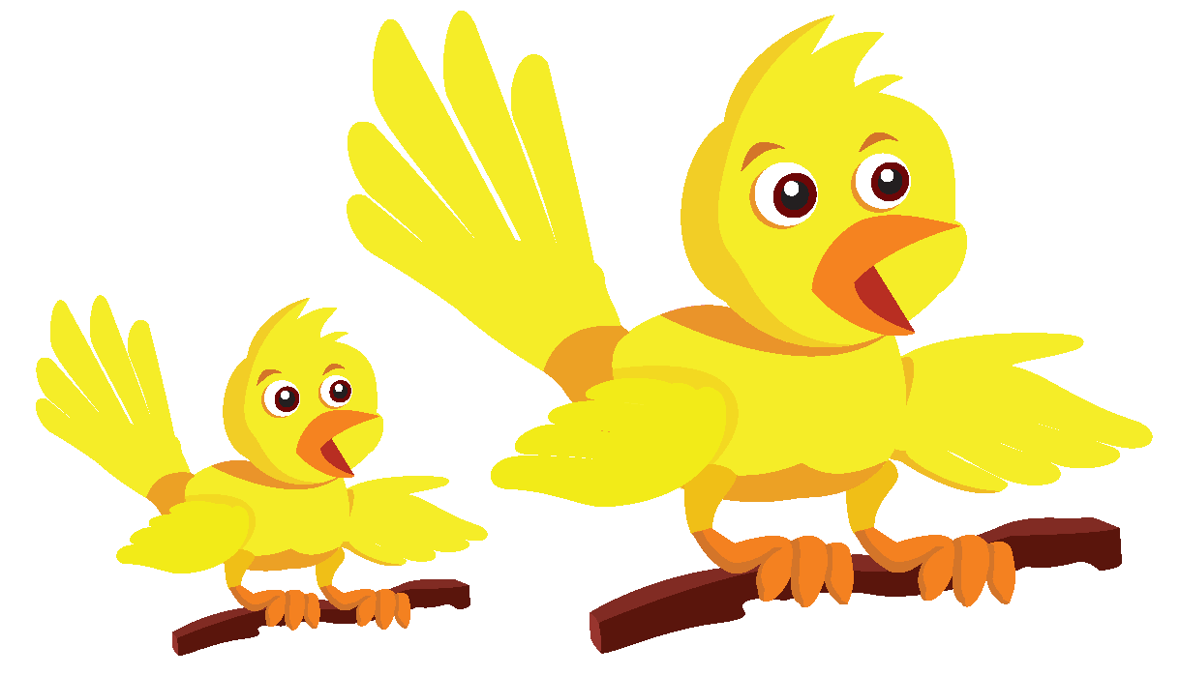  C.
8. | 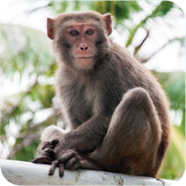  A. |  | 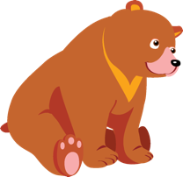  B. | 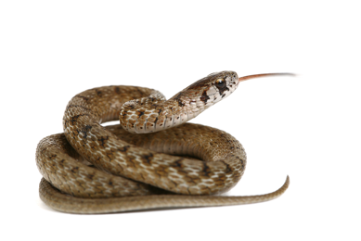  C.

PART 3
4 questions (1pt)
Listen and color. There is one example.
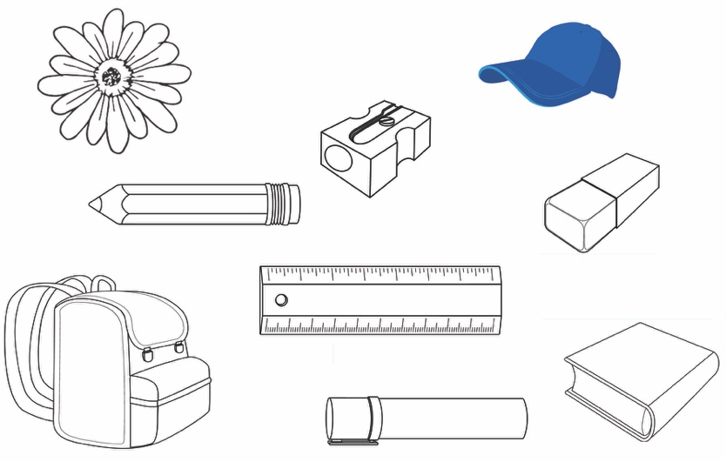

READING
PART 1
3 questions (0.75pt)
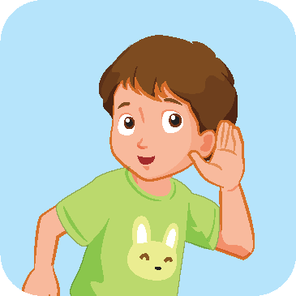
Read and draw lines. There is one example.
Listen.

1. This is my mother.

2. It’s a door.

3. I like dogs.


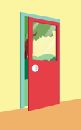


PART 2
4 questions (1pt)
Look, read and circle. There is one example.
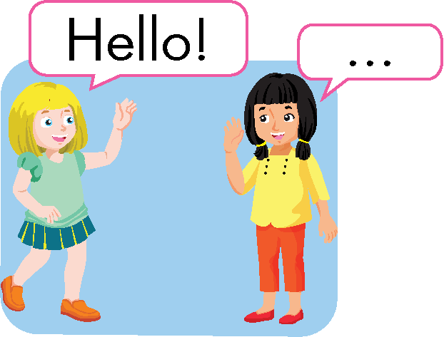  Example: | Hello, Kim | Goodbye, Kim.
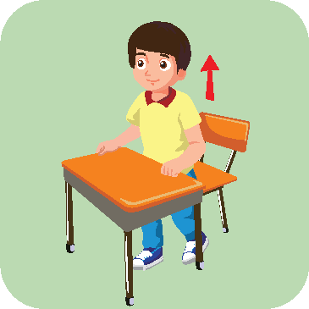  4. | Stand up. | Sit down.
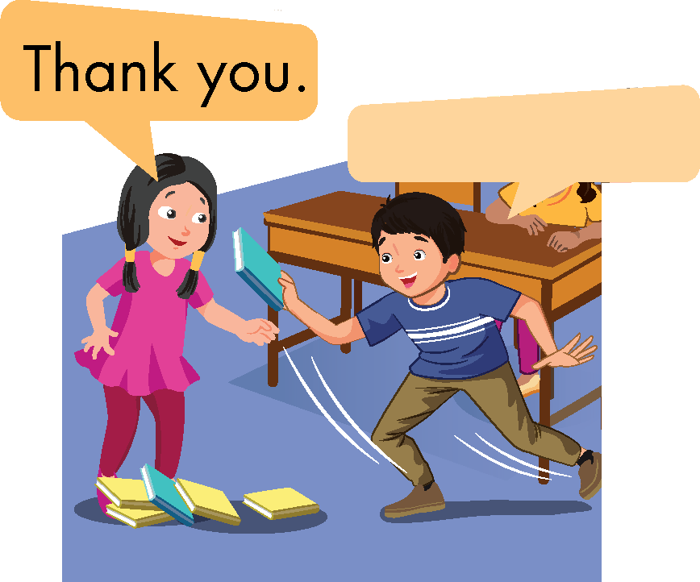  5. | That’s OK. | You’re welcome.
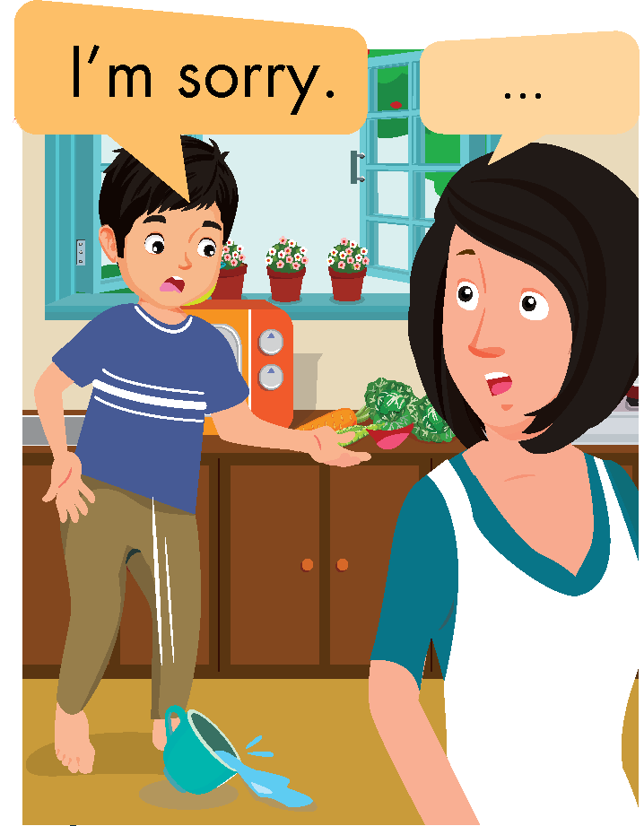  6. | That’s OK. | Nice to meet you.
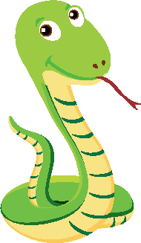  7. | This is a snake. | This is a bear.

PART 3
3 questions (1.5pts)
Look, read and put a tick (√) or a cross (×) . There is one example.
Example:
Listen. 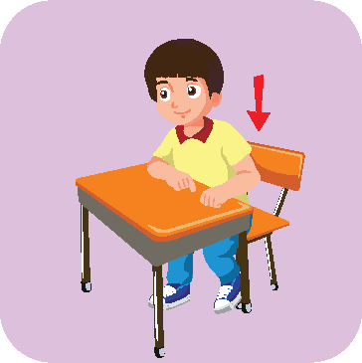 Stand up.
×
√
8. |  | This is a girl.
9. |  | It’s a white flower.
10. |  | Touch your leg.

WRITING
PART 1
3 questions (0.75pt)
Order the letters. There is one example.
Example
 | d e r | red
  1. | a h t e f r | _ _ _ _ _ _
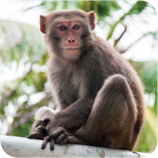  2. | n e o y m k | _ _ _ _ _ _
  3. | p a h e t e n | _ l _ _ _ _ _ _

PART 2
2 questions (1pt)
Order the words. There is one example.
Example
a
It’s
pencil

It’s a pencil.
a
It’s
bag
yellow
4.

is
brother
This
my
5.

PART 3
3 questions (1.5pts)
Look and write. There is an example.
book birds blue cap

Example: It’s a _ _ _ _.
→ It’s a book.

My name is Bill. This is my (6)  _ _ _. It’s (7)  _ _ _ _.
I like (8)  _ _ _ _ _. I like cats, too.

