SEMESTER 1 TEST
GRADE 2
Full name: …………………………………… | Mark: /10
School: ……………………………………… | Listening | Reading | Writing
Class: ………………………………………… | /3.75 | /3.25 | /3

LISTENING
PART 1
4 questions (1pt)
Listen and number the pictures. There is one example.

 |  |  |  |   0
PART 2
4 questions (1pt)
Listen and tick (√) the box. There is one example.
Example:
 |   A. |   B.  √ |   C.

5. |   A. | B. | C.
6. |   A. |   B. |   C.
7. | 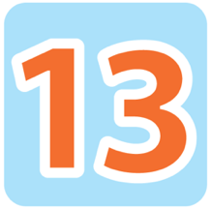  A. |   B. | 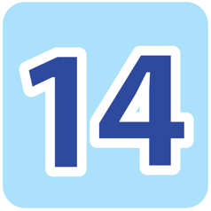  C.
8. | 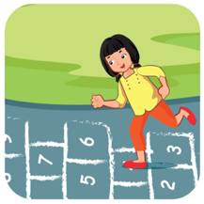  A. | 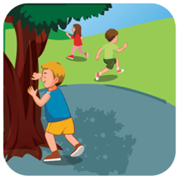  B. |   C.

PART 3
4 questions (1.75pts)
Listen and write a word or a number. There is one example.
Example: A pig.
9. I’m ___________ years old.
10. I’m ___________.
11. ___________ books.
12. On weekends I ___________.
READING
PART 1
3 questions (0.75pt)
Read and draw lines. There is one example.


I have a robot.

1. I’m sad.

2. It’s a duck.

3. I can see a tiger.




PART 2
3 questions (0.75pt)
Look, read and circle. There is one example.
  Example: | tag | soccer
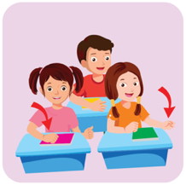  1. | Hands up. | Hands down.
  2. | She’s thirsty. | She’s bored.
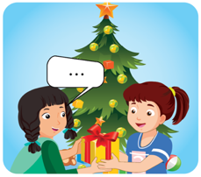  3. | Happy birthday. | Merry Christmas.

PART 3
4 questions (1.5pts)
Look, read and put a tick (√) or a cross (⋅) . There is one example.
Example:  It’s a nose.  It’s a nut.
√

1. | 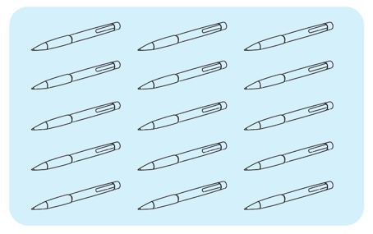 | How many pens are there?  Fourteen pens.
2. | 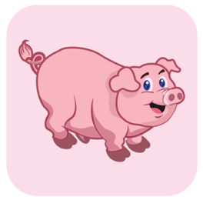 | What’s that?  It’s a pig.
3. | 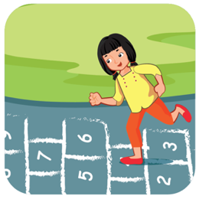 | Let’s play hopscotch.  OK.
4. | 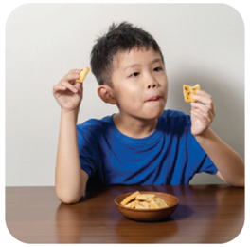 | What do you do on weekends?  I ride my bike.

WRITING
PART 1
3 questions (1pt)
Order the letters. There is one example.

 | Example | s e r a q | _ _ u _ _ _
1. | 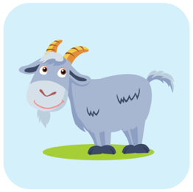 | a t o g | _ _ _ _
2. | 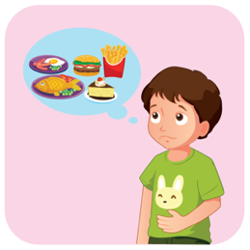 | r g y h n u | _ _ _ _ _ _
3. |  | m a u r l e l b | _ _ _ _ _ _ _ _ _ _ _

PART 2
3 questions (1.5pts)
Look and write. There is an example.
 | Example:
 |  | It’s a nut.
4. |  | It’s a tr_ _ _ _ _ _.
5. |  | Let’s play s _ _ _ _ _.
6. | 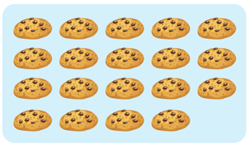 | There are n _ _ _ t _ _ _ cookies.

PART 2
2 questions (0.5pt)
Order the words. There is one example.
Example
a
It’s
rabbit

It’s a rabbit.
your
books
Close
7.

.
and
play
seek
Let’s
hide
8.

.

