END-OF-TERM TEST 6 (SEMESTER 1)
Full name: ............. Grade: ............. Mark: ............. / 20
A.Listening
Task 1. Listen and circle.
- I have__________.
- A book
- An eraser
- A pencil case
- Do you have _____?
- A pencil case
- An eraser
- A book
3
- Ruler
- Bag
- Eraser
Task 2. Listen and number.
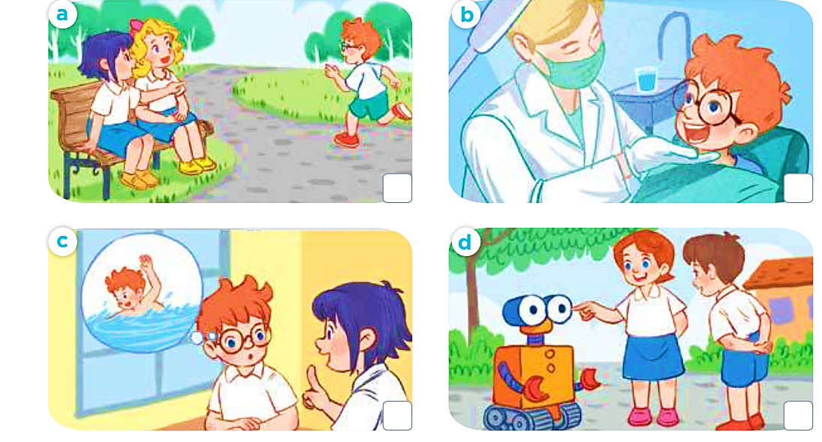

Task 3. Listen and write
1………………………… 2………………………….
3………………………... 4…………………………
5………………………… 6…………………………
7………………………. 8………………………..
Task 4. Listen and tick.
1 | 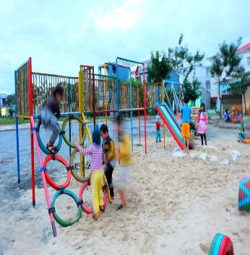  a.❑ | 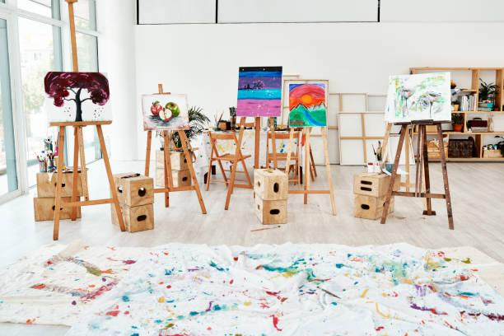  b.❑ | 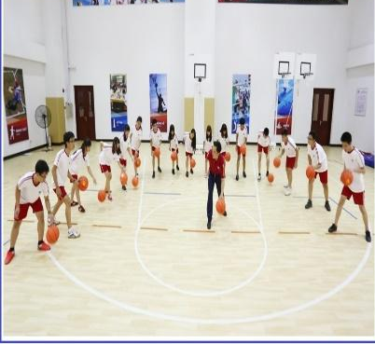  c.❑
2 |   a.❑ | 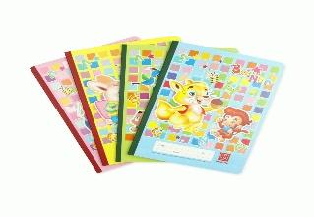  b.❑ | 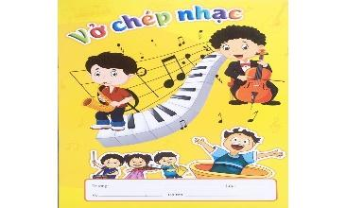  c.❑
3 | 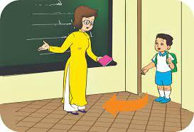  a. ❑ | 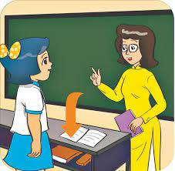  b. ❑ | 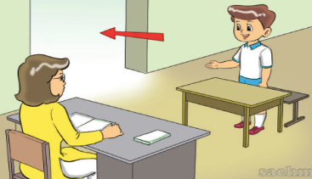  c. ❑
4 |   a. ❑ | 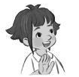  b. ❑ | 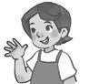  c. ❑

B. Reading and writing.

Task 5. Read and tick.
1. A: Ms Hoa, may I come in?
B: Yes, you can.
  a. ❑ | 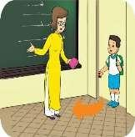  b. ❑ | 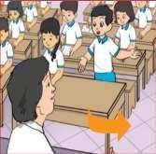  c. ❑
2. A: What’s your hobbies, Alex?
B: I like dancing and singing.
    a. ❑ |   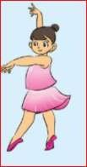  b. ❑ |   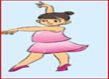  c. ❑

3. A: Is this your library?
B: No, it isn’t. It’s our music room.
  a. ❑ | 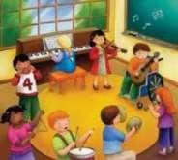  b. ❑ | 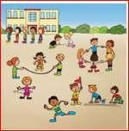  c. ❑

4. A: Sit down and touch your eye.
B: OK.
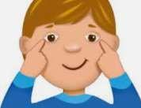  a. ❑ |   b. ❑ | 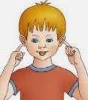  c. ❑
Task 6. Look and write.

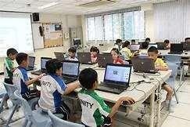  1. A: Let’s go to the computer room.  B: ____, _____ go. | 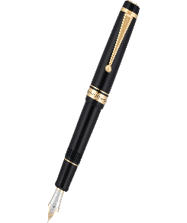  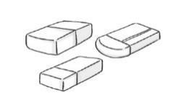  2. A: What colour are they?  B: They’re _____ and _____.
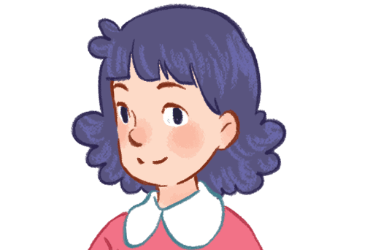  3. A: __________________?  B: My name’s Mai. | 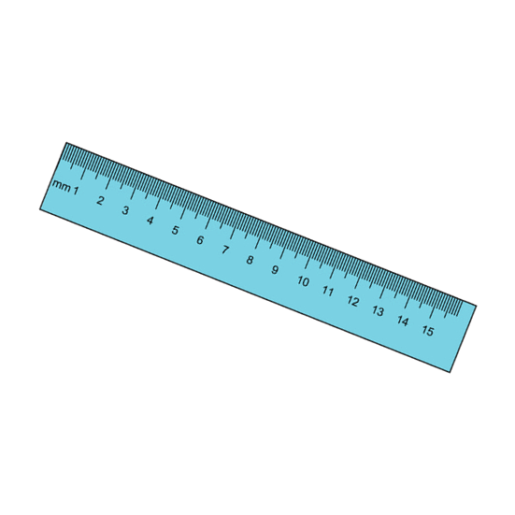  - A: What colour is it?  B______________________!
Task 7: Look and match:
a.
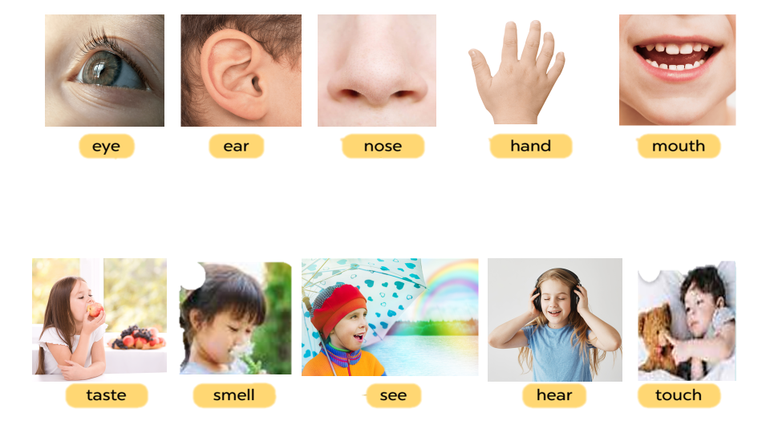

Task 8. Complete the sentence.
Break time puzzles plays football at
- It is break time.
- What do you...........break time?
- He ...............volleyball
- I play word..................
- We play............. at break time
Task 9:Rearrange the words to make the correct sentences
1. nose/ It’s /a/.
……………………………………….
2 .drawing/ He/ picture/ a/ likes.
…………………………………
3. is/ hobby/ cooking/ My/.
…………………………………..
4. Minh/ singing /likes/ cooking/and/.
……………………………………….
5. School/ Welcome/ our/ to/!
……………………………………
C. Speaking

5. Let’s talk.
1. Greeting  Responding to greetings.  1.Hello, (pupil’s name).  2. How are you  (Giving clues: Are you fine?/ OK? Yes? No?) | 2. Asking the student’s name/ age  Hi! My name’s __________.  1.What’s your name?  2.How old are you?  (Giving clues:  - My name’s ____.  - I’m _____ | 3. Introducing someone  Point to one student  (Point to one flash card, have the pupil give instructions or asking for permission.) | 4. Asking questions about parts of the body  1.We can use it to smell    2. We can use this to listen to music.  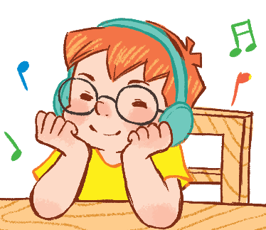 | 5. Asking about hobbies  1. What’s your  hobby?  It’s ...  I like ...  2. What’s his  hobby?  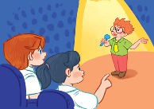  3.Do you like (swimming)?
6. Asking about school  Making suggestions/ Expressing agreement  1.Is this_____?  2. Let’s_______. | 7. Giving instructions/ Asking for permission  (Point to one flash card, have the pupil give instructions or asking for permission.)  1.What’s this? | 8. Asking about school things  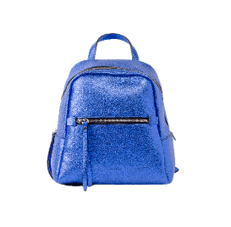  1I have a school bag. Do you have a school bag?  2. Is it red? Yes? No? | 9. Asking about the colour of a school thing  1. What colour is it?    2.What colour are they?     | 10. Talking about break time activities  1. I play badminton at break time. What about you, (pupil’s name)?

key
Task 1:
- a 2. b 3. c
Task 2:
- b 2. c 3. d 4. a

Task 3:
Audio script: 1. /θ/ 2. /h/ 3. /kl/ 4. /ʊ/
Key: 1. th 2. h 3. cl 4. oo

Task 4:
Audio script:
1. A: Let’s go to the playground.
B: OK, let’s go.
2. A: Bill, quick. Let’s go to the music room.
B: OK. My music notebook is here.
3. Woman: Come in and sit down, Nam. Let’s ........
4. Mum, this is my friend, Linh.
Key: 1. a 2. c 3. a 4. b
Task 5:
- b 2. c 3. a 4. a

Task 6:
- Yes, let’s
- white and black
- what’s your name?
- It’s blue

Task 7:
eye- see ear- hear nose- smell hand- touch mouth- taste

Task 8:
- do at
- plays
- puzzles
- football

