END-OF-TERM TEST 10 (SEMESTER 1)
Full name: ............. Grade: ............. Mark: ............. / 20

1. Listen and circle.
1. ai a 2. f v
3. m n 4. p r
2. Listen and tick.
1 | 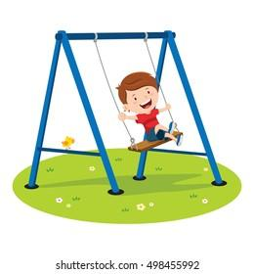  a. ❑ | 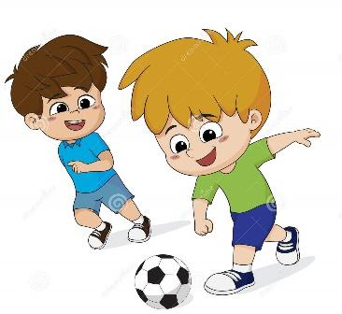  b. ❑ | 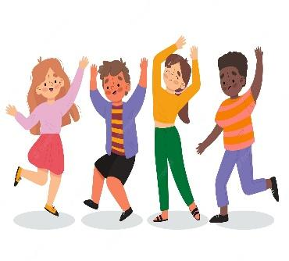  c. ❑
2 | 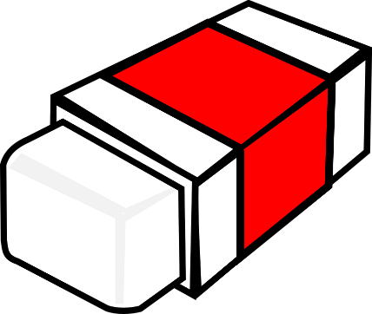  a. ❑ | 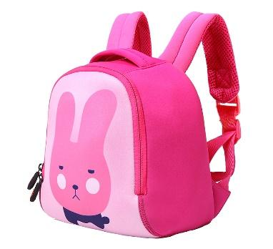  b. ❑ | 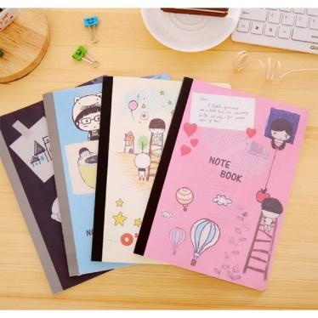  c. ❑
3 | 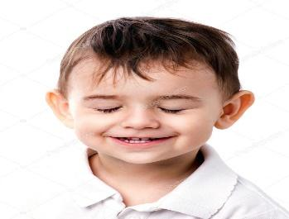  a. ❑ | 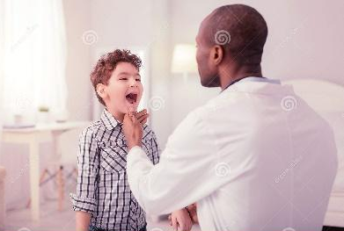  b. ❑ | 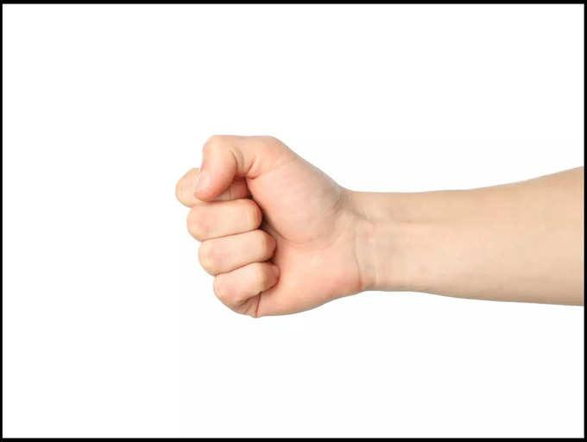  c. ❑
4 | 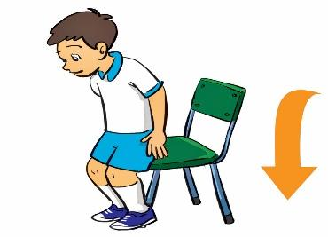  a. ❑ | 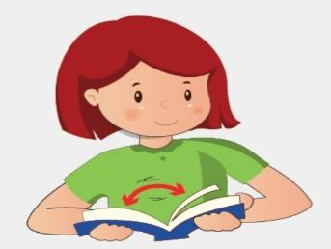  b. ❑ | 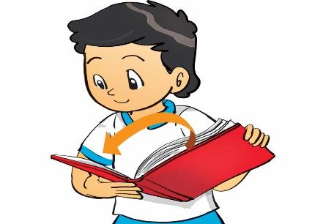  c. ❑
3. Read and tick.
1. A:what number is thí?
B: this is number 8.
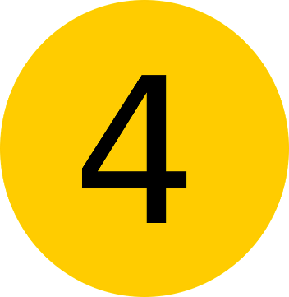  a. ❑ |   b. ❑ | 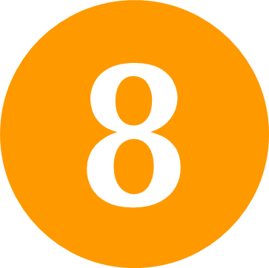 c. ❑

2. A: What’s your hobbies, Alex?
B: I like skating and jumping.
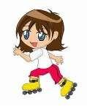  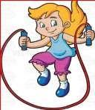  a. ❑ | 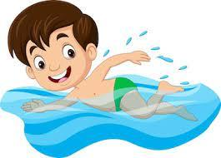  b. ❑ | 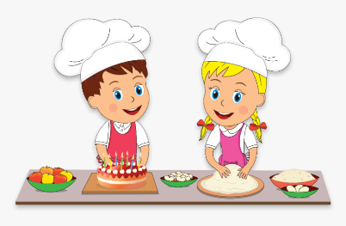  c. ❑

3. A: Is this your library?
B: No, it isn’t. It’s our music room.
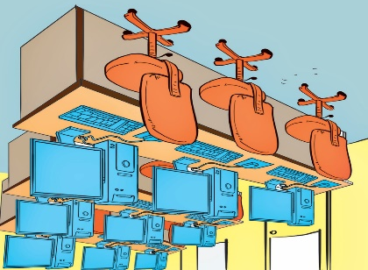  a. ❑ | 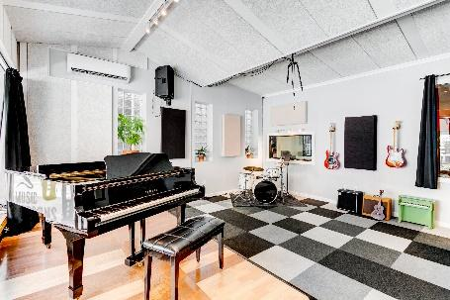  b. ❑ | 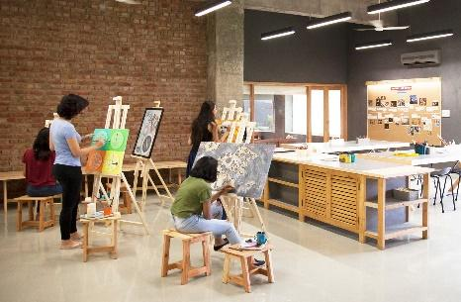  c. ❑

4. A: touch your eye.
B: OK.
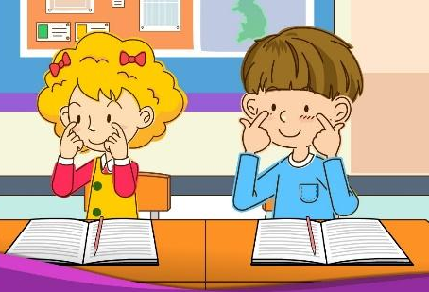  a. ❑ | 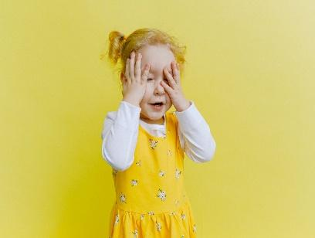  b. ❑ | 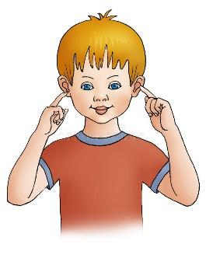  c. ❑

4. Look and write.

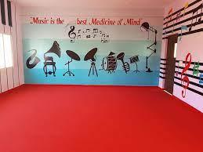  1. A: Let’s go to the music room.  B: ____, _____ go. | 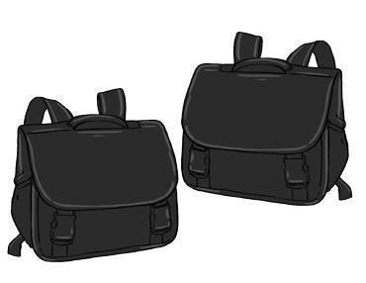  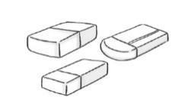  2. A: What colour are they?  B: They’re _____ and _____.
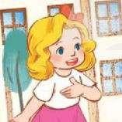  3. A: _________________?  B: My name’s Mary . | q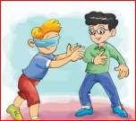  4. _________________!

5. Let’s talk.
1. Greeting  Responding to greetings.  1.Hello, (pupil’s name).  2. How are you  (Giving clues: Are you fine?/ OK? Yes? No?) | 2. Asking the student’s name/ age  Hi! My name’s __________.  1.What’s your name?  2.How old are you?  (Giving clues:  - My name’s ____.  - I’m _____ | 3. Introducing someone  Point to one student  (Point to one flash card, have the pupil give instructions or asking for permission.) | 4. Asking questions about parts of the body  1.We can use it to smell    2. We can use this to listen to music.  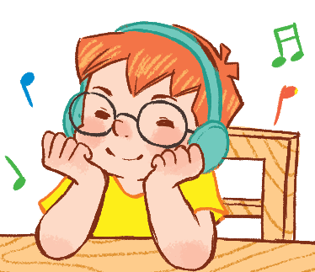 | 5. Asking about hobbies  1. What’s your  hobby?  It’s ...  I like ...  2. What’s his  hobby?  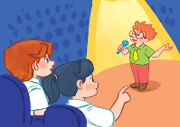  3.Do you like (swimming)?

ANSWER KEY

1.
Audio script: 1. /eɪ/ 2. /f/ 3. /n/ 4. /r/
Key: 1. a 2. f 3. n 4. r
2.
Audio script:
1. A: What do you do at break time?
Bill: I play football with my friends.
2. Mary: Can I borrow your eraser, Nam?
Nam: Yes, you can.
3. Open your mouth! Good boy!
4. This is a … Nam, close your book, please.
Key: 1. b 2. a 3. b 4. c
3.
1. c 2. a 3. b 4. a
4.
1. OK, let’s
2. white - black / black - white
3. What’s your name
4. Blind man’s bluff

5.
Suggested questions and answers:
1. Hello, (pupil’s name). How are you? (Giving clues: Are you fine?/ OK? Yes? No?)
2. Hi! My name’s _____________. What’s your name?/ How old are you?
(Giving clues: My name’s ____./
I’m _____ and you are _______./ Are you ______? Yes? No?)
3. Is this (one pupil’s name)?
4. What’s this?/ Touch your (a body part).
(Point to any body parts learnt to ask or give command to check pupil’s understanding.)
5. What’s your hobby? (Giving clues: Do you like (swimming)? Swimming? Yes? No?)
6. Is this __________?
Let’s ___________.
7. May ___________?
(Point to one flash card, have the pupil give instructions or asking for permission.)
8. I have _______. Do you have _______?
9. What colour is it? What colour are they? (Giving clues: Is it red? Yes? No?)
10. I play badminton at break time. What about you, (pupil’s name)?
For some topics, the teacher points to the flash card or realia, have the pupils listen and say/ respond. Depending on pupil’s speaking performance, the teacher can give him/ her some clues to encourage him/ her to speak English.

