END-OF-TERM TEST 7 (SEMESTER 1)
Full name: ............. Grade: ............. Mark: ............. / 20
1. Listen and tick.
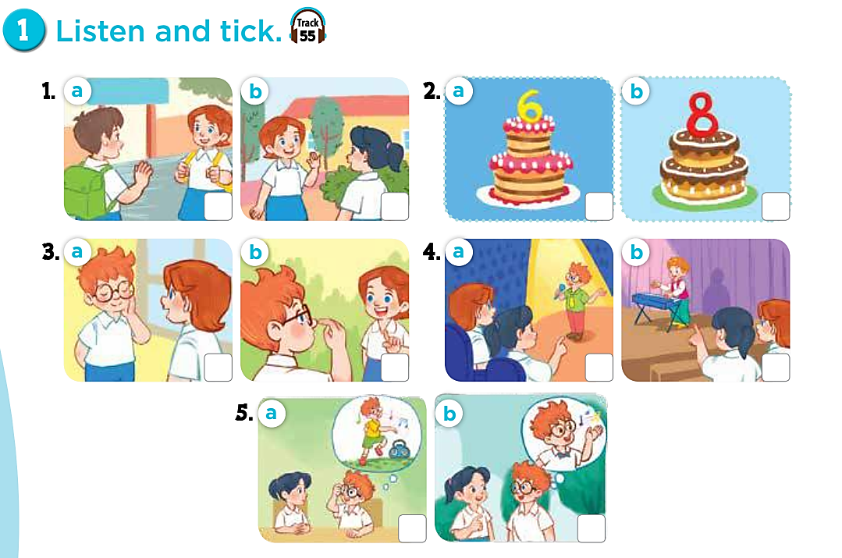
2. Listen and tick.
1 | 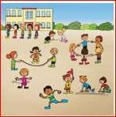  a.❑ | 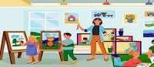  b.❑ | 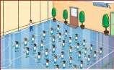  c.❑
2 |   a.❑ | 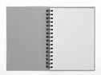  b.❑ | 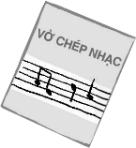  c.❑
3 | 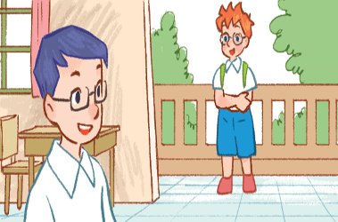  a. ❑ | 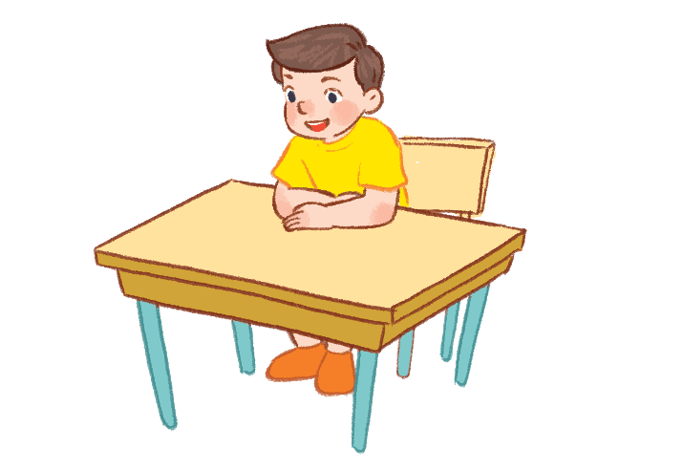  b. ❑ | 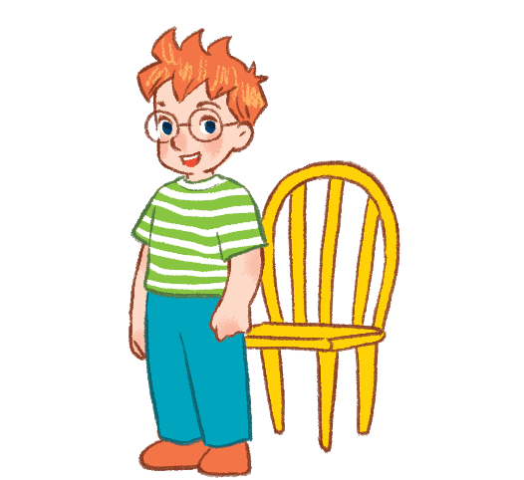  c. ❑
4 | 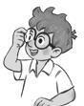  a. ❑ | 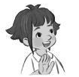  b. ❑ | 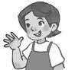  c. ❑

3. Read and tick.
1. A: Hi. I’m Ben
B: Hi, Ben. I’m Mai.
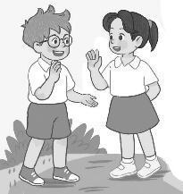  a. ❑ | 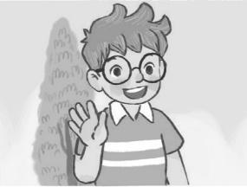  b. ❑ | 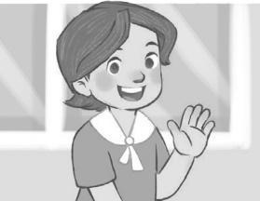  c. ❑

2. A: What’s this?
B: It’s a nose.
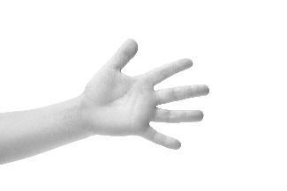  a. ❑ | 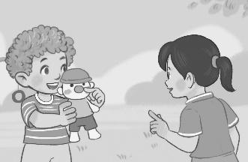  b. ❑ | 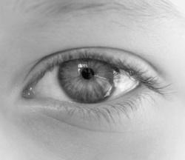  c. ❑

3. I have a pencil case.
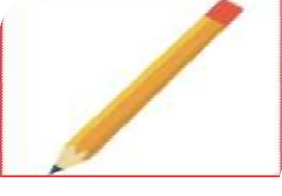  4.  \  a. ❑ | 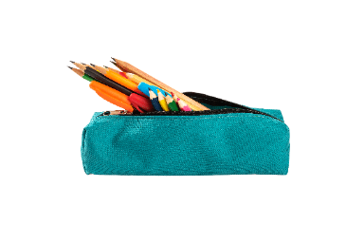  b. ❑ | 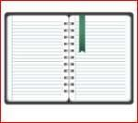  c. ❑

4. It’s break time. Let’s play volleyball.
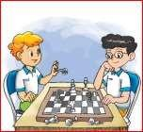  a. ❑ | 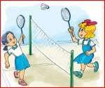  b. ❑ | 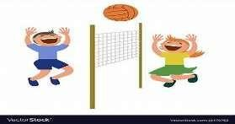  c. ❑

4. Look and write.

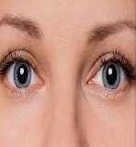
1. A: What’s your hobby?  B: It’s _____________. | 2. A: What’s this?  B: It’s ______.
3. A: _________ in, Ms Hoa?  B: Yes, you can. | 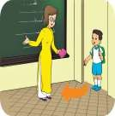  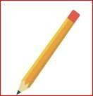  4. A: Do you __________?  B: Yes, I do.

C. Speaking
5. Let’s talk.
1. Greeting  Responding to greetings.  1.Hello, (pupil’s name).  2. How are you  (Giving clues: Are you fine?/ OK? Yes? No?) | 2. Asking the student’s name/ age  Hi! My name’s __________.  1.What’s your name?  2.How old are you?  (Giving clues:  - My name’s ____.  - I’m _____ | 3. Introducing someone  Point to one student  (Point to one flash card, have the pupil give instructions or asking for permission.) | 4. Asking questions about parts of the body  1.We can use it to smell    2. We can use this to listen to music.  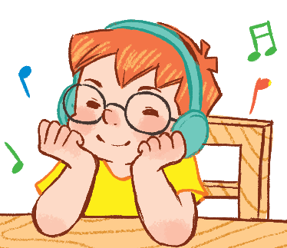 | 5. Asking about hobbies  1. What’s your  hobby?  It’s ...  I like ...  2. What’s his  hobby?  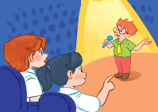  3.Do you like (swimming)?
ANSWER KEY
Task 1:
1.b 2. b 3.b 4.a 5.a

Task2:
1.b 2.c 3.d 4.a

Task 3:
1.c 2.b 3.b 4.c

Task4:
- Snging 2. Eyes 3. May I 4. Have

