END-OF-TERM TEST 9 (SEMESTER 1)
Full name: ............. Grade: ............. Mark: ............. / 20

1. Listen and circle.
1. th h 2. h b
3. pl cl 4. oo ea

2.Listen and write
1………………………… 2………………………….
3………………………... 4…………………………
5………………………… 6…………………………
7………………………. 8………………………..

3. Listen and tick.
1 | 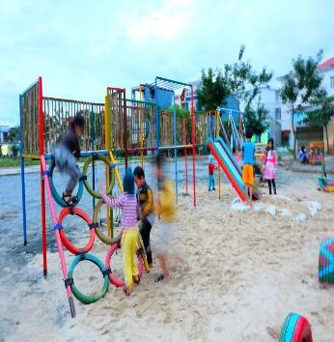  a.❑ | 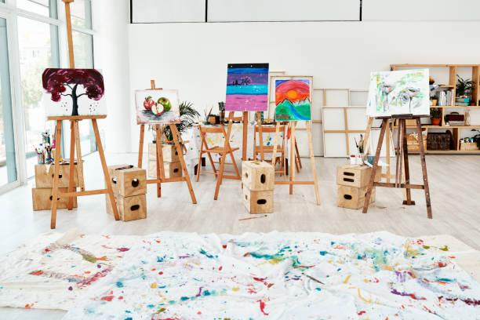  b.❑ | 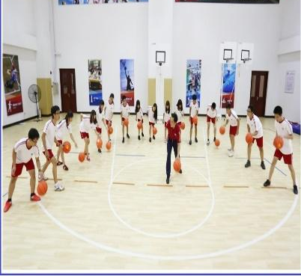  c.❑
2 |   a.❑ | 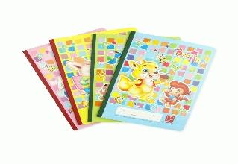  b.❑ | 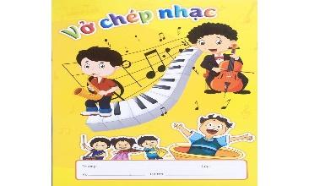  c.❑
3 | 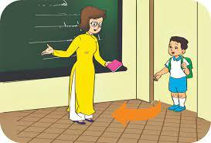  a. ❑ | 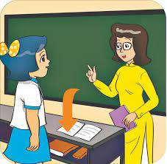  b. ❑ | 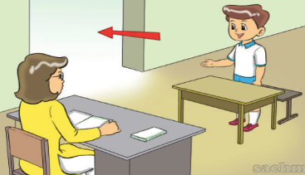  c. ❑
4 | 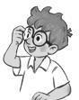  a. ❑ | 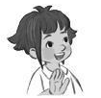  b. ❑ | 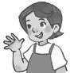  c. ❑

4. Read and tick.
1. A: how old are you?
B: I am nine years old

  a. ❑ |   b. ❑ | 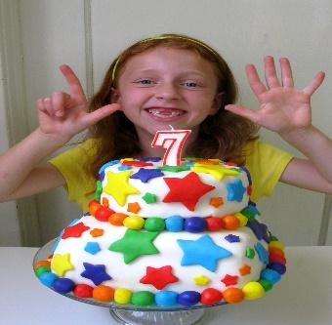  c. ❑

2. A: What’s this?
B: It’s a nose.
  a. ❑ | 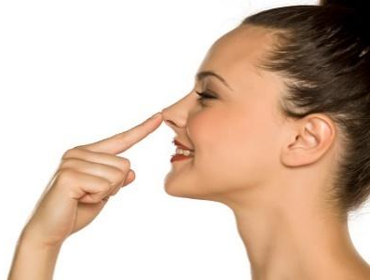  b. ❑ |   c. ❑

3. I have a pencil
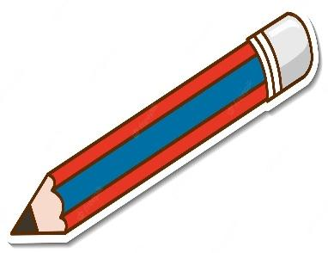  a. ❑ | 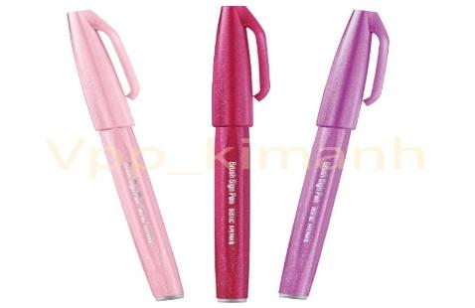  b. ❑ | 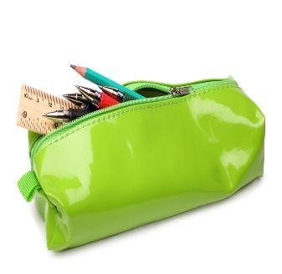  c. ❑

4. It’s break time. Let’s play volleyball.
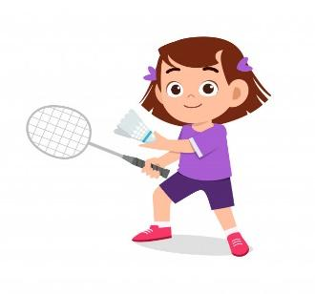  a. ❑ | 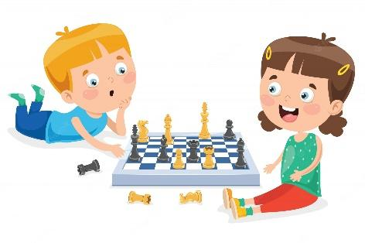  b. ❑ | 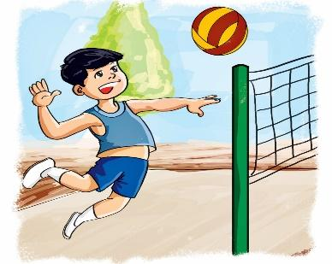  c. ❑

5. Look and write.

  1. A: What do you can?  B: I can touch your_____________. | 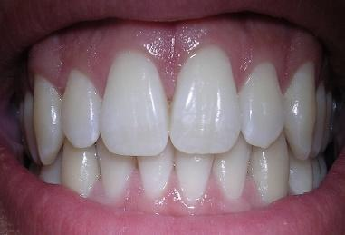  2. A: What’s this?  B: It’s ______.
  3. A: who is this ?  B: ………my teacher. |   4. A: what number is this?  B: It’s________.






6. Complete the sentence.

hobby
name




How

I’m
Goodbye

- Hi, I’m Minh.
- are you, Mary? – I’m fine, thank you. 2.What’s your ______? – My name’s Lucy.
- Goodbye, Miss Hien. - , Lan
- What’s your ? I like dancing.

6. Let’s talk.
1. Greeting  Responding to greetings.  1.Hello, (pupil’s name).  2. How are you  (Giving clues: Are you fine?/ OK? Yes? No?) | 2. Asking the student’s name/ age  Hi! My name’s __________.  1.What’s your name?  2.How old are you?  (Giving clues:  - My name’s ____.  - I’m _____ | 3. Introducing someone  Point to one student  (Point to one flash card, have the pupil give instructions or asking for permission.) | 4. Asking questions about parts of the body  1.We can use it to see  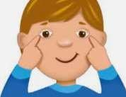  2. We can use this to listen to music.  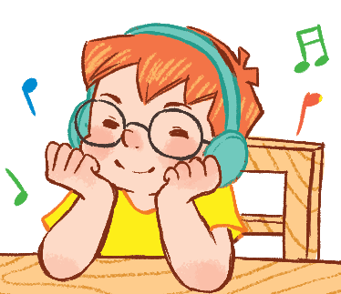 | 5. Asking about hobbies  1. What’s your  hobby?  It’s ...  I like ...  2. What’s his  hobby?    3.Do you like (swimming)?

Task1.
Audio script: 1. /θ/ 2. /h/ 3. /kl/ 4. /ʊ/
Key: 1. th 2. h 3. cl 4. oo
Task2.
- a pencil
- a pen
- a bag
- a book
- a desk
- a chair
- a ruler
- an eraser

Task 3.
Audio script:
1. A: Let’s go to the playground.
B: OK, let’s go.
2. A: Bill, quick. Let’s go to the music room.
B: OK. My music notebook is here.
3. Woman: Come in and sit down, Nam. Let’s ........
4. Mum, this is my friend, Linh.
Key: 1. a 2. c 3. a 4. b

Task 4.
1.b 2. b 3. a 4. c

Task 5.
- Nose 2. Tooth 3. This 4. Number one/ one

Task 6:
- How 2. Name 3. Goodbye 4. Hobby

