END-OF-TERM TEST 2 (SEMESTER 2)
Time allowed: 35 mins
Full name: ............. Grade: ............. Mark: ............. / 20
Listen and write Y or N. | Listen and tick. | Look, read and put (✔) or (🗶). | Read and complete. | Let’s talk.
………/ 4 | ………/ 4 | ………/ 4 | ………/ 4 | ………/ 4

1. Listen and write Y (Yes) or N (No).
  1.❑ |   2.❑ |   3.❑ |   4.❑

2. Listen and tick.
1. | a.❑ |   b.❑ |   c.❑
2. |   a.❑ |   b.❑ | c.❑
3. |   a.❑ |   b.❑ |   c.❑
4. | a.❑ |   b.❑ |   c.❑

3. Look, read and put a tick (✔) or cross (🗶).

   | 1. A: Who’s this?  B: It’s my brother.  ❑
   | 2. A: Where’s the bathroom?  B: It’s there.  ❑
 | 3. There are two windows in the room.  ❑
 | 4. A: How many cats do you have?  B: I have some cats.  ❑
4. Read and complete.
mother cycling dog park father flying

Hi. My name is Kate. There are three people in my family: my father, my (1) ____________ and me. We are in the (2) _____________. My (3) ________ is drawing a picture. My mother is (4) __________ . I am (5) ____________ a kite. This is our (6) ____________. It is running.

5. Let’s talk.
Point, ask and answer. / Point and say.
- 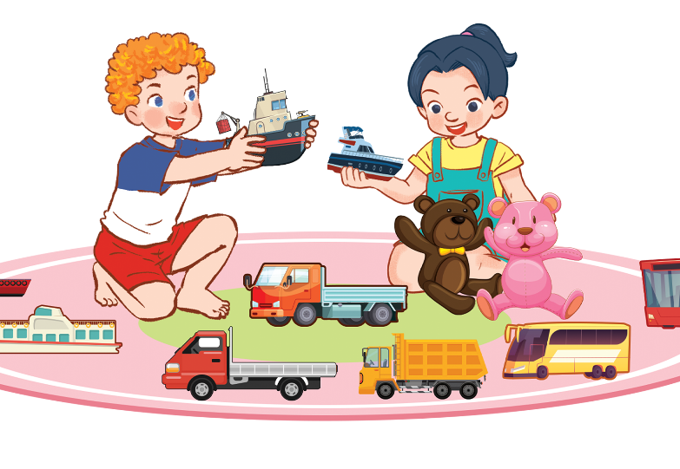 | 2.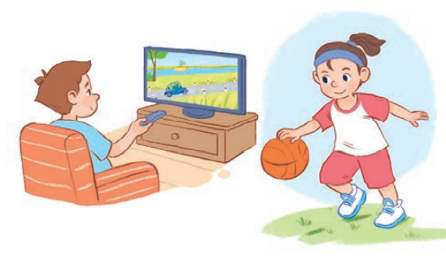
3.  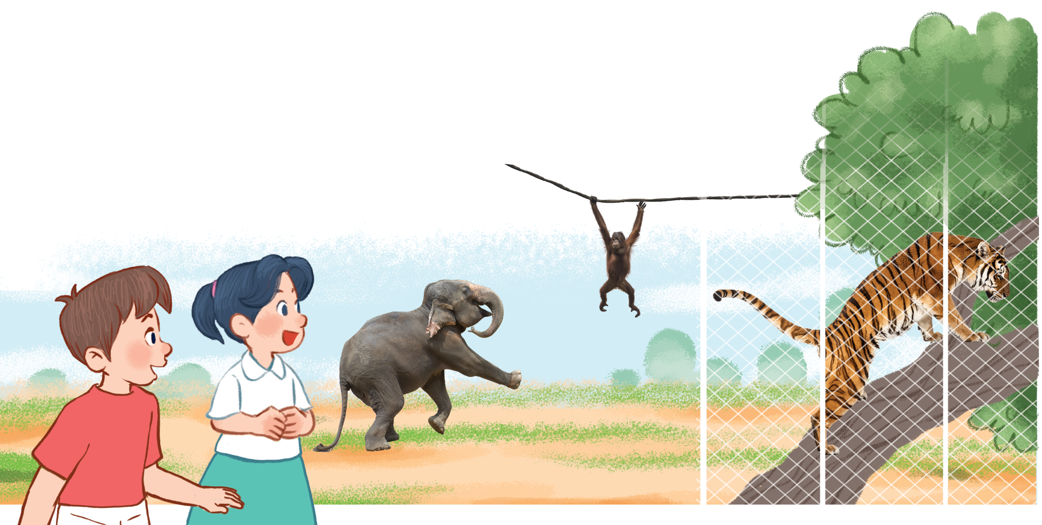 | 4.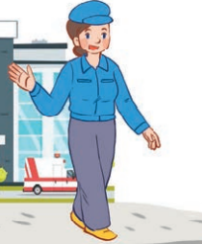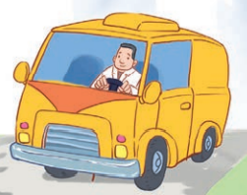

ANSWER KEY
1. Audio script:
1. My sister is a nurse.
2. I’m flying a kite in the park.
3. She has three goldfish.
4. The tiger is dancing.
Key: 1. N 2. N 3. Y 4. N
2. Audio script:
1. A: How old is your brother?
B: He’s fifteen years old.
2. A: Is she a singer?
B: No, she isn’t. She is a worker.
3. A: Where are the tables?
B: They’re in the kitchen.
4. A: What’s she doing?
B: She’s painting a picture.
Key: 1. c 2. c 3. a 4. a
3.
1. 🗶 2. ✔ 3. ✔ 4. 🗶

4.
1. mother 2. park 3. father 4. cycling 5. flying 6. dog
5.
Lưu ý:
- Đối với kỹ năng nói, GV có thể sử dụng kết quả đánh giá thường xuyên trong các giờ học hoặc/ và kết quả kiểm tra kỹ năng này cuối học kỳ.
- GV có thể tiến hành theo cá nhân HS hoặc chia cặp/ nhóm để đánh giá về kỹ năng nói.
- GV có thể sử dụng tranh gợi ý trong bài test hoặc hỏi các câu hỏi khác liên quan đến các competencies đã học.
- Một số gợi ý về ngôn ngữ khi sử dụng tranh như sau:

 | Competences | Suggested language
1 | Talking about having toys | - He has …  - She has …  - They have …
2 | Talking about what someone is doing | He’s / She’s …
2 | Asking and answering questions about what someone is doing | - What’s he / she doing?  - He’s / She’s …
3 | Asking and answering questions about what animals someone can see at the zoo | - What can you see?  - I can see …
3 | Asking and answering questions about what a zoo animal is doing | - What’s the … doing?  - It’s …
4 | Asking and answering questions about the job of a family member | - What’s his/ her job?  - He’s / She’s …
4 | Asking and answering questions about the job of a family member | - Is he / she …?  - Yes, he / she is. / No, he / she isn’t.

