END-OF-TERM TEST 3 (SEMESTER 1)
Time allowed: 35 mins
Full name: ............. Grade: ............. Mark: ............. / 20
Listen and circle. | Listen and tick. | Read and tick. | Look and write. | Let’s talk.
………/ 4 | ………/ 4 | ………/ 4 | ………/ 4 | ………/ 4

1. Listen and circle.
1. a. Touch your hair!
b. It’s an ear.
2. a. Is this a fox?
b. May I speak Vietnamese?
3. a. That’s my friend, Lucy.
b. It’s very nice of you, Mai.
4. a. Do you like painting, Peter?
b. Is it your new ruler, Nam?
2. Listen and tick.
1 | 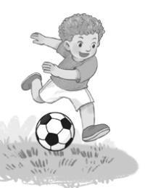  a. ❑ | 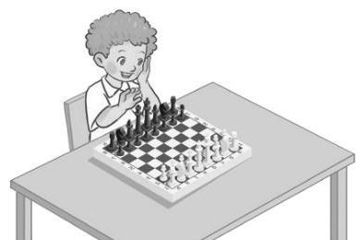  b. ❑ | 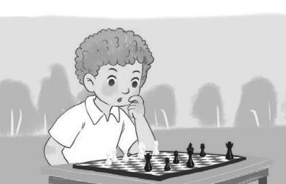  c. ❑
2 | 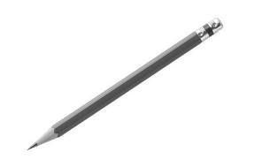  a. ❑ |   b. ❑ | 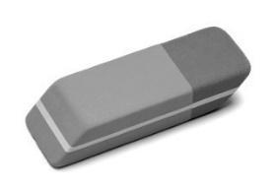  c. ❑
3 | 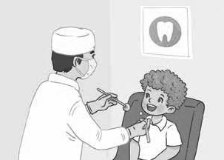  a. ❑ | 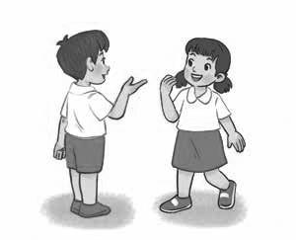  b. ❑ |   c. ❑
4 |   a. ❑ |   b. ❑ | 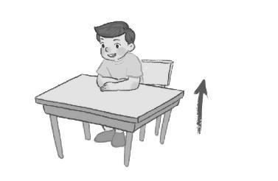  c. ❑

3. Read and tick.

1. A: Ms Hoa, may I come in?
B: Yes, you can.
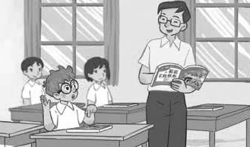  a. ❑ | 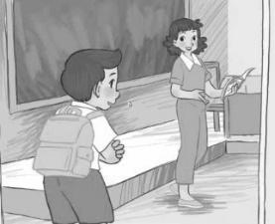  b. ❑ | 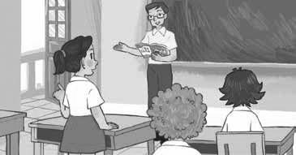 c. ❑

2. A: What’s your hobby, Alex?
B: I like dancing and singing.
  a. ❑ |   b. ❑ |   c. ❑

3. A: Is this your library?
B: No, it isn’t. It’s our music room.
  a. ❑ | 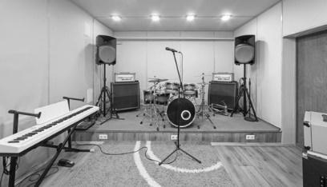  b. ❑ | 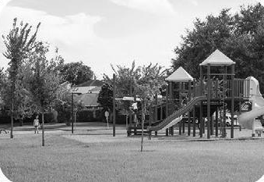  c. ❑

4. A: Sit down and touch your eye.
B: OK.
  a. ❑ |   b. ❑ |   c. ❑

4. Look and write.

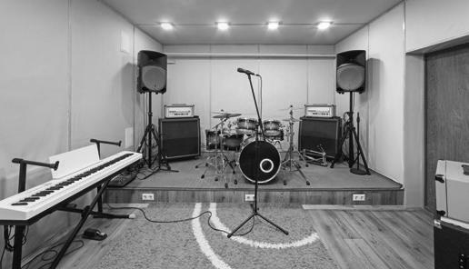  1. A: Let’s / room.  B: OK/ go.  => A: ____________________.  B: ____________________. | 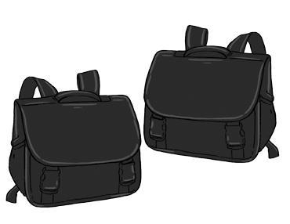  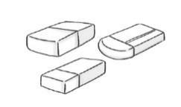  2. A: colour/ they/ ?  B: are/ and  => A: ____________________?  B: ____________________.
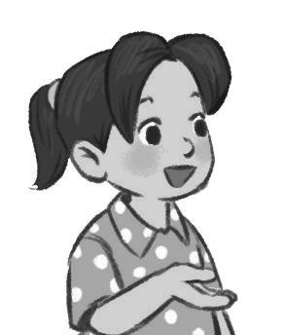  3. A: name?  B: Mai/ .  => A: __________________?  B: __________________. | 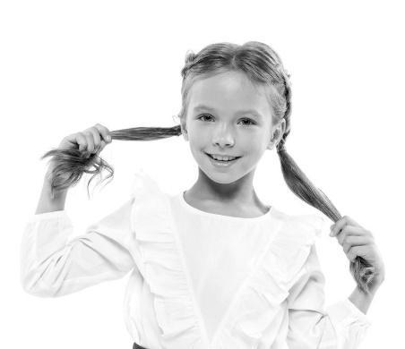  4. _________________!

5. Let’s talk.
1. Greeting/  Responding to greetings | 2. Asking the student’s name/ age | 3. Introducing someone | 4. Asking questions about parts of the body | 5. Asking about hobbies
6. Making suggestions/ Expressing agreement | 7. Giving instructions/ Asking for permission | 8. Asking about school things | 9. Asking about the colour of a school thing | 10. Talking about break time activities

ANSWER KEY
1.
Audio script:
1. It’s an ear.
2. May I speak Vietnamese?
3. That’s my friend, Lucy.
4. Is it your new ruler, Nam?
Key: 1. b 2. b 3. a 4. b
2.
Audio script:
1. A: What do you do at break time?
Bill: I play football with my friends.
2. Mary: Can I borrow your eraser, Nam?
Nam: Yes, you can.
3. Open your mouth! Good boy!
4. Nam, close your book, please.
Key: 1. a 2. c 3. a 4. b
3.
1. b 2. b 3. b 4. a
4.
1. A: Let’s go to the music room.
B: OK, let’s go
2. A: What colour are they?
B: They’re white and black.
3. A: What’s your name?
B: My name’s Mai./ It’s Mai./ Mai.
4. Touch your hair!

5.
Suggested questions and answers:
1. Hello, (pupil’s name). How are you? (Giving clues: Are you fine?/ OK? Yes? No?)
2. Hi! My name’s _____________. What’s your name?/ How old are you?
(Giving clues: My name’s ____./ I’m _____ and you are _______./
Are you ______? Yes? No?)
3. Is this (one pupil’s name)?
4. What’s this?/ Touch your (a body part).
(Point to any body parts learnt to ask or give commands to check pupil’s understanding.)
5. What’s your hobby? (Giving clues: Do you like (swimming)? Swimming? Yes? No?)
6. Is this __________?
Let’s ___________.
7. May ___________?
(Point to one flash card, have the pupil give instructions or ask for permission.)
8. I have _______. Do you have _______?
9. What colour is it? What colour are they? (Giving clues: Is it red? Yes? No?)
10. I play badminton at break time. What about you, (pupil’s name)?
For some topics, the teacher points to the flash card or realia, has the pupils listen and say/ respond. Depending on the pupil's speaking performance, the teacher can give
him/ her some clues to encourage him/ her to speak English.

