UNIT 15

game: favourite breakfast

What would you like for breakfast?

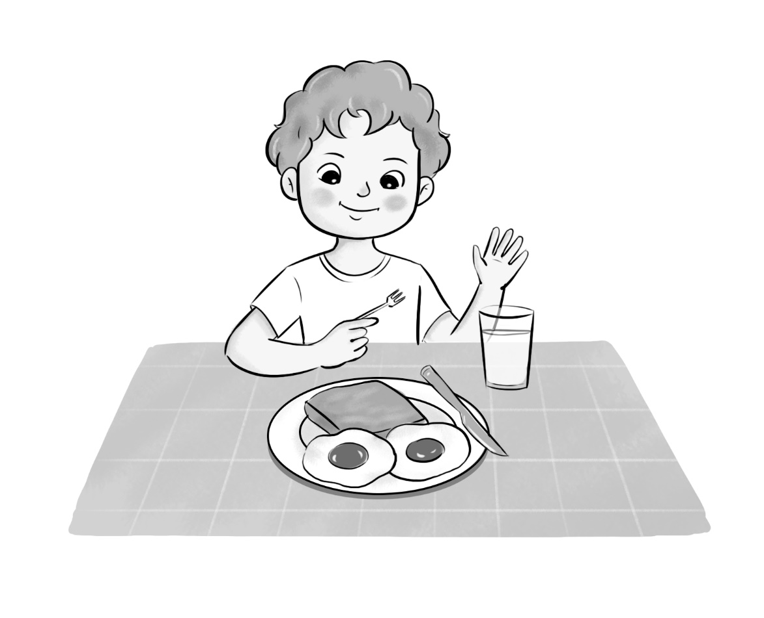

Teacher’s guide:
1. Goal:
- To revise vocabulary related to the topic Food and drinks.
2. Input:
- Paper, coloured pencils/ crayons
3. Suggested procedure:
- Tell pupils that they are going to draw food and drink items they would like to have for breakfast and play Game Find someone who has the same favourite breakfast as you do.
- Have pupils to draw their favourite breakfast (show the illustration above as an example).
- When they finish the work, ask them to go around the classroom, ask questions
What would you like to eat/ drink for breakfast? to find the pupil that wants the same breakfast as he/ she does. The pupils that find his/ her partners fastest will win.
4. Extension:
- For better class, ask pupils to show their pictures and talk about the topic Healthy breakfast.

