UNIT 11

the number game

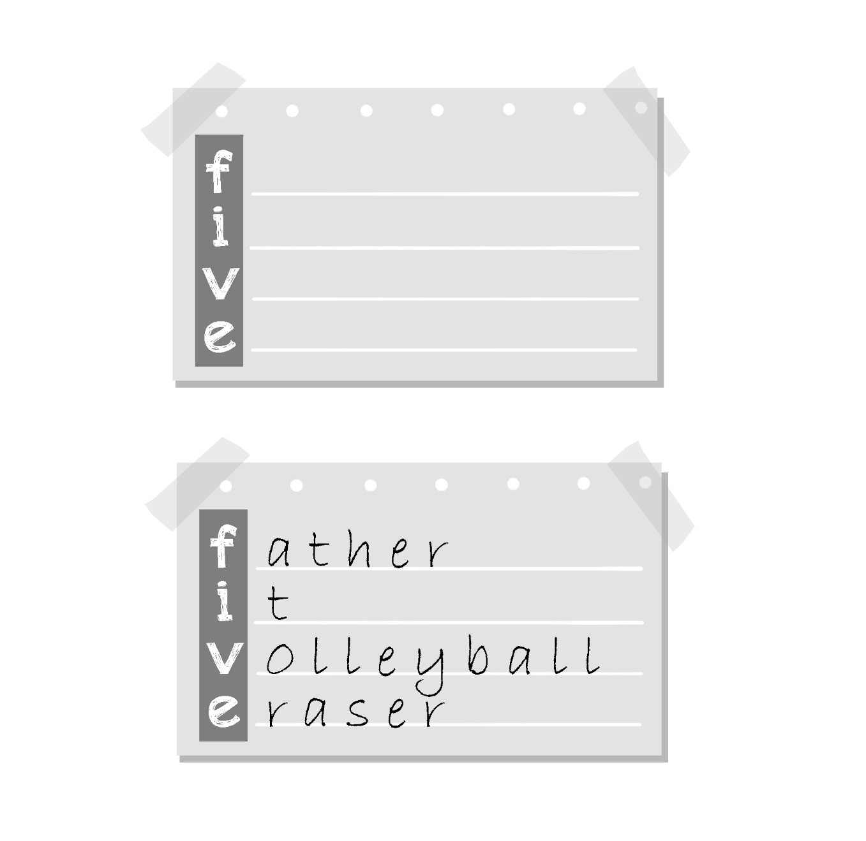

Teacher’s guide:
1. Goal:
- To revise numbers pupils have learnt in Unit 11.
- To revise vocabulary items in previous units.
2. Input:
- Numbers 1-10 (easier for pupils to find words)
- Chalk, blackboard, paper, pens/ pencils
3. Suggested procedure:
- Explain how the game is played. Write a number on the board, e.g. FIVE. Ask pupils to elicit a word beginning with each of the letters of the word FIVE, then write the word next to each letter (as shown in the illustration above).
- Ask pupils to work in pairs or group. Give each pair/ group one number (by chance): e.g. 2, 6, 10, ...
- Ask pupils to take a piece of paper and write down the numbers (in words) or ask them to spell out the numbers. For weaker class, dictate the numbers or write them on the board for pupils to copy.
- Let pupils work in pairs/ groups, elicit words and complete the puzzle. The pair/ group that completes the puzzle first will win.
4. Extension:
- Ask pupils to make sentences using each word.

