UNIT 4

game

Flip the coin

How to play:
1. Work in groups.



2. Flip the coin, : move 2 spaces, : move 1 space
3. Read aloud, answer or act.
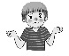
- Don’t know: lose your turn.

- Finish first to win.
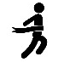
START:

1. What’s this?  - ________.   | 2. Touch your ____!   | 3. Open your __________!  and say  Apple.  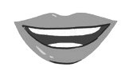 | 4. LOSE YOUR TURN.   | 5. How many fingers are there?  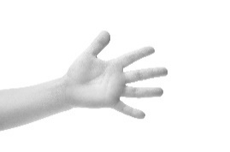
6. Jump up and say Hello, everyone.  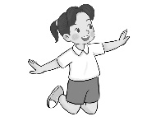 | 7. Draw your face to the air. | 8. Go back number 3. | 9. Touch your hair and say Hello, I’m ____ (your name). | 10. Touch your friend’s hand and ask How old are you?
11. Touch your ear and say Excuse me!   | 12. Move to 13.   | 13. Open your eyes then open your mouth. | 14. Touch your face and say Hello, I’m ____ (your name). | 15. What’s this?  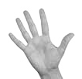  and wave goodbye.
 FINISH
Touch / Open / What’s this?/ What’s that?
ear, eye, face, hair, hand, mouth, nose

