WORKSHEET– No. 12
English
Name: ……………………………………
Class: 4/ ……

- Write the names of the subjects: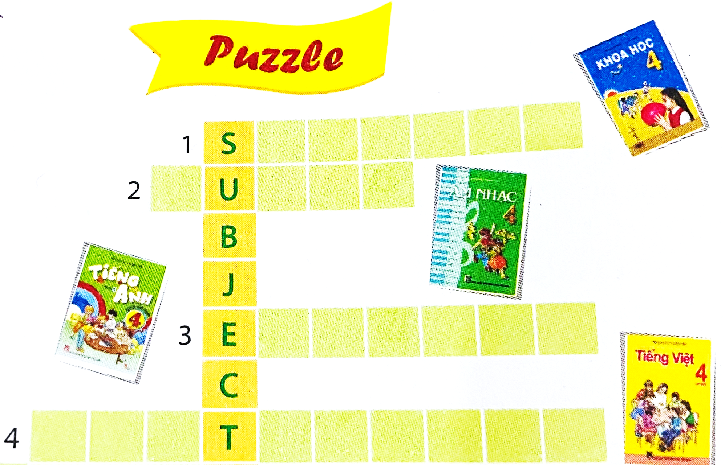

- Look and write the answers:

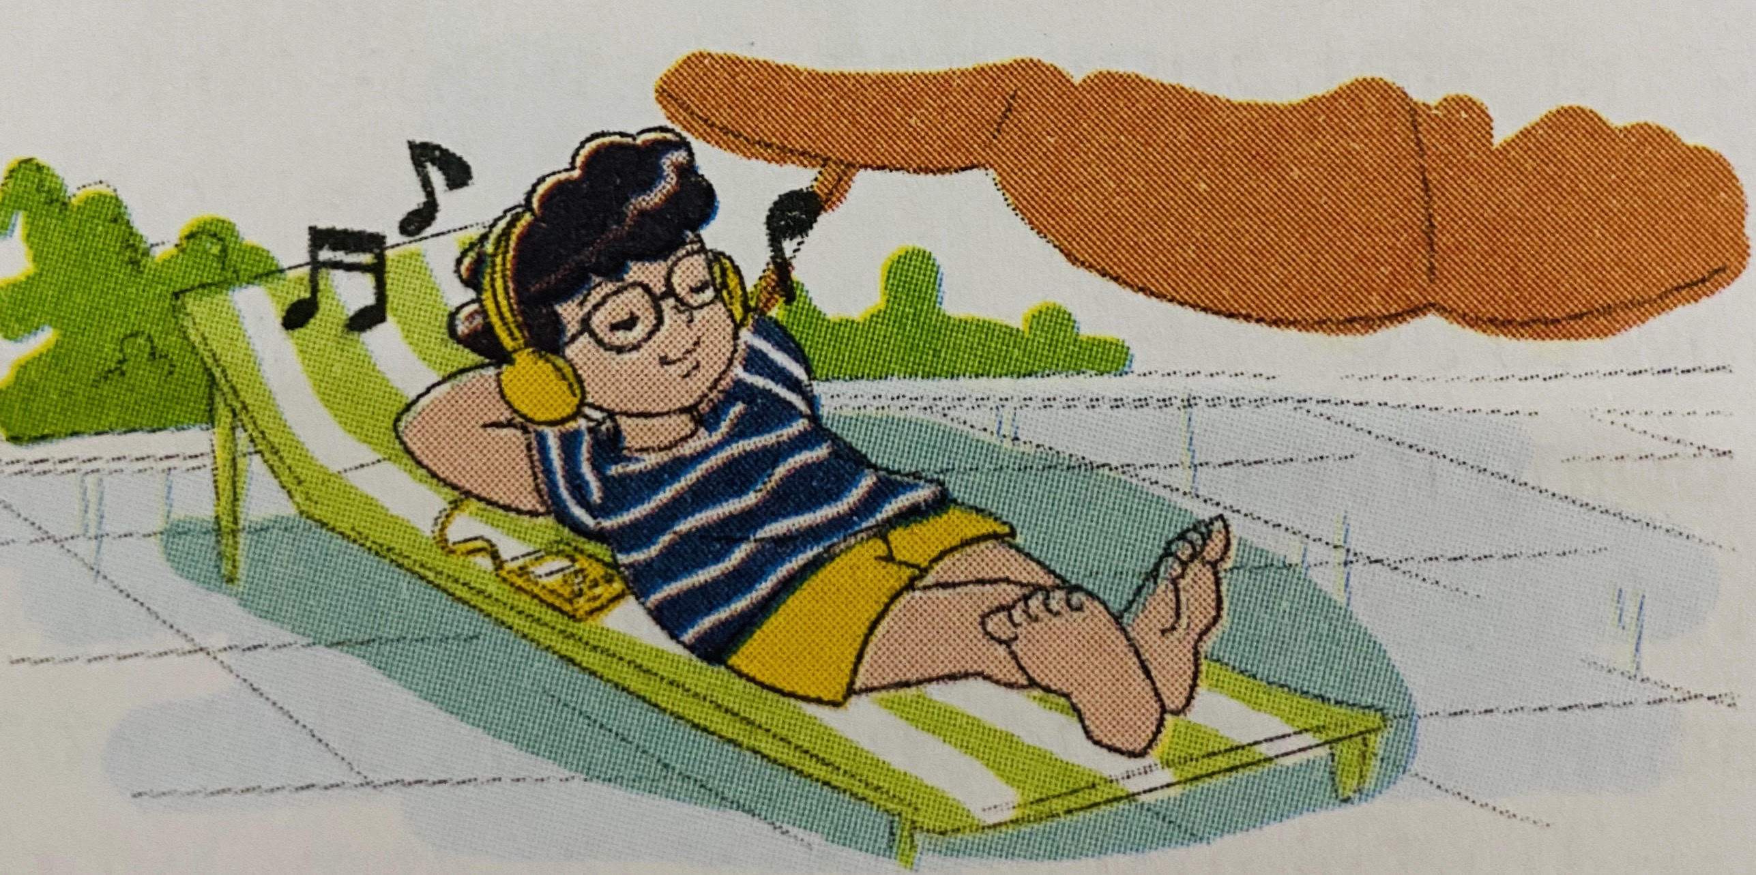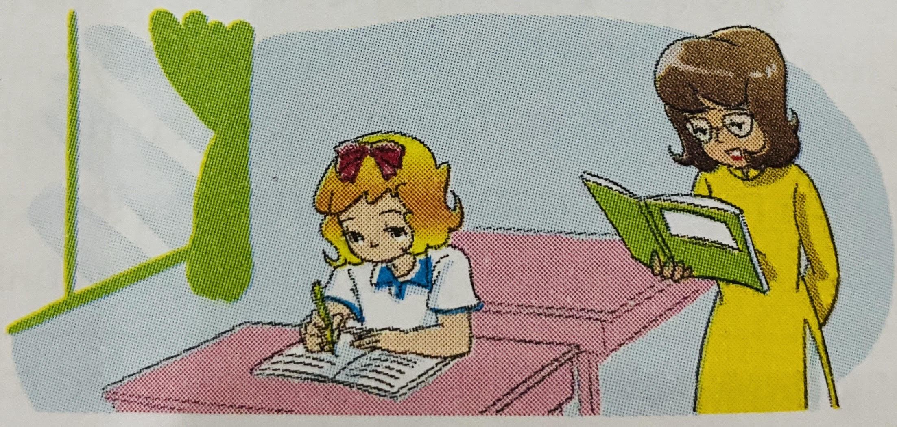
- What’s Phong doing? 2. What’s Linda doing?
________________________________ ____________________________________

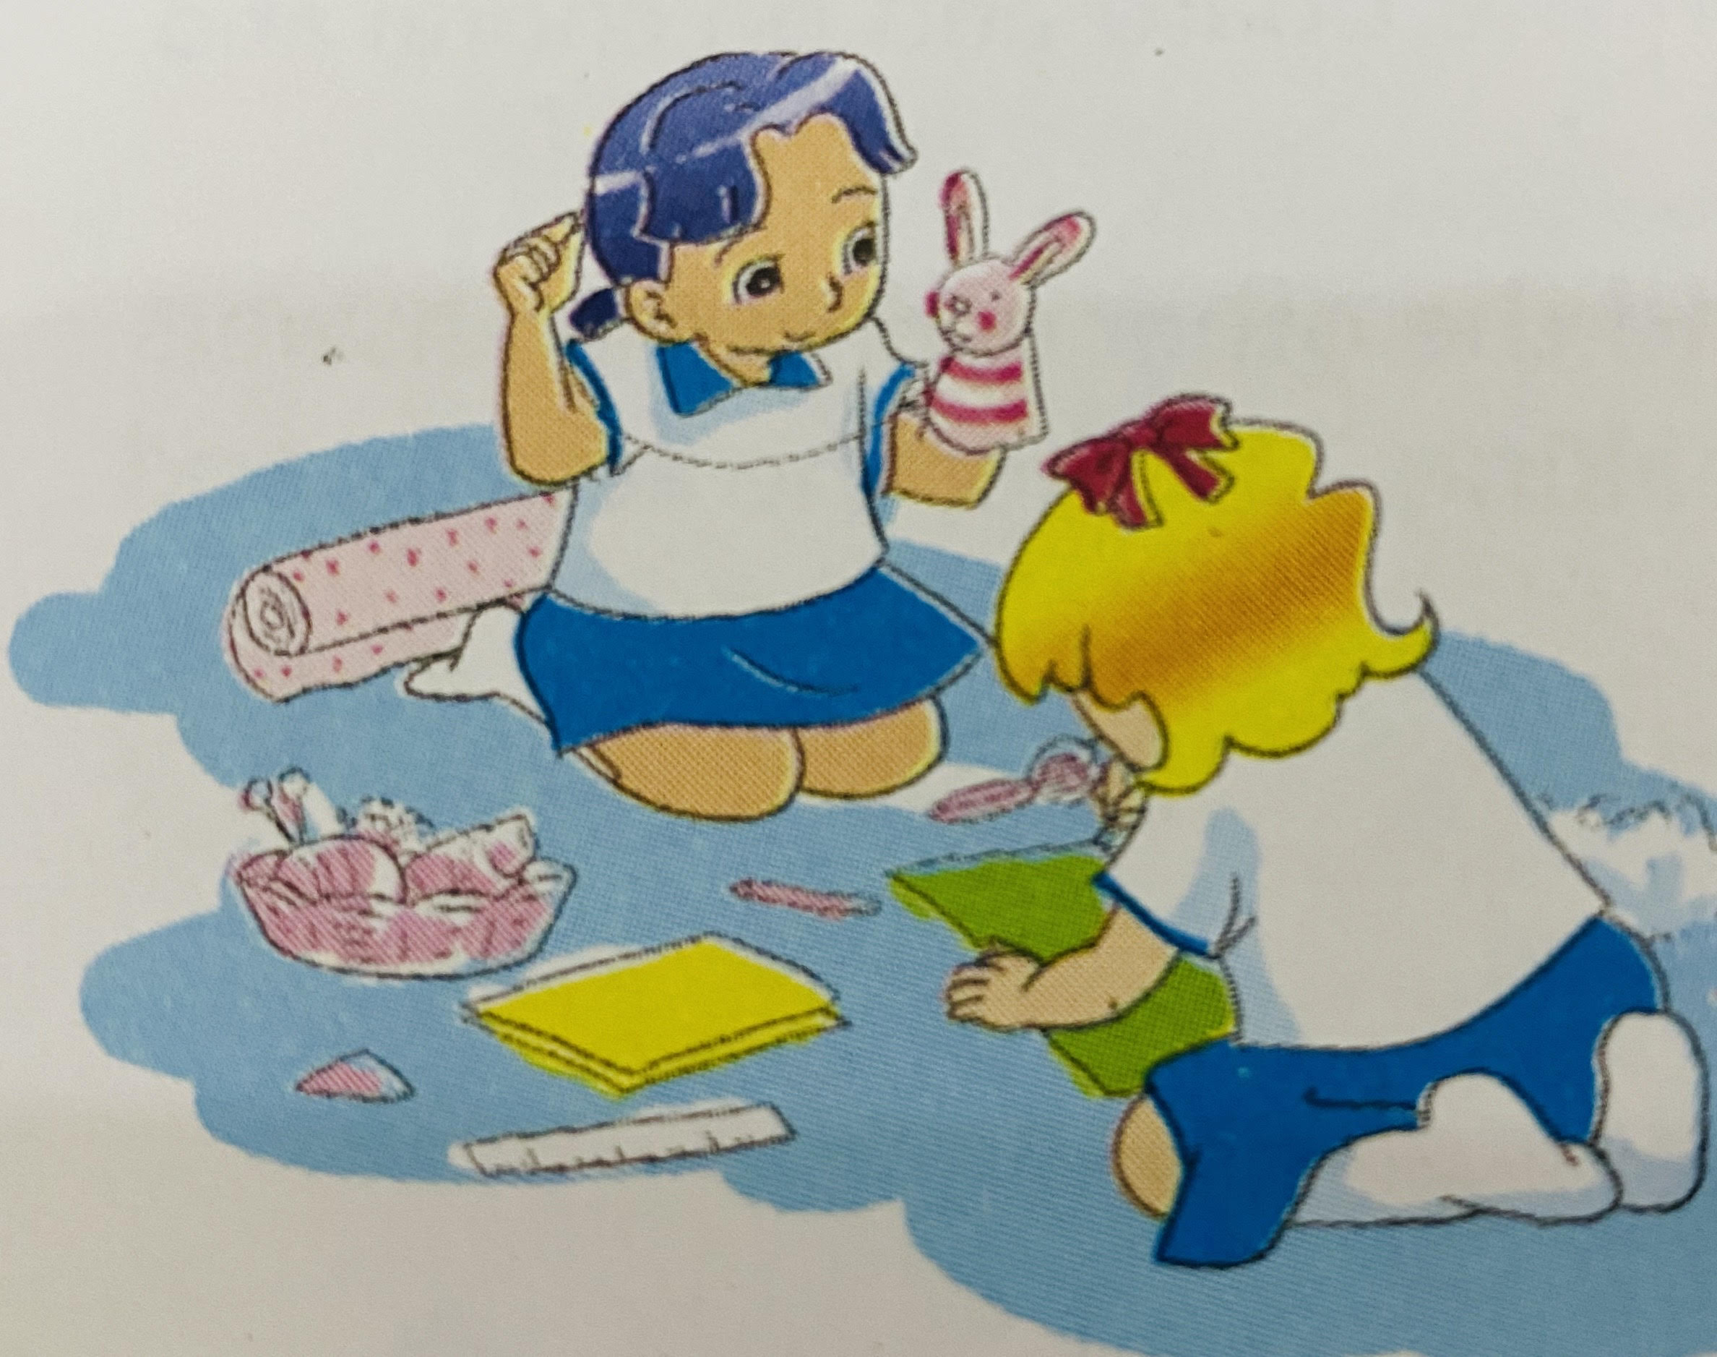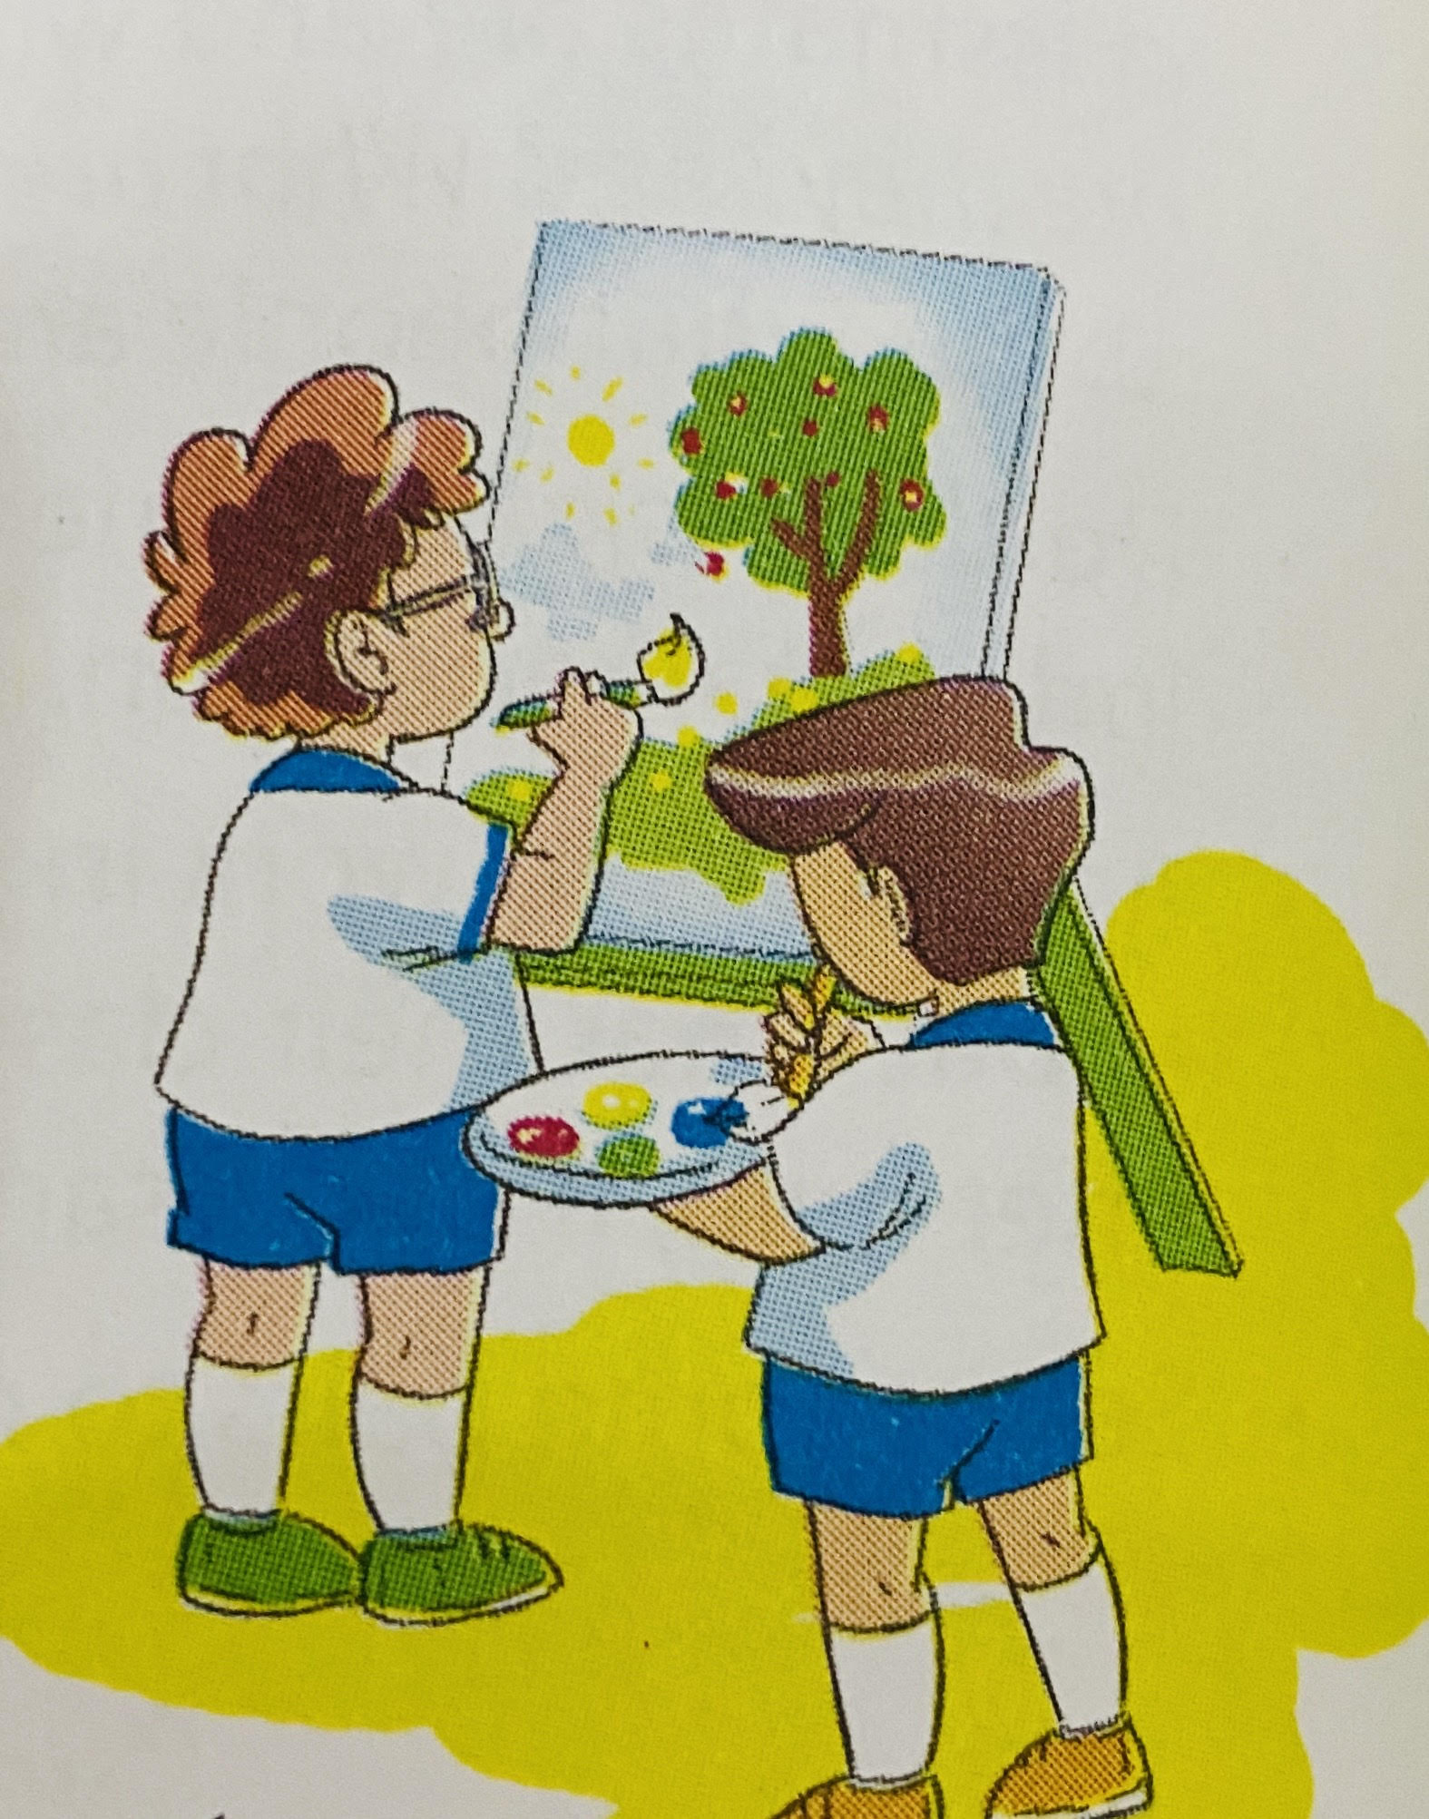
3.What are they doing? 4. What are they doing?
___________________________________ ___________________________________

- Read and match:

A |  | B
- What did your father do in the afternoon? | 1 - | - I like riding a bike
2. What time do you have lunch? | 2 - | - She likes watching TV
3.What does Mai like doing? | 3 - | - I have it on Monday.
4.What’s your hobby? | 4 - | - He played chess
5. Where was Tom yesterday? | 5 - | - He was at home
6. When do you have Science? | 6 - | - It’s six thirty.

