WORKSHEET– No. 10
English
Name: ……………………………………
Class: 5/ ……

I. Read, circle and write.
1. What will you do this Monday?  ___________________________ | a. I’ll paint a picture.  b. I painted a picture.
2. Where will you be next Sunday?  ___________________________ | a. I was at the English club.  b. I’ll be at the English club.
3. Will you explore a cave next month?  ___________________________ | a. Yes, we do.  b. Yes, we will.
4. Where will you play badminton?  ___________________________ | a. We will play it on the school playground.  b. We play it on the school playground.
5. Will you be at the cinema tomorrow?  __________________________ | a. Sorry, I won’t.  b. Sorry, I didn’t.

II. Look and order the letters to make the correct words.
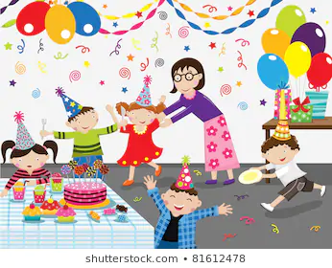


oinj vitein
1. ___________ the funfair 2. _________ friends to the party
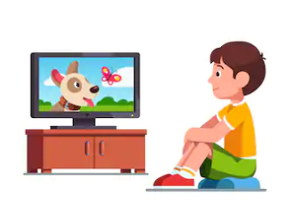
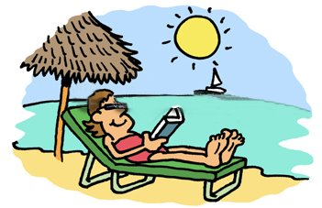

joyen atchw
3. __________ the holiday 4. _________ videos

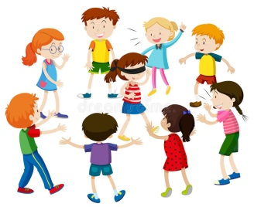


atch aypl
5. ___________ with friends 6. __________ blind man’s bluff

III. Read and complete.

What | How often

1. _______________ do you do in the morning? – I usually go to school.
2. _______________ do you do in the afternoon? – I often go to the school library.
3. _______________ do you go to the school library? – Once a week.
4. _______________ do you do in the evening? – I watch TV.
5. _______________ do you watch TV? – I watch TV three times a week.

IV. Write about yourself.

1. My favourite fairy tale is _______________________________________________.
2. My favourite character is _______________________________________________.
3. I like him/ her very much because ________________________________________.

