WORKSHEET– No. 35
English
Name: ……………………………………
Class: 5/ ……

- Look and write:
1.The …….. and the ……………. | 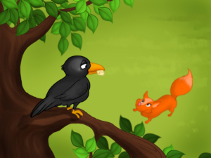
2.The story of …………………… | 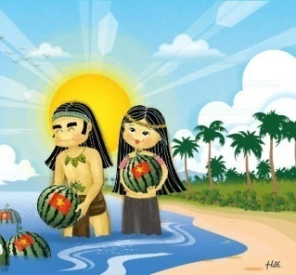
3.Aladdin and ……………………. | 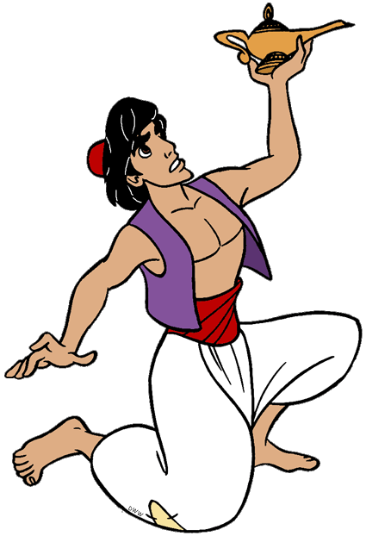
4.Snow …………and the seven …… | 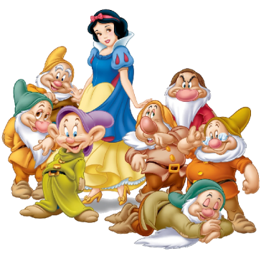
5.The story of ……… and ……. | 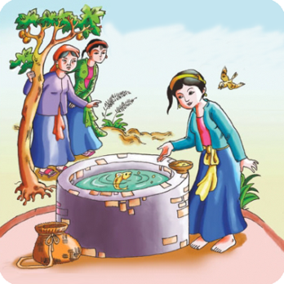

II. Choose the best answer:
1. What is the Fox………?
A. like B. liking C. likes D. to like
2. What are you………….?
A. read B. reading C. reads D. to read
3. What is your……………story? It’s Tam Cam.
A. free B. reading C. like D. favourite
4. Let’s ………….basketball.
A. play B. playing C. plays D. to play

III. Put the words in correct order:
- is/ kind/ very/ Tam/.
..........................................................................................................................
- What/ you/ reading /are/?
...........................................................................................................................
3. is/ What/ Snow White/ like?
.............................................................................................................................
4.It’s /story/ two/ about /a /girls/.
...........................................................................................................................
5.character/ Who /the /main /is/?
...........................................................................................................................

