WORKSHEET– No. 40
English
Name: ……………………………………
Class: 5/ ……

- Look and write the names of subjects.

- Maths | 
- _________ | 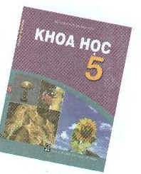
- _________ | 
- ________ | 
- ________ | 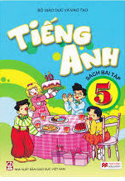
- _________ | 

II. Rewrite the words in correct order to make meaningful sentences.
- favourite/ Art / Music/ her/ subjects/ are/ and/.
- ……………………………………………………………………………………………
- Nam/has/ every/ school day/ Maths/.
- …………………………………………………………………………………………….
- English / have / We / don’t / on / lessons / Saturdays/.
- …………………………………………………………………………………………….
- We/four/ have/ today/ lessons/.
- ……………………………………………………………………………………………
- I/ to/ school/Sunday / except/ go/ everyday/ Saturday/ and/.

- Match the column A with the column B.

A | B
1. Where’s Tony now?  2. What’s Linda doing in the gym?  3. When will Sports Day be?  4. What will Phong and Nam do on Sports Day?  5. Will you take part in the singing contest? | A. He’s in the gym.  B. Yes, I will.  C. It’ll be next month.  D. They’ll swim.  E. She’s playing table tennis.

