ĐỀ CƯƠNG ÔN TẬP MÔN TIẾNG ANH LỚP 3
A. Tổng hợp từ vựng và mẫu câu từ bài 1 đến bài 10
 | VOCABULARY | STRUCTURE
1 | - Greetings: hello, hi | - Hello/hi. I’m + tên  - How are you ? I’m fine, thanks
2 | - The alphabets (bảng chữ cái Tiếng Anh) | - What’s your name? My name is ………  - How do you spell your name ? ……….
3 | - Numbers from 1 to 10: one, two, three, four, five, six, seven, eight, nine, ten | - How old are you ? I’m ….. years old.  - Who’s that ? It’s + tên  What do you do in your free time ?  I play football
4 | - Friend: name | - This is my friend  - Arre they your friend ? Yes, they are/ No, they aren’t
5 | - Các câu mệnh lệnh trong lớp học: stand up, sit down, close your book, open your book, come in, come here, ask a question, go out | - May I come in ? Yes, you can/ No, you can’t
6 | - School: gym, playground, computer room, music room, library, classroom  - Tính từ miêu tả: big, small, old, young, new, large, beautifull. | – That’s the computer room  - Is the computer room small?
7 | School things: pen, pencil, pencil case, pencil sharpener, ruler, rubber, school bag, book, notebook | - cách sử dụng của 4 đại từ chỉ định This/ that/ those/ these
8 | - Colour: red, yellow, blue, green, purple, gray, white, black, brown | - What colour is it? It’s + màu  - What colour are they? They’re + màu
9 | - Sports: football, basketball, volleyball, table tennis, chess, badminton  - Games: hide and seek, blind man’s bluff, skating, skipping | - what do you do at break time ? I play football  - Do you like skipping ?Yes, I do/ No, I don’t
B. Một số câu hỏi ôn tập phần thi nói
1. What’s your name ?
2. How do you spell your name ?
2. How old are you?
3. What class are you in ?
4. What’s your school’s name ?
5. How many members are there in your family ? Who are they ?
6. What do you do at break time ?
7. Do you like ….?
8. What colour is this?
9. What colour are they ?
C. Một số dạng bài thi thường gặp
I. LISTENING
Task 1. Listen and number
Task 2. Listen and tick (v) or cross(x)
Task 3. Listen and circle
Task 4. Listen and complete
Task 5. Listen and write Yes or No
II. READING AND WRITING
Task 1. Look and write.
  1. hloocs →  s_ _ _ _ _ | 
  2. ewn →  n_ _ | 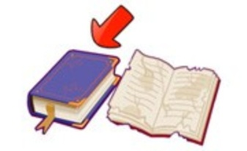
  3. lasscoomr →  c_ _ _ _ _ _ _ _ | 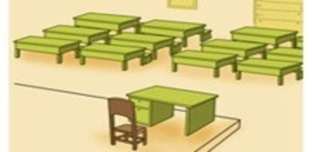
  4. llsma →  s_ _ _ _ | 
 |  |  | 6. esY →  Y _ _
  5. laypgruond →  p_ _ _ _ _ _ _ _ _ | 
  7. siht →  t _ _ _ | 
  8. htat →  t _ _ _ | 
  9. onTy →  T _ _ _ | 
  10. oN →  N _ | 

Task 2. Read and tick  or cross .
1. |  | 2.
Do you like table tennis?  Yes, I do. | 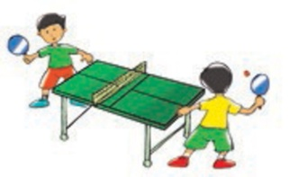 | What do you do at break time?  We play basketball. | 
 | 

3. |  | 4.
Do you play chess at break time?  Yes, I do. | 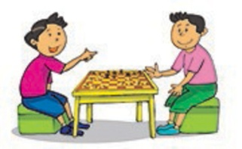 | They play hide-and-seek at break time. | 

Task 3. Read and complete. There is one example

hello | who's | hi | friends | yes | it's

Mai: (0) Hello, Nam.
Nam: (1) ___________ Mai.
Mai: Who's that boy?
Nam: (2) __________ Phong.
Mai: And (3) __________ that girl?
Nam: It's Linda.
Mai: Are they your (4) __________?
Nam: (5) ______, they are.

Task 5. Order the word
1. Are / friends / they / ? / your /
___________________________
2. your / Is / sharpener ? / this / pencil /
________________________________
3. My / Hello. / Mary/ name’s/
________________________________
4. colour / your/ What/ pencil case ? / are/
________________________________
5.Linda / is / My / name
________________________________
6. What/ name/ ?/ is/ your
________________________________
7. time / do/ What/ break / do/ you/ at/?
________________________________
8. play / I / football / break time. / at /
________________________________
9. Nice / you, / meet/ to/ too.
________________________________
10. you/? / How/ are/
________________________________
The end

