ĐỀ CƯƠNG ÔN TẬP MÔN TIẾNG ANH LỚP 4
A. Tổng hợp từ vựng và mẫu câu từ bài 1 đến bài 10
 | VOCABULARY | STRUCTURE
1 | - morning, afternoon, evening, night, tomorrow, later, again, see, meet, | - Good morning/ afternoon/ evening.  - Goodbye. See you tomorrow./ Bye. See you later./ Good night.
2 | - Country: America, Japan, Australia, England, Viet Nam, Malaysia  - Nationality: English, American, Japanese, Australian, vietnamese, Malaysia  Malaysia, Malaysian, Viet Nam, Vietnamese | - Where are you from? - I’m from+ tên nước  - What nationality are you? - I’m + quốc tịch
3 | - Days: today, Monday, Tuesday, Wednesday, Thursday, Friday, Saturday, Sunday. | - What day is it today? - It’s...  - What do you do on + tên ngày trong tuần? - I... in the morning/ in the afternoon.  What do you do in your free time ?  I play football
4 | - Months: January, February, March, April, May, June, July, August, September, October, November, December  - Ordinal numbers: …………………. | - What is the date today? - It’s...  - When’s your birhday? - It’s on the + số thứ tự của ngày of tháng.
5 | - Verb: can, ride, cook, skate, skip, sing, swim, swing, dance, play  - Sports: guitar, piano, volleyball, table tennis, chess, football, chess, basketball. | - What can you do? - I can...  - Can you ...? - Yes, I can./ No, I can’t
6 | - street, road, village, district, address, class, school, study | – Where’s your school? - It’s in + địa điểm...  – What class are you in? - I’m in Class...
7 | - V+ing: swimming, cooking, collecting stamps, riding a bike, playing, badminton, flying a kite, taking photographs,watching tv, Painting a mask, writing a dictation, making | - What do you like doing? - I like + động từ -ing + danh từ.  - What’s your hobby? - I like + động từ -ing  - What’s he/she doing? - He/She’s + V-ing  - What are they doing? - They’re + V-ing
8 | - Subject: IT (Information Technology), Maths, Music, Art, Science, Vietnamese, PE(Physical Education) | - What subjects do you have today? - I have + môn học.  - When do you have + môn học? - I have it on + ngày
9 | - yesterday, at home, at the zoo, at school, on the beach, in the school library, listen, wash, water  - V+ed: played, watched, listened, painted, watered…. | - Where were you yesterday? - I was ...  - What did you do yesterday? - I + Ved.  - Cách chia của động từ Tobe ở thì quá khứ
B. Một số câu hỏi ôn tập phần thi nói
1. What’s your name ?
2. How old are you?
3. What class are you in ?
4. What’s your school’s name ?
5. How many members are there in your family ? Who are they ?
6. What’s your hobby ?
7. Where are you from ?
8. What nationality are you ?
9. When’s your birthday ?
10. What can you do ?
11. What subjects do you have today ?
12. What’s your favourite subject ?
13. Where were you yesterday ?
14. What did you do yesterday ?
C. Một số dạng bài thi thường gặp
I. LISTENING
Task 1. Listen and number
Task 2. Listen and tick (v) or cross(x)
Task 3. Listen and circle
Task 4. Listen and complete
Giaoandethitienganh.info sưu tầm

Task 5. Listen and write Yes or No
II. READING AND WRITING
Task 1. Look and write.

  1. igconok  → _ _ _ _ _ _ _ | 
  2. siinngg  → _ _ _ _ _ _ _ | 
  3. sngkpipi  → _ _ _ _ _ _ _ _ | 
  4. ktngias  → _ _ _ _ _ _ _ | 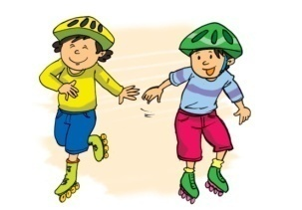
 |  | 6
  5. llageiv  → _ _ _ _ _ _ _ | 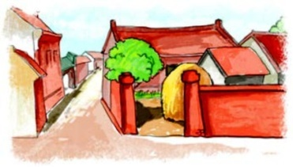
  2. oard  → _ _ _ _ | 
 |  | 8
  7. idtricts  → _ _ _ _ _ _ _ _ | 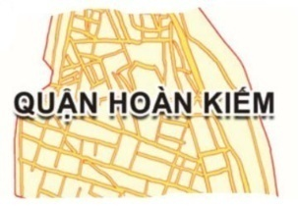
  4. rpimayr  → _ _ _ _ _ _ _ | 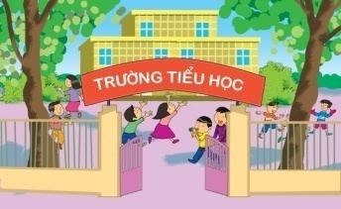
Task 2. Read and tick  or cross .

  1.
  Phong likes playing football. | 
   | 
  2.
  Nam's hobby is watching TV. | 
  3.
  Mai and Linda like dancing. | 
  4.
  Tom and Quan like playing table tennis. | 
Task 3. Read and complete the answers. There is one example (0).
Hi. My name is David. I'm ten years old. I'm English. My hobby is drawing. I usually draw pictures on Saturdays. My parents love my pictures very much. I like playing football, but I don't like swimming. My best friend Jane likes collecting flowers, but she doesn’t like playing football. She likes my pictures and I like her beautiful flowers.
0. What’s his name? | - His name's David
1. What is his hobby? | - It’s ___________.
2. What does he usually do on Saturdays? | - He ___________.
3. What does he like playing? | - He likes playing ___________.
4. What doesn’t he like doing? | - He doesn’t like ___________.
5. What does his friend Jane like doing? | - She likes ___________.
Task 4. Read and number the sentences in the correct order.
0. | A | Mia: Hi, Alex. What are you doing here?
 | B | Alex: No, I don’t. Were you here yesterday?
 | C | Mia: No, I wasn’t. I was at the library yesterday. My hobby is reading.
 | D | Mia: I’m going with my brother. He’s flying a kite. Do you like kites?
 | E | Alex: Oh, I like reading, too.
 | F | Alex: Hi, Mia. I’m just riding a bike. What about you?
Task 5. Read and write YES or NO. There is an example (0)
Hello, I’m Mia from Oxford Primary School. It’s Monday today. We have Art and Science today. I’m in the Art class now. The girls are drawing flowers. The boys are making paper planes. It was Sunday yesterday. I was at home. In the morning, I painted a picture. In the afternoon, I played tennis. In the evening, I played computer games.
0. Mia is a pupil at Oxford Primary School. | YES
1. She has Art and Science on Mondays. | _____
2. All pupils are drawing flowers in the Art class now. | _____
3. Yesterday Mia was at school. | _____
4. She painted a picture on Sunday morning. | _____
5. She played tennis on Sunday evening. | _____
Task 6. Order the word
- have/ on/ Music/ I/ Friday.
………………………………………………………………
- garden/ I / watered/ in/ the/ the/ flowers
……………………………………………………………….
- Where / from/ ? are/ you
……………………………………………………………….
- From/ I/ am/ Malaysia
………………………………………………………………
- Your/ where / is/ school/?
………………………………………………………………
- on/ / February/ My/ the/ birthday/ is/ third/of
……………………………………………………………….
The end

Task 7. Read and complete the answers.
Hello, I’m Maria from West House Primary School. It’s Monday today. We have PE and Science today. I’m in the PE class now. The girls are playing badminton. The boys are playing football.
It was Sunday yesterday. I was at home. In the morning, I visited my grandparents. In the afternoon, I played tennis. In the evening, I watched TV.
Giaoandethitienganh.info sưu tầm

0. What is the name of Maria’s school? – It’s West House Primary School.
1. What subjects does Maria have on Mondays? - She has _____________ and Science.
2. What are the boys doing now? – They’re ____________.
3. Where was Maria yesterday? – She was ____________.
4. What did she do in the morning? – She _________ her grandparents.
5. What did she do in the evening? – She _________.
Task 8. Read and write

  1.
  They're ……………. | 
  2.
  They're …………… | 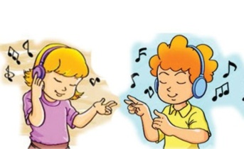
  3.
  He's…................. | - 
  4.
  He's …… | - 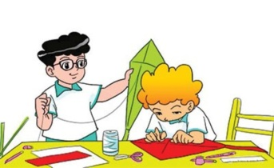
  5.
  He's ………. | 
  6.
  Bye, see ……… | 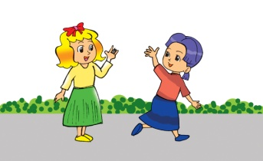
  7. tginh  → _ _ _ _ _ | 
  8. veennig  → _ _ _ _ _ _ _ | 
  9. oinmgrn  → _ _ _ _ _ _ _ | 
  10. ftoornane  → _ _ _ _ _ _ _ _ _ | 

