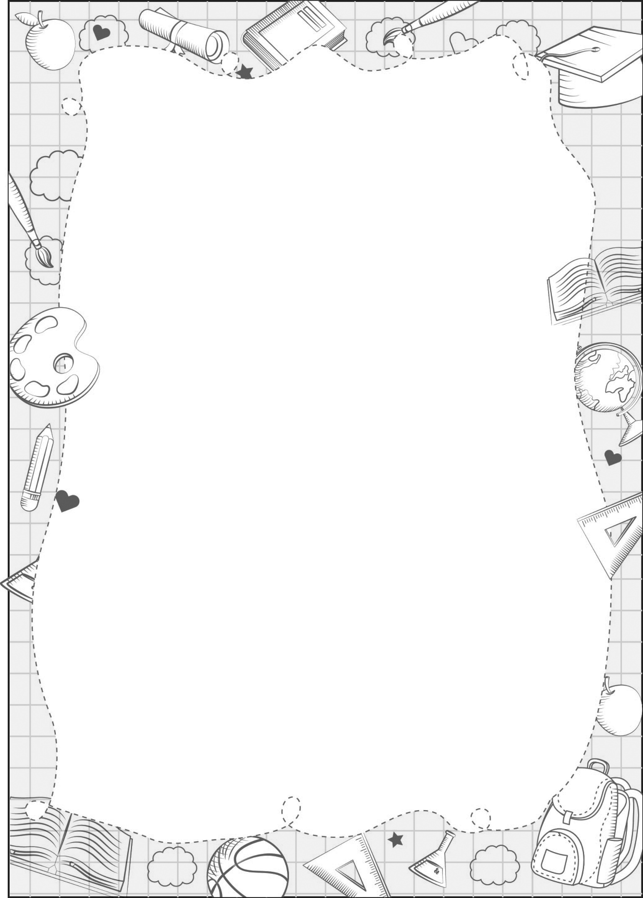
UNIT 1

portfolio

Create your portfolio cover.

School: .............................................................
Class: ...............................................................
Full name: .........................................................

You can draw here

