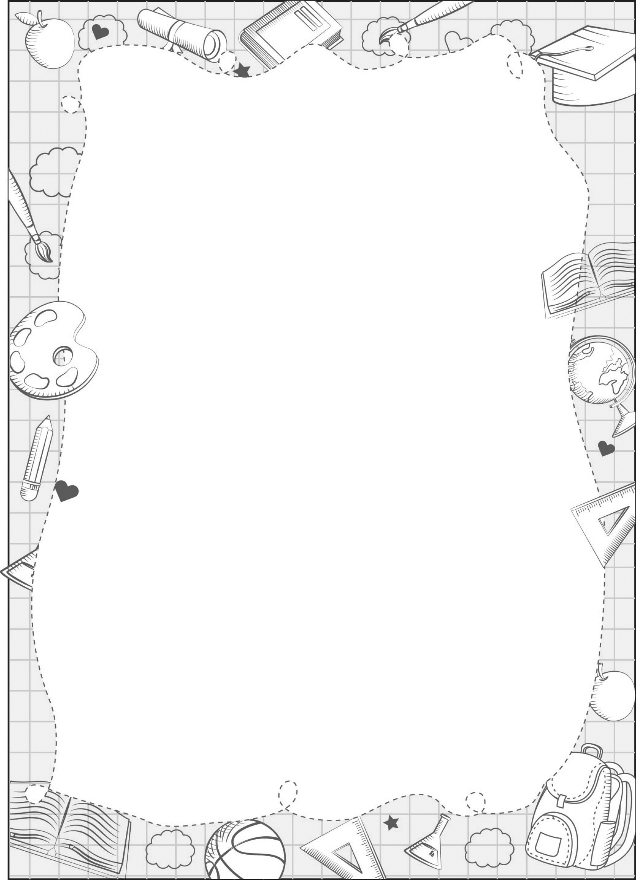
UNIT 5

my research portfolio

Sở thích nhóm 2
Sở thích nhóm 1

 cooking  dancing  drawing painting  singing | running  walking  swimming
My Family
What’s your hobby?
Draw
yourself
grandfather
grandmother
mum
dad
sister
brother
my pet

My friends - Group
What’s your hobby?

My friends | Running | Swimming | Walking | Dancing | Cooking | Painting | Drawing | Singing
E.g: Lan: It’s running. | ✓
..................
..................
..................
..................
Total | …
Created by _______________________
What’s your hobby?
- It’s _____./
- I like cooking/ dancing/ drawing/ painting/
running/ singing/ swimming/ walking.

