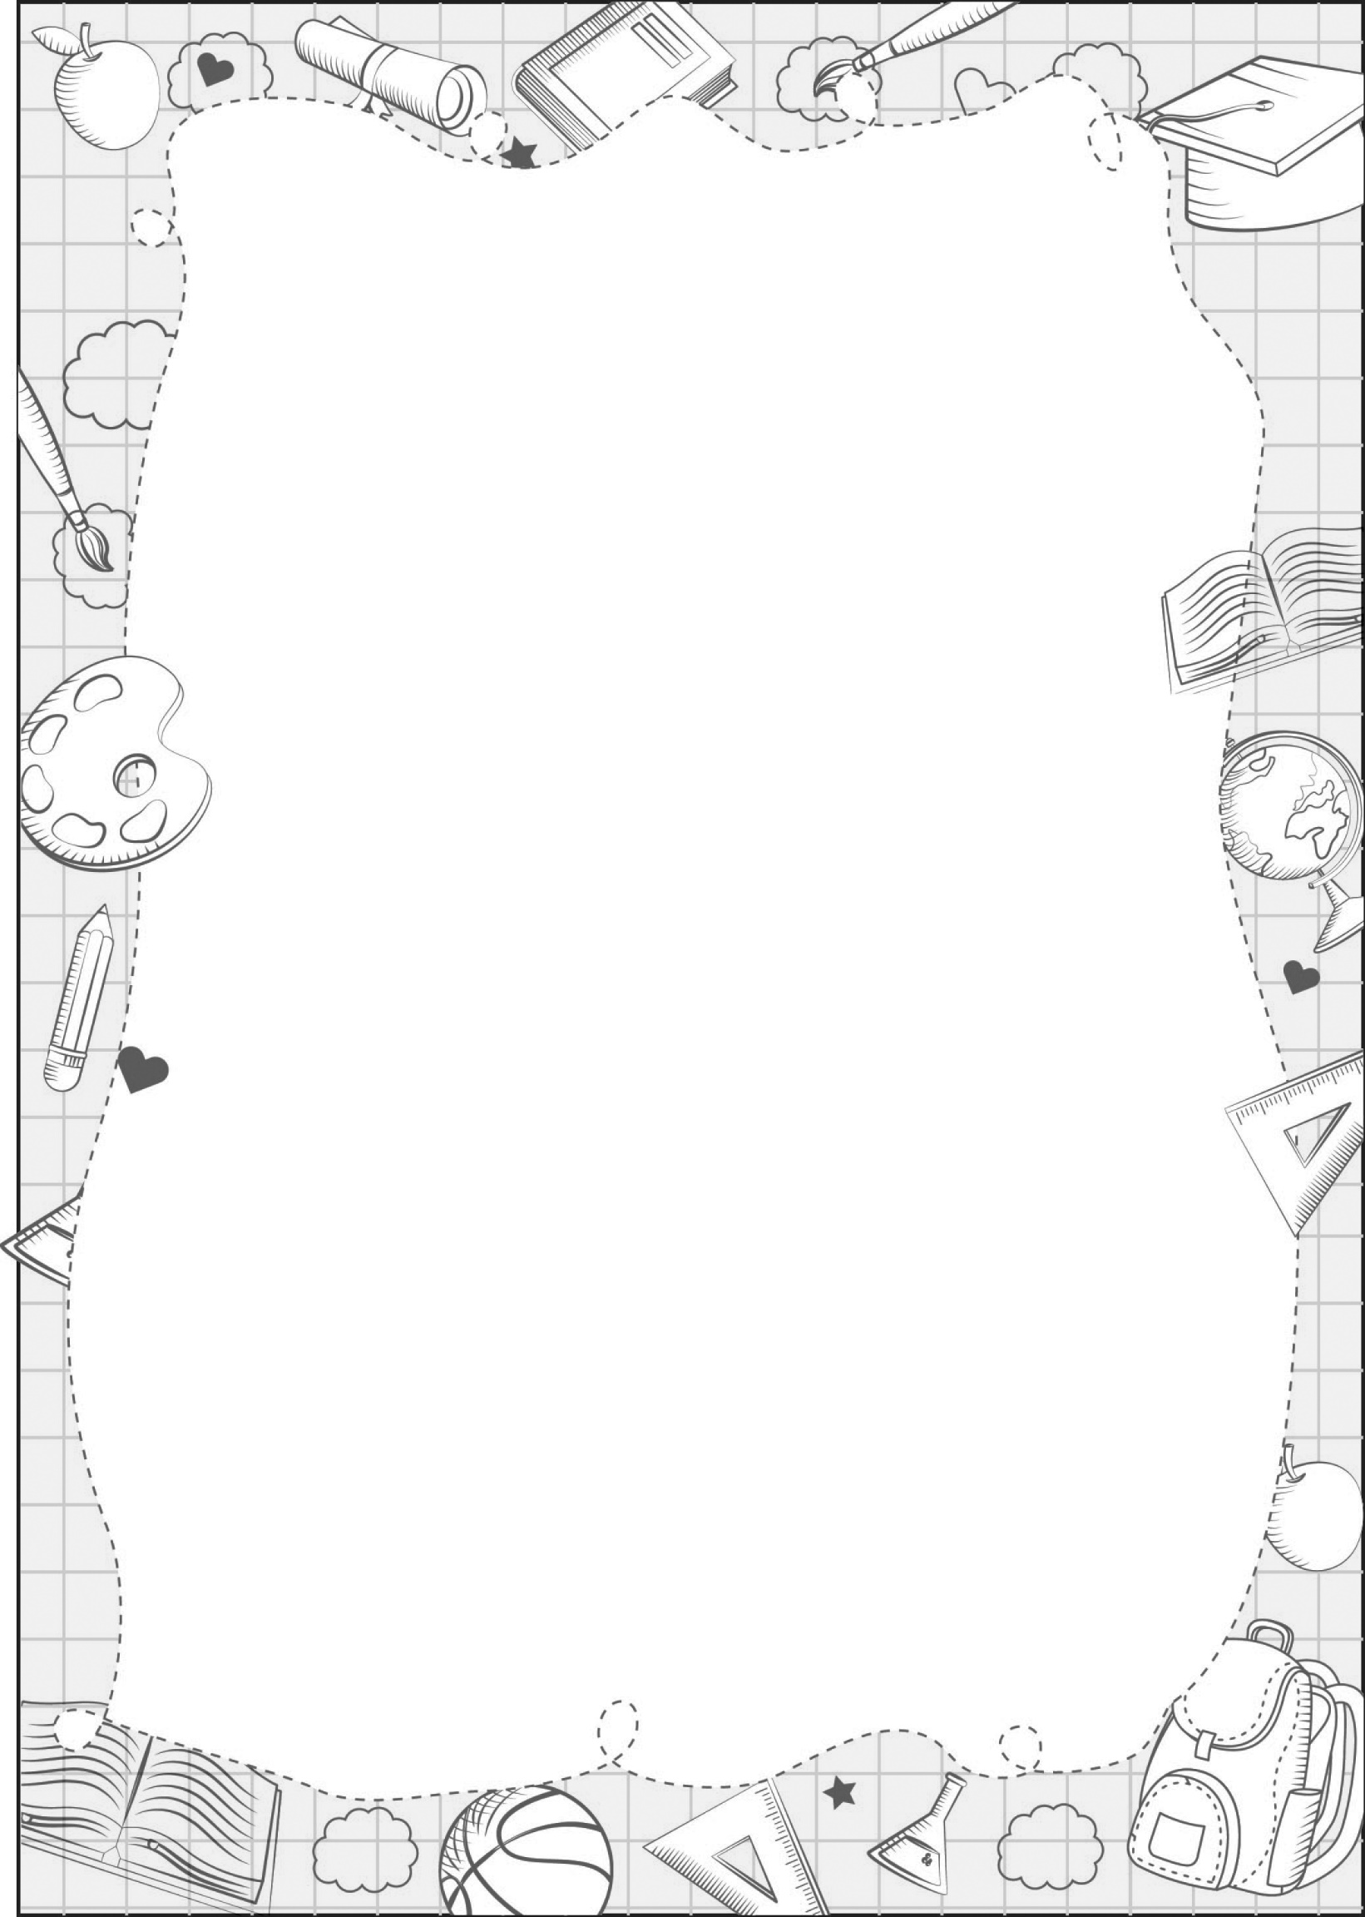
UNIT 7

portfolio

Class: .............
Name: .............

Complete.

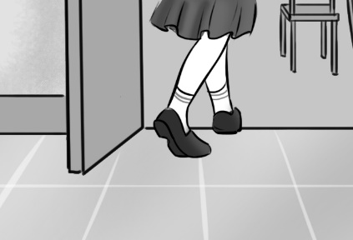  - May I _____________? | 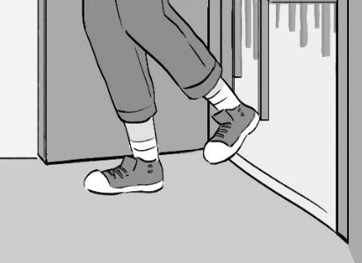  - May I _____________? |   - May I _____________?

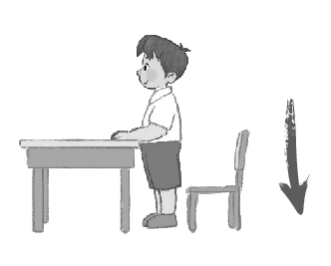  - May I _____________? | 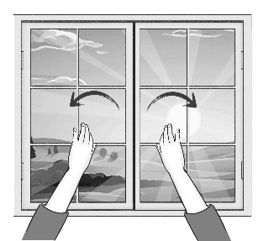  - May I _____________? | 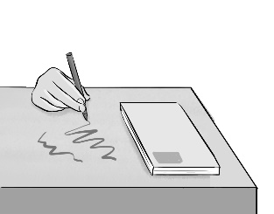  - May I _____________?

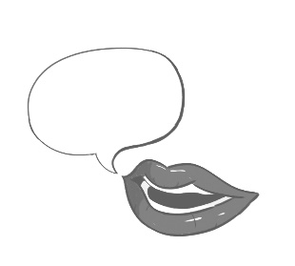  I ____.  - May I _____? | 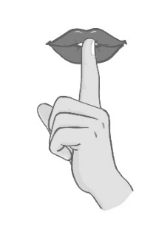  - May I ______? |   - May I ________? | 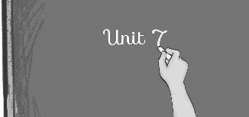  10. May I _____?
Created by …….........................…
__________, please!
May I _________? - Yes, you can./ No, you can’t.
close, come in, go out, sit down, speak, talk, speak English, stand up

Key
- May I come in?
- May I go out?
- May I stand up?
- May I sit down?
- May I close the window?
- May I draw on the table?
- May I speak English / Vietnamese?
- May I talk in class?
- May I sing a song?
- May I write on the board?

