UNIT 18

PROJECT

My first dictionary
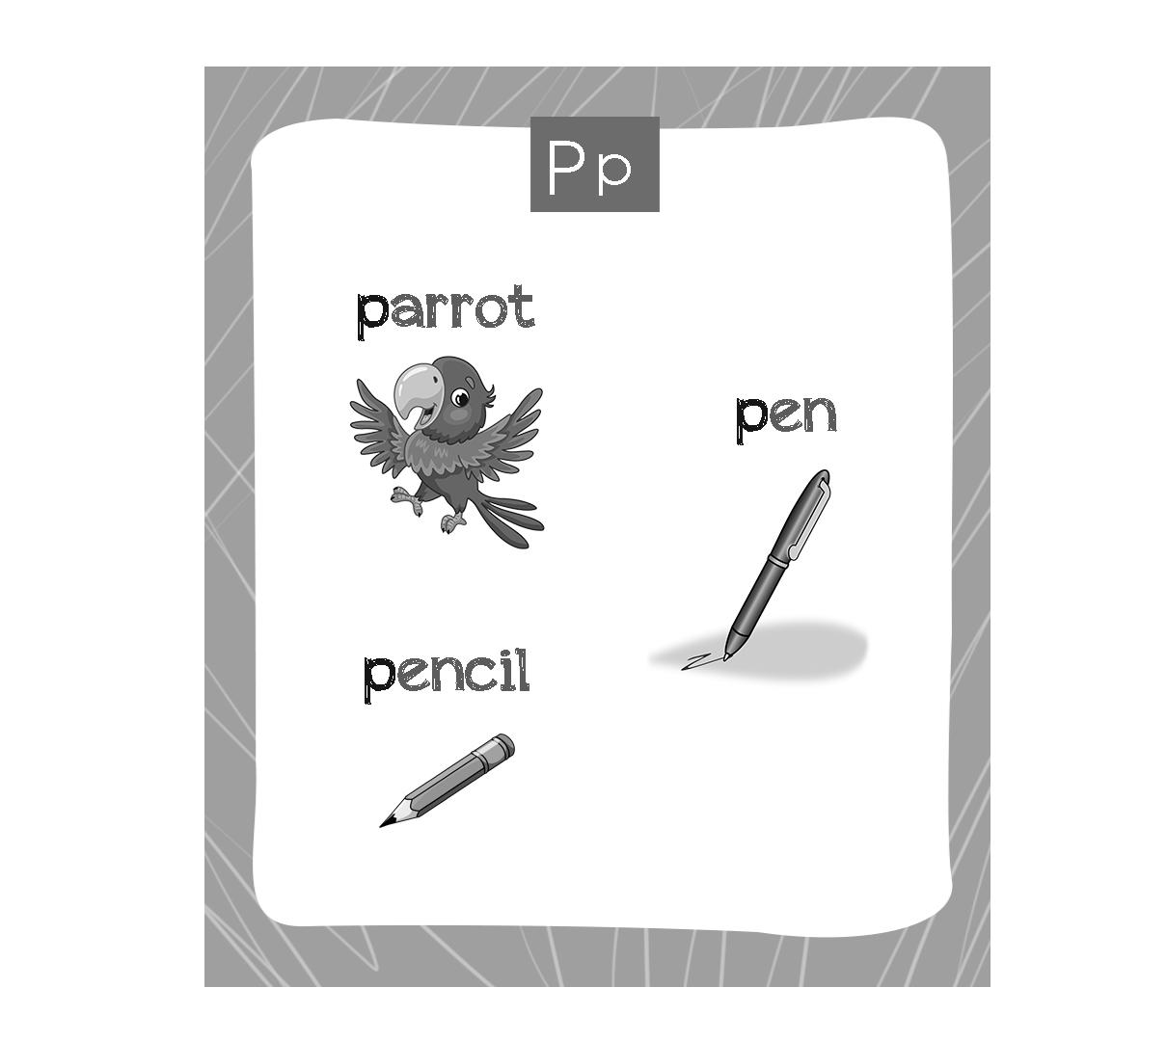

Teacher’s guide:
1. Goal:
- To revise the alphabet and vocabulary learnt from Unit 1 to Unit 18.
2. Input:
- Paper, pen, colour pencils/ crayons
3. Suggested procedure
- Tell pupils that they are going to design their own picture dictionary in a simple way. Show them the picture above to make sure they understand what to do.
- Divide the class into groups (the number of groups depends on the number of the alphabet letters you want to use for the project).
- Give each group a letter and ask them to design the dictionary and draw pictures for illustration (see the picture above).
- Have groups show their dictionary in front of class. Ask the rest of class to observe and give comments.
4. Extension:
- For better class, ask pupils to write short sentences under the pictures in the dictionary.

