School: “A” Long Giang Primary School.  Name:  Class: 3 | KIỂM TRA CUỐI HỌC KỲ I  MÔN: TIẾNG ANH – LỚP 3  NĂM HỌC: 2022 - 2023  Thời gian: 35 phút

SKILL | Listening | Reading | Writing | Speaking | TOTAL
MARK
COMMENT

PART I. LISTENING (20minutes)

Question 1. Listen and tick. (1pt) Nghe và đánh dấu √

1 |   a.❑ | 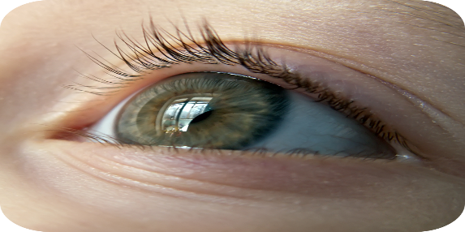  b.❑
2 | 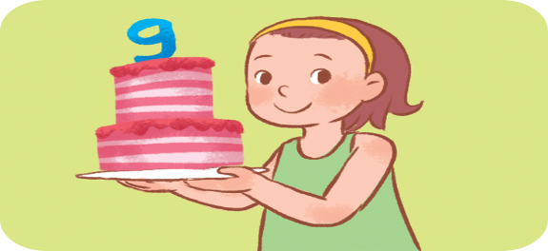  a.❑ |   b.❑
3 | 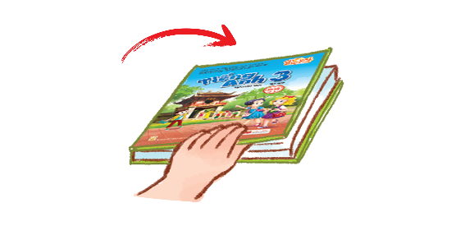  a.❑ | 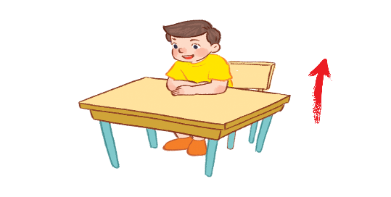  b.❑
4 | 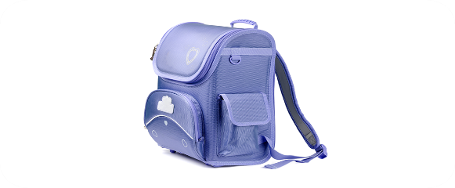  a.❑ | 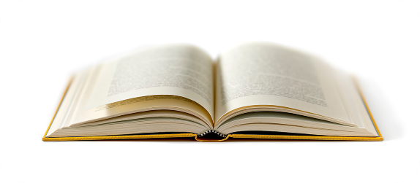  b.❑

Question 2. Listen and number. (1pt) Nghe và đánh số

a |   ❑ | b | 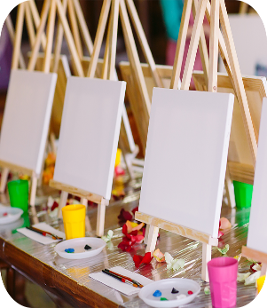  ❑ | c |   ❑ | d |   ❑

Question 3: Listen and circle (1pt) Nghe và khoanh tròn

- Let’s go to the____________

a. library b. classroom c. computer room

- Is that our ________________?
a. music room b. gym c. playground

3. I have_______________
a. an eraser b. a pencil case c. a school bag

4. Do you have__________________?
a. a pen b. a book c. a ruler
Question 4: Listen and write (1pt) Nghe và viết
1. Open your _______________ .
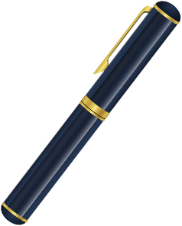
2. I have a _________________ .

3. May I _________________ . 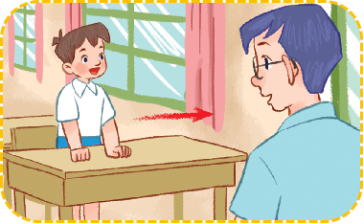

4. Let’s go to the________________ . 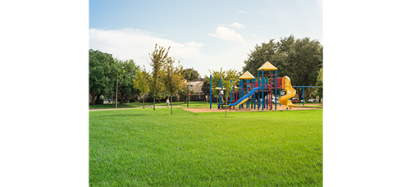

PART II. READING AND WRITING

Question 5: Read and match. (1pt) Đọc và nối

1. Open your mouth! |  | a | 
2. It’s drawing |  | b | 
3. Touch your face! |  | c | 
4. It’s singing |  | d | 

Question 6: Read and complete (1pt) Đọc và điền vào chỗ trống

colour | have | gym | blue
A: I (1) ………. a book.
B: What (2) …………….. is it ?
A: It’s (3) …. ……….
B: Oh. Let’s go to the (4) …………………

Question 7: Look at the pictures and write the words. (1pt) Nhìn tranh và viết từ

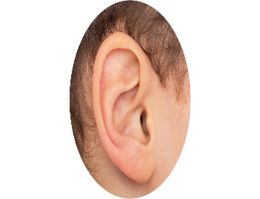 | - r e a  => _ _ _ |  | 2. o o i n g c k  => _ _ _ _ _ _ _
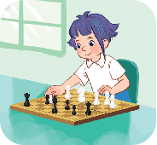 | 3. s e h c s  => _ _ _ _ _ | 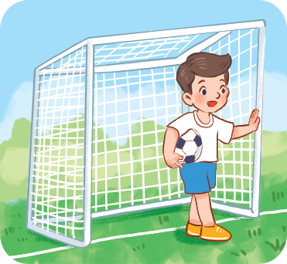 | 4. b l a l f t o o  => _ _ _ _ _ _ _ _

Question 8: Put the words in order (1pt): (Xếp các từ theo đúng vị trí)
1. is / What / name / your / ?

2. name / Bill / My / is / .

3. What / are / colour / they / ?

4. are / red / They / .

--- THE END ---

ĐÁP ÁN
ĐỀ KIỂM TRA CUỐI KỲ I
MÔN: TIẾNG ANH – KHỐI 3
NĂM HỌC: 2022-2023

PART I: LISTENING
Question 1: Listen and tick (1pt)

1. a(0,25ms) | 2. b(0,25ms) | 3. b(0,25ms) | 4. a(0,25ms)

Question 2: Listen and number (1pt)

1. c (0,25ms) | 2. b(0,25ms) | 3. d(0,25ms) | 4. a(0,25ms)

Question 3: Listen and circle (1pt)

1. b(0,25ms) | 2. c(0,25ms) | 3. a(0,25ms) | 4. b (0,25ms)

Question 4: Listen and write (1pt) Nghe và viết
1. book 2. pen 3. go out 4. playground

PART II. READING AND WRITING
Question 5: Read and match. (1pt)

1. b(0,25ms) | 2. d (0,25ms) | 3. a (0,25ms) | 4. c (0,25ms)

Question 6: Read and complete (1pt)

1.  have(0,25ms) | 2. colour(0,25ms) | 3. blue(0,25ms) | 4. gym(0,25ms)

Question 7: Look at the pictures and write the words. (1pt)
1. ear (0,25)
2. cooking(0,25)
3. chess (0,25)
4. football (0,25)

Question 8: Put the words in order (1pt):
- What is your name ?
- My name is Bill.
- What colour are they ?
- They are red.
III. SPEAKING (2pts)
-------- The End--------

