Name:.............................................................  Class: 4........ | KIỂM TRA CUỐI HỌC KỲ I MÔN: TIẾNG ANH – LỚP 4 NĂM HỌC: 2022-2023  Thời gian: 35 phút

SKILL | Listening | Reading | Writing | Speaking | TOTAL
MARK
COMMENT | ..........................................................................................................................  ..........................................................................................................................  .......................................................................................... ................................  Giaoandethitienganh.info sưu tầm

PART 1: LISTENING (15 minutes)

Question 1: Listen and number (1pt): (Nghe và đánh số)
  a  |   b 
  c  |   d 

Question 2: Listen and tick (1pt): (Nghe và đánh dấu ✓)
1.    a  |   b  | 2.    a  |   b 
3.    a  |   b  | 4.    a  |   b 

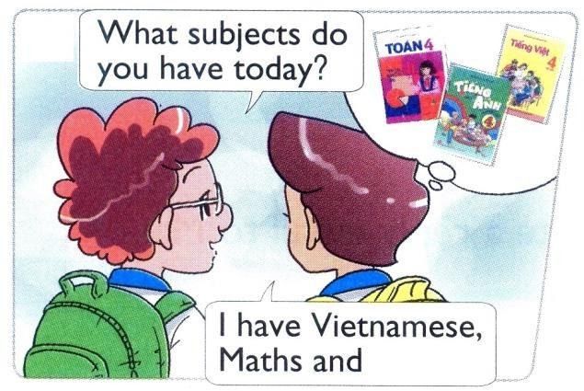
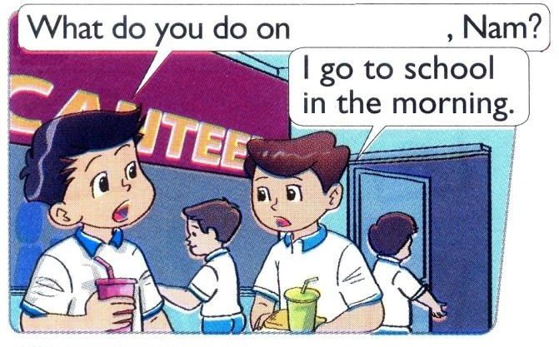
Question 3: Listen and write ✓(tick) or ✗ (cross) (1pt): (Nghe và viết ✓ hoặc ✗)
1.   |  | 2.   | 
3.   |  | 4.   | 
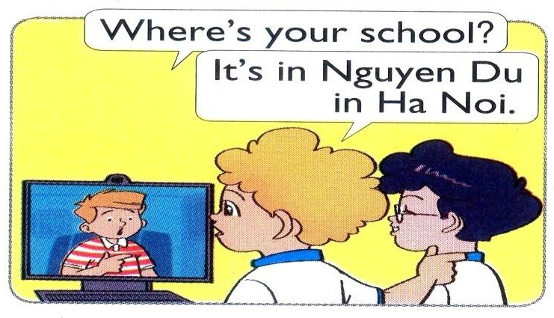

Question 4: Listen and write a missing word (1pt): (Nghe và viết 1 từ còn thiếu)
1.  ………… | 2.  ……………
3.  …………… | 4.  …………

PART 2: READING (10 minutes)
Question 5: Read and match (1pt): (Đọc và ghép)
1. Where are you from, Akiko? |  | a. It’s on the second of September.
2. What are Linda and Mai doing? |  | b. I have Maths, IT and English.
3. When’s your birthday? |  | c. They’re skipping.
4. What subjects do you have today? |  | d. I’m from Japan.


Question 6: Read and complete (1pt): (Đọc và hoàn chỉnh)

playing | doing | flying | play

Peter: I have a new kite. Let’s fly it.
Nam: I’m sorry but I don’t like (1) …………………. kites.
Peter: What do you like (2) ………………….?
Nam: I like (3) …………………. chess.
Giaoandethitienganh.info sưu tầm

Peter: OK, let’s (4) ………………….

PART 3: WRITING (10 minutes)

Question 7: Look and write (1pt): (Nhìn và viết)
 | 1.  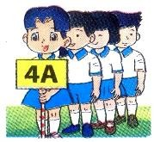 | A: What class are you in?  B: I’m in Class ………………
 | 2.   | A: What are they doing?  B: They’re ……………… a mask.
 | 3.   | A: What do you like doing? B: I like ………………
 | 4.   | A: Where were you yesterday? B: I was at the ………………

Question 8: Put the words in order (1pt): (Xếp các từ theo đúng vị trí)

1. What / the date / is / today?  → ........................................................... | 2. My school / Nguyen Du / is in / Street.  → .............................................................
3. collecting / I / stamps / like.  → ........................................................... | 4. nationality / What / you / are?  → .............................................................

PART 4: SPEAKING (3 minutes for one student)

Question 9: Getting to know each other (1pt):
- What’s your name?
- How old are you?
- What class are you in?

- What do you like doing?

Question 10: Describing the picture (1pt):
- How many boys are there in the picture?
- How many girls are there?
- Where are they?
- What are they doing?

--- THE END ---

ANSWER KEYS – GRADE 4 ĐÁP ÁN – LỚP 4
PART 1: LISTENING (15 minutes)

Question 1: Listen and number (1pt):
a. 1 b. 4 c. 3 d. 2

Question 2: Listen and tick (1pt):
1. a 2. b 3. a 4. a

Question 3: Listen and write ✓(tick) or ✗ (cross) (1pt):
1. ✗ 2. ✓ 3. ✓ 4. ✗

Question 4: Listen and write a missing word (1pt):
  - Street 2. watching 3. English 4. Fridays

PART 2: READING (10 minutes)

Question 5: Read and match (1pt):
a. 3 b. 4 c. 2 d. 1
Question 6: Read and complete (1pt):
1. flying 2. doing 3. playing 4. play

PART 3: WRITING (10 minutes)
Question 7: Look and write (1pt):
1. 4A 2. painting 3. swimming 4. zoo
Question 8: Put the words in order (1pt):
1. What is the date today? 2. My school is in Nguyen Du Street.
3. I like collecting stamps. 4. What nationality are you?

PART 4: SPEAKING (3 minutes for one student)
Giaoandethitienganh.info sưu tầm

Question 9: Getting to know each other (1pt):
1. My name’s ………… 2. I’m ………… (years old).
3. I’m in Class ………… 4. I like …………

Question 10: Describing the picture (1pt):
1. There are two boys. 2. There is one girl.
3. They are at home. 4. They’re watching TV.

